1.Draw a Use Case Diagram for an online Library Management System

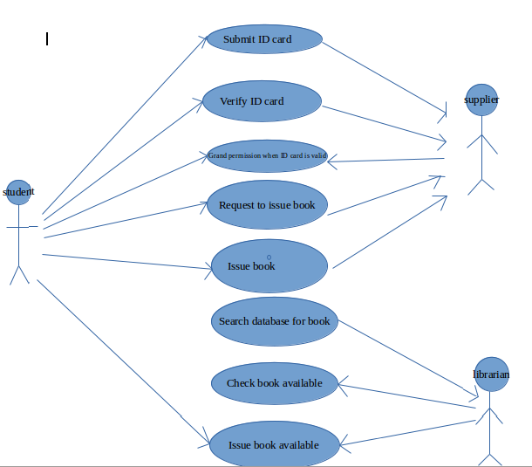
2.List down the best practices from Agile/Scrum methodology
Agile scrum methodology consists of certain good practices that enabled its wide acceptance some of the such methods are:
- Sprint planning meetings: Every day the development team and the scrum masters and the product owners are assembled together in order to discuss the current position of the project.The problems which are arised are discussed in another meeting that is arranged later The scrum team consists of a maximum of 9 members.
- Product backlog:Determining the product backlog is one of the most important feature of the agile methodology.The product backlog consist of all the features that are necessary in the development of the project. Scrum backlog is the subset of the product backlog that consists of the prioritised features of the product backlog.
- Test first design:The term test-first design is a programming best practice.In this method we are writing single test before writing enough production code. The unit tests pile up and build an automated regression test suite that could be run periodically.
- Refactoring is the method of making small changes to the code without affecting the semantics.This method is used to improve the quality of the project the codes are rewritten using the updated ones which brings better results.The combination of the TFD and refactoring brings Test Driven Design.
- Continuous integration automatically compiles,test and validates the components of our solution whenever a components changes
- Pair programming consists of two programmers sharing a single workstation . The programmer at the keyboard is usually called the driver the other, also actively involved in the programming task but focusing more on overall direction is the navigator the programmers swap roles every few minutes or so.

3.Collaboration
a.How does collaboration help agile development?
- The team delivers the products early and successfully and this would satisfy the customers
- The team welcomes changing requirements
- There would be regular meetings between the dev team and the clients
- The team regularly tunes and adjusts its behaviour
- The collaboration allows the teams to interact successfully and share the ideas among them for that purpose each of the member should find the negative aspects of the project so that they can reduce the errors and the risks that are about to occur in future
b.What if the team is distributed and can you achieve the same
productivity?
- No when the team is distributed they can’t succussfully share the ideas
- Most of the conversation occurs through the telephone or the email
- This effort may not be much effective because the sharing of the ideas won’t takes place much
- Some of the members would be in some other floor and thus there won’t be much ideas sharing
- This would result in as relatively low productivity,So it will be better to stay collaborative
c.What would you do to achieve the productivity for a distributed team?
- From the above section we have found that the collaborated system produces better performance than distributed system
- Inorder to increase the productivity of the distributed sysytem the team members should be brought together
- Arranging them in the nearby desks increase the collaboration among themselves
- As a result the arguments and suggestions would arise and it result un the betterment of the project
4.What is Sprint Zero in Agile?Describe the activities that are done inSprint Zero
- Sprint zero is the project initialization step in a project
- It have several other names such as Iteration zero
- Sprint zero is a necessary step in a project because there are certain matters that needs to be taken care before the beginning of as project such as the recruitement of the employees,assembling of the resources creating a produce backlog etc.
- It is also known as a project before a project phase because at the beginnig of a project there should be a detailed analysis about how the project has to be done.
- One of the biggest problems with having a sprint zero is that it establishes a precedent that there are certain sprints or sprint types that have unique rules.

The main activities that are involved with the sprint zero are:
- Achieving active stakeholder participation
- Obtain funding and support
- Start building the team
- Initial requirements envisioning
- Initial architecture envisioning
- Setup environment

