1.How do you evaluate the performance of a project in agile?

- Normally the performance evaluation in the traditional method is based on the factors such as cost,quality and effort
- But when it comes to the agile method there are several other factors that determine the performance.
- Agile project monitoring is based on frequent delivery,Collocation,Dailty team meeting,Project review meeting.
- Frequent delivery indicates the measure of succesful delivery of the software.So that it indicate how far the work is complete,how better we are utilising the time etc.
- Collocation is placing the members of the development team together so that they can communicate efficiently through face-face conversations.
- Daily team meetings are an evaluation of work progress and the remaining schedule of work
- Time box meetings consists of product demonstration and retrospective,which includes providing the software to the product owner and discussing how to improve the efficiency
- The agile project matrices includes the key measures that are used for evaluating the performance such as velocity,hitrate,work remaining on task,project cost.
- Velocity indicates the units of efforts completed during one sprint
- Velocity is measured at the end of each Timebox
- Measure of Velocity is used to predict the Velocity for subsequent
Timeboxes in the Release Plan.
- Hit Rate is the Percentage of work allocated to a Timebox
that was actually completed
- Work remaining on the task includes the estimation of the work remaining on the given task.
- The Project cost measurement includes 3 measurements:
– Cost Performance Index (CPI)
– Schedule Performance Index (SPI)
– Earned Business Value (EBV)
- Cost Performance Index (CPI) = (Baseline Cost per Story
Point)/(Actual Cost per Story Point)
- Schedule Performance Index (SPI) = (Actual Velocity/Baseline Velocity)

CPI > 1 is an indication that cost incured for the project is less than what expected .
CPI<1 is an indication that the cost has exceeded the expected value.
SPI
SPI > 1 is an indication that the project has finished earlier than expected.
SPI < 1 is an indication that the project has finished late than expedcted.
SPI = CPI = 1 : means that the project development is as according to the plan.
EBV
In agile methodology CPI and SPI values are not only the necessary criterion to measure the performance.Instead we do also consider the business value.It measures the outcomes rather than outputs.Customer’s satisfation is a measure that improve this value. It accounts for what all features (as demanded by the user) a0re there in the software produced.

2.Compare traditional monitoring & control with agile monitoring & control with respect to metrics generation?

Sl No: | Traditional Method | Agile Method
1 | Project monitoring and controlling will take place in the last phase of the project | Monitoring and controlling takes place after each sprint
2 | Velocity is less . It takes more time to produce a working software. | Velocity is more. It takes less time to produce a working software as it is used in sprints.
3 | Project success depends on the CPI,SPI values | Project success depends on the EBV
4 | Delivery takes time. | Frequent delivery
5 | It doesnot focus on earned business value | It focuses on Earned Business value. Business value is based on customer satisfaction
6 | Hit rate depends on the overall completion of the delivery | Hit rate depends on the completion of each sprint.
7 | Colocation is not necessary in this method. | Colocation is necessary for the effective delivery.
8 | Schedule for the total project is estimated | Schedule for the each sprint is estimated
9 | Quality is measured in only one phase in the whole project life. | Quality is measured in each sprint life cylcle.

3.With a total project budget of $ 175,000, and having
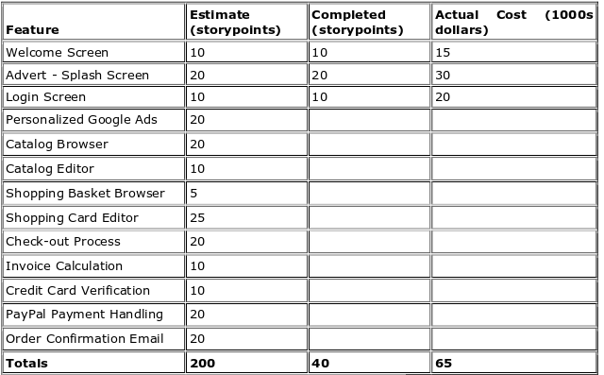
completed one out of four Iterations, we have this product backlog and these actuals:

In our example, after Iteration 1 we should be at 25% complete)
Calculate
Planned Value
Actual % Complete
Earned Value

Planned value = cost of work expected to be completed(25/100)*175000
=$43750
Actual % complete =(TAC/TPC)*100
=(40/200)*100
=20%
Earned value =(TPC)*(BC/SP)
=(20/100)*175000
=$35000

