1.When to use (Rapid Application Development) RAD model
When not to use (Rapid Application Development) RAD model?
- RAD - Rapid application development.
- It is adoption of waterfall model,it aims at developing a softwarein a short span of time.
- It concentrates on input output source and destination ofinformation.
- It is based on Model Phases
The RAD method is used when
  - RAD should be used only when a system can be modularized to be delivered in incremental manner.
  - It should be used if there is high availability of designers for
modeling
  - It should be used only if the budget permits use of automated
code generating tools
  - RAD SDLC model should be chosen only if domain experts are
available with relevant business knowledge.
  - Should be used where the requirements change during the
course of the project and working prototypes are to be
presented to customer in small iterations of 2-3 months.
The RAD method is not used when
  - When the team consist of inexperienced members
  - Can’t be used when the duration of the projects are large
  - When user won’t be able to be a part of the project
  - When the modelling skils are weak
  - Inapplicable to cheaper projects as cost of modelling
  - and automated code generation is very high

2.Define an ER diagram of a software Organization with all the relationship model that was discussed in the classroom

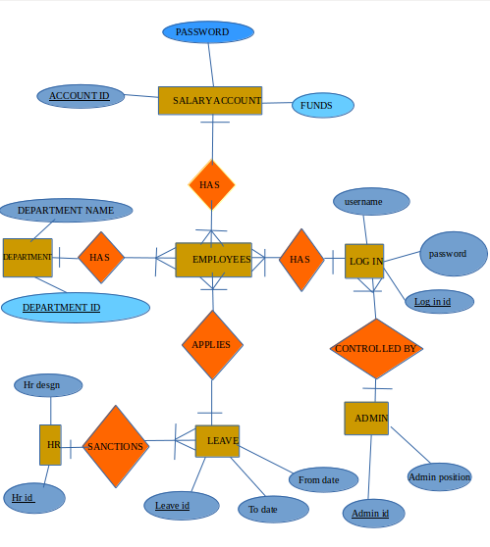

3.Describe the Entity Relationships for the following diagram

An entity–relationship model (ER model) describes inter-related things of interest in a specific domain of knowledge. An ER model is composed of entity types (which classify the things of interest) and specifies relationships that can exist between instances of those entity types.

Here the entity consists of an
- Admin
- Login details
- Staff details
- Leave details
In entities
- Several admins have several login details.each login details consists of several attributes(eg: login username,password of the admins so that each of them can access to thier particular offices).
- Here the admins can add new staffs to the website with their attributes as staff name,staff id,username,contact etc.here the primary key is the staff id.
- Here the staffs can login to their profile using their login details,which means many staffs has many login with thier attributes like barcode access etc.
- The many staffs can apply for many leaves using their leave id as thier primary key and staff id as thier foreign key provides the other attributes such as from date,to date,apply date,status and type of leave.
- Many admins can access to thier leave details using their leave id where he gets the details of the leave such as from date,to date,apply date,status and type of leave.

