**Vellore Institute of Technology, Andhra Pradesh**



School of Computer Science and Engineering (SCOPE)

**Final ECS Project report-2023-2024**

A Project on

**Prediction of Aquatic species behavioral modification in response to Anthropogenic Stressors using Arduino**

**Submitted by**

Praanesh S – 22BCE9319

Nithesh V S – 22BCE9351

Sushanth B – 22BCE8341

Praveen Kanna P J – 22BCE8525

Under the Guidance of Dr. Misha Chandar B

**Abstract**

Human actions continue to remain a significant and ongoing threat to underwater environments, highlighting the critical need for a comprehensive understanding of how these stressors impact marine life. In order to address this pressing issue, we have embarked on an ambitious project that harnesses the capabilities of Arduino technology to develop an advanced monitoring system. The primary aim of this system is to anticipate, track, and gain a deep understanding of the behavioral responses of aquatic species to stressors caused by human activities. To obtain real-time data on stressor levels and behavioral changes in aquatic organisms, we deploy a wide range of sensors that are compatible with Arduino technology. These sensors include monitors specifically designed to measure the quality of the water, temperature sensors that detect fluctuations in temperature, and detectors adept at identifying motion. By strategically placing these sensors in various aquatic environments, we are able to gather valuable data on stressor levels and observe the adaptive behaviors that aquatic species undergo. The key sensors incorporated in our monitoring system encompass pH sensors, temperature sensors, sound sensors, and turbidity sensors. Through a thorough analysis of the data collected by these sensors, we can determine the concentration of dissolved oxygen in the water, contributing to a comprehensive understanding of the ecosystem's dynamics. The insights gained from our monitoring system provide valuable information regarding the impact of human activities on aquatic ecosystems. Fluctuations in temperature and sound levels can be observed, potentially leading to the identification of correlations between these factors. Additionally, distinct patterns in sound levels throughout the day and across seasons become apparent, suggesting the existence of seasonal variations in human activities that can influence aquatic ecosystems. Based on our findings, it becomes increasingly clear that this project has the potential to bridge existing knowledge gaps concerning the relationship between human activities and their consequences on aquatic ecosystems. The conclusions derived from our project highlight the urgent need to address stressors caused by human activities in order to effectively preserve these fragile ecosystems. To support our research, we have extensively referenced various studies on water quality monitoring systems, the utilization of Arduino technology in water quality assessment, and research on fish reactions to disturbances caused by human activities. By using the available and pre-existing knowledge, our project significantly contributes to the field of environmental conservation by providing valuable insights into the intricate relationship between stressors induced by human activities and the behavior of aquatic species.

|  |  |  |
| --- | --- | --- |
| **TABLE OF CONTENTS [ T O C]** | | |
| **Sr. NO** | **DESCRIPTION** | **PAGE NO** |
| 01 | INTRODUCTION | 1 |
| 02 | BACKGROUND | 2 |
| 03 | PROBLEM DEFINITION | 2 |
| 04 | OBJECTIVE OF THE PROPOSED WORK | 2 |
| 05 | METHODOLOGY | 3 |
| 06 | RESULTS AND DISCUSSION | 7 |
| 07 | CONCLUSION AND FUTURE SCOPE | 11 |
| 08 | REFERENCES | 12 |
| 09 | CODE APPENDIX | 14 |

**1.Introduction**

Aquatic ecosystems, with their intricate balance, continually face threats from human-induced stressors that impose significant challenges on the survival and behavior of marine life. [10] Pollution, habitat degradation, and changes in water quality and temperature are among the myriad factors that profoundly impact the behavioral adaptations of aquatic species. These alterations hold the key to understanding the intricate dynamics of aquatic ecosystems, playing a pivotal role in effective conservation efforts and ecosystem management. Recognizing the urgency of comprehending these impacts, our research project takes center stage, leveraging the power of Arduino technology. Arduino, celebrated for its flexibility and accessibility, emerges as the linchpin of our endeavor to predict, monitor, and comprehend the behavioral responses of aquatic species to anthropogenic stressors. This research is not merely a technical exploration but a vital step towards harmonizing human activities with the delicate rhythms of aquatic ecosystems. [5] As human activities expand and intensify, the toll on aquatic environments becomes increasingly evident. Pollution, whether from industrial discharges or agricultural runoff, introduces contaminants that alter the chemical composition of water, posing immediate threats to the species that call these environments home. Habitat degradation, often a consequence of urbanization and deforestation, further disrupts the delicate balance, leaving aquatic species vulnerable to displacement and loss of crucial breeding and feeding grounds. One of the critical consequences of these stressors is the alteration of water quality and temperature. Fluctuations in these parameters can have cascading effects on the physiology and behavior of aquatic organisms. Temperature, in particular, is a key determinant of metabolic rates and biochemical processes in aquatic species. Shifts in water temperature can disrupt the timing of life cycle events, such as spawning and migration, with potential repercussions for entire ecosystems. Understanding these multifaceted challenges requires a holistic and interdisciplinary approach. It is not enough to quantify the impact of stressors solely through traditional ecological studies. Our research recognizes the interconnectedness of biological responses with technological innovation. Arduino technology, with its open-source platform and versatility, provides an ideal toolkit for constructing a monitoring system that can capture the nuances of aquatic species' behaviors in response to anthropogenic stressors. This project is more than a scientific endeavor; it is a conscientious effort to integrate technological solutions with environmental stewardship. Predicting and monitoring the behavioural responses of aquatic species, we aim to decipher the language of these organisms, written in the subtle changes of their movements, the modulation of their calls, and the adaptations they exhibit in the face of adversity. Through Arduino, we not only collect data but translate it into meaningful insights that can inform policies, guide conservation initiatives, and foster a sustainable coexistence between humans and the delicate ecosystems we impact. In the pages that follow, we delve into the intricacies of our methodology, the selection of sensors, the deployment of our monitoring system, and the analysis of the rich dataset we have acquired. Each section contributes to the overarching narrative of understanding and mitigating the impacts of human-induced stressors on aquatic ecosystems.

**2.Background**

This project aims to explore the effects of human-induced stressors on aquatic species’ behavior by employing Arduino technology. Anthropogenic factors like pollution, habitat alterations, and changes in environmental conditions significantly impact aquatic ecosystems. Through the utilization of Arduino-compatible sensors such as water quality monitors, temperature sensors, and motion detectors, our goal is to develop a monitoring system. This system will enable real-time data collection on stressor levels and behavioral changes in aquatic organisms.

Our primary objective is to establish connections between variations in stressor levels and observable alterations in aquatic species' behavior. This analysis seeks to unravel how these stressors influence the behavioral adaptations of aquatic life.

The project holds significance in enhancing our understanding of the intricate relationship between human-induced stressors and aquatic species' behavior. By leveraging Arduino technology, we aim to predict and comprehend the behavioral modifications of aquatic species, underscoring the urgency of addressing human-induced stressors for the preservation of these invaluable ecosystems

**3.Problem Definition**

To propose an Arduino-driven monitoring system to predict and mitigate the impact of anthropogenic stressors on aquatic biodiversity for Sustainable environmental conservation.

**4.Objectives of the proposed work**

[8] Anthropogenic stress alters the balance in aquatic ecosystems in various ways. Here, we review the contemporary literature on how alterations in aquatic systems through environmental pollution, invasive species, and [9] hydro morphological changes carry over to Aquatic ecosystems

We further review the literature to assess the present state of the field and identify gaps in our knowledge. We begin with discussing the factors that determine how an individual responds to a change in the environment and whether the response is adaptive or not.

**5.Methodology:**

Curate a suite of Arduino-compatible sensors, including water quality sensors for pH, turbidity, temperature sensors, and sound sensors. These sensors will be strategically deployed in aquatic environments to capture data on stressor levels while simultaneously monitoring the behavioral adaptations of aquatic species.

**pH Sensor:**

Arduino compatible pH sensor which is designed for accurate and reliable pH measurement in industrial processes has been used. It uses a combination of electrodes and sensitive materials to detect and measure the hydrogen ion concentration in a solution, which indicates its pH level. A pH value within a specific range is generally indicative of water quality. For example: pH 6.5-8.5.

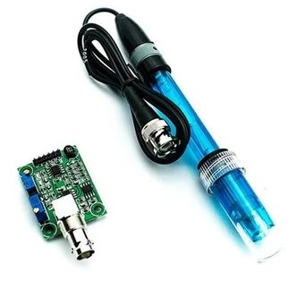

Fig-1 pH sensor and it’s module

**Temperature Sensor:**

The temperature sensor is a device implemented to measure the temperature of a substance. In this research, we used the DS18B20 model, a thermistor-based temperature sensor, to quantify the temperature of the water. The thermistor is a semiconductor device whose resistance changes with temperature. The change in resistance is used to calculate the temperature of the water.

|  |  |
| --- | --- |
| **Types of fishes based on environment** | **Ideal temperature** |
| Freshwater fish | 18-24°C (64-75°F) |
| Tropical fish | 24-28°C (75-82°F) |
| Coldwater fish | 10-20°C (50-68°F) |

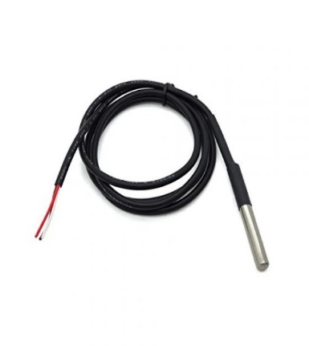

Fig-2 DS18B20 Temperature sensor

**Sound Sensor:**

Sound sensors are devices that can detect and measure sound levels or variations in sound. We used the KY-038 model sound sensor, they often use components like microphones or specialized transducers to convert sound waves into electrical signals that can be analyzed or utilized by electronic systems.

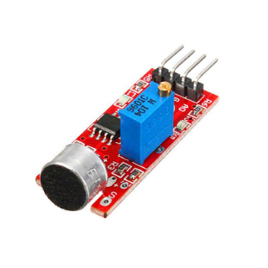

Fig-3 KY-038 sound sensor

**Turbidity Sensor:**

The turbidity sensor works on the principle of light scattering. The sensor emits a beam of light, which is scattered by the suspended particles in the water. The amount of scattered light is measured by the sensor, which is proportional to the turbidity of the water.

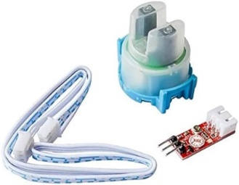

Fig-4 Turbidity sensor with module

**Calculation of Dissolved Oxygen:**

The dissolved oxygen concentration is calculated using the temperature, pH, and turbidity values. The calculation is based on the solubility of oxygen in water, which is affected by temperature, pressure, and pH. In this research, the dissolved oxygen concentration is calculated from the output of the sensors.

To calculate the dissolved oxygen concentration (DO) from sensor readings, we can use the following formula:

***DO = T * normalized_T +pH * normalized_pH +TUR *normalized_TUR***

(or) ***DO = a * e(b*T) * 10(pH - c * TUR),*** (replace a,b,c with calculated calibration values)

(or) ***DO = T + round (-0.1 * round (Turbidity)/2) + (0.5 * (pH) + 8), (***-0.1,0.5 and 8, these values are calculated calibration values for used sensors. This formula has +- 0.4 error)

DO = Dissolved oxygen level in mg/L

T = Temperature of Water (in Celsius, obtained from a temperature sensor and converted to Kelvin)

pH = pH value noted by pH sensor

TUR = Turbidity value by the turbidity sensor

**Hardware implementation:**

The hardware of the system consists of an Arduino microcontroller, a Temperature sensor (Model: DS18B20), A sound sensor (Model: KY – 038), a Turbidity sensor, a pH sensor (Model: EC5327), a pH sensor module, a 4.7k Ω resistor, a breadboard and jumper wires (M-M, M-F, F-F). Before assembling the sensors, the sensors should be calibrated and each sensor should be checked precisely using some standard techniques like testing the temperature sensor in different temperatures, testing the sound sensor at different decibel levels, etc. The following will explain how to assemble the setup as shown in Fig-5.

* Every sensor has 2 common pins which are ground and power (5V).
* Connect the power and ground from Arduino to the breadboard using jumper wires.
* Temperature sensor: Connect the power and ground to the breadboard and the sensor has one more wire which is a communication wire, connect it directly to the Arduino setup. Temperature cannot take 5V, so connect a 4.7K Ω resistor to the power and communication line in the breadboard.
* Sound sensor: Connect the power and ground pins parallel to the temperature sensor and the sensor has 2 more pins which are analog output and digital output which can be directly connected to Arduino.
* Turbidity sensor: Connect the power and ground pins parallel to the temperature sensor and the sensor has one more pin which is analog and can also be directly connected to the sensor.
* pH sensor: pH sensor cannot be connected directly to Arduino because it does not have the BNC connector for the electrode, so we need a separate module for it, connect the power and ground between the pH module and breadboard using jumper wires parallel to the temperature senor. Connect the PO directly to the analog pin input in the Arduino and connect the pH electrode to the pH module through the BNC connector.

At last, connect your Arduino to the computer using a USB connector to get the readings.

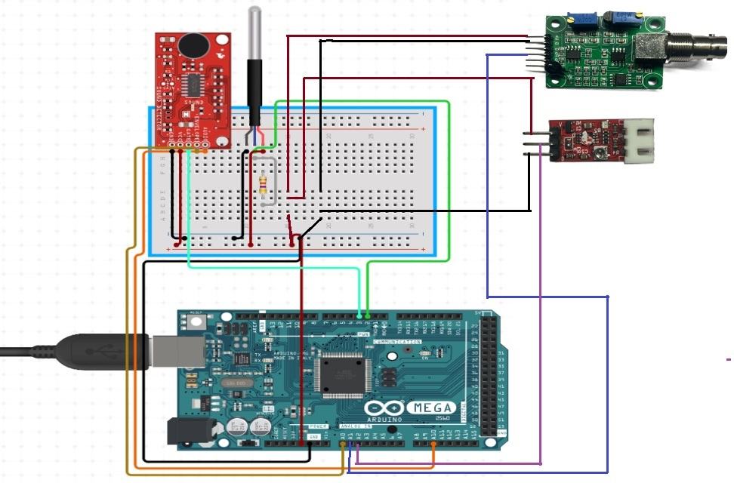

Fig-5‑ Hardware design of the prototype

**6.Result and Discussion**

* Login page:

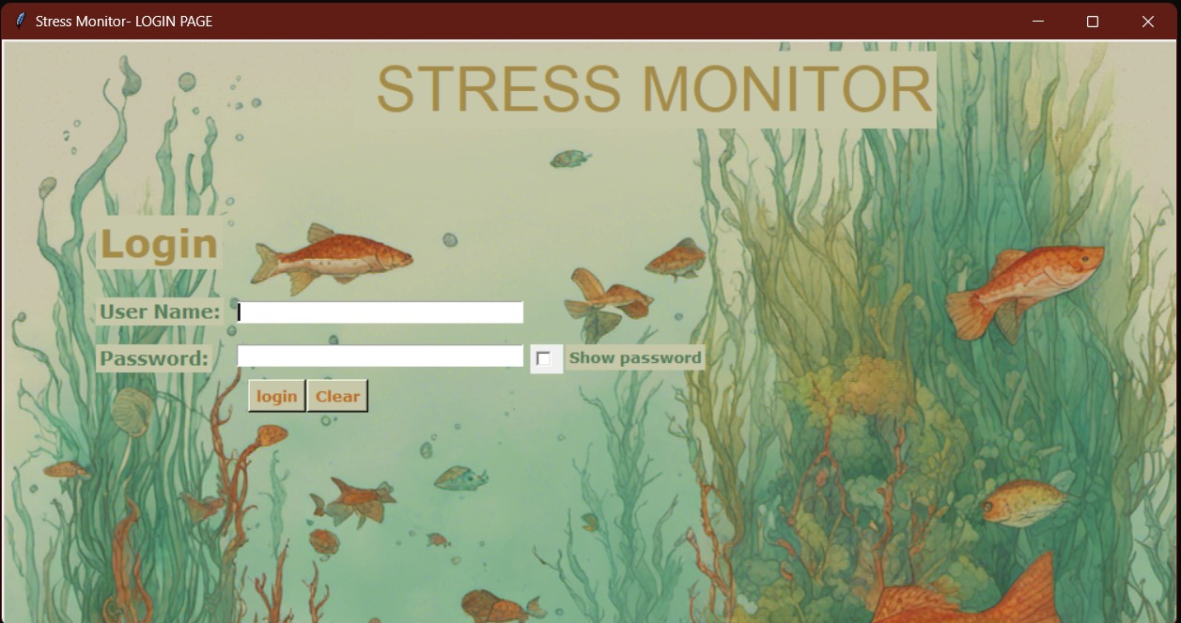Fig-6

* Menu Window:

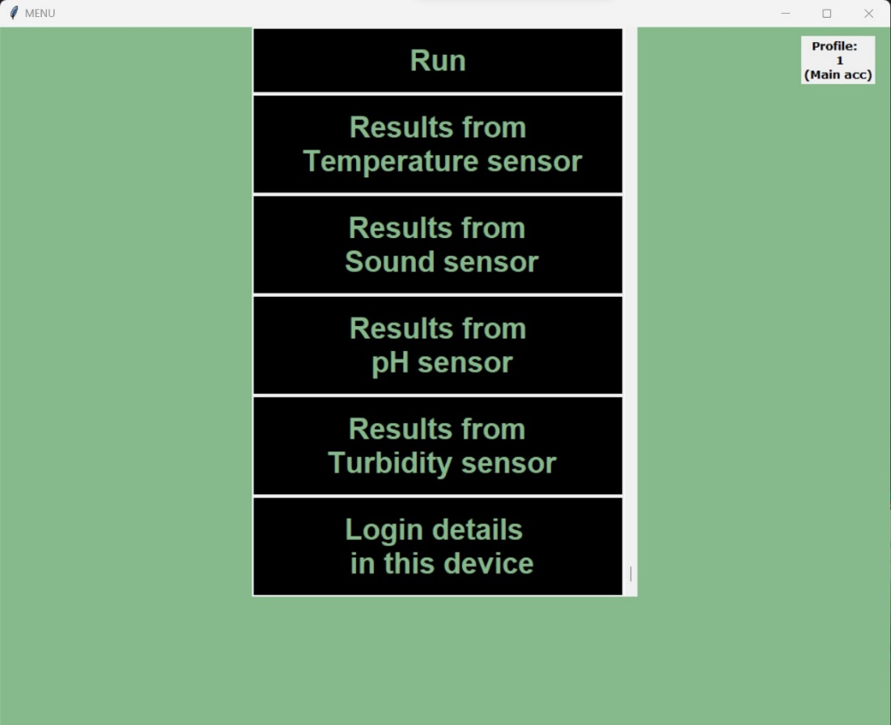

Fig-7

* If we press the Run button, the Output Window shows up [Fig-8].

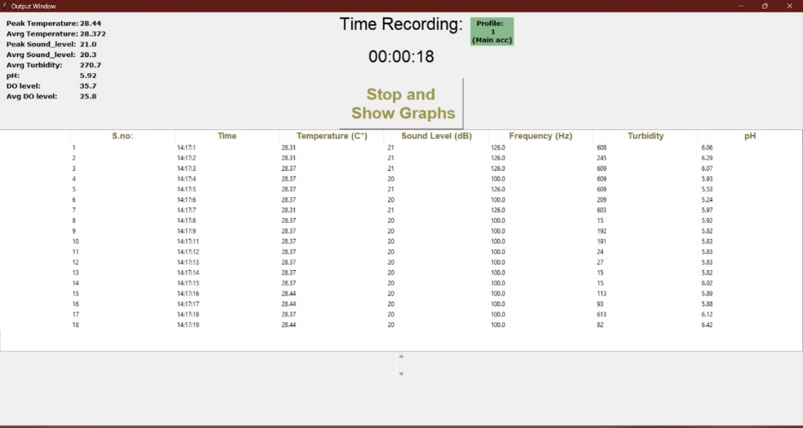Fig-8

* After the Output window stops, here we get Graph window [Fig-9]

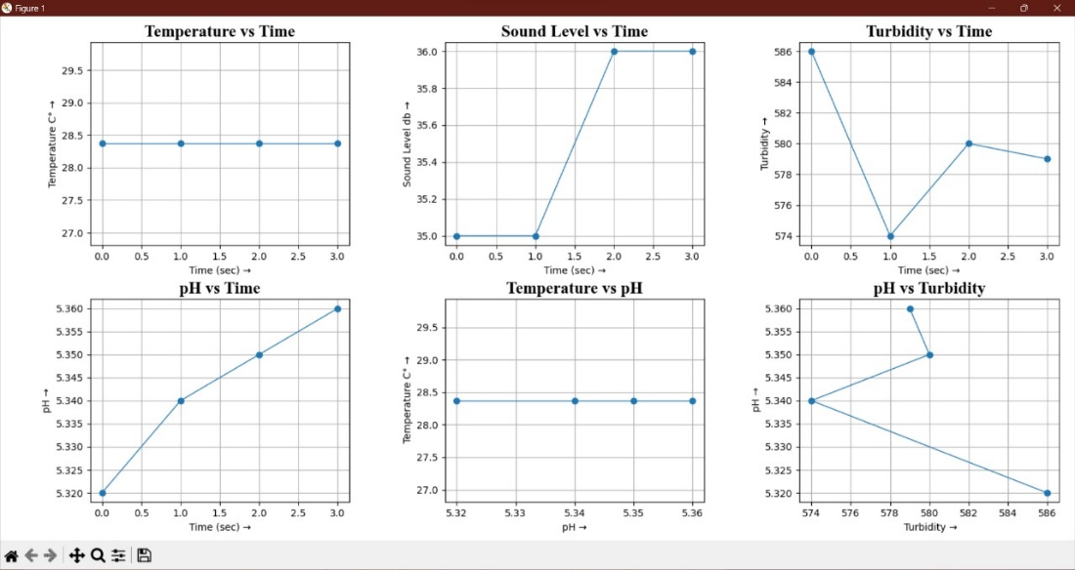Fig-9

* If we click the “**Results from temperature sensor**” button, it shows all temp. results up to now with specific dates and times [Fig-10].

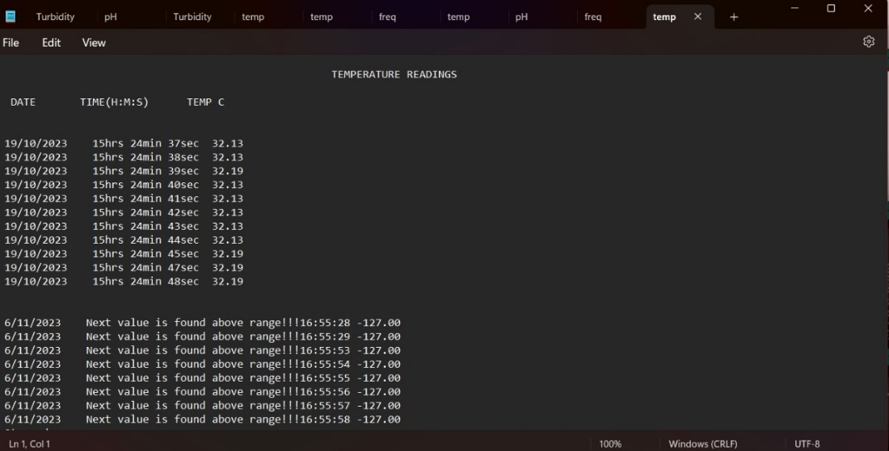Fig-10

* If we click the “**Results from sound sensor**” button, it shows all temp. results up to now with specific dates and times. [FIg-11]

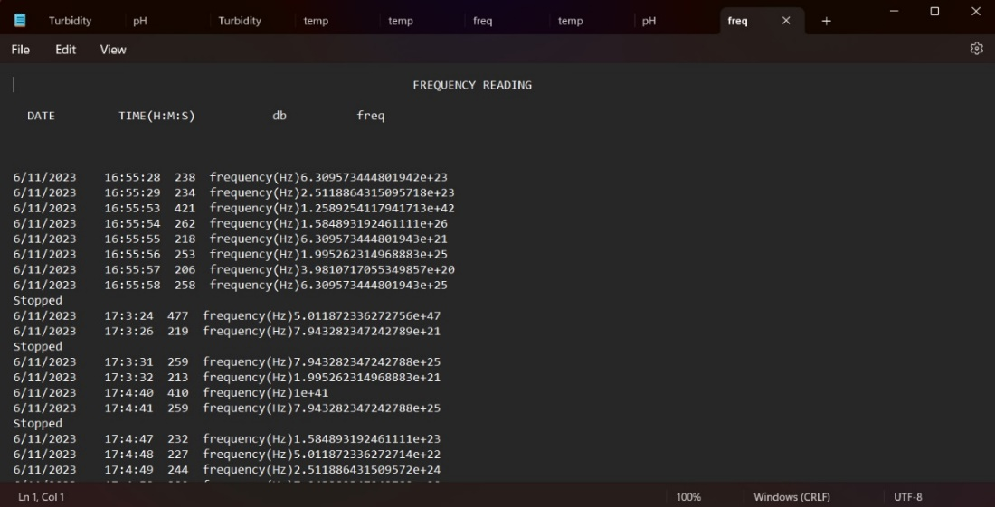Fig-11

* If we click the “**Results from turbidity sensor**” button, it shows all temp. results up to now with specific dates and times [Fig-12].

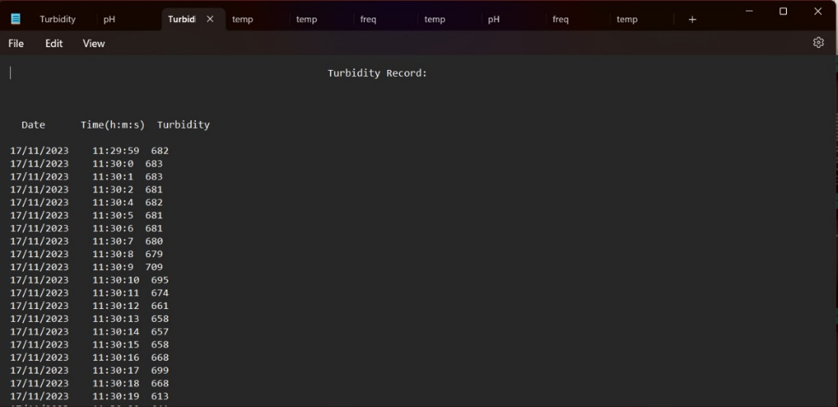Fig-12

* If we click the “**Results from pH sensor**” button, it shows all temp. results up to now with specific date and time [Fig-13].

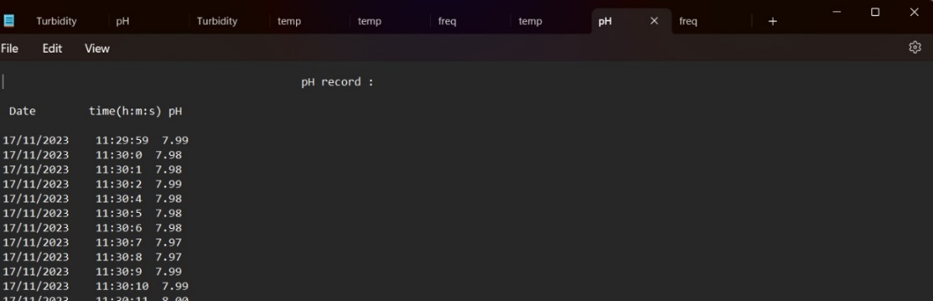Fig-13

**7.Conclusion and future scope**

The conclusion of our project marks a significant milestone in bridging the intricate relationship between human activities and their impact on aquatic ecosystems. The implementation of Arduino technology has proven to be a pivotal tool in predicting and comprehending the behavioral modifications of aquatic species in response to anthropogenic stressors. Through the deployment of a multi-sensor monitoring system, we have garnered valuable insights into the dynamics of aquatic ecosystems and the effects of human-induced stressors on marine life.

Thi project's results have unveiled compelling observations, particularly in the realms of temperature dynamics and sound level variations. The consistent temperature increases detected suggest potential anthropogenic or climate-related influences on aquatic environments. Furthermore, the correlation between sound levels and temperature during warmer periods indicates a tangible link between human activities and increased sound levels. These findings emphasize the need for further investigation into specific stressors, such as boat traffic or industrial processes, that may be contributing to elevated sound levels. The diurnal and seasonal trends in sound levels have provided additional layers of understanding. Peaks in sound levels during daytime hours and correlations with temperature changes highlight potential seasonal shifts in human activities impacting aquatic ecosystems. This nuanced insight underscores the importance of considering both short-term and long-term patterns in environmental monitoring and conservation efforts.

In conclusion, our project not only enhances the scientific understanding of aquatic ecosystems but also emphasizes the urgency of addressing human-induced stressors for the conservation of these fragile environments. The Arduino-driven monitoring system serves as a practical and accessible tool for ongoing research in this field. As we move forward, the implications of our findings extend into the realm of sustainable environmental conservation. The identified stressor patterns and behavioral adaptations provide a foundation for developing targeted conservation strategies to mitigate the impact of human activities on aquatic biodiversity. The future scope of this project involves expanding the monitoring network to different aquatic environments, conducting long-term studies to capture more nuanced patterns, and integrating machine learning algorithms for predictive analysis. By continually refining our understanding of the complex interplay between anthropogenic stressors and aquatic species behavior, we contribute to the collective effort to safeguard these vital ecosystems for future generations.

**8.References**

1. N. R. Moparthi, C. Mukesh and P. Vidya Sagar, "Water Quality Monitoring System Using IOT," 2018 Fourth International Conference on Advances in Electrical, Electronics, Information, Communication and Bio-Informatics (AEEICB), Chennai, India, 2018, pp. 1-5, doi: 10.1109/AEEICB.2018.8480963

URL:<https://ieeexplore.ieee.org/stamp/stamp.jsp?tp=&arnumber=8480963&isnumber=8480843>

1. P. Manikandan, S. M. Kanna, S. D. K. Reddy, and S. Subhash, "Water Quality Identification System Using Arduino," 2021 3rd International Conference on Advances in Computing, Communication Control and Networking (ICAC3N), Greater Noida, India, 2021, pp. 704-708, doi: 10.1109/ICAC3N53548.2021.9725632

URL:<https://ieeexplore.ieee.org/stamp/stamp.jsp?tp=&arnumber=9725632&isnumber=9725386>

1. Nedelec, Sophie & Radford, Andrew & Gatenby, Peter & Davidson, Isla & Velasquez Jimenez, Laura & Travis, Maggie & Chapman, Katherine & Mccloskey, Kieran & Lamont, Timothy & Illing, Björn & Mccormick, Mark & Simpson, Stephen. (2022). Limiting motorboat noise on coral reefs boosts fish reproductive success. Nature Communications.13.2822.10.1038/s41467-022-30332-5. <https://www.researchgate.net/figure/Spiny-chromis-Acanthochromis-polyacanthus-nest-at-the-edge-of-coral-reef_fig4_360728639>
2. Candolin, U., & Rahman, T. (2023). Behavioral responses of fishes to anthropogenic disturbances: Adaptive value and ecological consequences. Journal of Fish Biology, 103(4),773783.<https://doi.org/10.1111/jfb.15322>, <https://onlinelibrary.wiley.com/doi/10.1111/jfb.15322>
3. Grant E. Brown, Jean-Guy J. Godin, Ecological uncertainty and antipredator behaviour: an integrative perspective, Frontiers in Ethology, 10.3389/fetho.2023.1238167,2,2023). <https://www.frontiersin.org/articles/10.3389/fetho.2023.1238167/full>
4. Iain Barber, Andrew G. Hirst, Carl Smith, The challenges faced by fish in a dynamic world, Journal of Fish Biology, 10.1111/jfb.15545, 103, 4, (749-751), (2023). <https://onlinelibrary.wiley.com/doi/10.1111/jfb.15545>
5. William Bernard Perry, Dining amidst the decibels is not an issue when you have company: anthropogenic noise and the topmouth Gudgeon, Journal of Fish Biology, 10.1111/jfb.15459, 102, 6, (1271-1271), (2023)

<https://onlinelibrary.wiley.com/doi/10.1111/jfb.15459>

1. Nedelec, Sophie & Radford, Andrew & Gatenby, Peter & Davidson, Isla & Velasquez Jimenez, Laura & Travis, Maggie & Chapman, Katherine & Mccloskey, Kieran & Lamont, Timothy & Illing, Björn & Mccormick, Mark & Simpson, Stephen. (2022). Limiting motorboat noise on coral reefs boosts fish reproductive success. Nature Communications. 13. 2822. 10.1038/s41467-022-30332-5

<https://researchgate.net/figure/Spiny-chromis-Acanthochromis-polyacanthus-nest-at-the-edge-of-coral-reef_fig4_360728639>

1. Schulz R, Bundschuh M, Entling MH, Jungkunst HF, Lorke A, Schwenk K, Schäfer RB. A synthesis of anthropogenic stress effects on emergence-mediated aquatic-terrestrial linkages and riparian food webs. Sci Total Environ. 2023 Oct 30;908:168186. doi: 10.1016/j.scitotenv.2023.168186. Epub ahead of print. PMID: 37914130.

<https://pubmed.ncbi.nlm.nih.gov/37914130/>

1. Hoch, J. M., Sokol, E. R., Bush, M. R., & Trexler, J. C. (2022). Anthropogenic structures influence small-fish movement in wetlands. Environmental Biology of Fishes., 105, 1933–1952. <https://doi.org/10.1007/s10641-022-01268-y>
2. Nedelec, S. L., Radford, A. N., Pearl, L., Nedelec, B., McCormick, M. I., Meekan, M. G., & Simpson, S. D. (2017). Motorboat noise impacts parental behaviour and offspring survival in a reef fish. Proceedings of the Royal Society B-Biological Sciences, 284(1856), 20170143. <https://doi.org/10.1098/rspb.2017.0143.>
3. Candolin, U. (2019). Mate choice in a changing world. *Biological Reviews*, **94**(4), 1246–1260. <https://doi.org/10.1111/brv.12501>.
4. Manjakkal, L., Lorenzelli, L., Willander, M., Akhter, F., Siddiquei, H.R., Alahi, M.E.E. and Mukhopadhyay, S.C. (2023). An Internet of Things-Enabled System for Monitoring Multiple Water Quality Parameters. In Sensing Technologies for Real Time Monitoring of Water Quality (eds L. Manjakkal, L. Lorenzelli and M. Willander). <https://doi.org/10.1002/9781119775843.ch13>
5. Benedict, S., Gowtham, N., Giri, D., & Sreelakshmi, N. (2018, October). Real time water quality analysis framework using monitoring and prediction mechanisms. In *2018 Conference on Information and Communication Technology (CICT)* (pp. 1-6). IEEE. [Real Time Water Quality Analysis Framework using Monitoring and Prediction Mechanisms | IEEE Conference Publication | IEEE Xplore](https://ieeexplore.ieee.org/abstract/document/8722381)
6. Manfrin, A., Singer, G., Larsen, S., Weiss, N., van Grunsven, R. H. A., Weiss, N. S., … Holker, F. (2017). Artificial light at night affects organism flux across ecosystem boundaries and drives community structure in the recipient ecosystem. *Frontiers in Environmental Science*, **5**, 61. <https://doi.org/10.3389/fenvs.2017.00061>.
7. Mousseau, T. A., & Fox, C. W. (1998). The adaptive significance of maternal effects. *Trends in Ecology & volution*, **13**(10), 403407.  
    <https://doi.org/10.1016/s0169-5347(98)01472-4>.

**9.Codes in Appendix**

**Arduino code:**

#include <OneWire.h>

#include <DallasTemperature.h>

#define ONE_WIRE_BUS 2

OneWire oneWire(ONE_WIRE_BUS);

DallasTemperature sensors(&oneWire);

int soundSensorPin = A2;

int analogPin = A0;

int pHSensorPin = A1;

void setup() {

Serial.begin(9600);

sensors.begin();

}

void loop() {

sensors.requestTemperatures();

int Turbidity = analogRead(analogPin);

float temperature = sensors.getTempCByIndex(0);

int soundLevel = analogRead(soundSensorPin);

int pHValue = analogRead(pHSensorPin);

float voltage = (float)pHValue * (5/1023.0/2);

float pH = 3.5*voltage;

Serial.print(temperature);

Serial.print(" , ");

Serial.print(soundLevel);

Serial.print(" , ");

Serial.print(Turbidity);

Serial.print(" , ");

Serial.println(pH);

delay(1000);

}

**Python code:**

import serial

import os

import datetime

import random

import threading

import time

import matplotlib

from tkinter import *

from matplotlib.backends.backend_tkagg import FigureCanvasTkAgg

matplotlib.use('TkAgg')

import matplotlib.pyplot as plt

td = []

sd = []

fd = []

tid = []

ser = serial.Serial('COM5', 9600)

t = open('temp.data', 'a+')

f = open('freq.data', 'a+')

login_db = {"1": "1”}

def graph():

global dfl

global td,sd,tid,fd

dfl = False

fig, (ax1, ax2,ax3) = plt.subplots(1,3)

current_datetime = datetime.datetime.now()

filename = "temp_sound"+current_datetime.strftime("%Y-%m-%d_%H-%M-%S")

custom_figure_name = filename

ax1.plot(tid, td,marker='o')

ax1.set_xlabel("Time (sec) →")

ax1.set_ylabel("Temperature C° →")

ax1.set_title("Temperature vs. Time")

ax2.plot(tid, sd,marker='o')

ax2.set_xlabel("Time (sec) →")

ax2.set_ylabel("Sound Level db →")

ax2.set_title("Sound Level vs. Time")

ax3.plot(fd,tid,marker='*')

ax3.set_xlabel("Time (sec) →")

ax3.set_ylabel("Frequency Hz →")

ax3.set_title("Frequency vs. Time")

plt.suptitle("Sensor Data V/S Time")

plt.show()

td=[]

sd=[]

tid=[]

output_window = None

def ot(output_window):

stop_flag = threading.Event()

sno = 1

def stop():

global dfl

stop_flag.set()

dfl = True

graph()

stop_button = Button(output_window, text="Stop", font=("Arial 23 bold"), command=stop, bg="purple")

stop_button.pack()

output_text = Text(output_window, wrap="none")

output_text.pack(fill="both", expand=True)

try:

while not stop_flag.is_set():

now = datetime.datetime.now()

s = (str(now.day) + '/' + str(now.month) + '/' + str(now.year) + ' ')

line = ser.readline().decode().strip()

print(line)

data = line.split(',')

if len(data) == 2:

temperature, sound_level = data

td.append(float(temperature))

sd.append(float(sound_level))

freq = float(round(10 ** (round(float(sound_level)) / 10)))

fd.append(float(freq))

t.write(str(now.hour) + 'hrs' + ' ' + str(now.minute) + 'min' + ' ' + str(now.second) + 'sec' + " " + temperature + '\n')

f.write(str(now.hour) + 'hrs' + ' ' + str(now.minute) + 'min' + ' ' + str(now.second) + 'sec' + " " + sound_level + " " + "frequency(Hz)" + str(freq) + '\n')

message = str(sno) + '. ' + str(now.hour) + 'hrs' + ' ' + str(now.minute) + 'min' + ' ' + str(now.second) + 'sec' + " temp c" + temperature + " sound.lvl dB" + sound_level + " frequency:" + str(freq)

tid.append(sno-1)

sno += 1

update_output(output_text, message)

output_window.update()

time.sleep(1)

except Exception:

print("Stopped")

finally:

t.close()

f.close()

def update_output(text_widget, message):

text_widget.insert("end", message + "\n")

text_widget.see("end")

def notice():

output_window = Toplevel()

output_window.title("Output Window")

threading.Thread(target=ot, args=(output_window,)).start()

notice()

**For full code reference:** <https://innowcrew.wordpress.com/2023/11/25/python-code-prediction-of-aquatic-species-behavior-in-response-to-anthropogenic-stressors-using-arduino/>