Praarthana Ramakrishnan

Professor Sabarish Babu

Human Computer Interaction

4 Feb 2016

Prominence of Design in Everyday Things

## **Report Introduction**

As new products with modern technology are being used by the users, the need for good design of the product is becoming a major factor for better usability. The main purpose of the report is to summarize how good design is needed in everyday things. If the developer imagines the user’s mental model of the product while designing it, then there are more chances that it will have a good design. The report teaches how to eliminate problems using the fundamental principles and turn out every day works into a pleasurable experience. It teaches how the designer should also include user’s mental model of the product, before they start developing the product. In order to make the product more usable and successful, the users’ ease of usability has to be taken into account. The flow of the report is as follows. Initially, the report talks about how bad design leads to the frustration of the users and reduces the usability. The various factors that can contribute to the product’s good design such as signifiers, affordances, good conceptual models are discussed in detail. The report provides users with information on how to select usable and comprehensible products over the non-usable ones.

# **Chapter 1**

## **Introduction:**

The first chapter deals with how design of everyday things matter in day-to-day life. The concept of terms such as affordances, signifiers are described in detail. The various principles such as feedback, mapping and visibility, play an important role while designing a product. Affordances describe what actions are possible, while the signifiers define the signs and signals of what could be done. By the end of this chapter, we how products should charm the users in order to be successful. The product should be designed in such a way that it provides feedback and is highly user friendly. The frustration related with the bad design and inefficacy of the product is an indicator of poor design of the product. This chapter brings insight on how good design affects users of various simple everyday devices such as washing machine, mobile phones to complex industry oriented devices. The principles and concepts are explained with Computer Science and Information System related examples for better and meticulous understanding.

## **The frustration of everyday things:**

As technology advances, the usability of simple everyday things look more complex and difficult to operate. Users hardly understand how to operate and what actions are to be performed with the devices. The concept of making things look more stylish and attractive instead of usable brings frustration to the users. Design should involve easy interaction between people and technology, which engineers fail to realize. The restrictions imposed by the designers pose serious trouble for the end users while operating the devices. The engineers should design in such a way that it provides pleasurable experience for users.

### **Example:**

The classroom where I attend one of my course has a Smartboard installed. Smartboards are supposed to make teaching more convenient and time saving than the normal white boards. Having analyzed the design of the Smartboard for a few seconds, my professor decided to use it. When the professor tried to operate it, there were multiple controls and settings for a simple write and erase function. It was time consuming and frustrating for first-time users. So, the professor felt he would use the normal board instead. Though many Software developers put in their efforts to design Smartboards that have amazing features, the failure to make user experience more usable and pleasant, makes me think about the poor design of Smartboards.

## **Affordance**

Affordance refers to how easily the interacting agent can understand the properties of an object and how to use it. It indicates what actions are possible with the object. For example, the rods for the window blinds afford screening of windows. Some affordances are perceivable while other or not. Signifiers on the other hand, indicate where the communication with the object should take place. Though there are no signs (signifiers) or indications on how to operate the blinds, users tend to rotate the rods and check its functionality.

### **Example:**

When designing the User Interface of media players, the designers used the close (red colored cross) button at the top right corner for closing the media player. The cross button affords quitting the media player that the user can understood without any signifiers. Similarly, the play, pause buttons also affords playing and pausing without any signifiers. When the users know how to use the media players without the need to explain, then it is considered good design.

## **Conceptual Model**

A conceptual model refers to the mental model on how things work. It is a high level description of how the system is organized and operated. The designer’s conceptual model differs a lot from the user’s conceptual model unless the user has enough information available. System image refers to the various information available to the user such as the device’s features, things told by the salesman, with which the user model is built up. Since the designer does not communicate with the user, the system image is very important in creating a good conceptual model. The user can have good experience with the product with a better conceptual model.

### **Example**

The user needs to create reports and he is using a word processing software (E.g., Microsoft word) for the first time. Eventually, the user learns how to use the software by searching the web and by looking at advertisements for creating reports and other such documents. Having known the techniques (the system image), the user prepares a conceptual model of the product. If the conceptual model developed by the user was good enough, then the user will have an amazing experience.

## **Principle of Visibility**

Signifiers are clues that provide where the actions need to take place. They help users understand the structure and operation of the device or products. Signifiers such as “PUSH” on the door specify that it needs to be pushed instead of pulled. Signifiers need to be perceived, else they fail to function. A signifier can be a written information or any graphical sign.

### **Example**

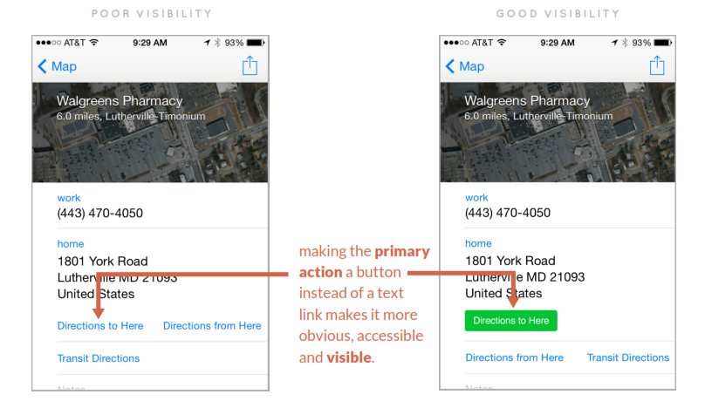

Fig1. An example of poor and good visibility [1]

In the map application, shown above in Figure 1, the concept of changing the text into buttons adds more visibility and thus acts as a good signifier [1]. Thus while developing applications, the developers’ need to keep in mind the concept of visibility to make it more user friendly and reduce frustration among users.

## **Principle of Mapping**

Mapping is the relationship between the devices being controlled and its control layout designs. Mapping is important since it determines how to use the device. An understandable mapping between the controls and the actions adds advantage to easy operation of the device. Example, in the figure below, the controls of the kitchen stove that is mapped/ aligned in the same way as the position of the four coils as shown in Figure 2.b is a good mapping compared to Figure 2.a where the controls are arranged in a row, which creates confusion as to which control is mapped to which stove. [2]

**Poor Mapping Good Mapping**

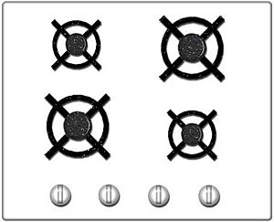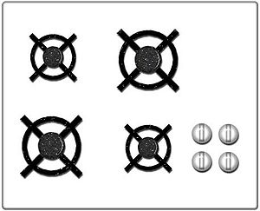

Fig 2. Kitchen stove with a) unnatural mapping in a row b) Natural mapping of controls [2]

### **Example:**

In a computer keyboard, the mapping between the control and effects of the up, down, left, and right arrow keys is an example of good mapping.

## **Principle of Feedback**

Feedbacks are used to signify a response, modify the behavior of the user and promoting understanding. It is used to confirm that the users’ inputs have been accepted and the system is acting with the input. Users cannot proceed unless they know the present state of the system. Feedbacks are a way of simplifying interaction between the user and the system. [3]

### **Example**

The error management related to software failure is a good example. Some applications require user’s acknowledgment before it proceeds to next step as shown in Fig 3. This is better than the feedback that simply prints a message and closes the application. [3]

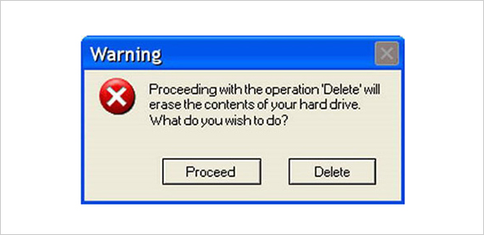

Fig 3. A good feedback in error management [3]

## **Discussions and Conclusions:**

The chapter brings awareness to readers regarding the tiny details that needs to be incorporated in designing things that can either be too simple or too complex. Design considerations are very critical for good user experience and successful usage of the products. This reading made me start analyzing the design of ordinary things deeper. As an engineer, I understood that making the product work just logically is not sufficient. A better design of the product makes it more valuable and enjoyable too.

# **CHAPTER 2**

## **Introduction**

The second chapter deals with the seven stage model of action and how different emotions occur at different stages and how it relates with the three level processing model. The three level processing model includes visceral, behavioral and reflective. It depicts how people falsely blame themselves and how positive psychology can help overcome it. This chapter explains how various factors for good design such as conceptual model, constraints, signifiers and good mapping can eliminate frustration in everyday actions.

## **The gulf of execution and why is it important**

The gulf of execution is referred as the gap between user’s goals and the methods to perform the goal. Signifiers, Mapping and Conceptual models are used to bridge the Gulf of execution.

### **Negative Examples**

1. VCR Problem

In order to record a TV show, the user just presses a “Record” button. But to record in VCR, several steps has to be done [4]:

* Record button is pressed
* Change the hour and minute settings to mention the recording time.
* Specify channel number manually or through buttons
* Save the record settings by clicking the respective buttons

1. Online Shopping

The user decides to purchase an item in online store [5]. The user looks into an item that he/she likes and decides to put the item into the cart. But the user couldn’t find any icon to add the item into the cart. This is called gulf of execution where the user doesn’t know how to perform his goal of checking out the item.

### **Positive Examples**

1. Setting up WIFI enable devices

Setting up WIFI enabled devices like Wii, Wireless gateway in IPhone has the narrowest gap with respect to gulf of execution. The methods are pretty obvious for the user to achieve the goal.

1. Modern Home Alarm System

Today, the home alarm systems have a prompt (feedback) that shows a countdown timer. It mentions the time between the user’s commands and the arm time. This is helpful for users who don’t know whether the command worked and how much is left to leave the building [6]. Such feedback systems should be added by the designers in order to reduce the gulf of execution.

## **The gulf of evaluation and why is it important**

The gulf of execution is the expectations that the users have from the system or in other words it is the users figuring out what happened. Feedback and a good conceptual model are the design elements that help bridge the gulf of evaluation. The user expects feedback from an action and is not receiving what is expected.

### **Negative Examples**

### Online Shopping

The user adds an item into the shopping cart and tries to checkout using the “Checkout” button. The page is not responding, so the user waits and presses the button again [5]. The user waits again ad gets frustrated to see that the system has failed. This is called gulf of evaluation where the user has no feedback on what the current state of the system is.

* **Positive Examples**

1. Reading Filenames in the Computer

The user is trying to look at a directory full of photographs and guess from the filename who and what is in the picture [6]. Instead, the users’ evaluation is quicker by adding thumbnail of the picture along with its name.

1. GPS Locater

Olden GPS locaters gave only the latitude and longitude information of the current location. This made users decision as whether to turn left or right based on the GPS information more difficult [6]. But nowadays since the GPS includes street location and tells where to turn, the whole map-reading step has been reduced from the user to the device. Thus the gulf of evaluation has minimized to a far extent.

## **Human Cognition and emotion with implications to computing systems**

There are three levels of processing within the brain that applies of both human cognition and emotion and provides basic knowledge in understanding human behavior.

1. **The Visceral Level**

Visceral is the home of basic emotions and responds to the immediate present. The visceral design dominates the physical features. The visceral design can be studied by allowing people to note the designs and observe their reactions. When we perceive something as “beautiful”, the judgement comes from the visceral level.

* **Example**

Sales increased when Apple introduces colorful Mac even when these Mac contained same hardware and software features as other models. Thus at the visceral level, physical features such as look, feel, sound dominate than other features.

1. **The Behavioral Level**

The behavioral design involves understanding how people use the product. For example , the cup holder s in car became important only after realizing that the car sales was low because of the lack of cup holders.

1. **The Reflective Level**

The reflective level involves the conscious cognition. It encompasses deeper understanding rather than quick reflexes. Reflective design involves long-term consumer experience.

## **People as Story Tellers**

People’s behavior is generalized from the experience and story of others. People form a conceptual model based on their previous experience and knowledge. Based on this model, they predict the future outcomes that most probably turn out to be wrong. This is because, there might be a chain of events that is responsible for a particular event, but people take into account just one cause of the event.

## **Blaming the wrong thing**

When people fail at doing things after trying several times, they start blaming themselves. Similarly when the users are expecting a result and don’t get any responses, they repeat the action that can be equally dangerous. Feedbacks are highly important when performing tasks as it would satisfy people’s expectations.

## **Principle of mapping**

Due to the lack of usability and bad design of the devices, people make bad mappings and blame themselves. For example, when people buy new device such as a washing machine and try operating it, they blame themselves for not able to perform the desired operation. This is because of the bad design of the device.

## **Learned Helplessness and positive psychology**

Learned Helplessness refers to the situation where people start blaming themselves when they repeatedly fail at doing a task. Instead of blaming the poor design of the technology, people blame themselves and feel helpless. Looking at failure as a learning experience is a positive psychology. Failures are important for exploration and bringing creativity. The designers should take people’s difficulties as signifiers and improve on the product.

## **How technology users can falsely blaming technology**

If products or devices are designed based on the user’s requirements, the design and the usability of the product would be highly better than those designed without taking requirements into consideration. The device should work well even when thing go no as planned.

## **The seven stages of actions: seven fundamental design principles**

The seven stages of actions consists of two types of information’s called feedforward and feedback. Feedforward gives information on how to execute the process, whereas feedback helps in understanding what has happened. Signifiers, constraints and mappings are useful for obtaining feedforward information. The conceptual model does a critical role in providing feedback information. There are seven stages of action is shown in Fig 4 [7], and the corresponding seven fundamental principles of design are discussed below.

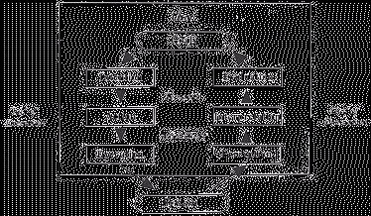

Figure 4. Seven stages of action [7]

1. Discoverability - Actions possible and current state
2. Feedback – Information on the results of action
3. Conceptual model – Enhancing discoverability by illustrating all information needed to create better conceptual model
4. Affordances –To perform desired actions
5. Signifiers – Ensure discoverability
6. Mapping – A good relationship between controls and their actions leads to good mapping
7. Constraints – For Easy interpretation

### **Example**

A software company designing a product with different teams involved, adopts agile methodology which is very analogous to the principles mentioned in the section. Agile methodology involves the following steps: acquiring the users’ requirements, analyzing the mental model of the design, getting feedback from the User interface Design experts, iterating back the requirements after every major improvement in the product’s design is made. The testing team along with the developing team contribute in meeting the end users’ needs. These steps adopted in companies are very helpful in attaining good design of the product.

## **Discussion and Conclusion**

This chapter builds ideas on how to take failures as learning experience and how to relate with the everyday actions. It made me understand how important the bridging between the user’s goals and methods of attain the goal is. It makes the product more utilizable and sensible for users. In the user’s perspective, this chapter instills the details needed before choosing a product. In the designers’ and developers’ perspective, it demonstrates how close the users and developers model need to match and how good design reflects the usability of the product.

# **Discussion and Conclusion**

It had made me ponder upon the design of the devices that I use everyday things and those that I wished to buy. I realized how one can view minute details and design of conventional things. It has really made me more thoughtful about the problems and the necessities of the people.

**References:**

[1]. User Experience, User Interface Design Coaching, Speaking and Workshops,. (2014). *Visibility: 5 Principles of Interaction Design To Supercharge Your UI (2 of 5)| User Experience, User Interface Design Coaching, Speaking and Workshops*. Retrieved 6 February 2016, from http://www.givegoodux.com/visibility-5-principles-interaction-design-supercharge-ui-2-5/

[2]. Wikipedia,. (2016). *Natural mapping (interface design)*. Retrieved 6 February 2016, from https://en.wikipedia.org/wiki/Natural_mapping_(interface_design)

[3]. Renaud, K., & Cooper, R. (2000). Feedback in Human-Computer Interaction | Characteristics and Recommendations. Retrieved from http://www.dcs.gla.ac.uk/~karen/Papers/saics.pdf

[4]. Wikipedia,. (2016). *Natural mapping (interface design)*. Retrieved 6 February 2016, from https://en.wikipedia.org/wiki/Natural_mapping_(interface_design)

[5]. Petekinser.com,. (2011). *Illustrated: Don Norman’s Action Cycle | Unthought Known - An Exploration of Experience*. Retrieved 6 February 2016, from http://petekinser.com/norman-action-cycle/

[6]. murphy, n. (2006). *Put the user in the driver's seat*. *Embedded*. Retrieved 6 February 2016, from http://www.embedded.com/design/real-time-and-performance/4006687/Put-the-user-in-the-driver-s-seat

[7]. Ascilite.org,. (2016). *IIMS 1994: Quinn - implications of instructional and game design for interactive multimedia interfaces*. Retrieved 6 February 2016, from http://ascilite.org/archived-journals/aset/confs/iims/1994/qz/quinn.html