"SpendLens" The Student Budget Intelligence Dashboard

1. Data Loading & Initial Inspection
The project began by ingesting the raw student_transactions.csv file into a Google Colab environment using the Pandas library. An initial inspection of the dataset revealed a "dirty" state, confirming the signals buried in the numbers required significant processing.
Initial Data Profile:
- Total Records: 1,530 transactions.
- Missing Values: 61 null entries were identified specifically in the "Category" column.
- Duplicate Entries: 20 identical rows were found, likely due to system logging errors.
- Structural Inconsistency: The "Category" column contained mixed-case entries (e.g., 'food' vs 'Food' and 'transport' vs 'Transport'), which would have caused fragmented analysis.
- Date Formatting: Dates were stored in inconsistent string formats (e.g., 08-08-2024 and 2024/10/28), preventing time-series analysis.

2. Data Cleaning Process (The "Standardization" Phase)
To ensure the dashboard insights were accurate and self-explanatory, the following cleaning pipeline was executed in Python:
- Null Value Imputation: All 61 missing categories were filled with the label 'Misc' to maintain the integrity of the total spending amount.
- Categorical Uniformity: Applied string capitalization to all categories. This merged 'food' and 'Food' into a single 'Food' entity and 'transport'/'Transport' into 'Transport'.
- Chronological Fixing: Converted the "Date" column into a standardized datetime format using pd.to_datetime with format='mixed'. This allowed for the identification of the "Sunday Spike" later in the analysis.
- Deduplication: Dropped the 20 redundant rows to ensure that "Total Spend" and "Average Transaction Value" were not artificially inflated.

3. Post-Cleaning EDA Results
After the cleaning process, the dataset was transformed into a high-quality "Cleaned" version ready for Power BI.
Final Data Profile:
- Cleaned Records: 1,502 unique transactions.
- Data Integrity: 0 Null values and 0 Duplicates.
- Unified Categories: The data now reflects 6 clean categories: Utilities, Education, Food, Entertainment, Transport, and Misc.
- Target Ready: The "Amount" column was verified to have no negative values or unrealistic outliers for a student profile, ensuring the "financial story" is realistic.
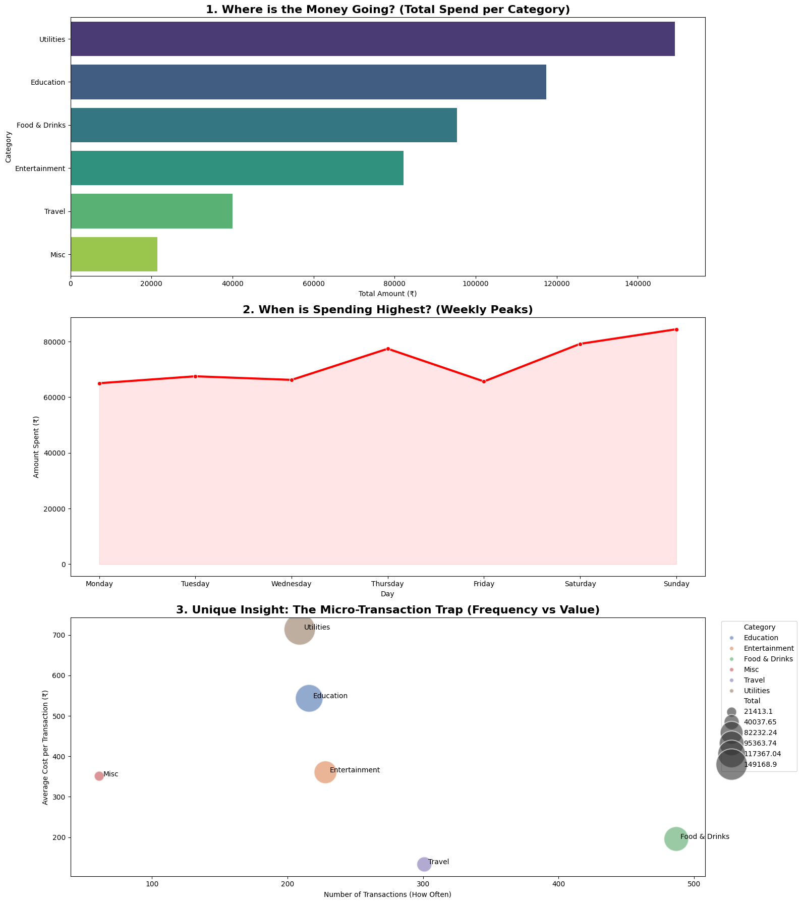
4. Data Ingestion & Model Setup
The "Cleaned_Student_Transactions.csv" file, exported from Google Colab, was imported into Power BI Desktop.
- Data Connection: Used the "Get Data" feature to link the CSV, ensuring that the previously standardized dates and categories remained intact.
- Verification: Performed a final check in the "Data View" to ensure all 1,502 records were present and that the "Amount" column was formatted as Currency (₹) with zero decimal places for better readability.
- Time Intelligence: Created a "Day Name" calculated column using the formula FORMAT([Date], "dddd") to enable the specific analysis of weekly spending peaks.

5. Dashboard Architecture (The Visual Story)
The dashboard was designed to be "self-explanatory," allowing a viewer to understand the financial story without additional captions.
A. High-Level KPI Cards (The "At-a-Glance" Metrics)
Placed at the top of the dashboard to provide immediate answers:
- Total Expenses: Displays the sum of all spending (₹505,583).
- Peak Day: Dynamically displays Sunday, identifying the highest outflow period.
- Top Category: Identifies Utilities as the primary budget consumer.
B. Core Visualizations
- Spending by Category (Bar Chart): Ranks categories from highest to lowest. It clearly surfaces that Utilities and Education are the dominant costs.
- Weekly Spending Trends (Area Chart): Visualizes the "When" of the budget. It confirms a massive spike every Sunday, which is a critical signal for behavioral change.
- Spending Split (Donut Chart): Breaks down the budget by Payment Mode. It reveals a heavy reliance on UPI, which correlates with the high frequency of small purchases.

6. Advanced Analytics: The "Micro-Transaction Trap"
To fulfill the requirement of finding "less intuitive signals," a Scatter Plot was developed:
- X-Axis: Count of Transactions (Frequency).
- Y-Axis: Average Amount per Transaction.
- The Insight: This visual isolates Food & Drinks as a "hidden leak." Despite a low average cost per transaction, its extremely high frequency (487 times) makes it a major contributor to budget depletion.

7. Interactivity & Filter Logic
To turn the report into a "Budget Intelligence Dashboard," interactive elements were added:
- Slicers: Added a Category Slicer and a Date Slider. These allow the student to filter the entire dashboard for specific needs, such as "How much did I spend on Food in October?".
- Cross-Filtering: All visuals are linked; clicking on a specific merchant in the Merchant Treemap updates the KPI cards and charts to show only that merchant’s impact on the budget.

8. Formatting & Compliance
Following the project guidelines:
- Rounding: All decimal values were rounded off for better readability.
- Labeling: Axes are clearly labeled with units (₹), and chart titles are descriptive rather than technical.
