**File Server**

File Server Application to upload/store files concurrently and reliably.

**About**

* MVC Asp.net application
* API Works asynchronously
  + Caller must poll for the status of the upload.
* Handle multiple requests simultaneously
* File size limited to 20MB per file. Limit is Configurable.
* Supports Two Modes
  + Local Mode
    - Use for testing on local machine
    - Stores the files uploaded to $UserDirectory/uploads/ (e.g.. c:\users\prabat)
  + Azure Mode
* Files are uploaded to azure container.
* <http://prabastorage.blob.core.windows.net/tekionuploads?restype=container&comp=list>
* Above url shows the list of uploaded files.
* A sample snapshot of the above url. Below highlighted url stores the actual file.

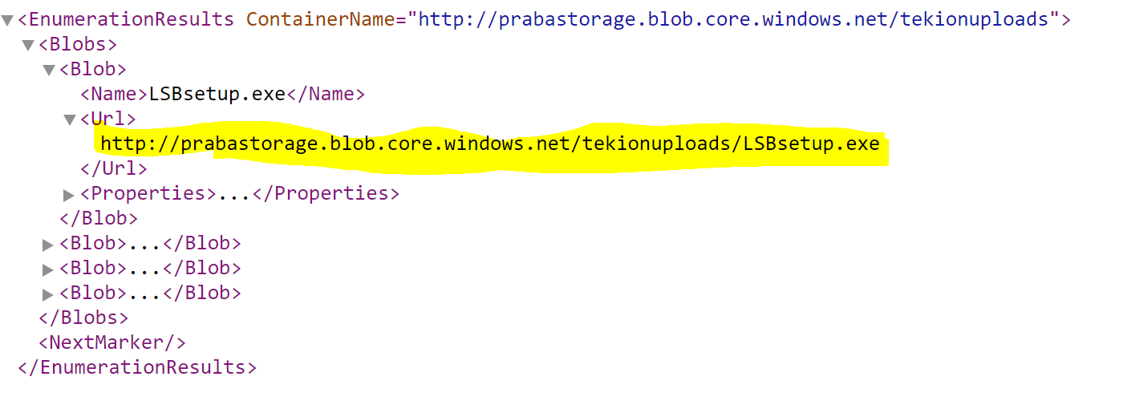

**Usage**

* Two parts of the application

Application Web Endpoint:

* <http://tekoinfileserver.azurewebsites.net/File>
* Using this should be self-explanatory.

API Url:

* <http://tekoinfileserver.azurewebsites.net/File/Upload>
* HTTP Post API can be called from various end points/tools.

**Source Code**

* Checked in to GitHub - <https://github.com/prabagaran/FileServer/tree/master/FileService>
* Asp.net MVC Code
* Controller - <https://github.com/prabagaran/FileServer/blob/master/FileService/FileServer/Controllers/FileController.cs>
* Service - <https://github.com/prabagaran/FileServer/tree/master/FileService/FileServer/Service>
* Views - <https://github.com/prabagaran/FileServer/tree/master/FileService/FileServer/Views/File>