# OVA Disaster Recovery procedure with ASR - steps

## Define proper failover action

Before DR switch is ordered, it needs to be agreed between the following teams:

* 1. OVA Support
  2. Infrastructure
  3. DBAs (in scenarios affecting DB)
  4. Data Replication (in case when xlink data replication is affected)

Then which OVA-PR server types of affected agency should be switched to DR (Data center B):

* 1. Citrix access (OVA URL)
  2. RDS servers (where user faced client apps are hosted)
  3. MDT servers (where ITDBSocket services are and SSRS Service is hosted)
  4. FSS server (where all operations and archive files are stored)
  5. APP servers (where server side processed are run)
  6. WPS server (that handles dedicated printing for a few agencies)

There are too many known root problems and several still unknown to build an algorithm defining exact steps for each of them. Therefore, the relevant information depending on the specific failover scenario needs to be properly derived from this document at the time of failover preparation.

Additionally, OVA is constantly subjected to various migrations or enhancements that should be taken under consideration when defining proper recovery scenario.

Therefore, the following criteria shall be considered:

* Time of identifying and fixing given problem of given servers/process.
* Time of building and deploying additional server of affected type (quick for RDS/MDT; long for APP, SQL; difficult to estimate for FSS, WPS).
* Need for data that will be unavailable if new machine is deployed i/o recovered

Note on ASR: The act of failover via Azure ASR technology is the same for all server workloads protected by ASR. Therefore, the ASR steps will be shown in section 4 and not repeated in this document.

## Order of starting and stopping by server type:

It is important to follow the order of shutting down and starting up given servers to avoid confusion and false errors:

|  |  |  |  |
| --- | --- | --- | --- |
| **Starting** | | | |
| order | OVA Server type | contains | Relies on: |
| 1 | OVA-PR-XX-FSS01 | File storage, scheduled tasks, user profiles and folders, accessed by DNS | OVA-FTP and OVA-Cyclone |
| 2 | SQL instance | SQL Services, Databases, accessed by Listener name / host name (exceptions) | FSS |
| 3 | OVA-PR-XX-MDT.. | ITDBSocket service, SSRS service always on MDT01 | SQL |
| 4 | OVA-PR-XX-APP.. | Dedicated Services, background applications, scheduled tasks, Rest APIs | FSS & SQL & MDT |
| 5 | OVA-PR-XX-RDS.. | Dedicated user end applications connecting to DB via MDT or APP server types | FSS & SQL & MDT & APP |
| 6 | OVA-PR-XX-WPS01 | Connects to agency local printing devices (exists for a few agencies) | RDS |

|  |  |  |  |
| --- | --- | --- | --- |
| **Stopping** | | | |
| order | OVA Server type | contains | Relies on: |
| 1 | OVA-PR-XX-WPS01 | Connects to agency local printing devices (exists for a few agencies) | RDS |
| 2 | OVA-PR-XX-RDS.. | Dedicated user end applications connecting to DB via MDT or APP server types | FSS & SQL & MDT & APP |
| 3 | OVA-PR-XX-APP.. | Dedicated Services, background applications, scheduled tasks, Rest APIs | FSS & SQL & MDT |
| 4 | OVA-PR-XX-MDT.. | ITDBSocket service, SSRS service always on MDT01 | SQL |
| 5 | SQL instance | SQL Services, Databases, accessed by Listener name / host name (exceptions) | FSS |
| 6 | OVA-PR-XX-FSS01 | File storage, scheduled tasks, user profiles and folders, accessed by DNS | OVA-FTP and OVA-Cyclone |

## Service Accounts verification

Support user should validate if OVA service account is present and has proper rights. Permissions are defined and enforced by Puppet.

[XXNNN-OVA-XX-SA01@msc.com](mailto:XXNNN-OVA-XX-SA01@msc.com) (applicable server types: FSS / APP / MDT01)

*Soon there will be list of dedicated gMSA for each OVA server – not it is not production setup.*

## ASR Failover Steps (same for all roles where ASR is concerned)

* 1. Validate the server workload in Azure to be failed over and validate that they are all showing protected, healthy, and residing in the production datacenter in Azure Portal.

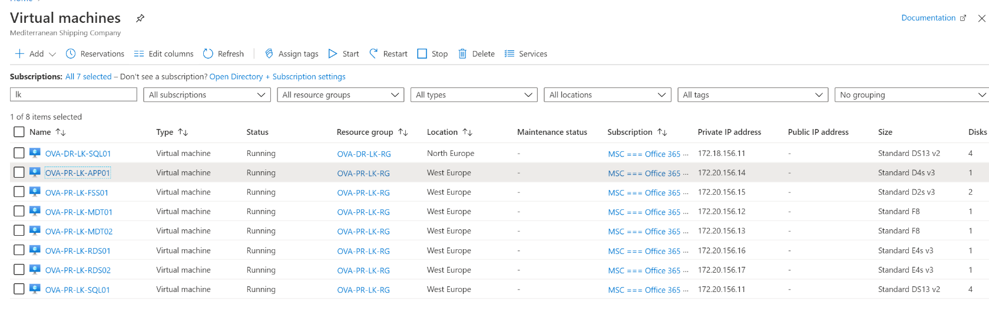

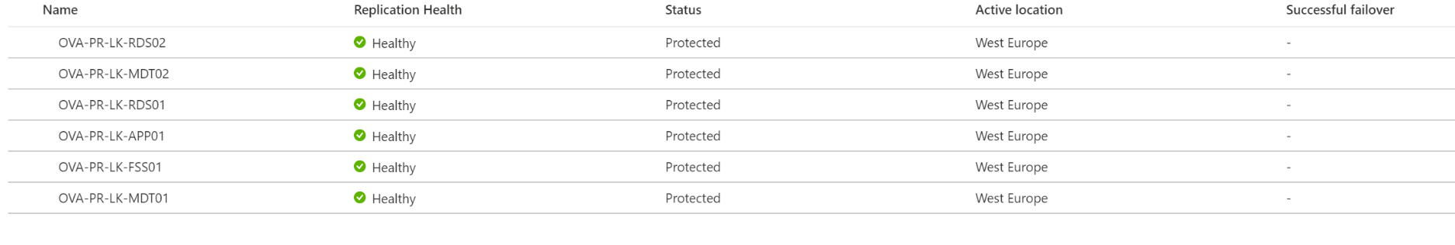

* 1. Start failover process by executing the Recovery Plan for the involved agency. Search the recovery group in vault (Ex. for TG Agency)

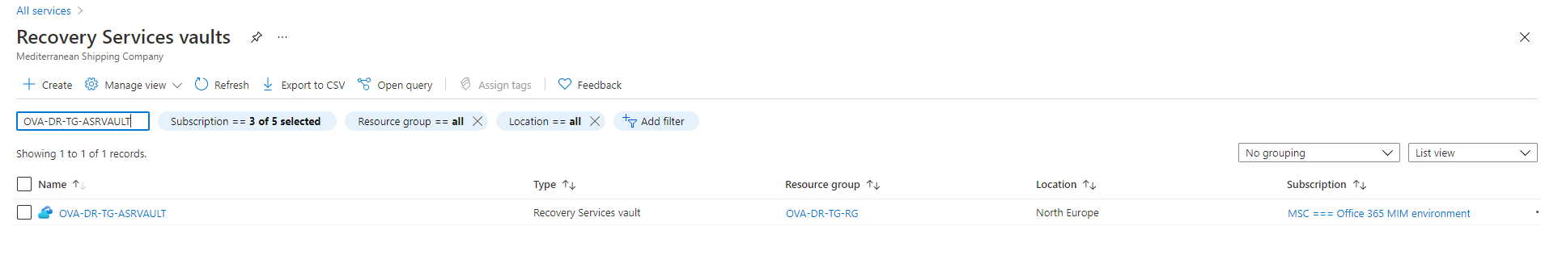

b.1 Select Recovery group

b.2 Site Recovery-manage recovery plan (See yellow highlighted)

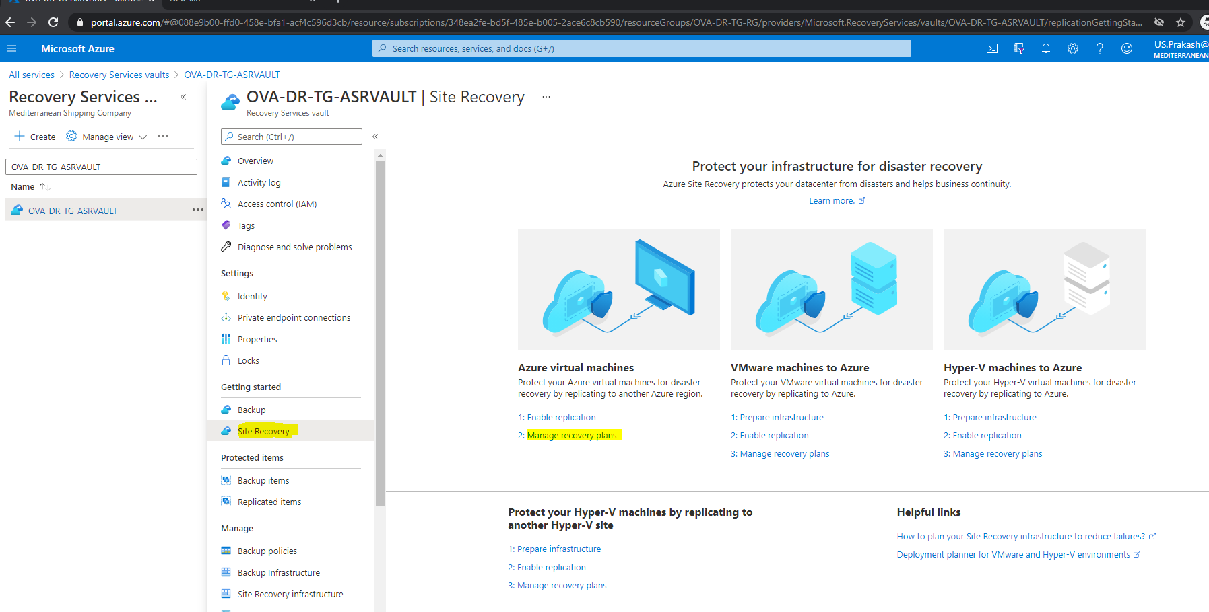

b.3 Select Recovery plan

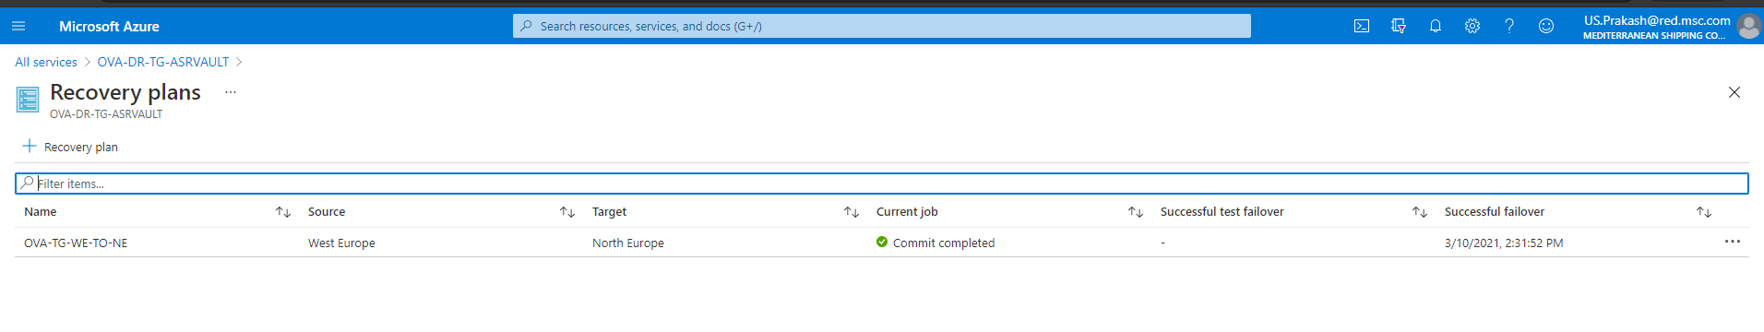

b.4 Click failover

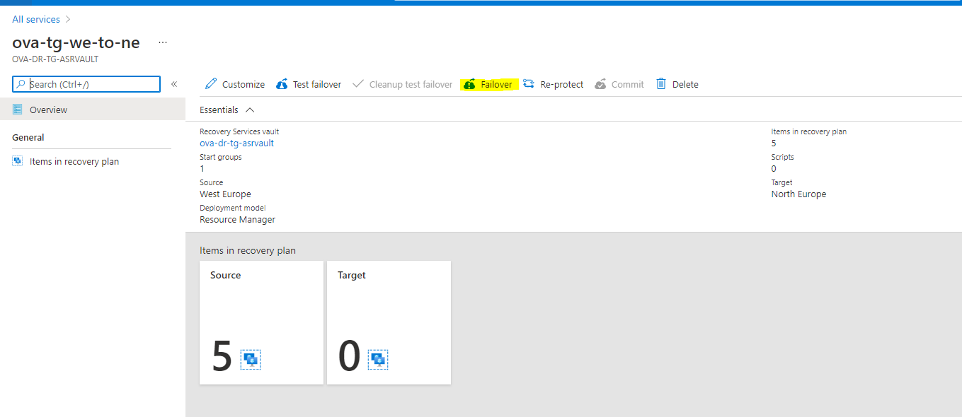

When completed, you can view the new “failed over” systems in DR datacenter and ‘Running’, while production systems are “Stopped (Deallocated)”.

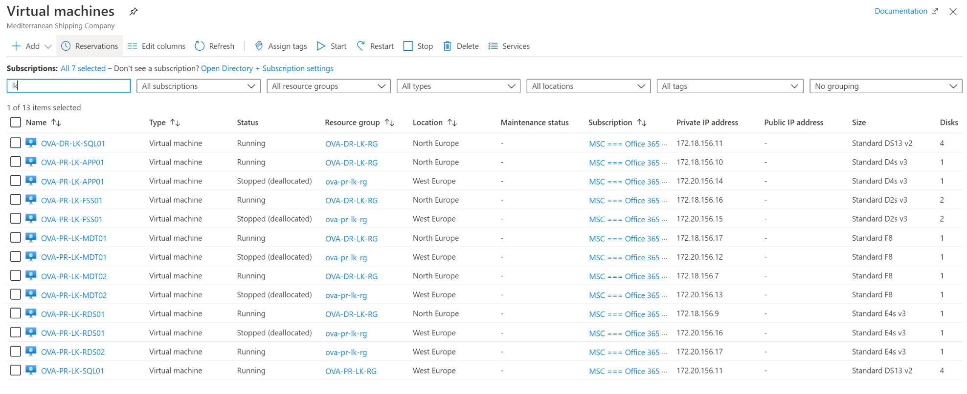

* 1. Verify DNS has updated and is providing new IP addresses from new datacenter after failover
  2. “Commit” the failover via Azure portal once we believe the process has completed successfully.
  3. “Re-protect” this group of servers in preparation for failing back to DR datacenter. Re-protect can be left uninitiated if we feel we may not want to replicate changes back to production for any reason.

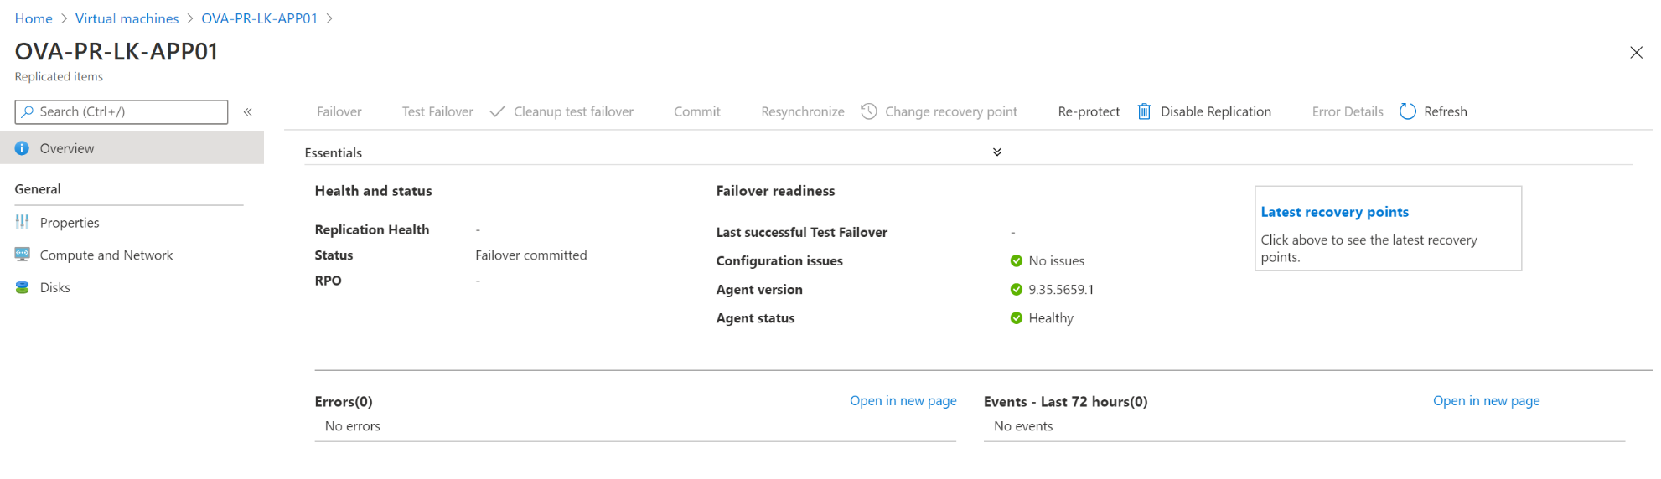

## RDS servers and Citrix access

* 1. Execution of ASR for RDS servers requires Infra team to confirm to Support team if citrix URL changes:

DR: <https://onevisiondr.msc.com>

PR: https://remote.msc.com

* 1. MIM security groups managing access to application hosted on RDS servers and folders on FSS server, should be confirmed by Infra team.

|  |  |
| --- | --- |
| Groups that have always access to all OVA: | US904-OVA_Rollout |
| US904-OVA Support L1 |

|  |  |
| --- | --- |
| Groups that have always access to given OVA: | XXNNN-RDS-Standard |
| XXNNN-RDS-KeyUsers |

|  |  |
| --- | --- |
| Groups that may have access to given OVA: | IN912-OVA-Users_XXNNN |
| BR963-OVA-Users_XXNNN |
| LV749-OVA-Users_XXNNN |
| LV749-OVA-SuperUser |
| MX190-OVA-SuperUser |

|  |  |
| --- | --- |
| Groups that have access to given OVA (last code define OVA): | AE587-OVA-Users_QA641 |
| SG413-OVA-Users_SG094 |
| DO344-OVA-Users_PA595 |
| DO344-OVA-Users_BS341 |
| MY172-OVA-Users_SG094 |

* 1. Servers connections should be verified by Support team for each RDS server switched via ASR:

|  |  |  |  |  |  |
| --- | --- | --- | --- | --- | --- |
| **App / Service** | **Location** | **File/Key** | **SQL** | **MT** | **Default value** |
| OVA/MSCLink | C:\Program Files (x86)\Interlink\MSCLink\Configuration File\ | MSCLINK Configuration.XML | n/a | MDT | OVA-DR-XX-MDT.. |
| XALink | C:\Program Files (x86)\Interlink\XALink\Configuration File\ | XALINK Configuration.XML | n/a | MDT | OVA-DR-XX-MDT.. |
| ChemLink | C:\Program Files (x86)\Interlink\ChemLink\ | connection.udl | List | n/a | Listener |
| MARS | C:\Program Files (x86)\MSC Technology\Applications\MARS\ | MARS.exe.config | n/a | APP | OVA-DR-XX-APP01/2 |
| OV CRM | C:\Program Files (x86)\MSC Technology\Applications\OV CRM\ | OV_CRM.exe.config | n/a | APP | OVA-DR-XX-APP01/2 |
| EDI Monitoring | C:\Program Files (x86)\MSC Technology\Applications\EDI_Monitor | Excel DB connection | List | n/a | Listener |
| RepSche Viewer | C:\Program Files (x86)\MSC Technology\Applications\ReportSchedulerViewer | n/a | n/a | n/a | n/a |
| RepGen Viewer | C:\Program Files (x86)\MSC Technology\Applications\ReportGeneratorViewer | n/a | n/a | n/a | n/a |

* 1. All the above apps need to be verified via citrix UI as well.
  2. Remote folders EDI Files (\\ch001-ov-a\xx-EDI01) / OVA Files (\\ch001-ov-a\xx-OVA01 ) / X Drive access should be checked as well (once FSS server is up).

## FSS01 Server

Fail over of the above server requires to stop processes on other server types (APP, SQL,) by Support team and DBAs. Once it is recovered by ASR, the following verification steps related to OVA should happen before processes on other server types resumed:

### Infra team should confirm that the DFSs for recovered server is active:

\\ch001-ov-a\xx-EDI01

\\ch001-ov-a\xx-OVA01

### Support team should verify if F: drive folders present. Their subfolders. There should be recent files present and enough free space:

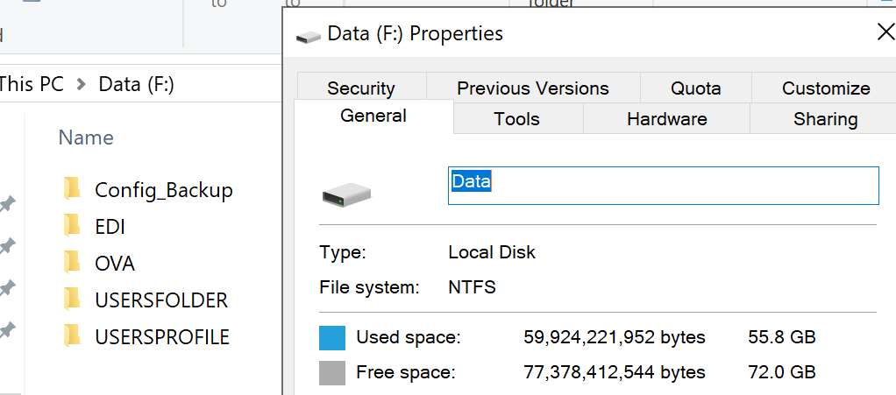

### Support team should verify if folder in C:\Scripts should is up to date and keeps at least the highlighted scripts:

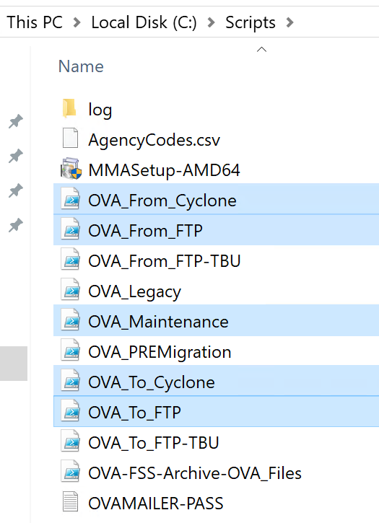

* 1. Infra team should confirm that FTP DNS \\ch001-ov-a\OVA-FTP\ points to active OVA FTP
  2. Infra team should confirm that Cyclone DNS \\ch001-ov-a\cyclone\OVA-CYCLONE\ points to active cyclone FSS server/drive
  3. Support team should validate if OVA Cyclone (KeyVault acc) and agency FTP (service account) can be accesses.
  4. Support team should verify if highlighted scheduled tasks can be run

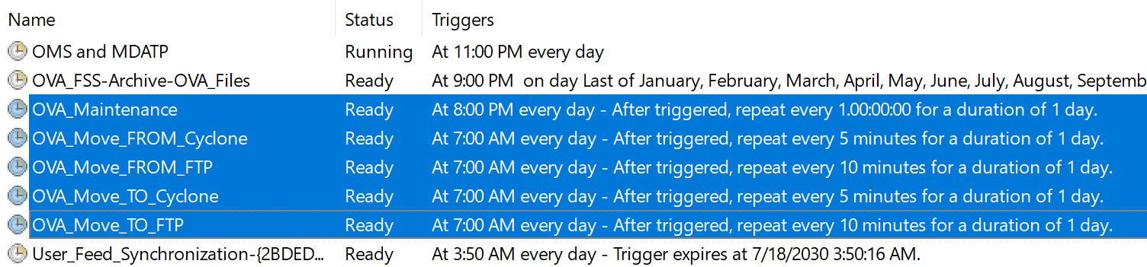

* 1. If all above are OK, Support team can start the tasks and DBAs can start SQL services that use FSS

## MDT Servers

## These server type runs ITDBSocket Service that uses port 8686 to connect to SQL. It is using Listener name to access DB.

* 1. Infra team should confirm that port 8686 is enabled
  2. DBAs should validate SSRS service on MDT01
  3. Support team should verify connection of DBSocket

|  |  |  |  |  |  |
| --- | --- | --- | --- | --- | --- |
| **App / Service** | **Location** | **File/Key** | **SQL** | **MT** | **Default value** |
| SQL Reporting Service | MS SQL component |  | Listener | n/a | Listener |
| ITDBSocket svc | C:\Program Files (x86)\MSC Technology\Application Servers\MSC Tech NA DBSocketService | ITDBSocketService.exe.config (encrypted) | Listener | n/a | Listener |

## APP server(s)

APP servers holds windows services, IIS based Rest APIs, schedule task and interactive applications used by OVA. These applications relay on SQL DBs, File DFS and External webservices (mostly in GVA).

* 1. Support team should verify SQL Listener access (by ping)
  2. Support team should verify DFS access \\ch001-ov-a\xx-EDI01 and \\ch001-ov-a\xx-OVA01
  3. Support team should verify all OVA scheduled tasks:

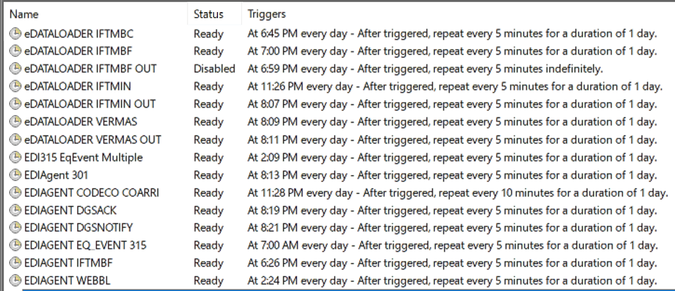

* 1. Support teamshould verify all OVA Services:

|  |  |  |
| --- | --- | --- |
| **App-service name** | **APP or Service** | **servers** |
| EDIAgentParser | Service | APP01 only |
| EDIEventParser | Service | APP01 only |
| MSC Tech NA ReportGenerator | Service | APP01 only |
| MSC Tech NA ReportScheduler | Service | APP01 only |
| MSC Tech NA Equipment Event Service | Service | APP01 only |
| MSCLinkSAP | Service | APP01 or APP02 |
| ICS Parser service | Service | APP01 or APP02 or APP03 |
| MSC Tech NA OV CRM CreateCaseFromEmail | Service | APP02 |
| MSC Technology SAP Payment Status Replication Service | Service | APP01 or APP02 |
| ECR Upload Service | Service | APP02 |
| ITParseEmail | Service | APP02 |
| Remote Service | Service | APP02 |
| MSCMAXS_ChemlinkImport | Service/app | APP01 or APP02 or APP03 |

* 1. Support team should verify C:\Scripts on APP01

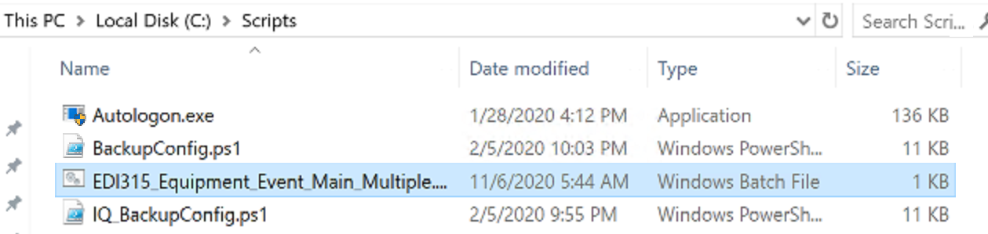

* 1. Support team should verify IIS APIs:

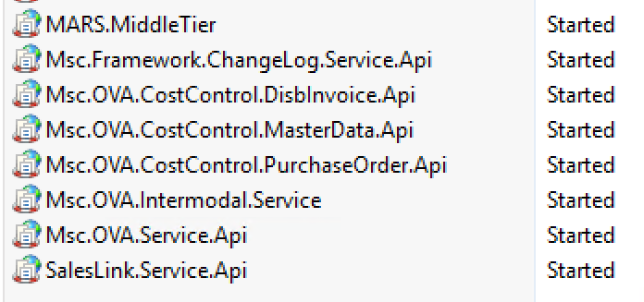

* 1. Support team should verify ChemLink Import application (*will be replaced by service soon – migration pending*)

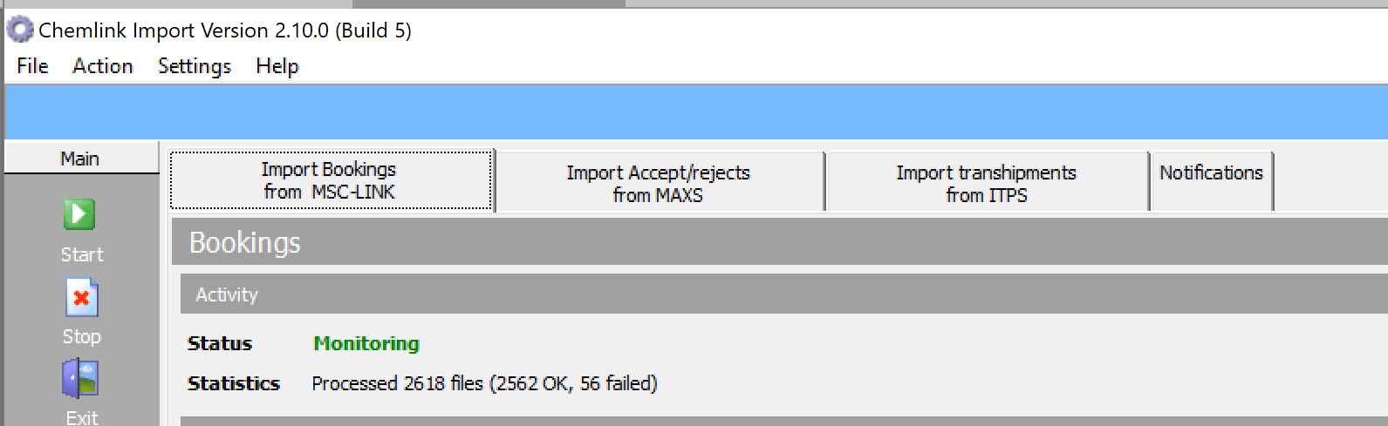

* 1. Support team should verify EDILink application (usually on APP02, if applicable):

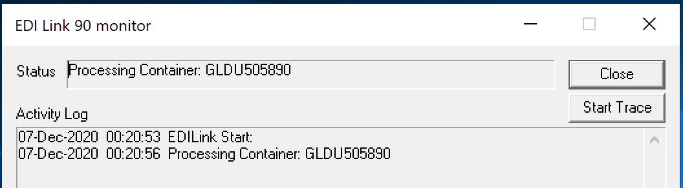

* 1. Data Replication Team should verify Consumer, Radar services

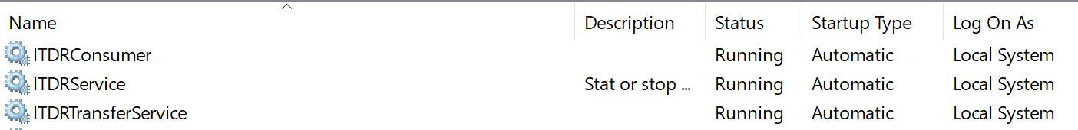

**connections details:**

|  |  |  |  |  |  |
| --- | --- | --- | --- | --- | --- |
| **App / Service** | **Location** | **File/Key** | **SQL** | **MT** | **Default value** |
| **APP01** | | | | | |
| MSCLink, EDIAgent | C:\Program Files (x86)\Interlink\MSCLink\Configuration File | MSCLINK Configuration.XML | n/a | yes | N/A |
| EDILink (MY, BS only) |
| eDataLoader | C:\Program Files (x86)\Interlink\eDataLoader90\ | eDataLoader.config | Listener | n/a | SQL Listener |
| Eq. Event SVC | C:\Program Files (x86)\MSC Technology\Application Servers\MSC Tech NA Equipment Event Service\ | MSC Tech NA Equipment Event Service.exe.config | Listener | n/a | SQL Listener |
| RepGen SVC | C:\Program Files (x86)\MSC Technology\Application Servers\ReportGenerator\ | ITReportGenerator.exe.config | Listener | n/a | SQL Listener |
| RepSch SVC | C:\Program Files (x86)\MSC Technology\Application Servers\ReportScheduler\ | ITReportScheduler.exe.config | Listener | n/a | SQL Listener |
| EDI Agent Parser SVC | C:\Program Files (x86)\MSC Technology\Application Servers\EDI Agent Parser\ | EDIAgentParser.exe.config | Listener | n/a | SQL Listener |
| EDI Event Parser SVC (MY, BS only) | C:\Program Files (x86)\MSC Technology\Application Servers\EDI Event Parser\ | EDIEventParser.exe.config | Listener | n/a | SQL Listener |
| ITPS eMC compare | C:\Program Files (x86)\Interlink\EMC_For_ITPS\eMCAutoCompare\ | Run_AutoCompare_PROD.bat | Listener |  | SQL Listener  MDT01 host name |
| ITPS eMC apply | C:\Program Files (x86)\Interlink\EMC_For_ITPS\eMCAutoApply\ | Run_AutoApply_PROD.bat | Listener |  | SQL Listener  MDT01 host name |
| **APP02 / 03 (if present)** | | | | | |
| MARS MT | C:\inetpub\wwwroot\MARS.MiddleTier\ | web.config (encrypted) | Listener | n/a | SQL Listener |
| SalesLink MT | C:\inetpub\wwwroot\SalesLink.MiddleTier\ | web.config (encrypted) | Listener | n/a | SQL Listener |
| Avantida API  (DE only) | C:\Program Files (x86)\MSC Technology\Application Servers\WebSites\Msc.OVA.Service.Api\V1.1 | web.config (encrypted) | Listener | n/a | SQL Listener |
| Intermodal API  (DE only) | C:\Program Files (x86)\MSC Technology\Application Servers\WebSites\IntermodalService | web.config (encrypted) | Listener | n/a | SQL Listener |
| ChemLink Import | C:\Program Files (x86)\Interlink\ChemLink Import\ | connection.udl | Listener | n/a | SQL Listener |
| SAP Adapter SVC | C:\Program Files\Interlink Technologies\Interlink MSCLink SAP Service\ | MSCLinkSAPSvc.exe.config | Listener | n/a | SQL Listener |
| Remote Service | C:\Program Files\MSC Technology\Application Servers\Remote Service\Plugins\ | ILIM_OS.CONFIG / GVATMSDemurrage.config / SAPMonitor.config / MTMonitor.config/ EDIAgentParserMonitor.config / DirectoryMonitor.config / PaymentStatusMonitor.config | Listener | n/a | SQL Listener |
| ITParseEmail SVC | C:\Program Files\MSC Technology\Application Servers\ITExchange Service\ | ITParseEmail.exe.config | Listener | n/a | SQL Listener |
| ECR Upload SVC | C:\Program Files (x86)\Interlink Technologies\ECR Service | ECRUpload.exe.config | Listener | n/a | SQL Listener |
| ICS receiver  (DE,HU,SI,HR, LV) | C:\Program Files\Interlink Technologies\Interlink MSCLink ICS Service | InterlinkICSReceiver.exe.config | Listener | n/a | SQL Listener  MDT host name |
| OV CRM | C:\Program Files (x86)\MSC Technology\Application Servers\SalesLinkCustomerServiceManager\ | ITSalesLinkCustomerServiceManagement.exe.config | Listener | yes | APP02 host name |
| Payment status SVC | C:\Program Files (x86)\MSC Technology\Application Servers\MSC Tech NA SAP Payment Status Replication Service | MSC Tech NA SAP Payment Status Replication Service.exe.config | Listener | n/a | SQL Listener |
| CostControl.  DisbInvoice.Api | C:\Program Files\MSC Technology\Application Servers\Msc.OVA.CostControl.DisbInvoice.Api | web.config | Listener | n/a | SQL Listener |
| CostControl.  MasterData.Api | C:\Program Files\MSC Technology\Application Servers\Msc.OVA.CostControl.MasterData.Api | web.config | Listener | n/a | SQL Listener |
| CostControl.  PurchaseOrder.Api | C:\Program Files\MSC Technology\Application Servers\Msc.OVA.CostControl.PurchaseOrder.Api | web.config | Listener | n/a | SQL Listener |

## SQL server(s)

* 1. Verify initial state of Availability Group in preparation for failover to ensure we have both a Primary and Secondary

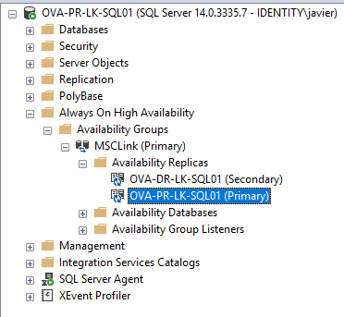

* 1. Switch AG to Synchronous from Asynchronous

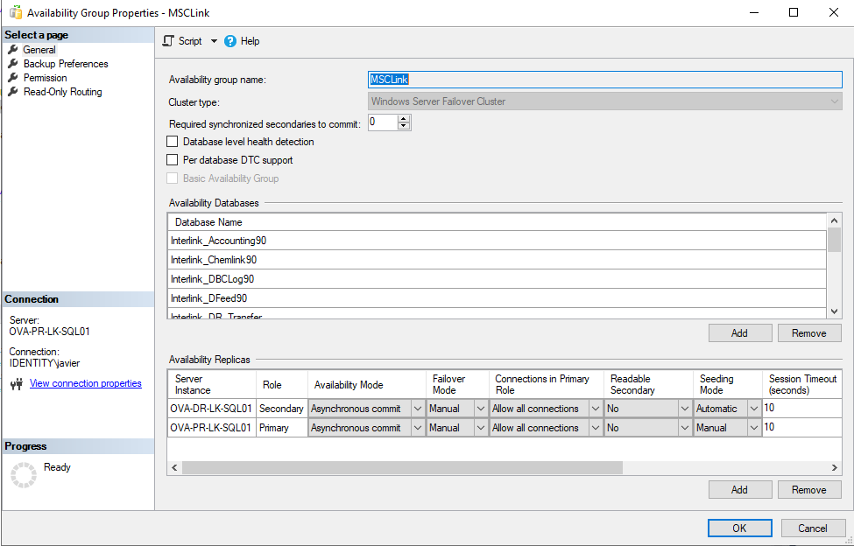

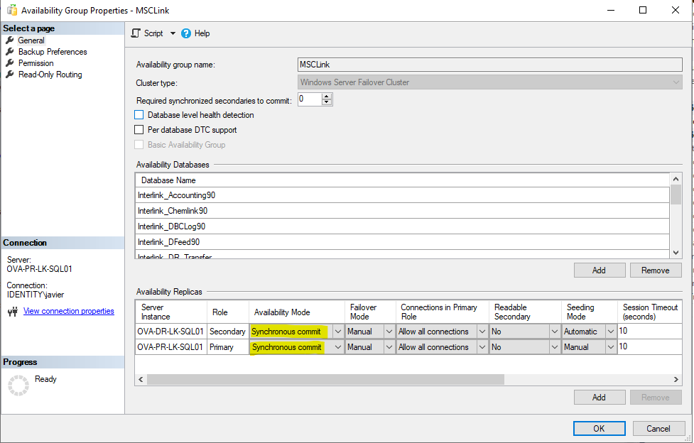

* 1. Failover from Primary to Secondary

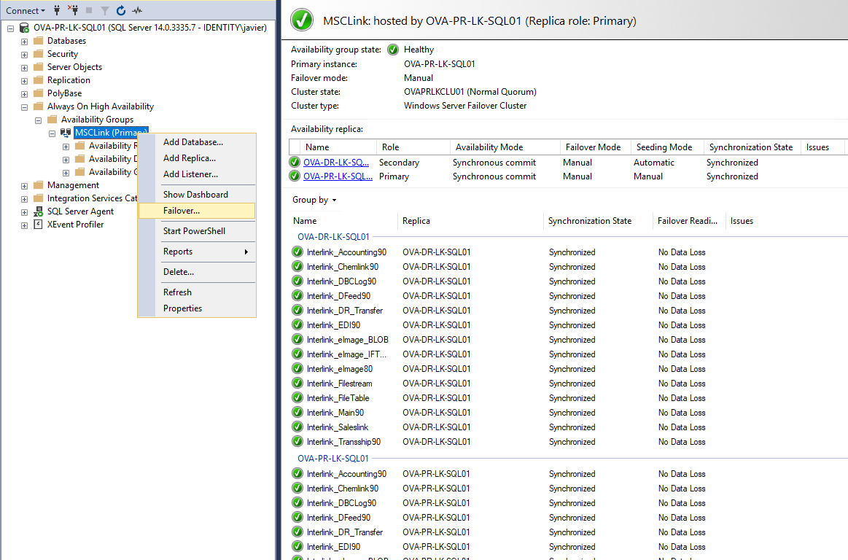

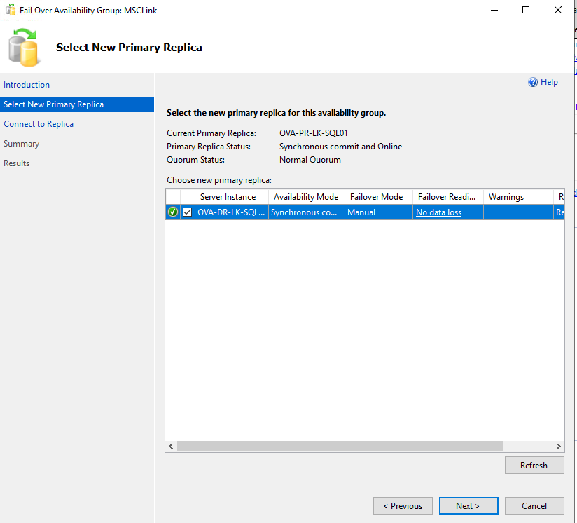

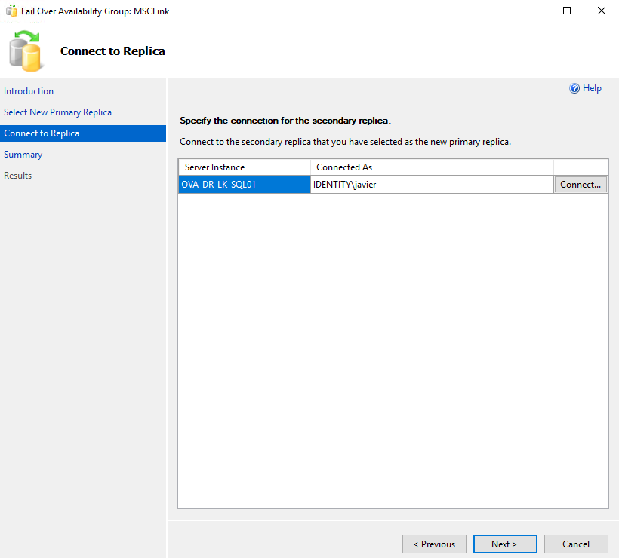

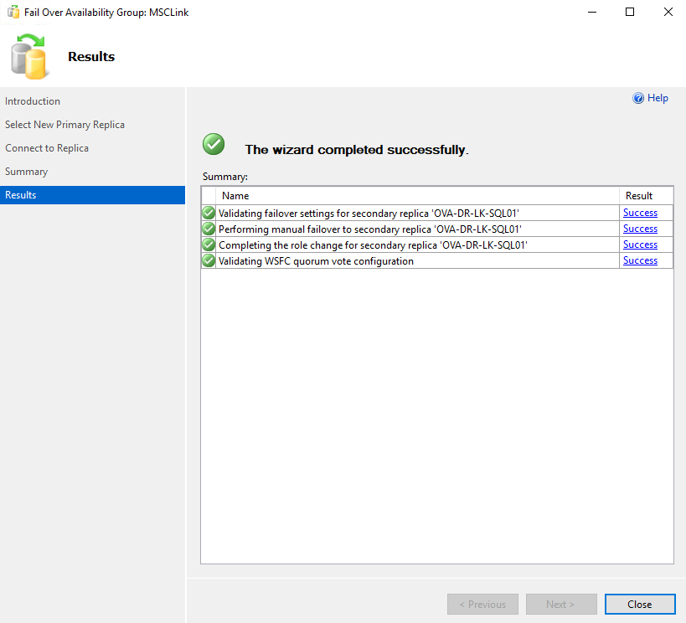

* 1. Failover Completed

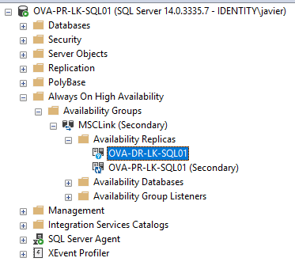

* 1. Disabling Agent on PR and making Active on DR

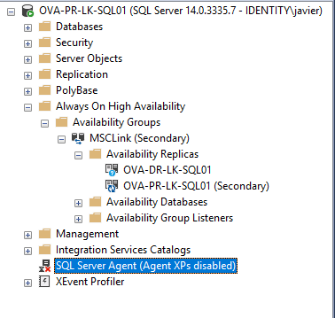

* 1. Enable Agent on DR

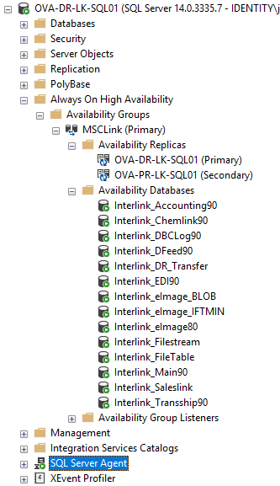

* 1. Update DB Params accordingly

Update DB_PARAMS on DR (when is primary)

UPDATE Interlink_Main90.dbo.DB_Param

SET sValue = replace(svalue,'OVA-PR-LK-SQL','OVA-DR-LK-SQL')

where svalue like '%OVA-PR-LK-SQL%'

To Failback (On OVA-PR-SS…..)

UPDATE Interlink_Main90.dbo.DB_Param

SET sValue = replace(svalue,'OVA-DR-LK-SQL','OVA-PR-LK-SQL')

where svalue like '%OVA-DR-LK-SQL%'

## Fail-back

Before failback, we need to re-protect all VM machines. This will take time to synchronize VM to production VMs.

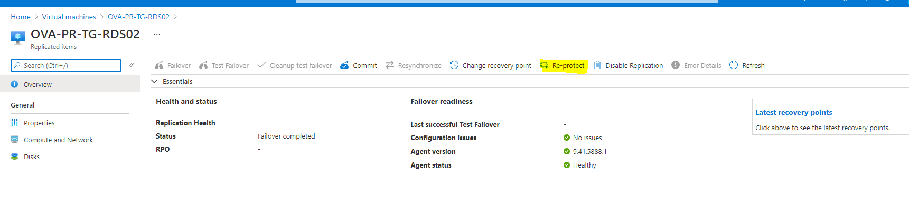

Once Synchronize complete to 100%, Failover option enabled on VMs.

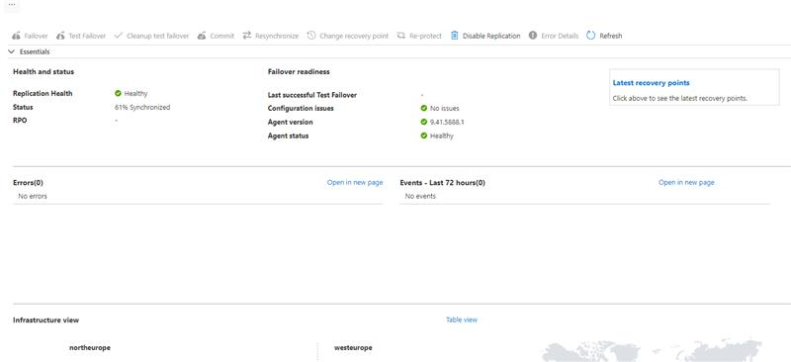

Please note that each fail over (to data center B) is a temporary stage and will require a scheduled fail-back after the problem of original server(s) is resolved. The fail-back (data center A) procedure should be scheduled during agency off hours.

## Groups contacts

OVA Support Team: SG413-MSCLinkAPSupportCenter@msc.com ; paulo.sackel@msc.com ; US904-InterlinkSupportMSCLink@msc.com ; in910-ova-rollout-technical@msc.com

DBAs: us904-ova-dbas-dl@msc.com

Data Replication Team: us904-datareplicationsupport@msc.com

Infra Team: [us904-warreninfrastructure@msc.com](mailto:us904-warreninfrastructure@msc.com)

*This document does not contain DR process of the following global systems used by OVA: OVA BizTalk , myMSC, OVA Cyclone, OVA FTP, Xlink*