PRABAKAR. S  22, Kovalan street,  Chennimalai-638051,  Erode (Dt).  E-mail : prabakar_s@live.com  Mobile no: +91 88074 79063 | 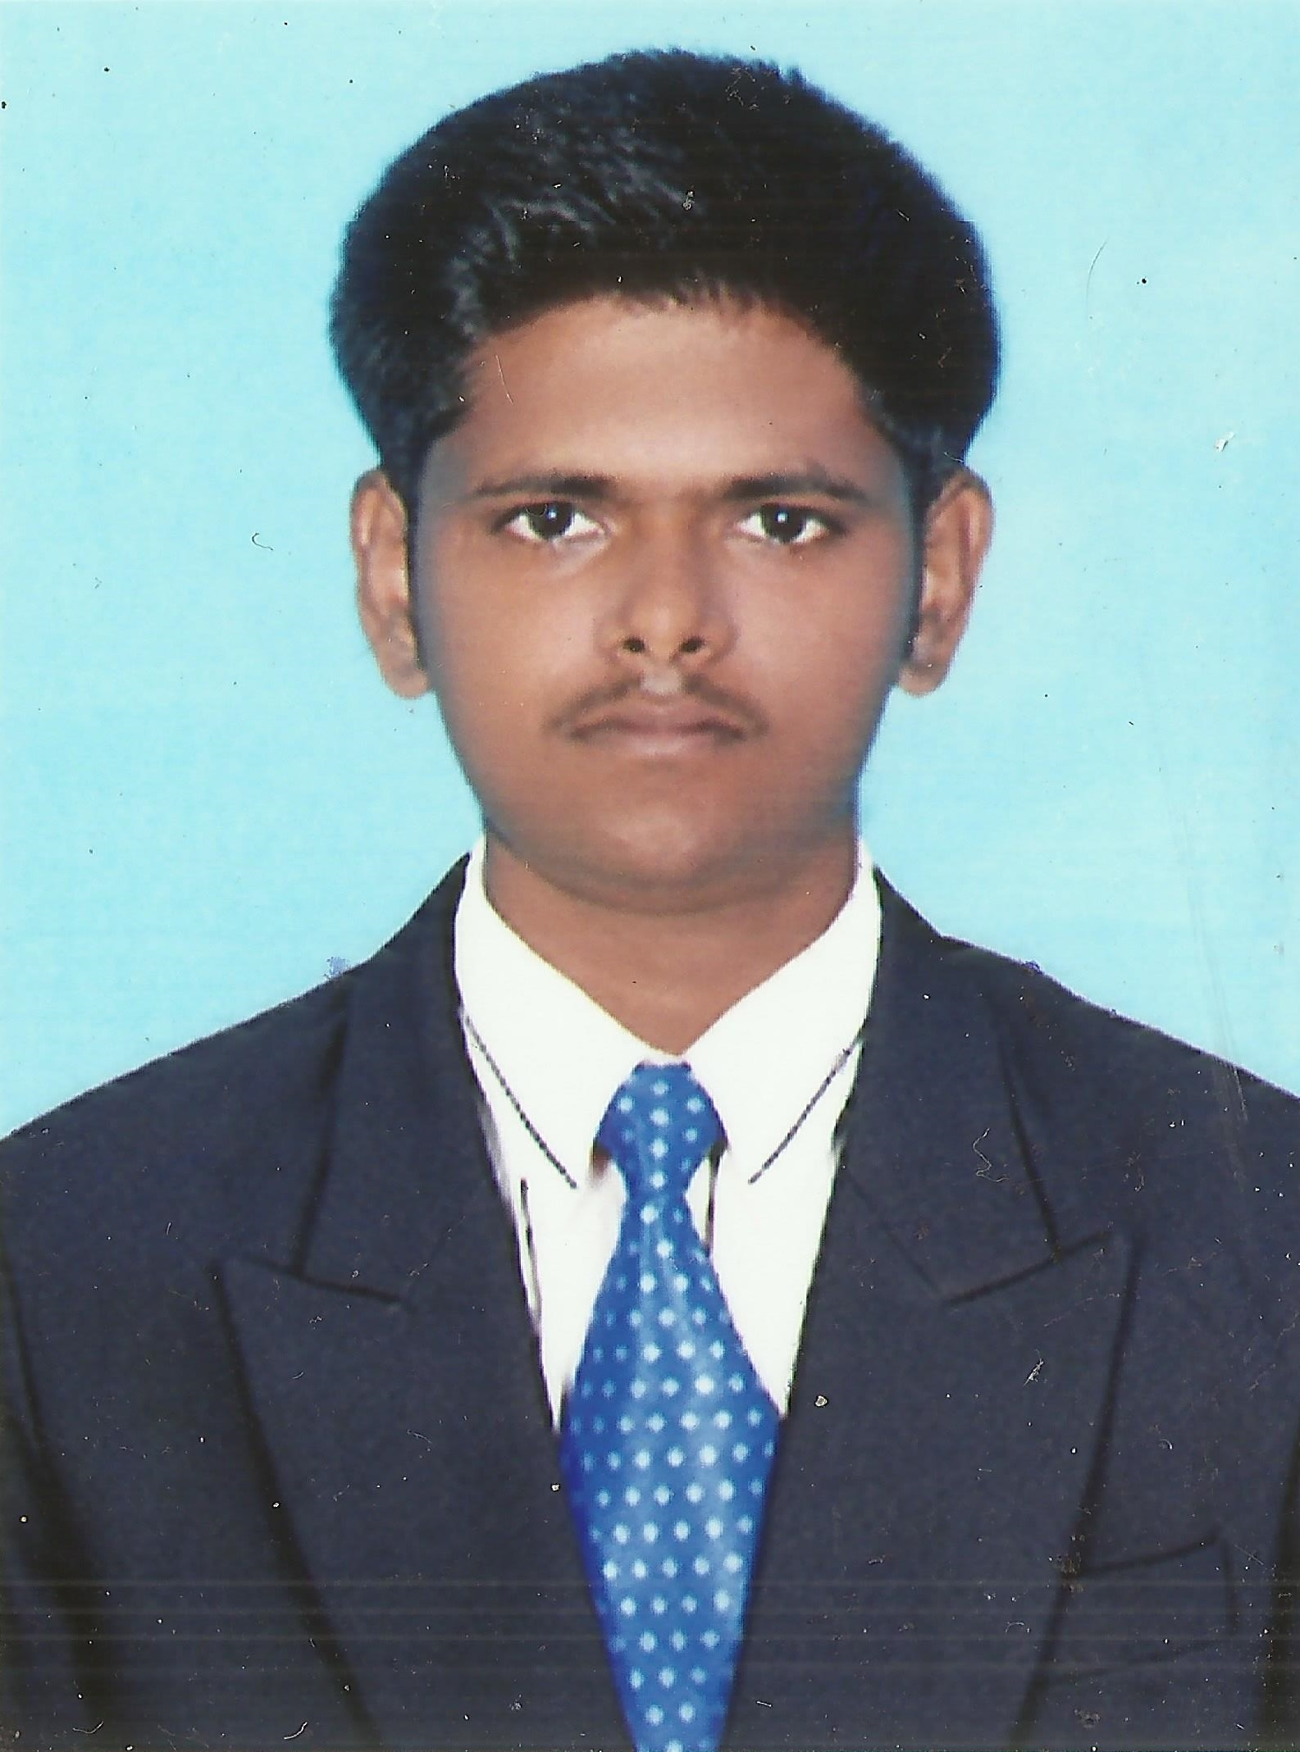
_______________________________________________________________________

OBJECTIVE:
To get engaged with an dynamic enterprise where I can perform energetically towards the company’s goals and develop myself to increase my inherent skills.

EDUCATIONAL BACKGROUND:
DEGREE /CERTIFICATE | NAME OF THE COLLEGE / UNIVERSITY/SCHOOL | YEAR OF STUDY | % OF MARKS / CGPA
BE., MECHANICAL | Erode Builder Educational Trust’s Group of Institutions, Tirupur. | 2010-14 | 8.62*
HSC | Vimala Matriculation Higher Secondary School, Chennimalai, Erode. | 2010 | 89.6
SSLC | Vimala Matriculation School,  Chennimalai, Erode.  87  - Auto CAD, Pro-E, Catia. | 2008 | 87
(*up to seventh semester)

AREA OF ACADEMIC INTEREST:
- Manufacturing Technology,
- Thermal Engineering.
SOFTWARE EXPOSURE:
Auto CAD, Pro-E, Catia, ANSYS, Edge CAM.
Non-Destructive Testing Level-II
PROJECTS UNDERGONE
- Undergone project work on “Fabrication Of Solar Tracking Parabolic Heliostat”
Concentration of solar power is more while using parabolic reflector than the plane reflector
can be used for various application
- Undergone project work on "Flow Analysis On Diesel Particulate Filter".
Provides a way to analysis the exhaust gas flow pattern and the parameters that governs the flow through the Diesel Particulate Filter which is very difficult in experimental analysis.

INTERNSHIPS / TRAININGS UNDERTAKEN:
- Certification course on “Fundamental Course in Welding and Plumbing Technology” at Sri Ramakrishna Advanced Training Institute during the period October 2010.
- Undergone In-plant training in Ambal Autos Pvt. Ltd, Erode the month of May 2011.
- Undergone In- Plant training in Autozone Automobile Pvt. Ltd, Coimbatore during the month of November 2011.
- Undergone In-plant training in MM Engineers Pvt. Ltd, Coimbatore at sites located in Erode during the month of May 2012.

PAPER PRESENTATION / WORKSHOPS ATTENDED:
- Attended One Day Workshop on “Nano Technology”, held at Institute Of Road and Transportation Technology, Sithode.
- Presented Paper titled “Power Production by Railway Track” at a National Level Technical Symposium held at Sri Krishna College Of Technology, Coimbatore.
- Presented Poster on topic “Solar Powered Stirling Engine” at Kongu Engineering College, Perundurai and won First Prize.
- Presented Paper on topic “Solar Powered Stirling Engine” at Government College of Technology, Coimbatore and subsequently at “Indian Institute of Technology”, Chennai.
- Attended two days workshop on topic “Internal Combustion Engines” at “Indian Institute of Technology”, Chennai.

EXTRA CURRICULAR ACTIVITIES / AWARDS:
- School Captain for Yellow House during the Academic year 2008 - 09 and won overall second prize.
- School Captain for Green House during the Academic year 2009 - 10.
- Certified as a Best Performer based on the involvement for In-Plant Training and its presentation at the college in the academic year 2011-12.
- Vice-Secretory for the Society of Automotive Engineers, EBET-i Collegiate Club during the academic year 2011-2012.
- Vice-Secretory for the Mechanical Engineering Association during the academic year 2012-2013.

PERSONAL DETAILS:

Parents Name : K. Subramani- S. Kannammal
DOB : 23.07.1993
Permanent Address : 22, Kovalan Street,
Kovakadu,
Chennimalai-638051,
Erode (DT).
Languages Known : English, Tamil.
Hobbies : Photography, playing cricket, cycling.

REFERENCE

Mr.K.Sakthivadivel M.E,  Assistant Professor,  Department of Mechanical Engineering,  EBETi.-Kangeyam.  E-mail: ks.mech@ebet.edu.in  Contact No.-9942262839 | Dr.P.R.Ramanathan,  Trichy.

DECLARATION

The above said information is true to the best of my knowledge and belief.

S. PRABAKAR.

