**FC-Densenet Model**

**Accuracy:**

Overall Accuracy: 0.6715

**Accuracy, Precision & Recall:**

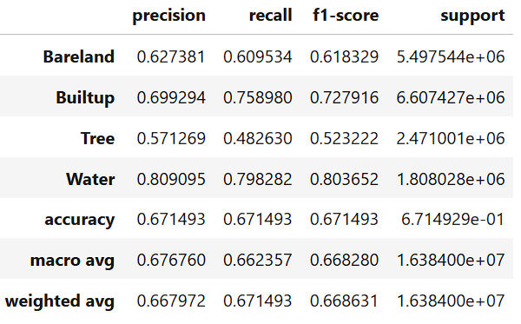

**IoU:**

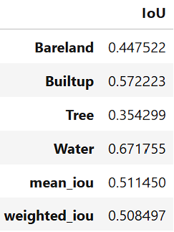

**Model Complexity Stats:**

=== Model Complexity ===

Total Parameters: 0.94M

Trainable Parameters: 0.92M

=== Model Performance Statistics ===

FLOPS: 12.90 GFLOPs

Speed: 16.60 FPS

**Train-Val Loss v/s epochs:**

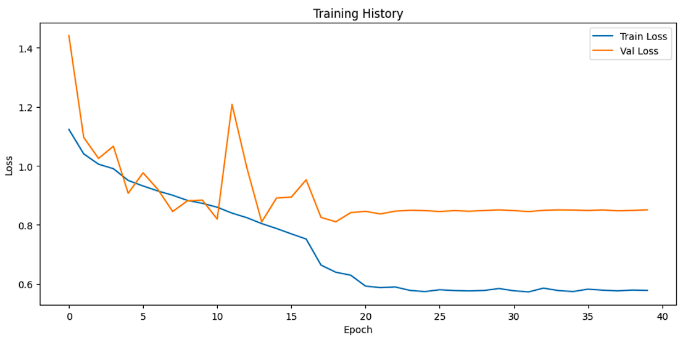

**Confusion Matrix:**

