**PSPnet Model**

**Accuracy:**

Overall Accuracy: 0.6136

**Accuracy, Precision & Recall:**

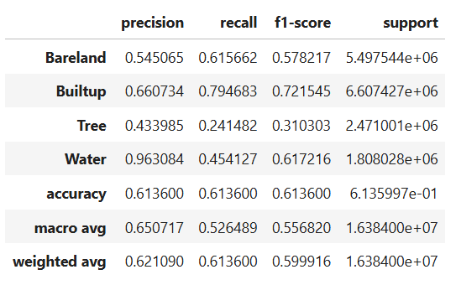

**IoU:**

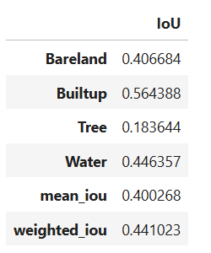

**Model Complexity Stats:**

=== Model Complexity ===  
Total Parameters: 3.41M  
Trainable Parameters: 3.41M

=== Model Performance Statistics ===  
FLOPS: 6.99 GFLOPs

Speed: 18.67 FPS

**Train-Val Loss v/s epochs:**

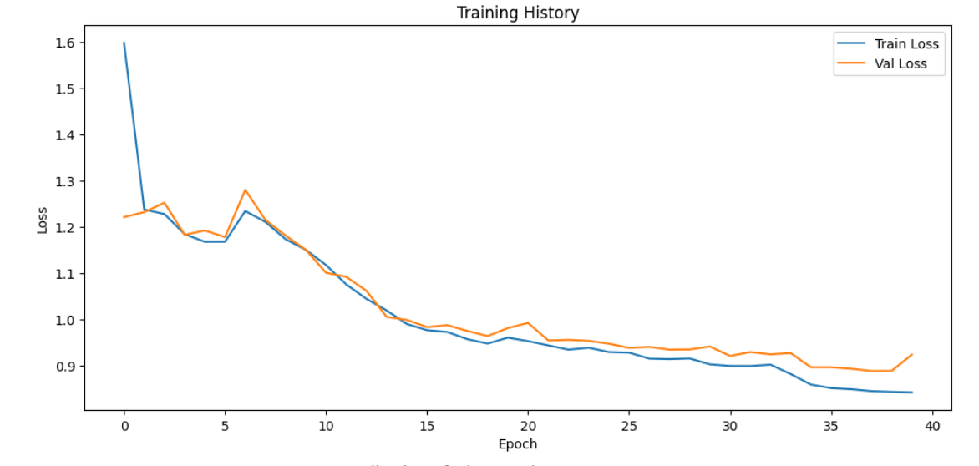

**Confusion Matrix:**

