**Unet Model**

**Accuracy:**

Overall Accuracy: 0.5843

**Accuracy, Precision & Recall:**

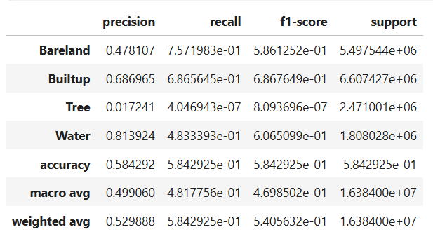

**IoU:**

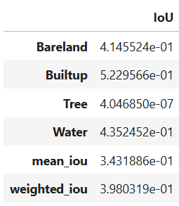

**Model Complexity Stats:**

=== Model Complexity ===  
Total Parameters: 0.48M  
Trainable Parameters: 0.48M

=== Model Performance Statistics ===  
FLOPS: 1.16 GFLOPs

Speed: 19.41 FPS

**Train-Val Loss v/s epochs:**

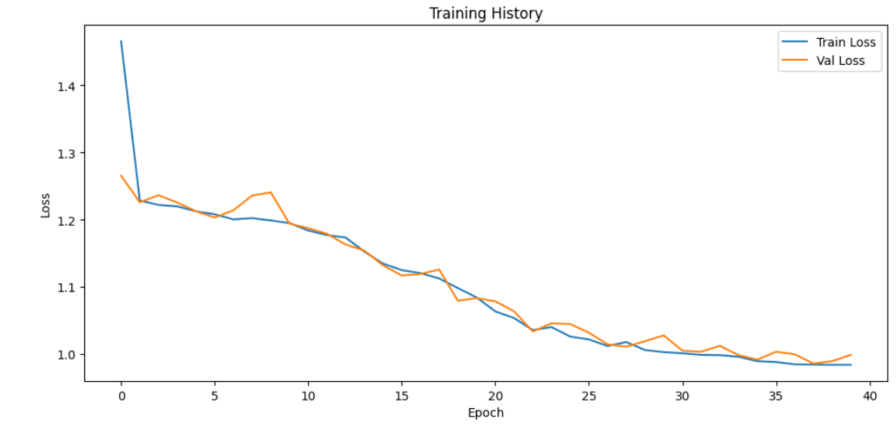

**Confusion Matrix:**

