**UNET :**

* **Accuracy:**

0.5980

* **Precision –Recall :**

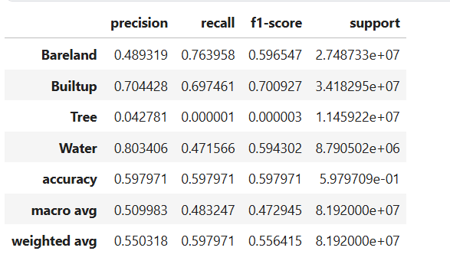

* **IoU - overall and class** **wise :**

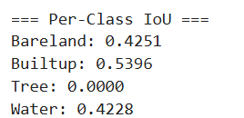

Mean IoU: 0.3468

* **Model Complexity Stats :**

Total Parameters: 0.48M  
 Trainable Parameters: 0.48M

FLOPS: 1.16 GFLOPs

Speed: 18.93 FPS

* **Train-Val Loss v/s epochs :**

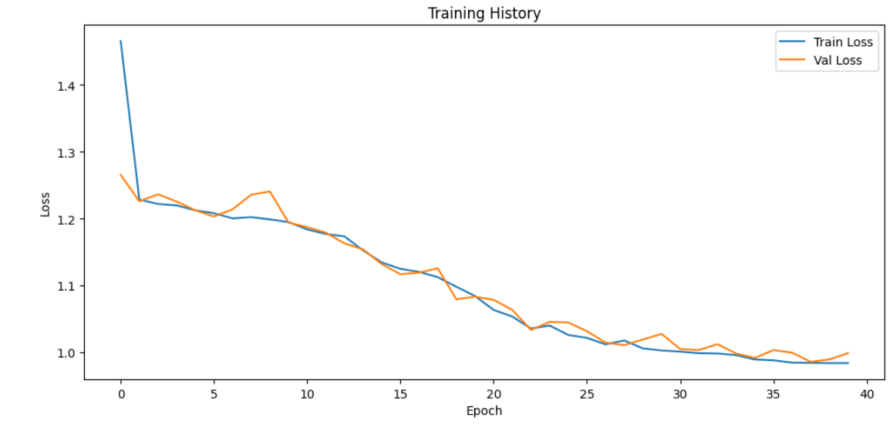

* **Confusion Matrix :**

