**FC-DenseNet**

**Overall Accuracy:**

Overall Accuracy: 0.7459

**Accuracy, F1 Score, Recall & Precision:**

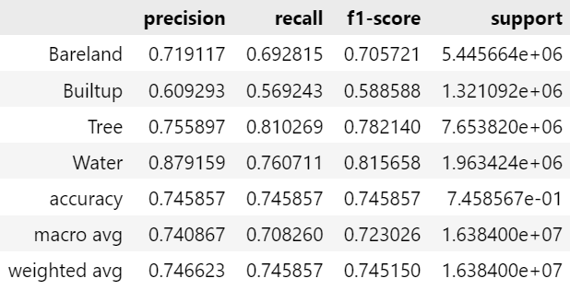

**IoU:**

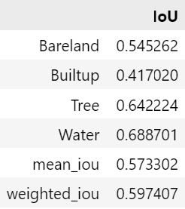

Model Complexity:

=== Model Complexity ===

Total Parameters: 0.94M

Trainable Parameters: 0.92M

=== Model Performance Statistics ===

FLOPS: 12.90 GFLOPs

Speed: 16.70 FPS

**Confusion Matrix:**

