**FRRN-B**

**Overall Accuracy:**

Overall Accuracy: 0.6250

**Accuracy, F1 Score, Recall & Precision:**

|  |  |  |  |  |
| --- | --- | --- | --- | --- |
|  | **precision** | **recall** | **f1-score** | **support** |
| Bareland | 0.599716 | 0.458781 | 0.519866 | 5.445664e+06 |
| Builtup | 0.494529 | 0.201487 | 0.286319 | 1.321092e+06 |
| Tree | 0.610479 | 0.809459 | 0.696028 | 7.653820e+06 |
| Water | 0.836231 | 0.652196 | 0.732837 | 1.963424e+06 |
| accuracy | 0.625033 | 0.625033 | 0.625033 | 6.250330e-01 |
| macro avg | 0.635239 | 0.530481 | 0.558762 | 1.638400e+07 |
| weighted avg | 0.624606 | 0.625033 | 0.608850 | 1.638400e+07 |

**IoU:**

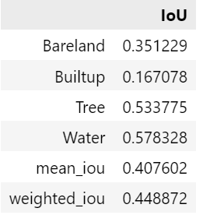

**Model Complexity:**

=== Model Complexity ===

Total Parameters: 0.30M

Trainable Parameters: 0.30M

=== Model Performance Statistics ===

FLOPS: 4.27 GFLOPs

Speed: 20.30 FPS

**Confusion Matrix:**

