**PSPNet**

**Overall Accuracy:**

Overall Accuracy: 0.6748

**Accuracy, F1 Score, Recall & Precision:**

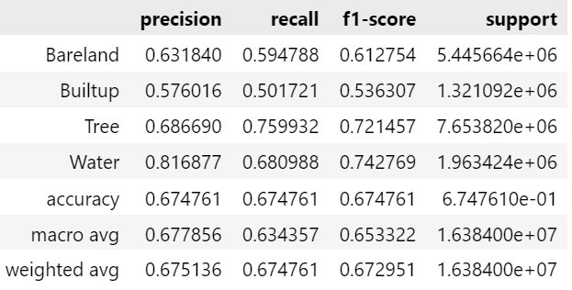

**IoU:**

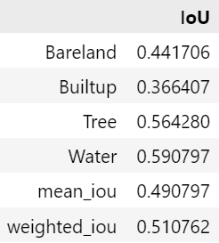

**Model Complexity:**

=== Model Complexity ===

Total Parameters: 3.41M

Trainable Parameters: 3.41M

=== Model Performance Statistics ===

FLOPS: 6.99 GFLOPs

Speed: 20.16 FPS

**Confusion Matrix:**

