**Unet**

**Overall Accuracy:**

Overall Accuracy: 0.6327

**Accuracy, F1 Score, Recall & Precision:**

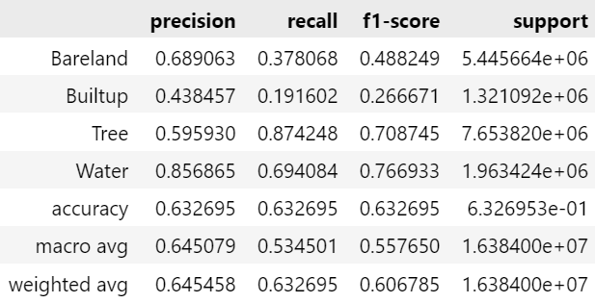

**IoU:**

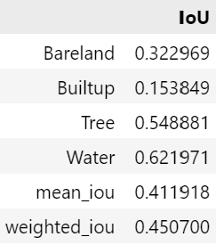

**Model Complexity:**

=== Model Complexity ===

Total Parameters: 0.48M

Trainable Parameters: 0.48M

=== Model Performance Statistics ===

FLOPS: 1.16 GFLOPs

Speed: 19.58 FPS

**Confusion Matrix:**

