Project Name: Beanworks Projects

Objective: The objective of the project is to sync and fetch data from any account available in xero Accounting System connecting through its API

Developed by: Prabal Mahanta

Required file: (1) app.js

(2) home.ejs

The application is developed using Node js (v 11.3.0) and ejs template engine. The app runs on port 3000.

How to run the app: (1) Please ensure that node js is already installed on the computer. The files should be installed on the root folder. Inside the root folder, copy/create a subfolder named ‘views’ and store the ‘home.ejs’ file in it.

(2)To start the app, go to command window, type the command - node app.js

(3) The console displays ‘server running on port 3000’ if it’s configured properly

(4) Go to browser, and browse <http://localhost:3000>

(5) The browser navigates to the following interface of xero , provided you are authorized to access

Xero Accounting System.

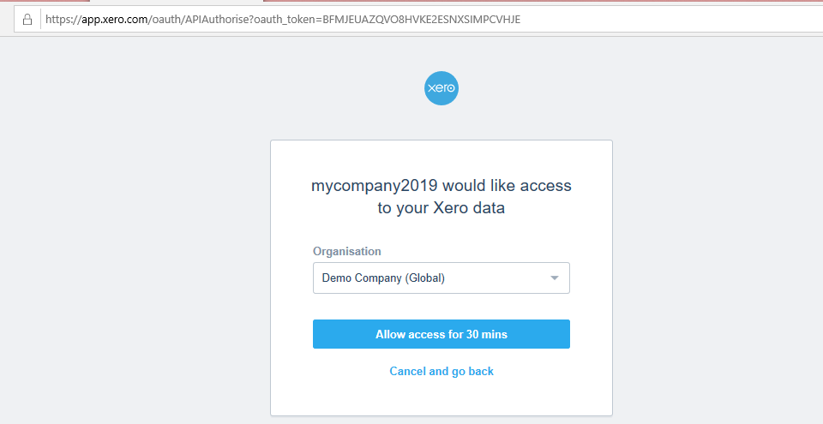

(6) Press ‘Allow access for 30 mins’

(7) It navigates to the app (screenshot below)

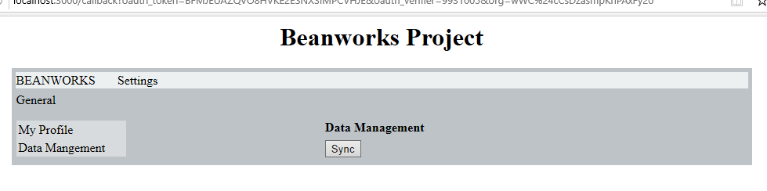

(8) Press the ‘Sync’ button to sync with Xero.

(9) The following is the next screen which renders the relevant data from the relevant account in xero.

