PRABAL GHSOH ROLL- AM.SC.P2CSC20040

SEMANTIC WEB PROJECT

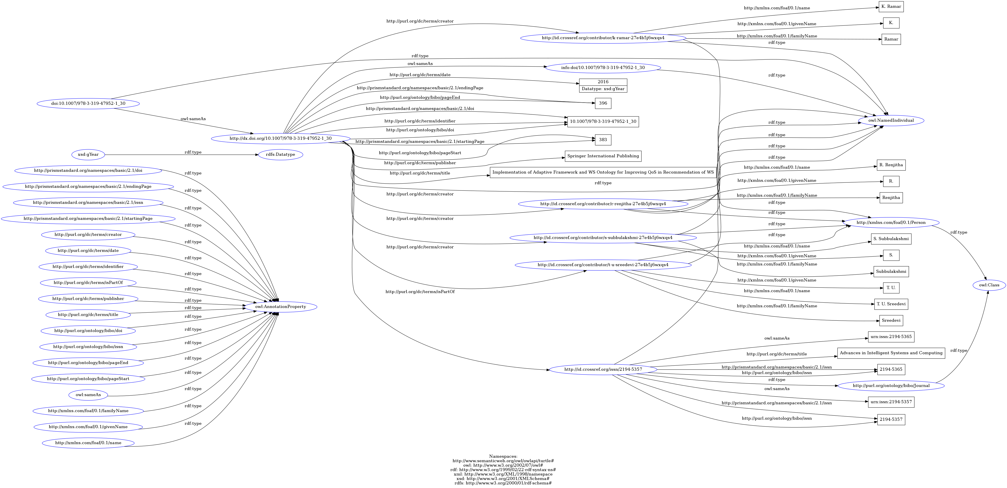

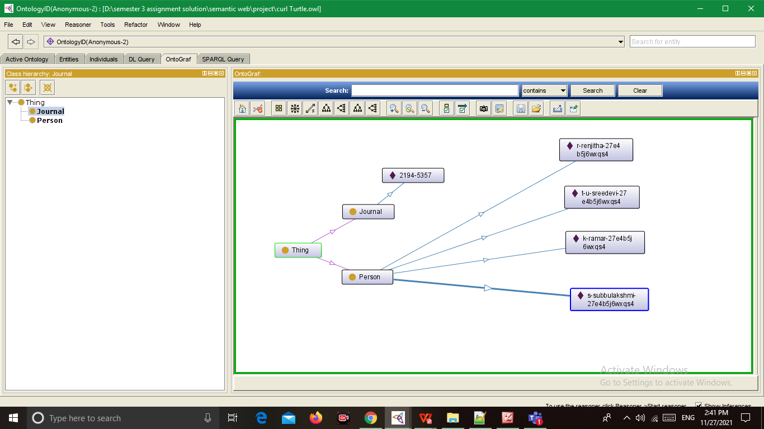

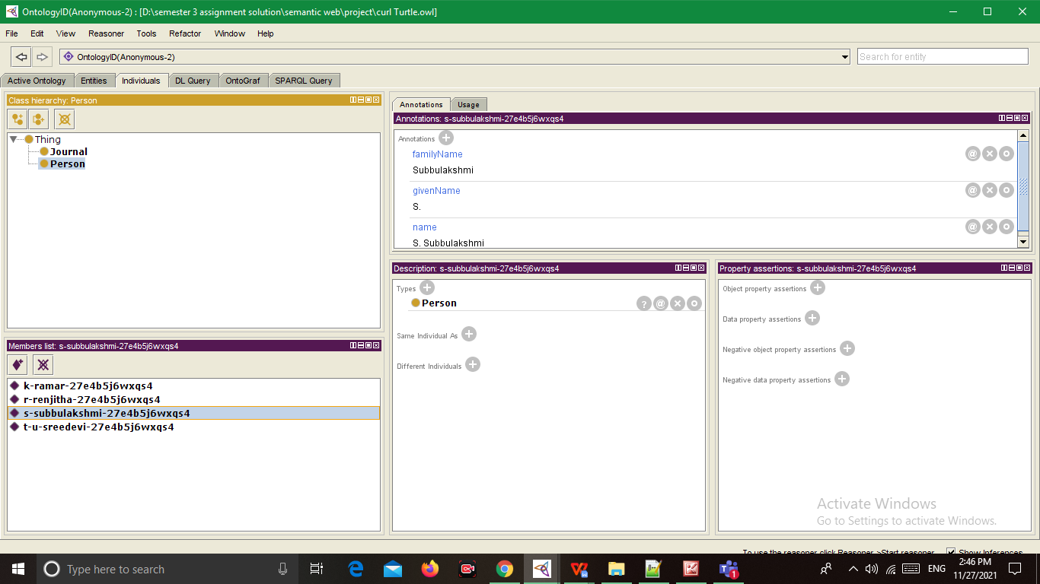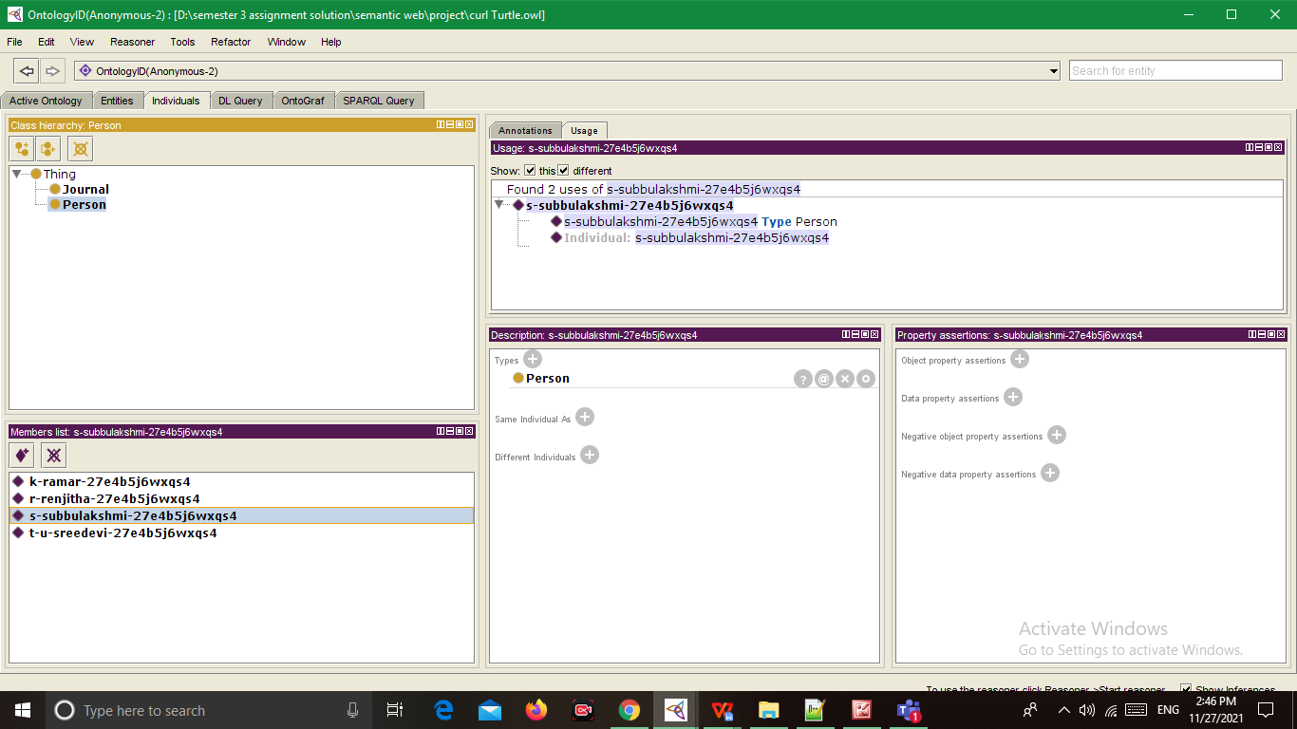

PREFIX rdf: <http://www.w3.org/1999/02/22-rdf-syntax-ns#>

PREFIX owl: <http://www.w3.org/2002/07/owl#>

PREFIX xsd: <http://www.w3.org/2001/XMLSchema#>

PREFIX rdfs: <http://www.w3.org/2000/01/rdf-schema#>

prefix xml: <http://www.w3.org/2001/XMLSchema#>

prefix : <http://www.semanticweb.org/owl/owlapi/turtle#>

1)

SELECT ?x ?y ?z

WHERE { ?x ?y ?z . }

2)

SELECT distinct ?x

WHERE { ?x rdf:type rdfs:Datatype .}

3)

SELECT distinct ?x

WHERE { ?x rdf:type owl:Class .}

4)

SELECT distinct ?x

WHERE { ?x rdf:type owl:NamedIndividual .}

5)

SELECT distinct ?x

WHERE { ?x rdf:type owl:NamedIndividual ,<http://purl.org/ontology/bibo/Journal>.}

6)

SELECT distinct ?x

WHERE { ?x rdf:type owl:NamedIndividual ,<http://xmlns.com/foaf/0.1/Person>.}

7)

SELECT distinct ?x ?name ?familyName ?givenName

WHERE { ?x rdf:type owl:NamedIndividual ,<http://xmlns.com/foaf/0.1/Person>;

<http://xmlns.com/foaf/0.1/name> ?name;

<http://xmlns.com/foaf/0.1/familyName> ?familyName ;

<http://xmlns.com/foaf/0.1/givenName> ?givenName .

}



8)

SELECT distinct ?x ?issn ?s ?title

WHERE {?x rdf:type <http://purl.org/ontology/bibo/Journal> ,

owl:NamedIndividual ;

<http://prismstandard.org/namespaces/basic/2.1/issn> ?issn ;

owl:sameAs ?s ;

<http://purl.org/dc/terms/title> ?title ;

}

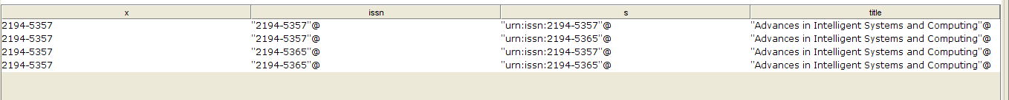

9)

SELECT distinct ?x ?issn ?s ?title ?error

WHERE {?x rdf:type <http://purl.org/ontology/bibo/Journal> ,

owl:NamedIndividual ;

<http://prismstandard.org/namespaces/basic/2.1/issn> ?issn ;

owl:sameAs ?s ;

<http://purl.org/dc/terms/title> ?title ;

<http://purl.org/ontology/bibo/issn> ?error

}

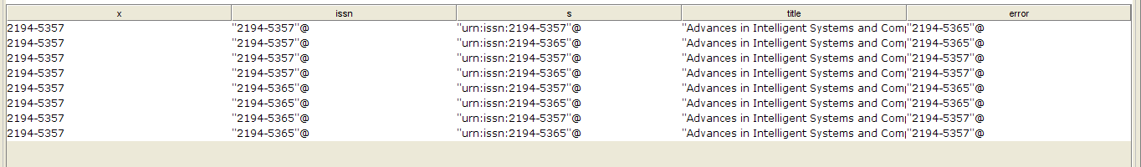

I am not able to extract the data for this “error” column as there are 2 literal values present for that object.

10)

SELECT distinct ?x ?date ?pageEnd ?doi ?pageStart ?publisher ?endingPage ?title ?identifier ?creator ?isPartOf ?sameAs

WHERE {?x rdf:type owl:NamedIndividual ; <http://purl.org/dc/terms/date> ?date ;

<http://purl.org/ontology/bibo/pageEnd> ?pageEnd ; <http://purl.org/ontology/bibo/doi> ?doi ; <http://purl.org/ontology/bibo/pageStart> ?pageStart ;

<http://purl.org/dc/terms/publisher> ?publisher ; <http://prismstandard.org/namespaces/basic/2.1/endingPage> ?endingPage ;

<http://purl.org/dc/terms/title> ?title ; <http://purl.org/dc/terms/identifier> ?identifier;

<http://purl.org/dc/terms/creator> ?creator; <http://purl.org/dc/terms/isPartOf> ?isPartOf ; owl:sameAs ?sameAs.

}



11)

SELECT distinct ?x ?date ?pageEnd ?doi ?pageStart ?publisher ?endingPage ?title ?identifier ?creator ?isPartOf ?sameAs ?title_Journal ?s ?issn ?name ?familyName ?givenName

WHERE{

{?x rdf:type owl:NamedIndividual ; <http://purl.org/dc/terms/date> ?date ;

<http://purl.org/ontology/bibo/pageEnd> ?pageEnd ; <http://purl.org/ontology/bibo/doi> ?doi ; <http://purl.org/ontology/bibo/pageStart> ?pageStart ; <http://purl.org/dc/terms/publisher> ?publisher ; <http://prismstandard.org/namespaces/basic/2.1/endingPage> ?endingPage ; <http://purl.org/dc/terms/title> ?title ; <http://purl.org/dc/terms/identifier> ?identifier; <http://purl.org/dc/terms/creator> ?creator; <http://purl.org/dc/terms/isPartOf> ?isPartOf ; owl:sameAs ?sameAs. }

UNION {?x rdf:type <http://purl.org/ontology/bibo/Journal> , owl:NamedIndividual ; <http://prismstandard.org/namespaces/basic/2.1/issn> ?issn ; owl:sameAs ?s ; <http://purl.org/dc/terms/title> ?title_Journal . }

UNION { ?x rdf:type owl:NamedIndividual ,<http://xmlns.com/foaf/0.1/Person>; <http://xmlns.com/foaf/0.1/name> ?name ;<http://xmlns.com/foaf/0.1/familyName> ?familyName ; <http://xmlns.com/foaf/0.1/givenName> ?givenName .}

}

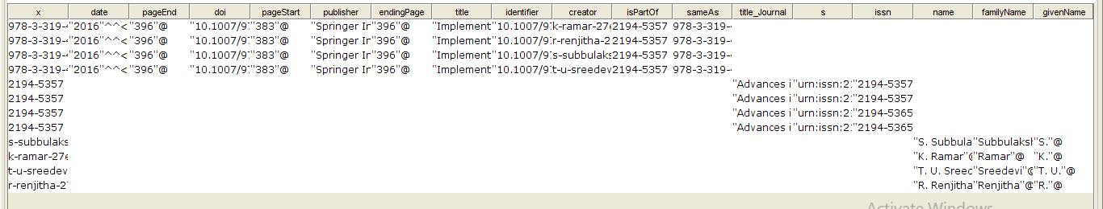

12)

SELECT distinct ?x ?creator ?title_Journal ?issn ?name ?familyName ?givenName

WHERE{ ?x rdf:type <http://purl.org/ontology/bibo/Journal> , owl:NamedIndividual ; <http://prismstandard.org/namespaces/basic/2.1/issn> ?issn ; <http://purl.org/dc/terms/title> ?title_Journal .

OPTIONAL { ?creator rdf:type owl:NamedIndividual ,<http://xmlns.com/foaf/0.1/Person>; <http://xmlns.com/foaf/0.1/name> ?name ;<http://xmlns.com/foaf/0.1/familyName> ?familyName ; <http://xmlns.com/foaf/0.1/givenName> ?givenName .}}

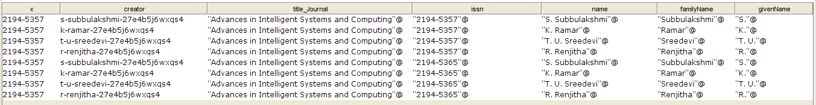

<https://link.springer.com/chapter/10.1007%2F978-3-319-47952-1_30>

