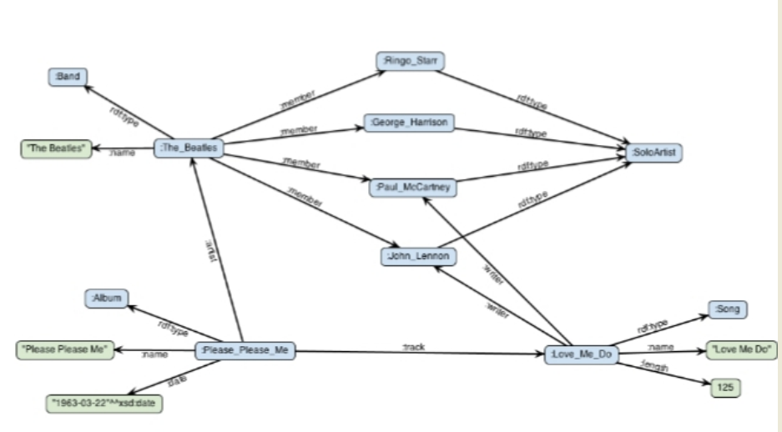PRABAL GHOSH ROLL-40

***RDF-TURTLE***

@prefix ex: <http://example.com/ex#> .

@prefix rdf: <http://www.w3.org/1999/02/22-rdf-syntax-ns#> .

@prefix rdfs: <http://www.w3.org/2000/01/rdf-schema#> .

@prefix xml: <http://www.w3.org/XML/1998/namespace> .

@prefix xsd: <http://www.w3.org/2001/XMLSchema#> .

ex:Band a rdfs:class.

ex:SoloArtist a rdfs:class.

ex:Album a rdfs:class.

ex:Song a rdfs:class.

ex:The_Beatles a ex:Band;

ex:name 'TheBeatles'^^xsd:string;

ex:member ex:Ringo_Starr,

ex:Hamison,

ex:Paul_MaCartney,

ex:John_Lennon.

ex:Please_Please_me a ex:Album;

ex:artist ex:The_Beatles ;

ex:name 'Please Please me'^^xsd:string;

ex:date '1968-03-22'^^xsd:date;

ex:track ex:Love_Me_Do.

ex:Love_Me_Do a ex:Song;

ex:name 'Love Me Do'@en;

ex:length '120'^^xsd:integer;

ex:writer ex:Paul_MaCartney,

ex:John_Lennon.

ex:name a rdf:Property;

rdfs:domain ex:Band,

ex:Album,

ex:Song ;

rdfs:range xsd:string .

ex:date a rdf:Property;

rdfs:domain ex:Album;

rdfs:range xsd:date.

ex:artist a rdf:Property;

rdfs:domain ex:Album;

rdfs:range ex:Band.

ex:track a rdf:Property;

rdfs:domain ex:Album;

rdfs:range ex:Song.

ex:length a rdf:Property;

rdfs:domain ex:Song;

rdfs:range '125'^^xsd:integer.

ex:member a rdf:Property;

rdfs:domain ex:Band;

rdfs:range ex:SoloArtist.

ex:Ringo_Starr a ex:SoloArtist.

ex:Hamison a ex:SoloArtist.

ex:Paul_MaCartney a ex:SoloArtist.

ex:John_Lennon a ex:SoloArtist.

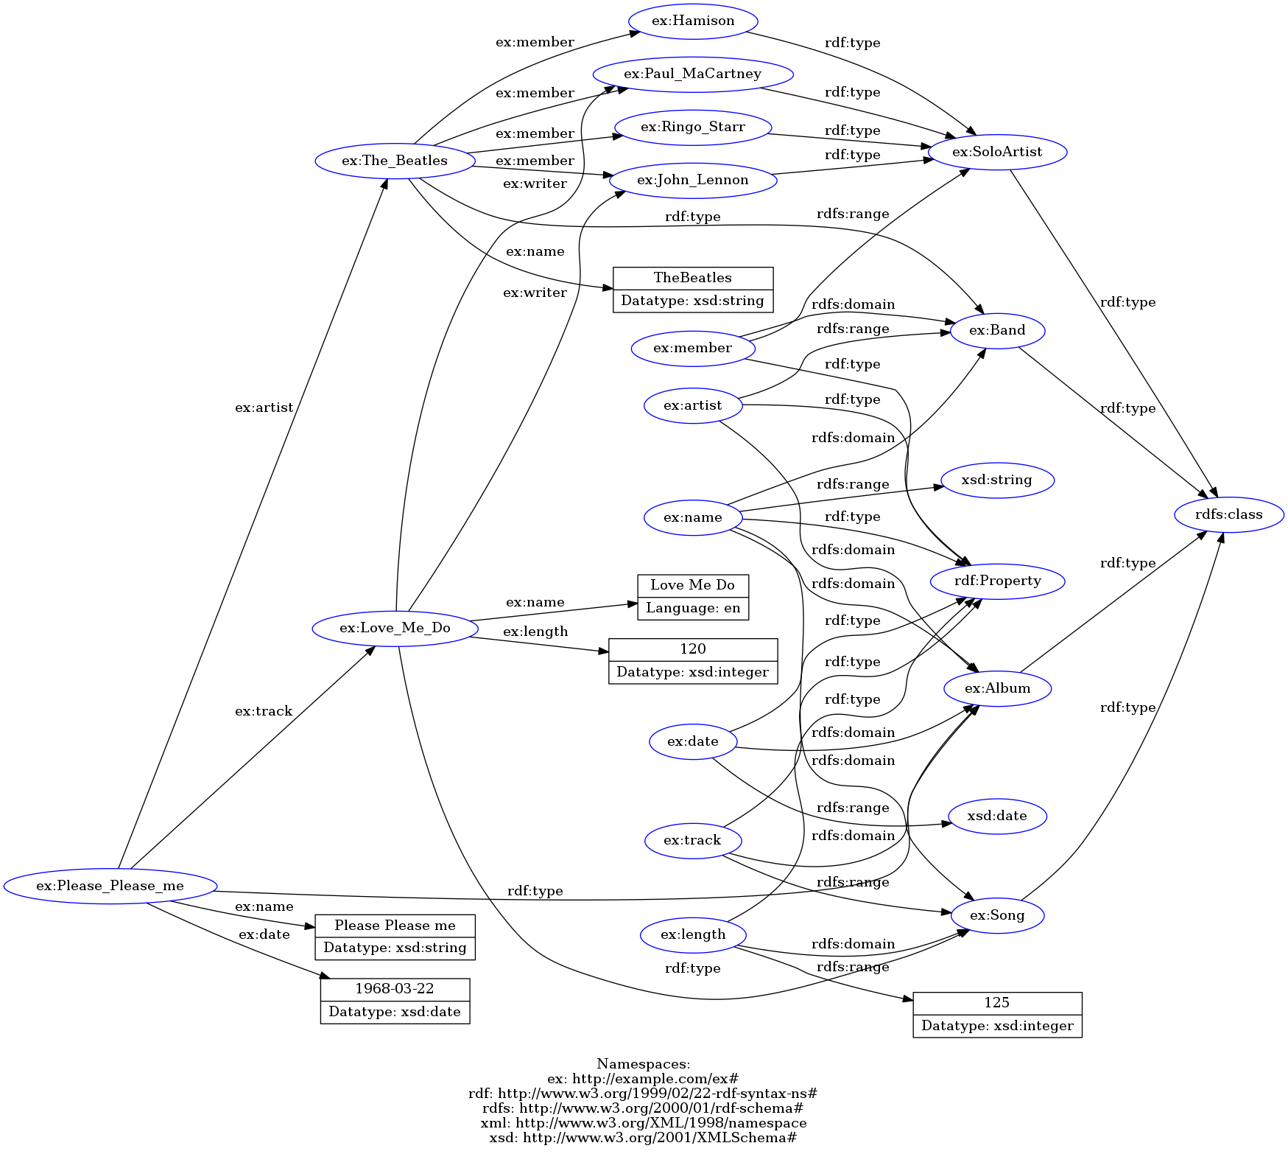

***METHOD-(RDF-XML)***

<?xml version="1.0" encoding="utf-8" ?>

<rdf:RDF xmlns:rdf="http://www.w3.org/1999/02/22-rdf-syntax-ns#"

xmlns:rdfs="http://www.w3.org/2000/01/rdf-schema#"

xmlns:ns0="http://example.com/ex#">

<rdfs:class rdf:about="http://example.com/ex#Band">

</rdfs:class>

<rdfs:class rdf:about="http://example.com/ex#SoloArtist">

</rdfs:class>

<rdfs:class rdf:about="http://example.com/ex#Album">

</rdfs:class>

<rdfs:class rdf:about="http://example.com/ex#Song">

</rdfs:class>

<rdf:Description rdf:about="http://example.com/ex#The_Beatles">

<rdf:type rdf:resource="http://example.com/ex#Band"/>

<ns0:name rdf:datatype="http://www.w3.org/2001/XMLSchema#string">TheBeatles</ns0:name>

<ns0:member>

<ns0:SoloArtist rdf:about="http://example.com/ex#Ringo_Starr">

</ns0:SoloArtist>

</ns0:member>

<ns0:member>

<ns0:SoloArtist rdf:about="http://example.com/ex#Hamison">

</ns0:SoloArtist>

</ns0:member>

<ns0:member rdf:resource="http://example.com/ex#Paul_MaCartney"/>

<ns0:member rdf:resource="http://example.com/ex#John_Lennon"/>

</rdf:Description>

<ns0:Album rdf:about="http://example.com/ex#Please_Please_me">

<ns0:artist rdf:resource="http://example.com/ex#The_Beatles"/>

<ns0:name rdf:datatype="http://www.w3.org/2001/XMLSchema#string">Please Please me</ns0:name>

<ns0:date rdf:datatype="http://www.w3.org/2001/XMLSchema#date">1968-03-22</ns0:date>

<ns0:track>

<ns0:Song rdf:about="http://example.com/ex#Love_Me_Do">

<ns0:name xml:lang="en">Love Me Do</ns0:name>

<ns0:length rdf:datatype="http://www.w3.org/2001/XMLSchema#integer">120</ns0:length>

<ns0:writer rdf:resource="http://example.com/ex#Paul_MaCartney"/>

<ns0:writer rdf:resource="http://example.com/ex#John_Lennon"/>

</ns0:Song>

</ns0:track>

</ns0:Album>

<rdf:Property rdf:about="http://example.com/ex#name">

<rdfs:domain rdf:resource="http://example.com/ex#Band"/>

<rdfs:domain rdf:resource="http://example.com/ex#Album"/>

<rdfs:domain rdf:resource="http://example.com/ex#Song"/>

<rdfs:range rdf:resource="http://www.w3.org/2001/XMLSchema#string"/>

</rdf:Property>

<rdf:Property rdf:about="http://example.com/ex#date">

<rdfs:domain rdf:resource="http://example.com/ex#Album"/>

<rdfs:range rdf:resource="http://www.w3.org/2001/XMLSchema#date"/>

</rdf:Property>

<rdf:Property rdf:about="http://example.com/ex#artist">

<rdfs:domain rdf:resource="http://example.com/ex#Album"/>

<rdfs:range rdf:resource="http://example.com/ex#Band"/>

</rdf:Property>

<rdf:Property rdf:about="http://example.com/ex#track">

<rdfs:domain rdf:resource="http://example.com/ex#Album"/>

<rdfs:range rdf:resource="http://example.com/ex#Song"/>

</rdf:Property>

<rdf:Property rdf:about="http://example.com/ex#length">

<rdfs:domain rdf:resource="http://example.com/ex#Song"/>

<rdfs:range rdf:datatype="http://www.w3.org/2001/XMLSchema#integer">125</rdfs:range>

</rdf:Property>

<rdf:Property rdf:about="http://example.com/ex#member">

<rdfs:domain rdf:resource="http://example.com/ex#Band"/>

<rdfs:range rdf:resource="http://example.com/ex#SoloArtist"/>

</rdf:Property>

<ns0:SoloArtist rdf:about="http://example.com/ex#Paul_MaCartney">

</ns0:SoloArtist>

<ns0:SoloArtist rdf:about="http://example.com/ex#John_Lennon">

</ns0:SoloArtist>

</rdf:RDF>

***METHOD-RDF-TURTLE***

@prefix rdfs: <http://www.w3.org/2000/01/rdf-schema#> .

@prefix ns0: <http://example.com/ex#> .

@prefix xsd: <http://www.w3.org/2001/XMLSchema#> .

@prefix rdf: <http://www.w3.org/1999/02/22-rdf-syntax-ns#> .

<http://example.com/ex#Band> a rdfs:class .

<http://example.com/ex#SoloArtist> a rdfs:class .

<http://example.com/ex#Album> a rdfs:class .

<http://example.com/ex#Song> a rdfs:class .

<http://example.com/ex#The_Beatles>

a <http://example.com/ex#Band> ;

ns0:name "TheBeatles"^^xsd:string ;

ns0:member ns0:Ringo_Starr, ns0:Hamison, ns0:Paul_MaCartney, ns0:John_Lennon .

ns0:Please_Please_me

a ns0:Album ;

ns0:artist ns0:The_Beatles ;

ns0:name "Please Please me"^^xsd:string ;

ns0:date "1968-03-22"^^xsd:date ;

ns0:track ns0:Love_Me_Do .

ns0:Love_Me_Do

a ns0:Song ;

ns0:name "Love Me Do"@en ;

ns0:length 120 ;

ns0:writer ns0:Paul_MaCartney, ns0:John_Lennon .

ns0:name

a rdf:Property ;

rdfs:domain ns0:Band, ns0:Album, ns0:Song ;

rdfs:range xsd:string .

ns0:date

a rdf:Property ;

rdfs:domain ns0:Album ;

rdfs:range xsd:date .

ns0:artist

a rdf:Property ;

rdfs:domain ns0:Album ;

rdfs:range ns0:Band .

ns0:track

a rdf:Property ;

rdfs:domain ns0:Album ;

rdfs:range ns0:Song .

ns0:length

a rdf:Property ;

rdfs:domain ns0:Song ;

rdfs:range 125 .

ns0:member

a rdf:Property ;

rdfs:domain ns0:Band ;

rdfs:range ns0:SoloArtist .

ns0:Ringo_Starr a ns0:SoloArtist .

ns0:Hamison a ns0:SoloArtist .

ns0:Paul_MaCartney a ns0:SoloArtist .

ns0:John_Lennon a ns0:SoloArtist .

***METHOD- N TRIPLES***

<http://example.com/ex#Band> <http://www.w3.org/1999/02/22-rdf-syntax-ns#type> <http://www.w3.org/2000/01/rdf-schema#class> .

<http://example.com/ex#SoloArtist> <http://www.w3.org/1999/02/22-rdf-syntax-ns#type> <http://www.w3.org/2000/01/rdf-schema#class> .

<http://example.com/ex#Album> <http://www.w3.org/1999/02/22-rdf-syntax-ns#type> <http://www.w3.org/2000/01/rdf-schema#class> .

<http://example.com/ex#Song> <http://www.w3.org/1999/02/22-rdf-syntax-ns#type> <http://www.w3.org/2000/01/rdf-schema#class> .

<http://example.com/ex#The_Beatles> <http://www.w3.org/1999/02/22-rdf-syntax-ns#type> <http://example.com/ex#Band> .

<http://example.com/ex#The_Beatles> <http://example.com/ex#name> "TheBeatles"^^<http://www.w3.org/2001/XMLSchema#string> .

<http://example.com/ex#The_Beatles> <http://example.com/ex#member> <http://example.com/ex#Ringo_Starr> .

<http://example.com/ex#The_Beatles> <http://example.com/ex#member> <http://example.com/ex#Hamison> .

<http://example.com/ex#The_Beatles> <http://example.com/ex#member> <http://example.com/ex#Paul_MaCartney> .

<http://example.com/ex#The_Beatles> <http://example.com/ex#member> <http://example.com/ex#John_Lennon> .

<http://example.com/ex#Please_Please_me> <http://www.w3.org/1999/02/22-rdf-syntax-ns#type> <http://example.com/ex#Album> .

<http://example.com/ex#Please_Please_me> <http://example.com/ex#artist> <http://example.com/ex#The_Beatles> .

<http://example.com/ex#Please_Please_me> <http://example.com/ex#name> "Please Please me"^^<http://www.w3.org/2001/XMLSchema#string> .

<http://example.com/ex#Please_Please_me> <http://example.com/ex#date> "1968-03-22"^^<http://www.w3.org/2001/XMLSchema#date> .

<http://example.com/ex#Please_Please_me> <http://example.com/ex#track> <http://example.com/ex#Love_Me_Do> .

<http://example.com/ex#Love_Me_Do> <http://www.w3.org/1999/02/22-rdf-syntax-ns#type> <http://example.com/ex#Song> .

<http://example.com/ex#Love_Me_Do> <http://example.com/ex#name> "Love Me Do"@en .

<http://example.com/ex#Love_Me_Do> <http://example.com/ex#length> "120"^^<http://www.w3.org/2001/XMLSchema#integer> .

<http://example.com/ex#Love_Me_Do> <http://example.com/ex#writer> <http://example.com/ex#Paul_MaCartney> .

<http://example.com/ex#Love_Me_Do> <http://example.com/ex#writer> <http://example.com/ex#John_Lennon> .

<http://example.com/ex#name> <http://www.w3.org/1999/02/22-rdf-syntax-ns#type> <http://www.w3.org/1999/02/22-rdf-syntax-ns#Property> .

<http://example.com/ex#name> <http://www.w3.org/2000/01/rdf-schema#domain> <http://example.com/ex#Band> .

<http://example.com/ex#name> <http://www.w3.org/2000/01/rdf-schema#domain> <http://example.com/ex#Album> .

<http://example.com/ex#name> <http://www.w3.org/2000/01/rdf-schema#domain> <http://example.com/ex#Song> .

<http://example.com/ex#name> <http://www.w3.org/2000/01/rdf-schema#range> <http://www.w3.org/2001/XMLSchema#string> .

<http://example.com/ex#date> <http://www.w3.org/1999/02/22-rdf-syntax-ns#type> <http://www.w3.org/1999/02/22-rdf-syntax-ns#Property> .

<http://example.com/ex#date> <http://www.w3.org/2000/01/rdf-schema#domain> <http://example.com/ex#Album> .

<http://example.com/ex#date> <http://www.w3.org/2000/01/rdf-schema#range> <http://www.w3.org/2001/XMLSchema#date> .

<http://example.com/ex#artist> <http://www.w3.org/1999/02/22-rdf-syntax-ns#type> <http://www.w3.org/1999/02/22-rdf-syntax-ns#Property> .

<http://example.com/ex#artist> <http://www.w3.org/2000/01/rdf-schema#domain> <http://example.com/ex#Album> .

<http://example.com/ex#artist> <http://www.w3.org/2000/01/rdf-schema#range> <http://example.com/ex#Band> .

<http://example.com/ex#track> <http://www.w3.org/1999/02/22-rdf-syntax-ns#type> <http://www.w3.org/1999/02/22-rdf-syntax-ns#Property> .

<http://example.com/ex#track> <http://www.w3.org/2000/01/rdf-schema#domain> <http://example.com/ex#Album> .

<http://example.com/ex#track> <http://www.w3.org/2000/01/rdf-schema#range> <http://example.com/ex#Song> .

<http://example.com/ex#length> <http://www.w3.org/1999/02/22-rdf-syntax-ns#type> <http://www.w3.org/1999/02/22-rdf-syntax-ns#Property> .

<http://example.com/ex#length> <http://www.w3.org/2000/01/rdf-schema#domain> <http://example.com/ex#Song> .

<http://example.com/ex#length> <http://www.w3.org/2000/01/rdf-schema#range> "125"^^<http://www.w3.org/2001/XMLSchema#integer> .

<http://example.com/ex#member> <http://www.w3.org/1999/02/22-rdf-syntax-ns#type> <http://www.w3.org/1999/02/22-rdf-syntax-ns#Property> .

<http://example.com/ex#member> <http://www.w3.org/2000/01/rdf-schema#domain> <http://example.com/ex#Band> .

<http://example.com/ex#member> <http://www.w3.org/2000/01/rdf-schema#range> <http://example.com/ex#SoloArtist> .

<http://example.com/ex#Ringo_Starr> <http://www.w3.org/1999/02/22-rdf-syntax-ns#type> <http://example.com/ex#SoloArtist> .

<http://example.com/ex#Hamison> <http://www.w3.org/1999/02/22-rdf-syntax-ns#type> <http://example.com/ex#SoloArtist> .

<http://example.com/ex#Paul_MaCartney> <http://www.w3.org/1999/02/22-rdf-syntax-ns#type> <http://example.com/ex#SoloArtist> .

<http://example.com/ex#John_Lennon> <http://www.w3.org/1999/02/22-rdf-syntax-ns#type> <http://example.com/ex#SoloArtist> .

***METHOD-1- (OWL) TURTLE***

@prefix owl: <http://www.w3.org/2002/07/owl#>.

@prefix xsd: <http://www.w3c.org/2001/XMLSchema#> .

@prefix rdfs: <http://www.w3.org/2000/01/rdf-schema#> .

@base <http://dbpedia.org/resource/> .

@prefix ex: <http://example.com/> .

ex:Band a owl:class.

ex:SoloArtist a owl:class.

ex:Album a owl:class.

ex:Song a owl:class.

ex:The_Beatles a ex:Band;

ex:name 'TheBeatles'^^xsd:string;

ex:member ex:Ringo_Starr,

ex:Hamison,

ex:Paul_MaCartney,

ex:John_Lennon.

ex:Please_Please_me a ex:Album;

ex:artist ex:The_Beatles ;

ex:name 'Please Please me'^^xsd:string;

ex:date '1968-03-22'^^xsd:date;

ex:track ex:Love_Me_Do.

ex:Love_Me_Do a ex:Song;

ex:name 'Love Me Do'@en;

ex:length '120'^^xsd:integer;

ex:writer ex:Paul_MaCartney,

ex:John_Lennon.

ex:name a owl:DatatypeProperty;

rdfs:domain ex:Band,

ex:Album,

ex:Song ;

rdfs:range xsd:string .

ex:date a owl:DatatypeProperty;

rdfs:domain ex:Album;

rdfs:range xsd:date.

ex:artist a owl:ObjectProperty;

rdfs:domain ex:Album;

rdfs:range ex:Band.

ex:track a owl:ObjectProperty;

rdfs:domain ex:Album;

rdfs:range ex:Song.

ex:length a owl:DatatypeProperty;

rdfs:domain ex:Song;

rdfs:range '125'^^xsd:integer.

ex:member a owl:ObjectProperty;

rdfs:domain ex:Band;

rdfs:range ex:SoloArtist.

ex:Ringo_Starr a ex:SoloArtist.

ex:Hamison a ex:SoloArtist.

ex:Paul_MaCartney a ex:SoloArtist.

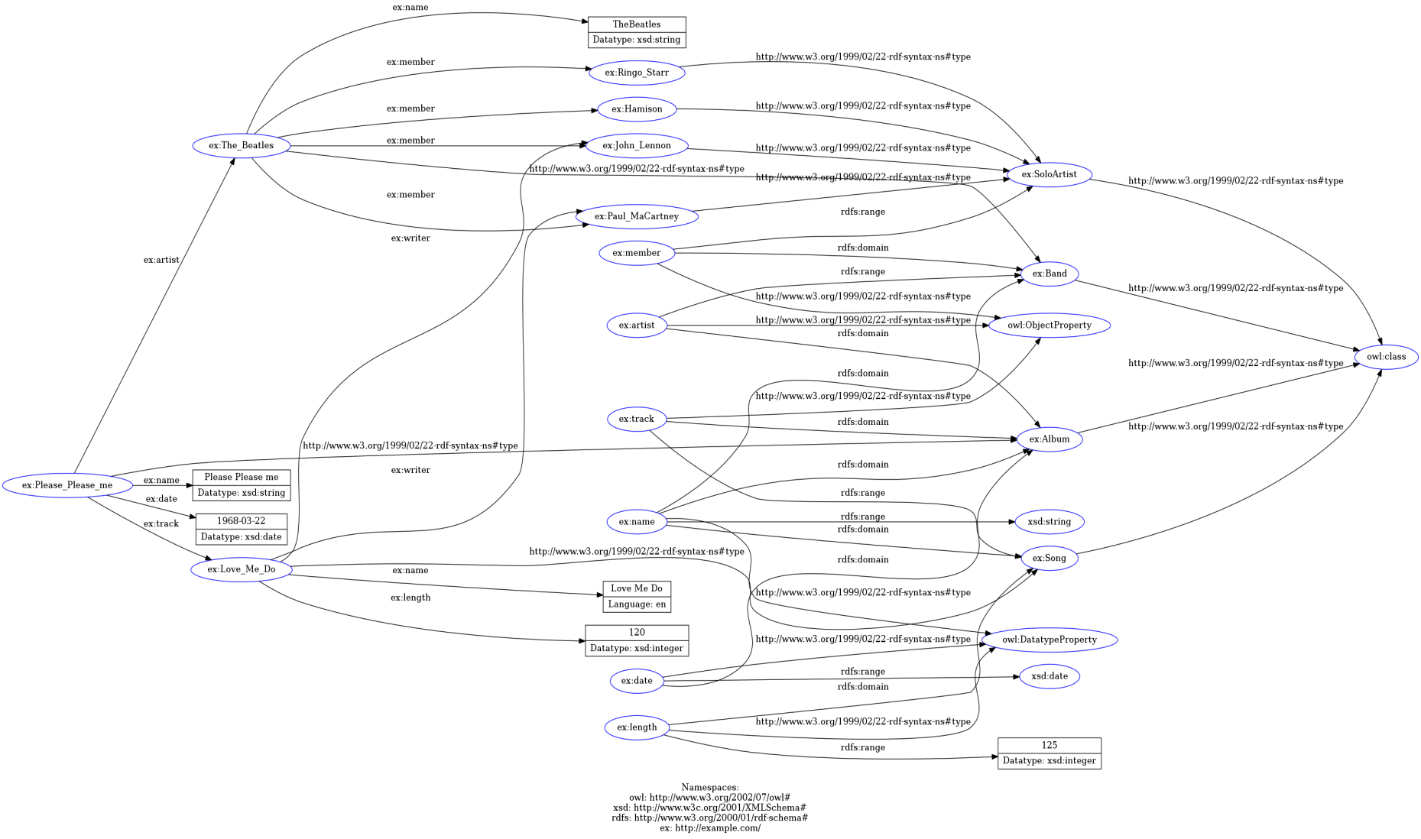ex:John_Lennon a ex:SoloArtist.

***RDF-TURTLE (SAME AS THE METHOD 1)***

@prefix owl: <http://www.w3.org/2002/07/owl#> .

@prefix ns0: <http://example.com/> .

@prefix ns1: <http://www.w3c.org/2001/XMLSchema#> .

@prefix rdfs: <http://www.w3.org/2000/01/rdf-schema#> .

<http://example.com/Band> a owl:class .

<http://example.com/SoloArtist> a owl:class .

<http://example.com/Album> a owl:class .

<http://example.com/Song> a owl:class .

<http://example.com/The_Beatles>

a <http://example.com/Band> ;

ns0:name "TheBeatles"^^ns1:string ;

ns0:member ns0:Ringo_Starr, ns0:Hamison, ns0:Paul_MaCartney, ns0:John_Lennon .

ns0:Ringo_Starr a ns0:SoloArtist .

ns0:Hamison a ns0:SoloArtist .

ns0:Please_Please_me

a ns0:Album ;

ns0:artist ns0:The_Beatles ;

ns0:name "Please Please me"^^ns1:string ;

ns0:date "1968-03-22"^^ns1:date ;

ns0:track ns0:Love_Me_Do .

ns0:Love_Me_Do

a ns0:Song ;

ns0:name "Love Me Do"@en ;

ns0:length "120"^^ns1:integer ;

ns0:writer ns0:Paul_MaCartney, ns0:John_Lennon .

ns0:name

a owl:DatatypeProperty ;

rdfs:domain ns0:Band, ns0:Album, ns0:Song ;

rdfs:range ns1:string .

ns0:date

a owl:DatatypeProperty ;

rdfs:domain ns0:Album ;

rdfs:range ns1:date .

ns0:artist

a owl:ObjectProperty ;

rdfs:domain ns0:Album ;

rdfs:range ns0:Band .

ns0:track

a owl:ObjectProperty ;

rdfs:domain ns0:Album ;

rdfs:range ns0:Song .

ns0:length

a owl:DatatypeProperty ;

rdfs:domain ns0:Song ;

rdfs:range "125"^^ns1:integer .

ns0:member

a owl:ObjectProperty ;

rdfs:domain ns0:Band ;

rdfs:range ns0:SoloArtist .

ns0:Paul_MaCartney a ns0:SoloArtist .

ns0:John_Lennon a ns0:SoloArtist .

***METHOD-2 (OWL)RDF-XML***

<?xml version="1.0" encoding="utf-8" ?>

<rdf:RDF xmlns:rdf="http://www.w3.org/1999/02/22-rdf-syntax-ns#"

xmlns:owl="http://www.w3.org/2002/07/owl#"

xmlns:ns0="http://example.com/"

xmlns:rdfs="http://www.w3.org/2000/01/rdf-schema#">

<owl:class rdf:about="http://example.com/Band">

</owl:class>

<owl:class rdf:about="http://example.com/SoloArtist">

</owl:class>

<owl:class rdf:about="http://example.com/Album">

</owl:class>

<owl:class rdf:about="http://example.com/Song">

</owl:class>

<rdf:Description rdf:about="http://example.com/The_Beatles">

<rdf:type rdf:resource="http://example.com/Band"/>

<ns0:name rdf:datatype="http://www.w3c.org/2001/XMLSchema#string">TheBeatles</ns0:name>

<ns0:member>

<ns0:SoloArtist rdf:about="http://example.com/Ringo_Starr">

</ns0:SoloArtist>

</ns0:member>

<ns0:member>

<ns0:SoloArtist rdf:about="http://example.com/Hamison">

</ns0:SoloArtist>

</ns0:member>

<ns0:member rdf:resource="http://example.com/Paul_MaCartney"/>

<ns0:member rdf:resource="http://example.com/John_Lennon"/>

</rdf:Description>

<ns0:Album rdf:about="http://example.com/Please_Please_me">

<ns0:artist rdf:resource="http://example.com/The_Beatles"/>

<ns0:name rdf:datatype="http://www.w3c.org/2001/XMLSchema#string">Please Please me</ns0:name>

<ns0:date rdf:datatype="http://www.w3c.org/2001/XMLSchema#date">1968-03-22</ns0:date>

<ns0:track>

<ns0:Song rdf:about="http://example.com/Love_Me_Do">

<ns0:name xml:lang="en">Love Me Do</ns0:name>

<ns0:length rdf:datatype="http://www.w3c.org/2001/XMLSchema#integer">120</ns0:length>

<ns0:writer rdf:resource="http://example.com/Paul_MaCartney"/>

<ns0:writer rdf:resource="http://example.com/John_Lennon"/>

</ns0:Song>

</ns0:track>

</ns0:Album>

<owl:DatatypeProperty rdf:about="http://example.com/name">

<rdfs:domain rdf:resource="http://example.com/Band"/>

<rdfs:domain rdf:resource="http://example.com/Album"/>

<rdfs:domain rdf:resource="http://example.com/Song"/>

<rdfs:range rdf:resource="http://www.w3c.org/2001/XMLSchema#string"/>

</owl:DatatypeProperty>

<owl:DatatypeProperty rdf:about="http://example.com/date">

<rdfs:domain rdf:resource="http://example.com/Album"/>

<rdfs:range rdf:resource="http://www.w3c.org/2001/XMLSchema#date"/>

</owl:DatatypeProperty>

<owl:ObjectProperty rdf:about="http://example.com/artist">

<rdfs:domain rdf:resource="http://example.com/Album"/>

<rdfs:range rdf:resource="http://example.com/Band"/>

</owl:ObjectProperty>

<owl:ObjectProperty rdf:about="http://example.com/track">

<rdfs:domain rdf:resource="http://example.com/Album"/>

<rdfs:range rdf:resource="http://example.com/Song"/>

</owl:ObjectProperty>

<owl:DatatypeProperty rdf:about="http://example.com/length">

<rdfs:domain rdf:resource="http://example.com/Song"/>

<rdfs:range rdf:datatype="http://www.w3c.org/2001/XMLSchema#integer">125</rdfs:range>

</owl:DatatypeProperty>

<owl:ObjectProperty rdf:about="http://example.com/member">

<rdfs:domain rdf:resource="http://example.com/Band"/>

<rdfs:range rdf:resource="http://example.com/SoloArtist"/>

</owl:ObjectProperty>

<ns0:SoloArtist rdf:about="http://example.com/Paul_MaCartney">

</ns0:SoloArtist>

<ns0:SoloArtist rdf:about="http://example.com/John_Lennon">

</ns0:SoloArtist>

</rdf:RDF>

***(OWL)RDF-XML (SAME AS THE METHOD 2 BUT IN DIFFERENT WAY)***

<rdf:RDF

xmlns:rdf="http://www.w3.org/1999/02/22-rdf-syntax-ns#"

xmlns:owl="http://www.w3.org/2002/07/owl#"

xmlns:xsd="http://www.w3c.org/2001/XMLSchema#"

xmlns:ex="http://example.com/"

xmlns:rdfs="http://www.w3.org/2000/01/rdf-schema#" >

<rdf:Description rdf:about="http://example.com/Album">

<rdf:type rdf:resource="http://www.w3.org/2002/07/owl#class"/>

</rdf:Description>

<rdf:Description rdf:about="http://example.com/Band">

<rdf:type rdf:resource="http://www.w3.org/2002/07/owl#class"/>

</rdf:Description>

<rdf:Description rdf:about="http://example.com/Love_Me_Do">

<ex:writer rdf:resource="http://example.com/John_Lennon"/>

<ex:writer rdf:resource="http://example.com/Paul_MaCartney"/>

<ex:length rdf:datatype="http://www.w3c.org/2001/XMLSchema#integer">120</ex:length>

<ex:name xml:lang="en">Love Me Do</ex:name>

<rdf:type rdf:resource="http://example.com/Song"/>

</rdf:Description>

<rdf:Description rdf:about="http://example.com/SoloArtist">

<rdf:type rdf:resource="http://www.w3.org/2002/07/owl#class"/>

</rdf:Description>

<rdf:Description rdf:about="http://example.com/name">

<rdfs:range rdf:resource="http://www.w3c.org/2001/XMLSchema#string"/>

<rdfs:domain rdf:resource="http://example.com/Song"/>

<rdfs:domain rdf:resource="http://example.com/Album"/>

<rdfs:domain rdf:resource="http://example.com/Band"/>

<rdf:type rdf:resource="http://www.w3.org/2002/07/owl#DatatypeProperty"/>

</rdf:Description>

<rdf:Description rdf:about="http://example.com/Paul_MaCartney">

<rdf:type rdf:resource="http://example.com/SoloArtist"/>

</rdf:Description>

<rdf:Description rdf:about="http://example.com/date">

<rdfs:range rdf:resource="http://www.w3c.org/2001/XMLSchema#date"/>

<rdfs:domain rdf:resource="http://example.com/Album"/>

<rdf:type rdf:resource="http://www.w3.org/2002/07/owl#DatatypeProperty"/>

</rdf:Description>

<rdf:Description rdf:about="http://example.com/track">

<rdfs:range rdf:resource="http://example.com/Song"/>

<rdfs:domain rdf:resource="http://example.com/Album"/>

<rdf:type rdf:resource="http://www.w3.org/2002/07/owl#ObjectProperty"/>

</rdf:Description>

<rdf:Description rdf:about="http://example.com/John_Lennon">

<rdf:type rdf:resource="http://example.com/SoloArtist"/>

</rdf:Description>

<rdf:Description rdf:about="http://example.com/The_Beatles">

<ex:member rdf:resource="http://example.com/John_Lennon"/>

<ex:member rdf:resource="http://example.com/Paul_MaCartney"/>

<ex:member rdf:resource="http://example.com/Hamison"/>

<ex:member rdf:resource="http://example.com/Ringo_Starr"/>

<ex:name rdf:datatype="http://www.w3c.org/2001/XMLSchema#string">TheBeatles</ex:name>

<rdf:type rdf:resource="http://example.com/Band"/>

</rdf:Description>

<rdf:Description rdf:about="http://example.com/Ringo_Starr">

<rdf:type rdf:resource="http://example.com/SoloArtist"/>

</rdf:Description>

<rdf:Description rdf:about="http://example.com/Please_Please_me">

<ex:track rdf:resource="http://example.com/Love_Me_Do"/>

<ex:date rdf:datatype="http://www.w3c.org/2001/XMLSchema#date">1968-03-22</ex:date>

<ex:name rdf:datatype="http://www.w3c.org/2001/XMLSchema#string">Please Please me</ex:name>

<ex:artist rdf:resource="http://example.com/The_Beatles"/>

<rdf:type rdf:resource="http://example.com/Album"/>

</rdf:Description>

<rdf:Description rdf:about="http://example.com/Song">

<rdf:type rdf:resource="http://www.w3.org/2002/07/owl#class"/>

</rdf:Description>

<rdf:Description rdf:about="http://example.com/member">

<rdfs:range rdf:resource="http://example.com/SoloArtist"/>

<rdfs:domain rdf:resource="http://example.com/Band"/>

<rdf:type rdf:resource="http://www.w3.org/2002/07/owl#ObjectProperty"/>

</rdf:Description>

<rdf:Description rdf:about="http://example.com/artist">

<rdfs:range rdf:resource="http://example.com/Band"/>

<rdfs:domain rdf:resource="http://example.com/Album"/>

<rdf:type rdf:resource="http://www.w3.org/2002/07/owl#ObjectProperty"/>

</rdf:Description>

<rdf:Description rdf:about="http://example.com/Hamison">

<rdf:type rdf:resource="http://example.com/SoloArtist"/>

</rdf:Description>

<rdf:Description rdf:about="http://example.com/length">

<rdfs:range rdf:datatype="http://www.w3c.org/2001/XMLSchema#integer">125</rdfs:range>

<rdfs:domain rdf:resource="http://example.com/Song"/>

<rdf:type rdf:resource="http://www.w3.org/2002/07/owl#DatatypeProperty"/>

</rdf:Description>

</rdf:RDF>

***(OWL) N-TRIPLE***

<http://example.com/Band> <http://www.w3.org/1999/02/22-rdf-syntax-ns#type> <http://www.w3.org/2002/07/owl#class> .

<http://example.com/SoloArtist> <http://www.w3.org/1999/02/22-rdf-syntax-ns#type> <http://www.w3.org/2002/07/owl#class> .

<http://example.com/Album> <http://www.w3.org/1999/02/22-rdf-syntax-ns#type> <http://www.w3.org/2002/07/owl#class> .

<http://example.com/Song> <http://www.w3.org/1999/02/22-rdf-syntax-ns#type> <http://www.w3.org/2002/07/owl#class> .

<http://example.com/The_Beatles> <http://www.w3.org/1999/02/22-rdf-syntax-ns#type> <http://example.com/Band> .

<http://example.com/The_Beatles> <http://example.com/name> "TheBeatles"^^<http://www.w3c.org/2001/XMLSchema#string> .

<http://example.com/The_Beatles> <http://example.com/member> <http://example.com/Ringo_Starr> .

<http://example.com/The_Beatles> <http://example.com/member> <http://example.com/Hamison> .

<http://example.com/The_Beatles> <http://example.com/member> <http://example.com/Paul_MaCartney> .

<http://example.com/The_Beatles> <http://example.com/member> <http://example.com/John_Lennon> .

<http://example.com/Ringo_Starr> <http://www.w3.org/1999/02/22-rdf-syntax-ns#type> <http://example.com/SoloArtist> .

<http://example.com/Hamison> <http://www.w3.org/1999/02/22-rdf-syntax-ns#type> <http://example.com/SoloArtist> .

<http://example.com/Please_Please_me> <http://www.w3.org/1999/02/22-rdf-syntax-ns#type> <http://example.com/Album> .

<http://example.com/Please_Please_me> <http://example.com/artist> <http://example.com/The_Beatles> .

<http://example.com/Please_Please_me> <http://example.com/name> "Please Please me"^^<http://www.w3c.org/2001/XMLSchema#string> .

<http://example.com/Please_Please_me> <http://example.com/date> "1968-03-22"^^<http://www.w3c.org/2001/XMLSchema#date> .

<http://example.com/Please_Please_me> <http://example.com/track> <http://example.com/Love_Me_Do> .

<http://example.com/Love_Me_Do> <http://www.w3.org/1999/02/22-rdf-syntax-ns#type> <http://example.com/Song> .

<http://example.com/Love_Me_Do> <http://example.com/name> "Love Me Do"@en .

<http://example.com/Love_Me_Do> <http://example.com/length> "120"^^<http://www.w3c.org/2001/XMLSchema#integer> .

<http://example.com/Love_Me_Do> <http://example.com/writer> <http://example.com/Paul_MaCartney> .

<http://example.com/Love_Me_Do> <http://example.com/writer> <http://example.com/John_Lennon> .

<http://example.com/name> <http://www.w3.org/1999/02/22-rdf-syntax-ns#type> <http://www.w3.org/2002/07/owl#DatatypeProperty> .

<http://example.com/name> <http://www.w3.org/2000/01/rdf-schema#domain> <http://example.com/Band> .

<http://example.com/name> <http://www.w3.org/2000/01/rdf-schema#domain> <http://example.com/Album> .

<http://example.com/name> <http://www.w3.org/2000/01/rdf-schema#domain> <http://example.com/Song> .

<http://example.com/name> <http://www.w3.org/2000/01/rdf-schema#range> <http://www.w3c.org/2001/XMLSchema#string> .

<http://example.com/date> <http://www.w3.org/1999/02/22-rdf-syntax-ns#type> <http://www.w3.org/2002/07/owl#DatatypeProperty> .

<http://example.com/date> <http://www.w3.org/2000/01/rdf-schema#domain> <http://example.com/Album> .

<http://example.com/date> <http://www.w3.org/2000/01/rdf-schema#range> <http://www.w3c.org/2001/XMLSchema#date> .

<http://example.com/artist> <http://www.w3.org/1999/02/22-rdf-syntax-ns#type> <http://www.w3.org/2002/07/owl#ObjectProperty> .

<http://example.com/artist> <http://www.w3.org/2000/01/rdf-schema#domain> <http://example.com/Album> .

<http://example.com/artist> <http://www.w3.org/2000/01/rdf-schema#range> <http://example.com/Band> .

<http://example.com/track> <http://www.w3.org/1999/02/22-rdf-syntax-ns#type> <http://www.w3.org/2002/07/owl#ObjectProperty> .

<http://example.com/track> <http://www.w3.org/2000/01/rdf-schema#domain> <http://example.com/Album> .

<http://example.com/track> <http://www.w3.org/2000/01/rdf-schema#range> <http://example.com/Song> .

<http://example.com/length> <http://www.w3.org/1999/02/22-rdf-syntax-ns#type> <http://www.w3.org/2002/07/owl#DatatypeProperty> .

<http://example.com/length> <http://www.w3.org/2000/01/rdf-schema#domain> <http://example.com/Song> .

<http://example.com/length> <http://www.w3.org/2000/01/rdf-schema#range> "125"^^<http://www.w3c.org/2001/XMLSchema#integer> .

<http://example.com/member> <http://www.w3.org/1999/02/22-rdf-syntax-ns#type> <http://www.w3.org/2002/07/owl#ObjectProperty> .

<http://example.com/member> <http://www.w3.org/2000/01/rdf-schema#domain> <http://example.com/Band> .

<http://example.com/member> <http://www.w3.org/2000/01/rdf-schema#range> <http://example.com/SoloArtist> .

<http://example.com/Paul_MaCartney> <http://www.w3.org/1999/02/22-rdf-syntax-ns#type> <http://example.com/SoloArtist> .

<http://example.com/John_Lennon> <http://www.w3.org/1999/02/22-rdf-syntax-ns#type> <http://example.com/SoloArtist> .