**PRABAL GHOSH ROLL-40**

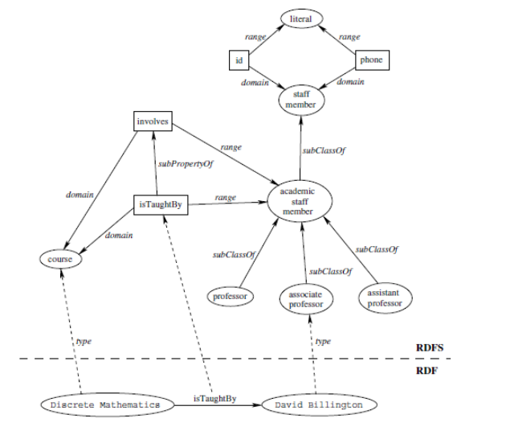

***RDF-TURTLE(1)***

@prefix : <http://example.com/ex#> .

@prefix rdf: <http://www.w3.org/1999/02/22-rdf-syntax-ns#> .

@prefix rdfs: <http://www.w3.org/2000/01/rdf-schema#> .

@prefix xml: <http://www.w3.org/XML/1998/namespace> .

@prefix xsd: <http://www.w3.org/2001/XMLSchema#> .

@prefix owl: <http://www.w3.org/2002/07/owl#>.

:Course a rdfs:class.

:Professor a rdfs:class.

:Assoicate_Professor a rdfs:class.

:Assistant_Professor a rdfs:class.

:Academic_Staff_Member rdf:type rdfs:Class ;

rdfs:subClassOf :Professor,:Assoicate_Professor,:Assistant_Professor .

:Staff_Member rdf:type rdfs:Class ;

rdfs:subClassOf :Academic_Staff_Member.

:isTaughtBy a owl:ObjectProperty;

rdfs:domain :Course;

rdfs:range :Academic_Staff_Member .

:involves a owl:ObjectProperty;

rdfs:subPropertyOf :isTaughtBy.

:id a owl:DatatypeProperty;

rdfs:domain :Staff_Member;

rdfs:range rdfs:Literal.

:phone a owl:DatatypeProperty;

rdfs:domain :Staff_Member;

rdfs:range rdfs:Literal.

:David_Billington a :Assoicate_Professor.

:Discrete_Mathematics a :Course;

:isTaughtBy :David_Billington .

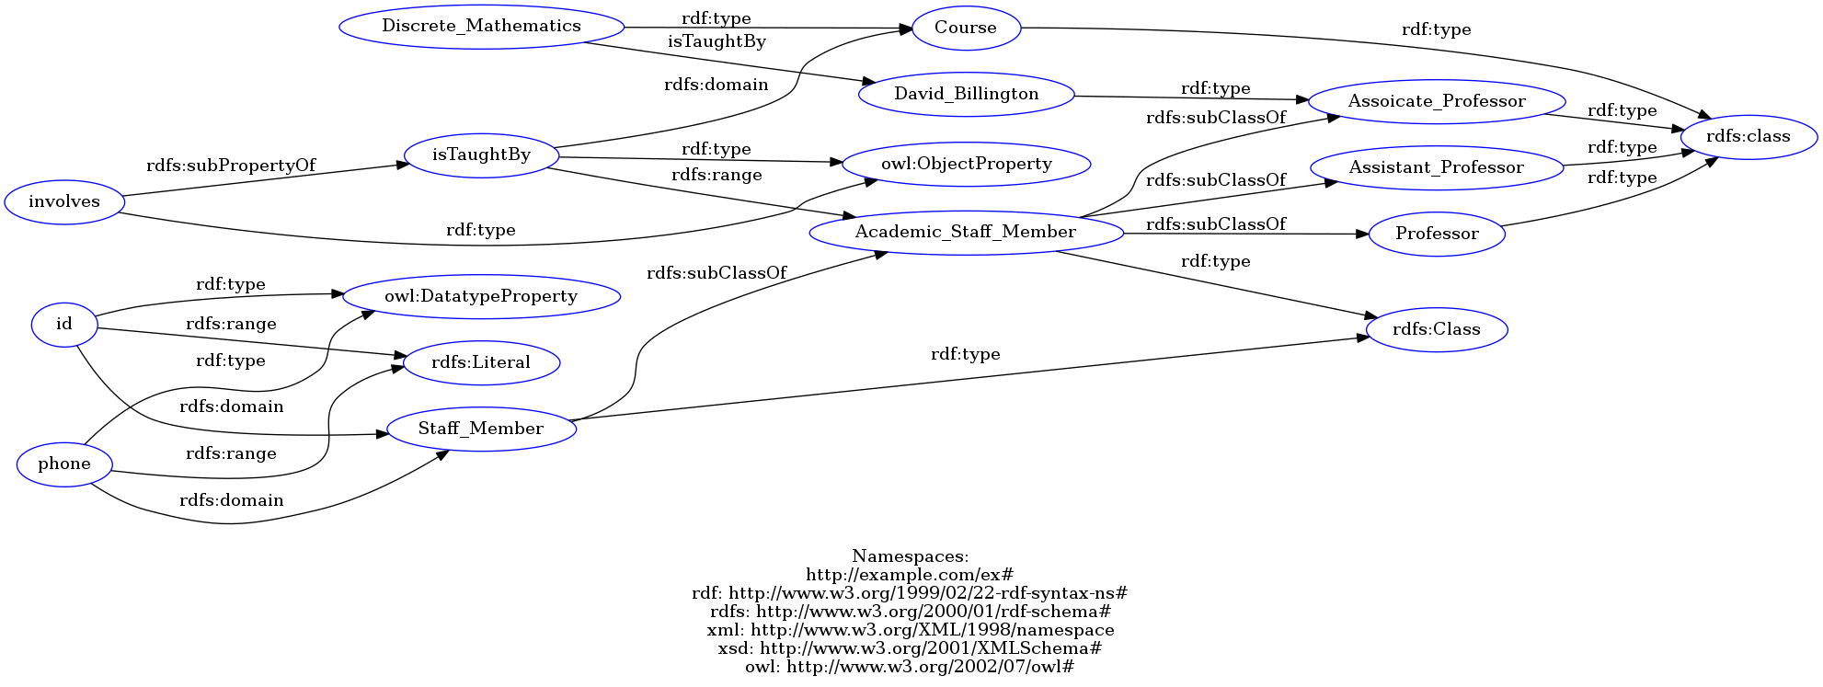

***RDF-TURTLE(2)***

@prefix rdfs: <http://www.w3.org/2000/01/rdf-schema#> .

@prefix owl: <http://www.w3.org/2002/07/owl#> .

@prefix ns0: <http://example.com/ex#> .

<http://example.com/ex#Course> a rdfs:class .

<http://example.com/ex#Professor> a rdfs:class .

<http://example.com/ex#Assoicate_Professor> a rdfs:class .

<http://example.com/ex#Assistant_Professor> a rdfs:class .

<http://example.com/ex#Academic_Staff_Member> a rdfs:Class ;

rdfs:subClassOf <http://example.com/ex#Professor>, <http://example.com/ex#Assoicate_Professor>, <http://example.com/ex#Assistant_Professor> .

<http://example.com/ex#Staff_Member> a rdfs:Class ;

rdfs:subClassOf <http://example.com/ex#Academic_Staff_Member> .

<http://example.com/ex#isTaughtBy> a owl:ObjectProperty ;

rdfs:domain <http://example.com/ex#Course> ;

rdfs:range <http://example.com/ex#Academic_Staff_Member> .

<http://example.com/ex#involves> a owl:ObjectProperty ;

rdfs:subPropertyOf <http://example.com/ex#isTaughtBy> .

<http://example.com/ex#id> a owl:DatatypeProperty ;

rdfs:domain <http://example.com/ex#Staff_Member> ;

rdfs:range rdfs:Literal .

<http://example.com/ex#phone> a owl:DatatypeProperty ;

rdfs:domain <http://example.com/ex#Staff_Member> ;

rdfs:range rdfs:Literal .

<http://example.com/ex#David_Billington> a <http://example.com/ex#Assoicate_Professor> .

<http://example.com/ex#Discrete_Mathematics> a <http://example.com/ex#Course> ;

ns0:isTaughtBy ns0:David_Billington .

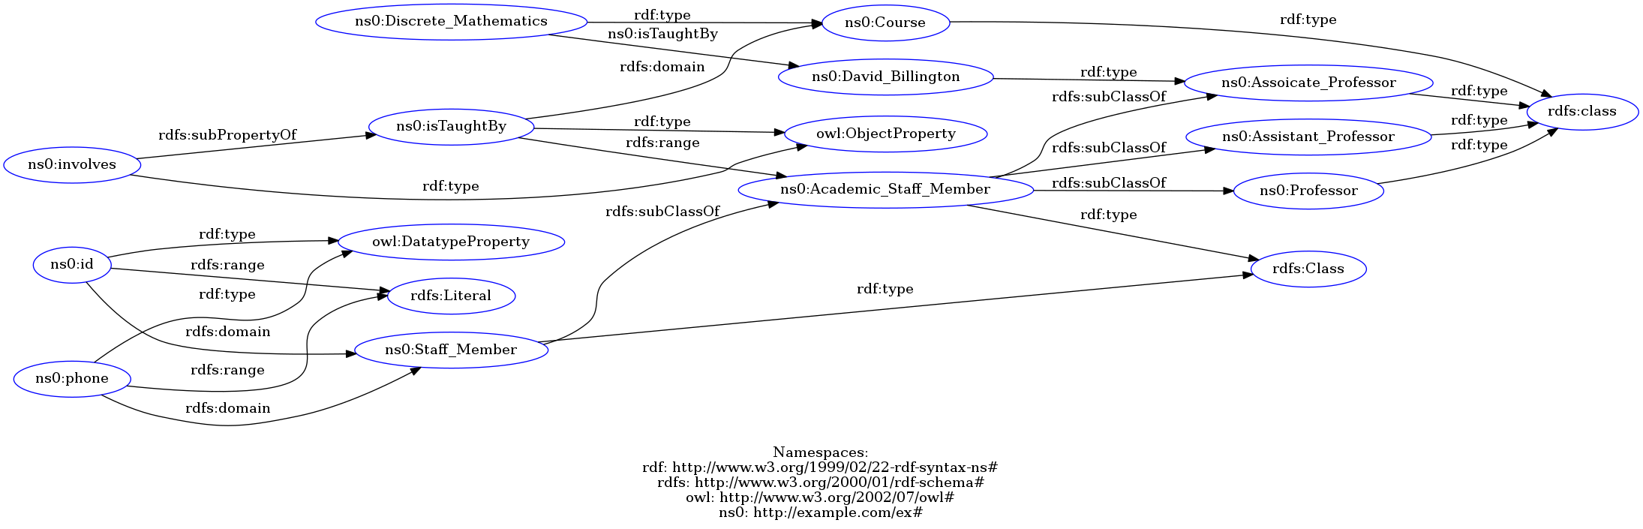

***RDF-XML(1)***

<?xml version="1.0" encoding="utf-8" ?><rdf:RDF xmlns:rdf="http://www.w3.org/1999/02/22-rdf-syntax-ns#"

xmlns:rdfs="http://www.w3.org/2000/01/rdf-schema#"

xmlns:owl="http://www.w3.org/2002/07/owl#"

xmlns:ns0="http://example.com/ex#">

<rdfs:class rdf:about="http://example.com/ex#Course">

</rdfs:class>

<rdfs:class rdf:about="http://example.com/ex#Professor">

</rdfs:class>

<rdfs:class rdf:about="http://example.com/ex#Assoicate_Professor">

</rdfs:class>

<rdfs:class rdf:about="http://example.com/ex#Assistant_Professor">

</rdfs:class>

<rdfs:Class rdf:about="http://example.com/ex#Academic_Staff_Member">

<rdfs:subClassOf rdf:resource="http://example.com/ex#Professor"/>

<rdfs:subClassOf rdf:resource="http://example.com/ex#Assoicate_Professor"/>

<rdfs:subClassOf rdf:resource="http://example.com/ex#Assistant_Professor"/>

</rdfs:Class>

<rdfs:Class rdf:about="http://example.com/ex#Staff_Member">

<rdfs:subClassOf rdf:resource="http://example.com/ex#Academic_Staff_Member"/>

</rdfs:Class>

<owl:ObjectProperty rdf:about="http://example.com/ex#isTaughtBy">

<rdfs:domain rdf:resource="http://example.com/ex#Course"/>

<rdfs:range rdf:resource="http://example.com/ex#Academic_Staff_Member"/>

</owl:ObjectProperty>

<owl:ObjectProperty rdf:about="http://example.com/ex#involves">

<rdfs:subPropertyOf rdf:resource="http://example.com/ex#isTaughtBy"/>

</owl:ObjectProperty>

<owl:DatatypeProperty rdf:about="http://example.com/ex#id">

<rdfs:domain rdf:resource="http://example.com/ex#Staff_Member"/>

<rdfs:range rdf:resource="http://www.w3.org/2000/01/rdf-schema#Literal"/>

</owl:DatatypeProperty>

<owl:DatatypeProperty rdf:about="http://example.com/ex#phone">

<rdfs:domain rdf:resource="http://example.com/ex#Staff_Member"/>

<rdfs:range rdf:resource="http://www.w3.org/2000/01/rdf-schema#Literal"/>

</owl:DatatypeProperty>

<rdf:Description rdf:about="http://example.com/ex#David_Billington">

<rdf:type rdf:resource="http://example.com/ex#Assoicate_Professor"/>

</rdf:Description>

<rdf:Description rdf:about="http://example.com/ex#Discrete_Mathematics">

<rdf:type rdf:resource="http://example.com/ex#Course"/>

<ns0:isTaughtBy rdf:resource="http://example.com/ex#David_Billington"/>

</rdf:Description>

</rdf:RDF>

***RDF-XML(2)***

<rdf:RDF

xmlns:rdf="http://www.w3.org/1999/02/22-rdf-syntax-ns#"

xmlns:owl="http://www.w3.org/2002/07/owl#"

xmlns:rdfs="http://www.w3.org/2000/01/rdf-schema#"

xmlns="http://example.com/ex#"

xmlns:xsd="http://www.w3.org/2001/XMLSchema#" >

<rdf:Description rdf:about="http://example.com/ex#Course">

<rdf:type rdf:resource="http://www.w3.org/2000/01/rdf-schema#class"/>

</rdf:Description>

<rdf:Description rdf:about="http://example.com/ex#Professor">

<rdf:type rdf:resource="http://www.w3.org/2000/01/rdf-schema#class"/>

</rdf:Description>

<rdf:Description rdf:about="http://example.com/ex#phone">

<rdfs:range rdf:resource="http://www.w3.org/2000/01/rdf-schema#Literal"/>

<rdfs:domain rdf:resource="http://example.com/ex#Staff_Member"/>

<rdf:type rdf:resource="http://www.w3.org/2002/07/owl#DatatypeProperty"/>

</rdf:Description>

<rdf:Description rdf:about="http://example.com/ex#Academic_Staff_Member">

<rdfs:subClassOf rdf:resource="http://example.com/ex#Assistant_Professor"/>

<rdfs:subClassOf rdf:resource="http://example.com/ex#Assoicate_Professor"/>

<rdfs:subClassOf rdf:resource="http://example.com/ex#Professor"/>

<rdf:type rdf:resource="http://www.w3.org/2000/01/rdf-schema#Class"/>

</rdf:Description>

<rdf:Description rdf:about="http://example.com/ex#Assistant_Professor">

<rdf:type rdf:resource="http://www.w3.org/2000/01/rdf-schema#class"/>

</rdf:Description>

<rdf:Description rdf:about="http://example.com/ex#id">

<rdfs:range rdf:resource="http://www.w3.org/2000/01/rdf-schema#Literal"/>

<rdfs:domain rdf:resource="http://example.com/ex#Staff_Member"/>

<rdf:type rdf:resource="http://www.w3.org/2002/07/owl#DatatypeProperty"/>

</rdf:Description>

<rdf:Description rdf:about="http://example.com/ex#Staff_Member">

<rdfs:subClassOf rdf:resource="http://example.com/ex#Academic_Staff_Member"/>

<rdf:type rdf:resource="http://www.w3.org/2000/01/rdf-schema#Class"/>

</rdf:Description>

<rdf:Description rdf:about="http://example.com/ex#Assoicate_Professor">

<rdf:type rdf:resource="http://www.w3.org/2000/01/rdf-schema#class"/>

</rdf:Description>

<rdf:Description rdf:about="http://example.com/ex#involves">

<rdfs:subPropertyOf rdf:resource="http://example.com/ex#isTaughtBy"/>

<rdf:type rdf:resource="http://www.w3.org/2002/07/owl#ObjectProperty"/>

</rdf:Description>

<rdf:Description rdf:about="http://example.com/ex#isTaughtBy">

<rdfs:range rdf:resource="http://example.com/ex#Academic_Staff_Member"/>

<rdfs:domain rdf:resource="http://example.com/ex#Course"/>

<rdf:type rdf:resource="http://www.w3.org/2002/07/owl#ObjectProperty"/>

</rdf:Description>

<rdf:Description rdf:about="http://example.com/ex#David_Billington">

<rdf:type rdf:resource="http://example.com/ex#Assoicate_Professor"/>

</rdf:Description>

<rdf:Description rdf:about="http://example.com/ex#Discrete_Mathematics">

<isTaughtBy rdf:resource="http://example.com/ex#David_Billington"/>

<rdf:type rdf:resource="http://example.com/ex#Course"/>

</rdf:Description>

</rdf:RDF>

1. ***TRIPLES***

<http://example.com/ex#Course> <http://www.w3.org/1999/02/22-rdf-syntax-ns#type> <http://www.w3.org/2000/01/rdf-schema#class> .<http://example.com/ex#Professor> <http://www.w3.org/1999/02/22-rdf-syntax-ns#type> <http://www.w3.org/2000/01/rdf-schema#class> .<http://example.com/ex#Assoicate_Professor> <http://www.w3.org/1999/02/22-rdf-syntax-ns#type> <http://www.w3.org/2000/01/rdf-schema#class> .<http://example.com/ex#Assistant_Professor> <http://www.w3.org/1999/02/22-rdf-syntax-ns#type> <http://www.w3.org/2000/01/rdf-schema#class> .<http://example.com/ex#Academic_Staff_Member> <http://www.w3.org/1999/02/22-rdf-syntax-ns#type> <http://www.w3.org/2000/01/rdf-schema#Class> .<http://example.com/ex#Academic_Staff_Member> <http://www.w3.org/2000/01/rdf-schema#subClassOf> <http://example.com/ex#Professor> .<http://example.com/ex#Academic_Staff_Member> <http://www.w3.org/2000/01/rdf-schema#subClassOf> <http://example.com/ex#Assoicate_Professor> .<http://example.com/ex#Academic_Staff_Member> <http://www.w3.org/2000/01/rdf-schema#subClassOf> <http://example.com/ex#Assistant_Professor> .<http://example.com/ex#Staff_Member> <http://www.w3.org/1999/02/22-rdf-syntax-ns#type> <http://www.w3.org/2000/01/rdf-schema#Class> .<http://example.com/ex#Staff_Member> <http://www.w3.org/2000/01/rdf-schema#subClassOf> <http://example.com/ex#Academic_Staff_Member> .<http://example.com/ex#isTaughtBy> <http://www.w3.org/1999/02/22-rdf-syntax-ns#type> <http://www.w3.org/2002/07/owl#ObjectProperty> .<http://example.com/ex#isTaughtBy> <http://www.w3.org/2000/01/rdf-schema#domain> <http://example.com/ex#Course> .<http://example.com/ex#isTaughtBy> <http://www.w3.org/2000/01/rdf-schema#range> <http://example.com/ex#Academic_Staff_Member> .<http://example.com/ex#involves> <http://www.w3.org/1999/02/22-rdf-syntax-ns#type> <http://www.w3.org/2002/07/owl#ObjectProperty> .<http://example.com/ex#involves> <http://www.w3.org/2000/01/rdf-schema#subPropertyOf> <http://example.com/ex#isTaughtBy> .<http://example.com/ex#id> <http://www.w3.org/1999/02/22-rdf-syntax-ns#type> <http://www.w3.org/2002/07/owl#DatatypeProperty> .<http://example.com/ex#id> <http://www.w3.org/2000/01/rdf-schema#domain> <http://example.com/ex#Staff_Member> .<http://example.com/ex#id> <http://www.w3.org/2000/01/rdf-schema#range> <http://www.w3.org/2000/01/rdf-schema#Literal> .<http://example.com/ex#phone> <http://www.w3.org/1999/02/22-rdf-syntax-ns#type> <http://www.w3.org/2002/07/owl#DatatypeProperty> .<http://example.com/ex#phone> <http://www.w3.org/2000/01/rdf-schema#domain> <http://example.com/ex#Staff_Member> .<http://example.com/ex#phone> <http://www.w3.org/2000/01/rdf-schema#range> <http://www.w3.org/2000/01/rdf-schema#Literal> .<http://example.com/ex#David_Billington> <http://www.w3.org/1999/02/22-rdf-syntax-ns#type> <http://example.com/ex#Assoicate_Professor> .<http://example.com/ex#Discrete_Mathematics> <http://www.w3.org/1999/02/22-rdf-syntax-ns#type> <http://example.com/ex#Course> .<http://example.com/ex#Discrete_Mathematics> <http://example.com/ex#isTaughtBy> <http://example.com/ex#David_Billington> .