PREFIX rdf: <http://www.w3.org/1999/02/22-rdf-syntax-ns#>

PREFIX owl: <http://www.w3.org/2002/07/owl#>

PREFIX xsd: <http://www.w3.org/2001/XMLSchema#>

PREFIX rdfs: <http://www.w3.org/2000/01/rdf-schema#>

PREFIX wikibase: <http://wikiba.se/ontology#>

SELECT ?subject

WHERE {

?subject rdf:type wikibase:Property,owl:NamedIndividual ;

rdfs:label "topic's main template"@en }

PREFIX rdf: <http://www.w3.org/1999/02/22-rdf-syntax-ns#>

PREFIX owl: <http://www.w3.org/2002/07/owl#>

PREFIX xsd: <http://www.w3.org/2001/XMLSchema#>

PREFIX rdfs: <http://www.w3.org/2000/01/rdf-schema#>

PREFIX wikibase: <http://wikiba.se/ontology#>

PREFIX wd: <http://www.wikidata.org/entity/>

SELECT ?subject

WHERE {

?subject rdf:type wikibase:Property;

rdfs:label "subclass of"@en}

PREFIX rdf: <http://www.w3.org/1999/02/22-rdf-syntax-ns#>

PREFIX owl: <http://www.w3.org/2002/07/owl#>

PREFIX xsd: <http://www.w3.org/2001/XMLSchema#>

PREFIX rdfs: <http://www.w3.org/2000/01/rdf-schema#>

PREFIX wikibase: <http://wikiba.se/ontology#>

PREFIX wd: <http://www.wikidata.org/entity/>

PREFIX pqn: <http://www.wikidata.org/prop/qualifier/value-normalized/>

SELECT ?x

WHERE {

?x rdf:type owl:ObjectProperty;

}

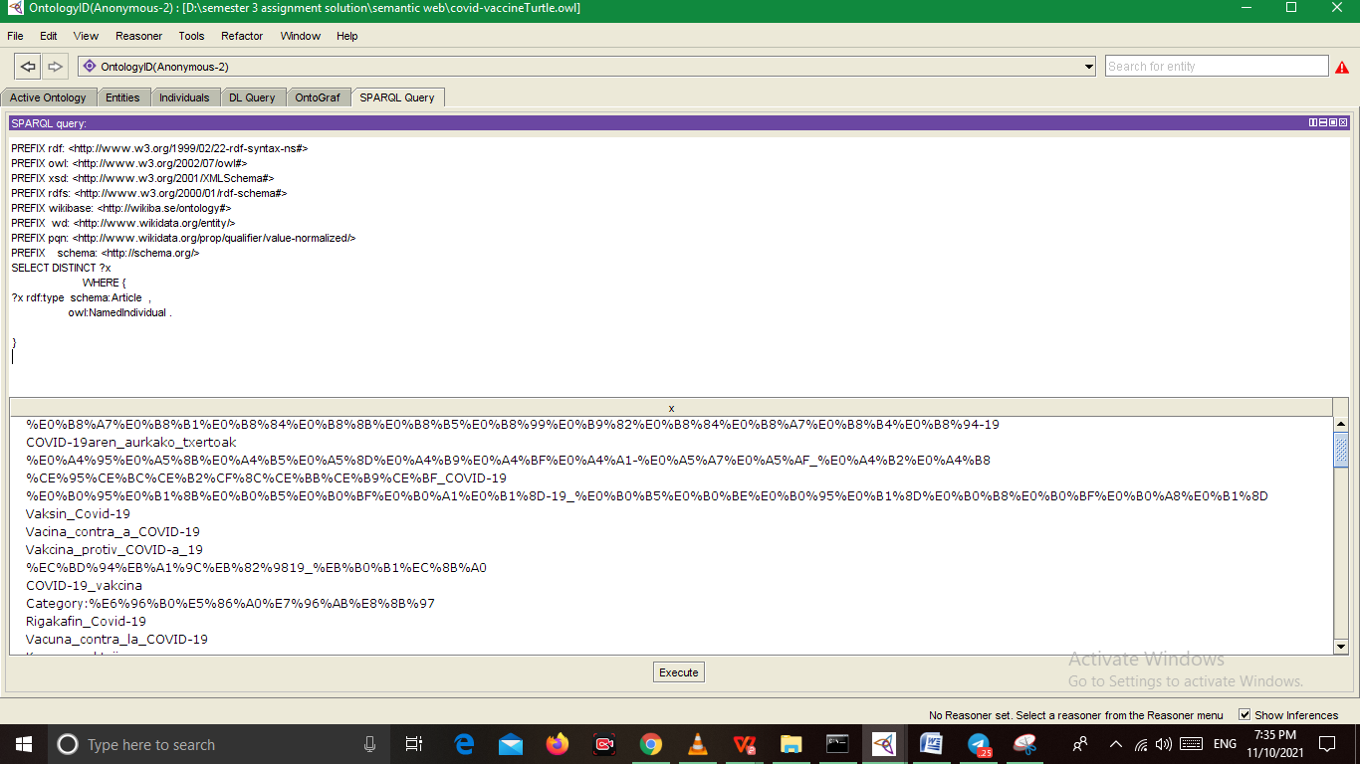

PREFIX rdf: <http://www.w3.org/1999/02/22-rdf-syntax-ns#>

PREFIX owl: <http://www.w3.org/2002/07/owl#>

PREFIX xsd: <http://www.w3.org/2001/XMLSchema#>

PREFIX rdfs: <http://www.w3.org/2000/01/rdf-schema#>

PREFIX wikibase: <http://wikiba.se/ontology#>

PREFIX wd: <http://www.wikidata.org/entity/>

PREFIX pqn: <http://www.wikidata.org/prop/qualifier/value-normalized/>

PREFIX schema: <http://schema.org/>

SELECT DISTINCT ?x

WHERE {

?x rdf:type schema:Article ,

owl:NamedIndividual .

}

PREFIX rdf: <http://www.w3.org/1999/02/22-rdf-syntax-ns#>

PREFIX owl: <http://www.w3.org/2002/07/owl#>

PREFIX xsd: <http://www.w3.org/2001/XMLSchema#>

PREFIX rdfs: <http://www.w3.org/2000/01/rdf-schema#>

PREFIX wikibase: <http://wikiba.se/ontology#>

PREFIX wd: <http://www.wikidata.org/entity/>

PREFIX pqn: <http://www.wikidata.org/prop/qualifier/value-normalized/>

PREFIX schema: <http://schema.org/>

PREFIX skos: <http://www.w3.org/2004/02/skos/core#>

SELECT ?subject

WHERE {

?subject rdf:type wikibase:Property;

schema:name ?n

FILTER ( ?n = "topic's main template").}

SELECT ?subject

WHERE {

?subject rdf:type wikibase:Property;

schema:name "topic's main template"

}

SELECT ?subject

WHERE {

?subject rdf:type wikibase:Property;

schema:name ?n

FILTER( ?n = "topic's main template")

FILTER(LANG(?n)="en")

}

SELECT ?subject

WHERE {

?subject rdf:type wikibase:Property.

FILTER( schema:name = "topic's main template")

}

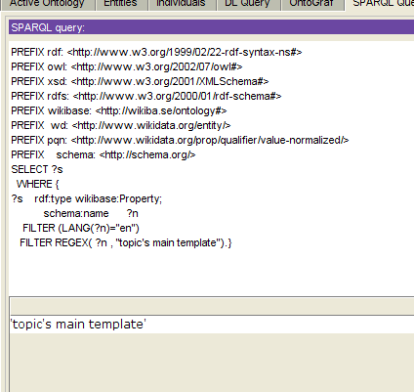

SELECT ?s

WHERE {

?s rdf:type wikibase:Property;

schema:name ?n

FILTER (LANG(?n)="en")

FILTER REGEX( ?n , "topic's main template").}

PREFIX rdf: <http://www.w3.org/1999/02/22-rdf-syntax-ns#> PREFIX s: <http://www.wikidata.org/entity/statement/> PREFIX owl: <http://www.w3.org/2002/07/owl#> PREFIX xsd: <http://www.w3.org/2001/XMLSchema#> PREFIX rdfs: <http://www.w3.org/2000/01/rdf-schema#> PREFIX ps: <http://www.wikidata.org/prop/statement/>

PREFIX wikibase: <http://wikiba.se/ontology#>

PREFIX wd: <http://www.wikidata.org/entity/>

PREFIX pqn: <http://www.wikidata.org/prop/qualifier/value-normalized/>

PREFIX schema: <http://schema.org/>

PREFIX skos: <http://www.w3.org/2004/02/skos/core#>

PREFIX :<http://www.wikidata.org/entity/Q87719492>

SELECT Distinct ?s ?x WHERE { ?s rdf:type wikibase:BestRank ,

wikibase:Statement ,

owl:NamedIndividual ;

ps:P9346 ?x ;

wikibase:rank wikibase:NormalRank .}

