Dissertation Individual

# Introduction

**“Let food be thy medicine and medicine be thy food.”** *– Hippocrates*

Health has always played a salient factor in the development of a society. We as a society have never truly developed without first procuring quality healthcare services, techniques and standards. While health may be overlooked as a necessity in the Scandinavian societies it is juxtaposed with the Indian subcontinent. While the upper class of the society may have accessible healthcare and high-quality health care services provided for them that rival the world's best health institutions, the same cannot be said for the middle class and the lower classes of the same societies The annual income of Nepalese on average is 1,362$ which in turn creates a lack of nutrition, lack of good housing, quality healthcare, and appalling quality of life. While this cannot be changed overnight with technology it could certainly be made better. The health scenario changed due to the pandemic. Although many apps recorded about a 500% rise in telemedicine booking during the pandemic although these were mostly Millennials and mostly from metro cities. Although the frequency of visiting primary clinics thrice is only about 22% many patients are visiting clinics twice and once a year 30% and 23% respectively. While this may seem optimistic average patient visit in the USA is 4 times, 5 times in the UK, and 14 times in japan.Most visits are done in private clinics and government hospitals which have the poor digital infrastructure and the main reasons patients avoid healthcare are long waiting times, no quality doctors available or needed services not available in the particular institution.

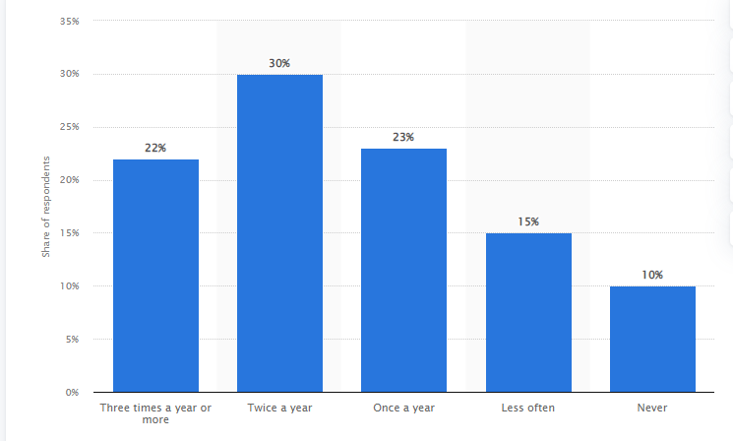

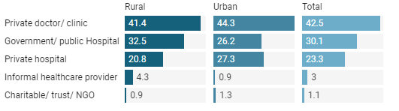

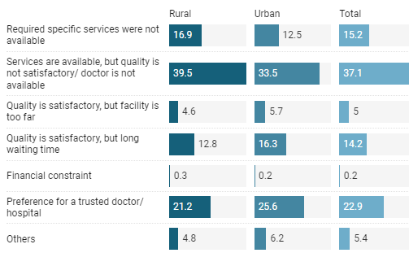

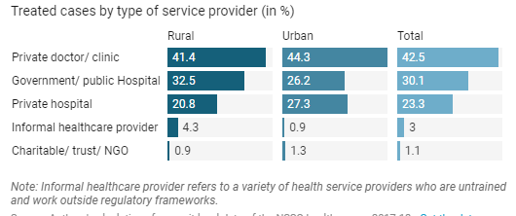

There have been times where I have spent countless hours searching for a piece of prescription that was prescribed by some doctor 2 years ago. I have stood in the line with my father in front of his oncologist’s office just for him to check the test reports. With a network as inefficient as this it truly made me wonder about the inadequacies and harshness the common people have to face and on top of that while they are sick , which makes it much worse. While medical records may be a modern concept records as a whole is not. We have saving records for ages, whether it be loans or taxes, or other important records. from stones to cocoa beans to reed knots and finally paper we have been through a lot of material throughout centuries, and with the rise of the internet now we have ventured into digital records. And while our shopping wishlists and our movies have gone digital we are still stuck in the 20th century without medical records.Presently private hospital have been storing medical records in EHR or electronic health records.

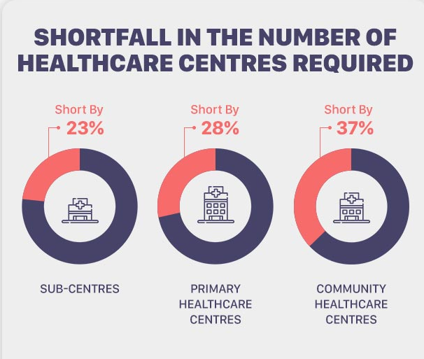

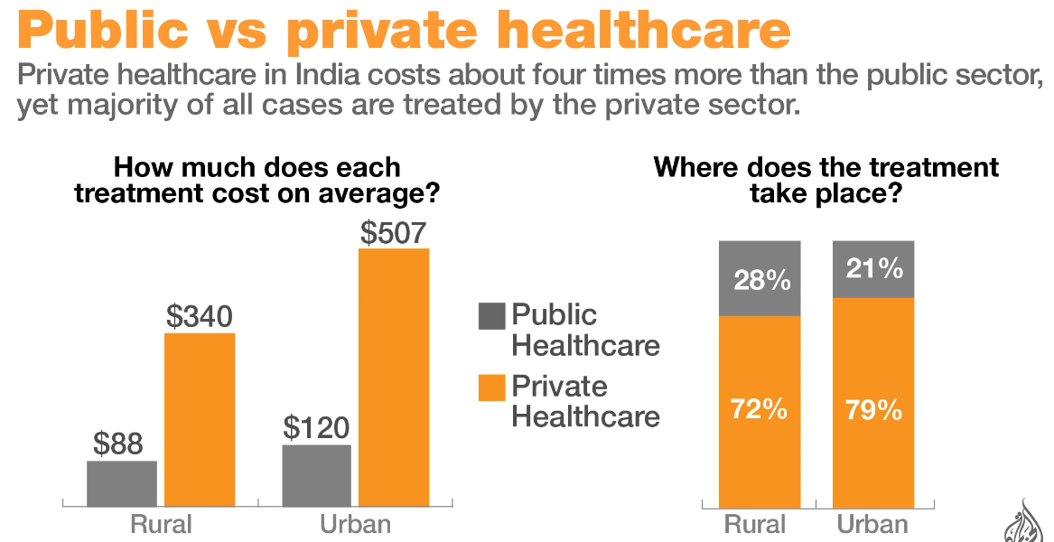

EHR or Electronic Health Record is the electronic version of a patient's health records along with their histories. As they are real-time and patient-centered, this allows the doctors to access the data on demand with authorization and while EHR is meant to contain the medical data of the patient, it is built as more of a Hospital Management System providing services such as billing, discharge, diagnosis, and prescription service. With EHR we can achieve improved patient care leading to High Development Index and higher living standards along with increased patient participation that stimulates the national economy. Also improved patient care is there which increases patient mortality rate and improved diagnostics reduced the diagnosis redundancy. Also with EHR efficient practices can be done saving costs.EHR creates interoperability of medical records so that patient can vary their health practitioner from national to even international level. This in turn also solidifies the fact that EHR helps to maintain less paperwork resulting in security and even less environmental damage.EHR can be applied to broader terms as they focus on the total health of the patient. EHR centers around the patient's healthcare as a whole rather than just storing medical records. They are built to share information with other health providers like labs and specialists so they can revolve the patients' data around the patient. Strangely enough, it was doctors who first realized the fast and sweeping changes that would soon be forced upon the human health practitioners. With the rise of digitization in also every industry and sector it was almost inevitable from the start that the health industry would be unaffected. The digitization of health systems had led to a significant increase in efficiency, accessibility and safety for patients. But as digitalization also became a more important part of our lives in general, so did it become an important part of our health. We found out that we were all way more connected than we previously thought, and we didn't even need to be physically together to feel each other's pain. The digitalization had changed not only how we cared for people; but also how people cared for themselves.

What's in a name? That which we call a rose by any other name would smell just as sweet. -*Shakesphere*

Like EHR there is another term called EMR which can also be called electronic medical records. emr contains both the medical histories and treatment history of the patient and can track data over time and also help the doctor identify and diagnose the diseases of the patient. Patients can also record their vitals there and while these may sound great in reality emr is not so better than ehr.EMRS are not much help than paper records.

# Aims

Analysis of the present condition of digitization of healthcare records in Nepal and restructuring PHR(Personal Health Record) with integration to telemedicine portal.

# Objective

* Learn and understand how telemedicine works
* Learn and understand how PHR (Personal Health Record) works.
* Understand the wider application of nationalization of digitized medical records.
* Apply technological solutions to create a standard usable prototype.
* Document all steps thoroughly.

# References