- Given int array find the 2nd minimum number . Return the number which should be come at 2nd position when we sort the array . Array may contain duplicates also . Hint : Use max PriorityQueue to remove some candidates (optimised approach, but first try the brute force approach for it) .
ex1 : arr = [9,3,5,8,4,7,8]
output : 4

ex2: arr = [3,9,8,8,5,3,3] -> [3, 3, 3, 5, 8, 8, 9]
output : 3

ex3: arr = [4,3]
output : 4

ex4: arr = [5]
output : "invalid input"

package Multithreading;
import java.io.IOException;
import java.util.Arrays;
public class FindingSecondElement {
public static void main(String[] args) {
System.out.println("inside method main");
FindingSecondElement findingSecondElement = new FindingSecondElement();
int[] input1 = new int[]{9,3,5,8,4,7,8};
int[] input2 = new int[]{38,5,3,3};
int[] input3 = new int[]{4,3};
int[] input4 = new int[]{5};
/* System.out.println(findingSecondElement.getSecondMinElement(input1));
System.out.println(findingSecondElement.getSecondMinElement(input2));
System.out.println(findingSecondElement.getSecondMinElement(input3));
System.out.println(findingSecondElement.getSecondMinElement(input4));*/
System.out.println(findingSecondElement.secondApr(input1));
System.out.println(findingSecondElement.secondApr(input2));
System.out.println(findingSecondElement.secondApr(input3));
System.out.println(findingSecondElement.secondApr(input4));
}
public int getSecondMinElement(int[] arr) {
int result = 0;
if(arr.length<2){
System.out.println("Invalid Parameter");
return -1;
}
if(arr.length > 0){
int small = 0,secSmall=Integer.MAX_VALUE;
int index=0;
for(int j =0 ;j<2;j++){
small = Integer.MAX_VALUE;
for(int i=j; i < arr.length;i++){
if(arr[i]<small){
small=arr[i];
index=i;
}
}
arr[index]=arr[j];
arr[j]=small;
}
result = small;
}
return result;
}
//Time Complexity -> O(n log(n))
public int secondApr(int[] arr1){
if(arr1.length>=2){
Arrays.sort(arr1);
return arr1[1];
}else{
return -1;
}
}
}
Output
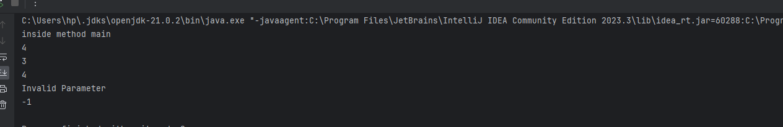

- Problem Statement: Return the name of the excel column?
- Input number : 4
- O/p Column : “D”
- Input number : 26
- O/p Column : “Z”
- Input number : 52
- O/p Column : “AZ”

package Multithreading;
public class FindNameOfExcelColumn {
public static void main(String[] args) {
FindNameOfExcelColumn obj =new FindNameOfExcelColumn();
System.out.println(obj.convertToColumn(51));
}
public String convertToColumn(int col) {
StringBuffer res = new StringBuffer();
while(col > 0){
int mod = col % 26;
res.append((char) (mod == 0 ? (90) : (mod + 64)));
col = col / 26;
if(mod == 0)
col--;
}
return res.reverse().toString();
}
}

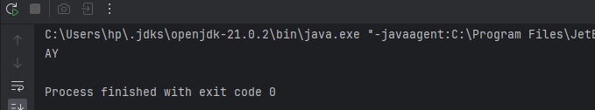

- Given an array of integers heights representing the histogram's bar height where the width of each bar is 1, return the area of the largest rectangle in the histogram.

package Multithreading;
class FindMaxRectangle {
static int getMaxArea(int arr[], int n) {
int maxArea = 0;
for (int i = 0; i < n; i++) {
int minHeight = Integer.MAX_VALUE;
for (int j = i; j < n; j++) {
minHeight = Math.min(minHeight, arr[j]);
maxArea = Math.max(maxArea, minHeight * (j - i + 1));
}
}
return maxArea;
}
public static void main(String[]args){
System.out.println(getMaxArea(new int[]{2,1,5,6,2,3,1},7));
}
}

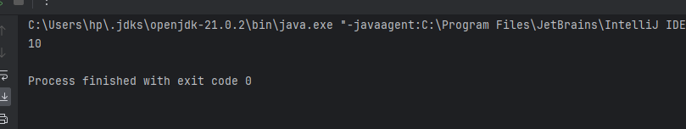

Given a string s containing just the characters '(', ')', '{', '}', '[' and ']', determine if the input string is valid.

package Multithreading;
import java.util.*;
class ValidParenthesisChecker {
public static boolean isValidParenthesis(String parenthesis) {
Stack<Character> charStack = new Stack<Character>();
for (char singeChar : parenthesis.toCharArray()) {
if (singeChar == '(' || singeChar == '[' || singeChar == '{')
charStack.push(singeChar);
else {
if(charStack.isEmpty()) return false;
char ch = charStack.pop();
if((singeChar == ')' && ch == '(') || (singeChar == ']' && ch == '[') || (singeChar == '}' && ch == '{')) continue;
else return false;
}
}
return charStack.isEmpty();
}
public static void main (String[] args) {
String s1 = "()}()]";
String s2 = "(){}";
String s3 = "(){}[]";
if (isValidParenthesis(s1) == true)
System.out.println("True");
else
System.out.println("False");
if (isValidParenthesis(s2) == true)
System.out.println("True");
else
System.out.println("False");
if (isValidParenthesis(s3) == true)
System.out.println("True");
else
System.out.println("False");
}
}

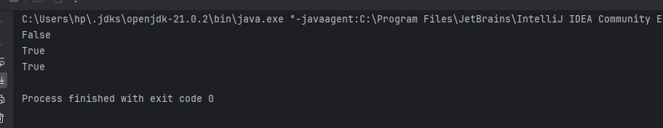

- need to write 1, 2,3 .........12 with the help of 3 threads, Threads and corresponding digits are there

package Multithreading;
public class ThreadExample implements Runnable{
public int PRINT_NUMBERS=10;
static int number=1;
int remainder;
static Object lock=new Object();
ThreadExample(int remainder)
{
this.remainder=remainder;
}
@Override
public void run() {
while (number < PRINT_NUMBERS-1) {
synchronized (lock) {
while (number % 3 != remainder) {
try {
lock.wait();
} catch (InterruptedException e) {
e.printStackTrace();
}
}
System.out.println(Thread.currentThread().getName() + " " + number);
number++;
lock.notifyAll();
}
}
}
public static void main(String[] args) {
ThreadExample thr1=new ThreadExample(1);
ThreadExample thr2=new ThreadExample(2);
ThreadExample thr3=new ThreadExample(0);
Thread t1=new Thread(thr1,"T1");
Thread t2=new Thread(thr2,"T2");
Thread t3=new Thread(thr3,"T3");
t1.start();
t2.start();
t3.start();
}
}

