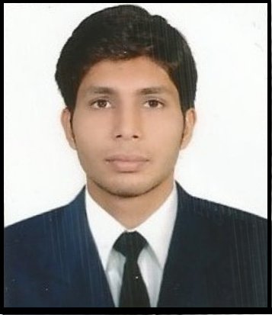**Prabal Shrivastava**

H.no 1 Brajmohan Nagar,

Bedinagar Nagpur Road

Jabalpur(M.P) 482001

Contact No (+91-7771865631)

prabalshrivastava54@gmail.com

**Career Objective :**To seek challenges in my job and benefit organisation by facing them.

**Educational Credentials :**Pursuing Bachelors of Engineering from GGITS(Gyan Ganga Institute of Technology and Sciences) with CGPA of 7.69

|  |  |  |  |  |  |
| --- | --- | --- | --- | --- | --- |
| **S.No** | **Semester/Class** | **College/School** | **University/Board** | **SGPA/Percentage** | **Year of passing** |
| 1. | VII SEM | GGITS | RGPV | 8.00 | 2015 |
| 2 | VI SEM | GGITS | RGPV | 8.25 | 2014 |
| 3. | V SEM | GGITS | RGPV | 7.88 | 2014 |
| 4. | IV SEM | GGITS | RGPV | 7.88 | 2013 |
| 5. | III SEM | GGITS | RGPV | 8.06 | 2013 |
| 6. | II SEM | GGITS | RGPV | 7.07 | 2012 |
| 7. | I SEM | GGITS | RGPV | 7.53 | 2011 |
| 8 | XII BOARD | ST Aloysius | CBSE | 76.2 % | 2011 |
| 9. | X BOARD | ST Aloysius | CBSE | 74.4 % | 2009 |

**Professional Skills**

**Technical Skills :** OOP, DBMS

**Programming skills :** C and C++

**Database Management :** Oracle 10g

**Cisco Certified Network Associate :** LAN, MAN, WAN, CSMA/CD, Serial link, IP, Hubs, Switching & Routing, Routing Protocols (RIP, IGRP, EIGRP, ISIS, OSPF, BGP), MTU, Subnetting & Supernetting, FLSM/VLSM, Switching Protocols (STP, RSTP), IPV6, Wireless.

**Trainings Undergone**

* Successfully completed Vocational Training on Software Engineering and Project management from “CMC Academy (A Tata Enterprise)” for 4 weeks.
* Successfully completed training on Web Fundamentals organised by Microsoft in GGITS for 7 days.
* Successfully completed training conducted by Oracle for 15 days.
* Successfully completed training on C language from “CMC Academy (A Tata Enterprise)” conducted in GGITS for 60 hours.
* Successfully completed training on Oracle 10g conducted by Oracle in GGITS for 15 days.

**Minor Project**

**Name of project :** Meditation-Lite

**Team size :** 2

**Front end :** C# Dot net

**Brief description :** a new guided way to meditation.

**Windows Store Link :**http://apps.microsoft.com/windows/engb/app/81735b13-9250-4032-92b3-7e8698ac9fdd

**Co-curricular Activities**

* Participated in “Code Master” a multiple programming language competition held at GGITS on 5th April 2014.
* Participated in Microsoft Imagine Cup camp at GGITS on 10th march 2014 conducted by Microsoft.
* Participated in workshop conducted by web unplugged in association with Ideabox creation conducted on 19/01/2014.
* Participated in NADC 2013 workshop on 6th march 2013 at GGCTconducted by ARK Technosolutions.

**Awards and Achievements**

* I deployed my first Windows 8.1 app to the app store.
* Volunteered in workshop organised by Web unplugged at BRBRAITT Jabalpur (M.P).
* Secured3rd in quiz competition organised on the eve of Engineer’s Day 15th September at GGITS.

**Personal details**

**Date of Birth :** 07/07/94.

**Father’s Name :** Mr GK Shrivastava.

**Father’s Occupation :** Officer at ICMR (Indian Council of Medical Research).

**Mother’s Name :** Mrs. Vinita Shrivastava.

**Mother’s Occupation :** AssistantTeacher at MLB.

**Blood Group :** A +.

**Hobbies :** Watching TV shows and Follow Youtube channels.

**Strengths :**Optimistic, Workaholic,Team Player,Gregarious personality.

**Declaration**

I hereby declare that whatever information have been furnished above is true and I will be responsible for its authenticity

**Date :**

**Place :** Jabalpur

**Signature :**