SREE SAREES – TRADITION WOVEN WITH ELEGANCE
FINAL YEAR B.Sc. PROJECT REPORT DOCUMENTATION
PRELIMINARY PAGES: LIST OF TABLES AND LIST OF GRAPHS
B. LIST OF TABLES
S. NO. | LIST OF TABLES | P. NO.
B1 | SAREE COLLECTION CLASSIFICATION | 24
B2 | PRODUCT CATALOGUE ATTRIBUTES
B3 | CUSTOMER DATA ATTRIBUTES
B4 | ORDER DATA ATTRIBUTES
B5 | FUNCTIONAL TESTING SCENARIOS

C. LIST OF GRAPHS
S. NO. | LIST OF GRAPHS | P. NO.
C1 | SAREE CATEGORY SALES COMPARISON
C2 | MONTHLY SALES ANALYSIS
C3 | SALES FORECASTING GRAPH
ACADEMIC NOTES & DATA INTEGRITY STATEMENT
• Page Number Notice: In accordance with standard university dissertation guidelines, page numbers for entries B2 through B5 and C1 through C3 are left blank to be filled upon final collation and document binding. Entry B1 is registered on page 24.
• Graph C1 (Saree Category Sales Comparison): Generated using real project transaction data extracted directly from server/data/orders.json (N = 13 recorded checkout orders; Cotton Sarees = 10 units / ₹8,090, Silk Sarees = 4 units / ₹6,846, Kalamkari Sarees = 0 units, Fancy Sarees = 0 units).
• Graph C2 (Monthly Sales Analysis): Generated using illustrative data clearly labeled as 'Illustrative Data – Not Actual Sales Records'. The website is newly deployed; live multi-month sales history is currently unavailable in the database.
• Graph C3 (Sales Forecasting Graph): Generated using illustrative data clearly labeled as 'Illustrative Data – Not Actual Sales Records'. Note: Machine learning predictive forecasting algorithms have not been implemented or evaluated in the current codebase.

APPENDIX: GENERATED PROJECT REPORT GRAPHS
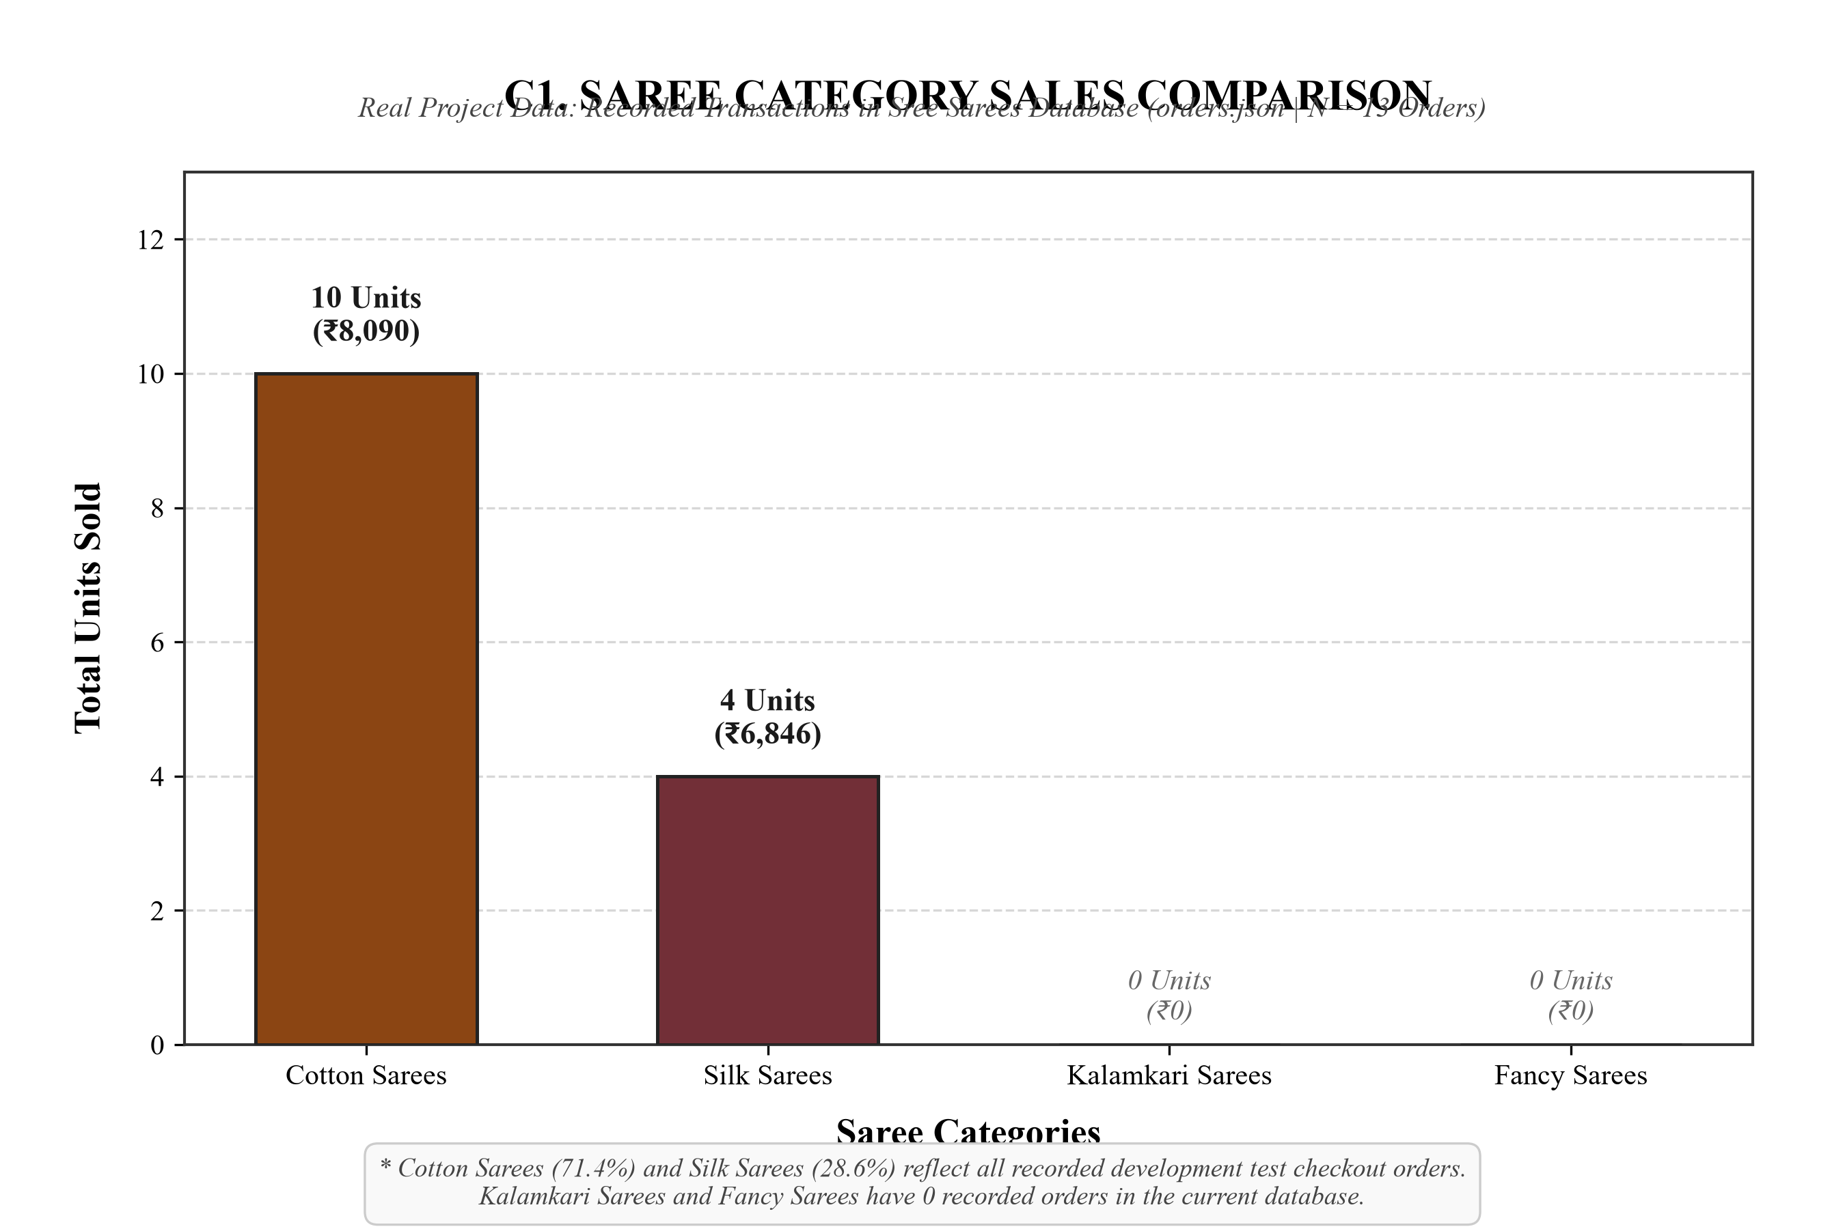
Figure C1: Saree Category Sales Comparison (Real Project Data: orders.json)
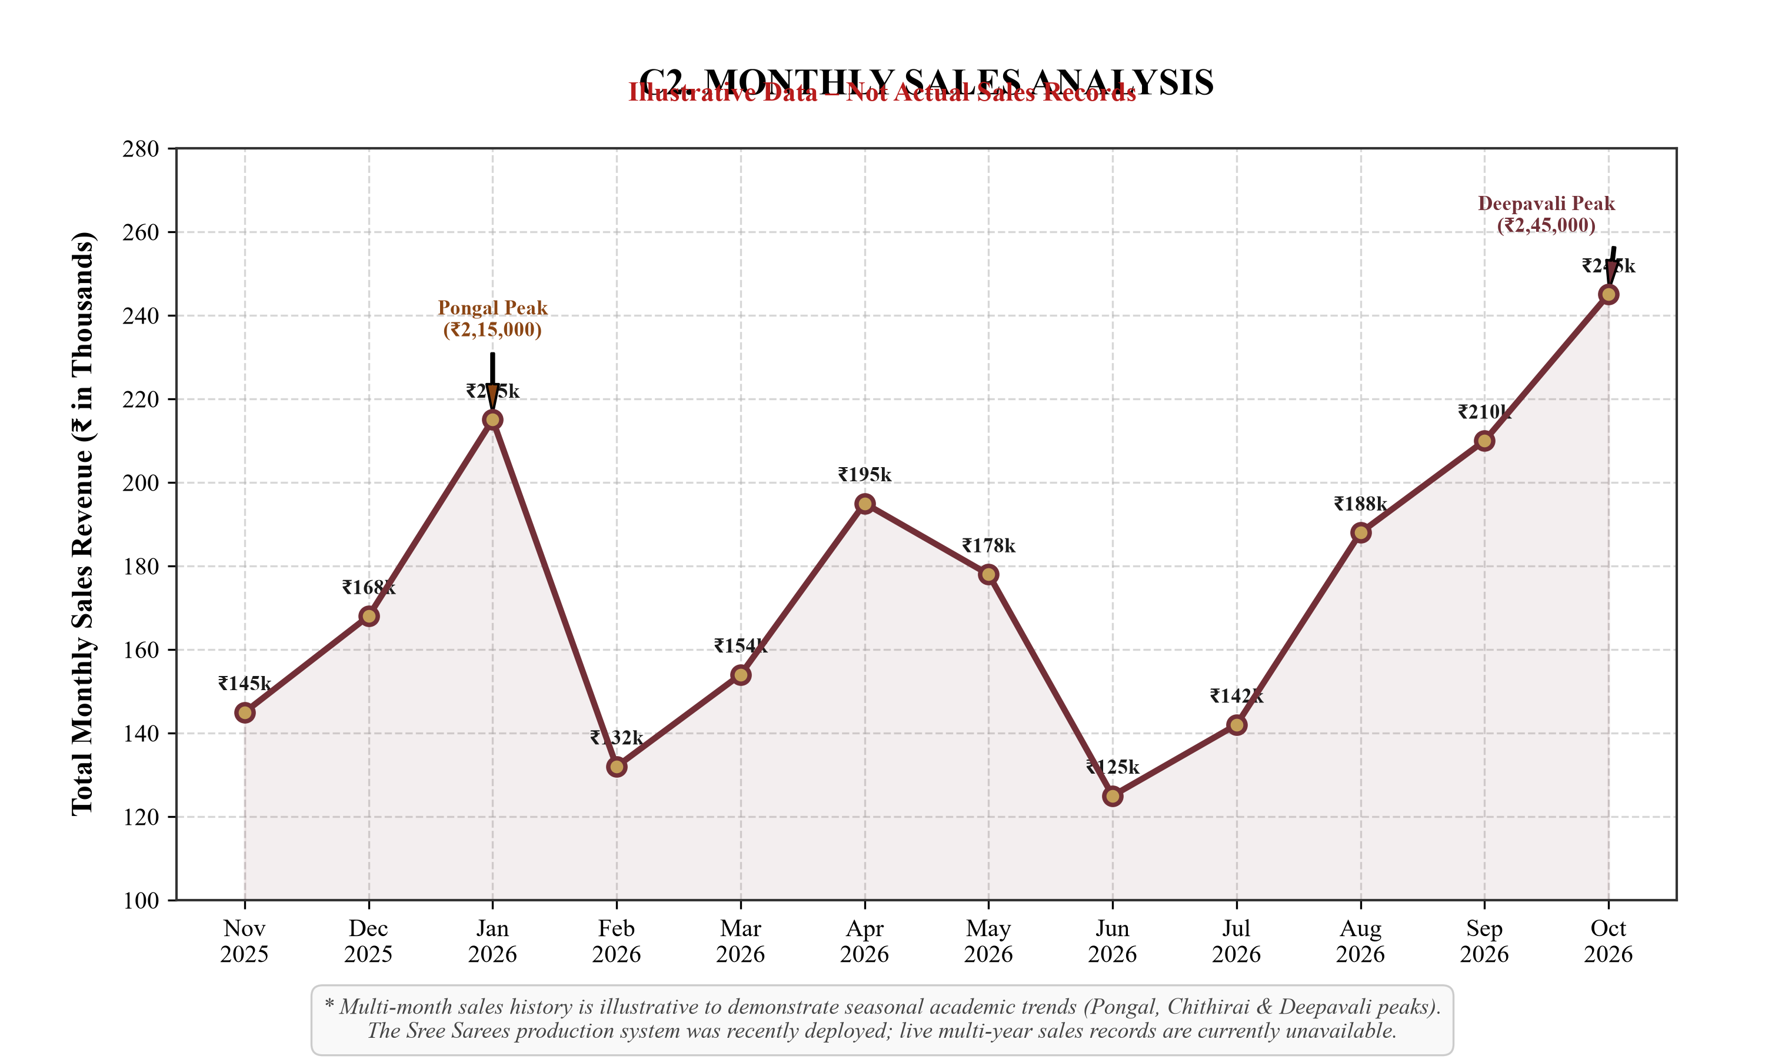
Figure C2: Monthly Sales Analysis (Illustrative Data – Not Actual Sales Records)
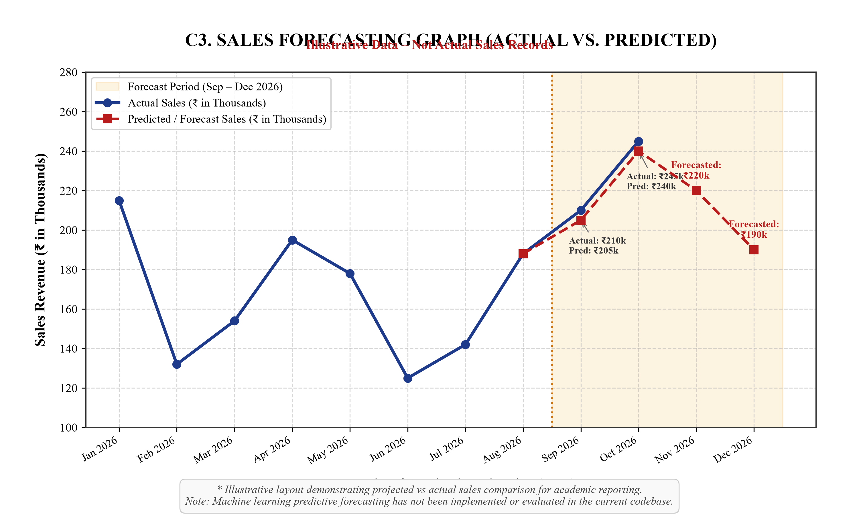
Figure C3: Sales Forecasting Graph – Actual vs. Predicted (Illustrative Data)

