OCUP FOUNDATION – MOCK TEST 1

1. Select the correct statement

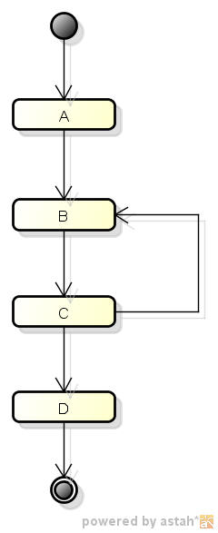

1. Sequence of execution is A->B->C->D
2. Sequence of execution is A->B->C->B->C->D
3. Infinite Loop occurs A ->B->C->B->C->B->C……
4. Action C is never executed
5. None of the Above
6. Please represent the instance of the class “Employee” having name as “XYZ”.

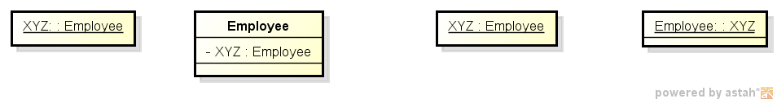

1. B) C) D)
2. Please select the number of event occurences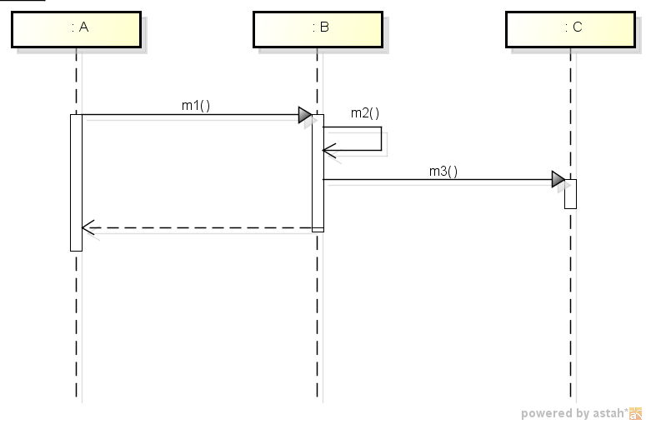
3. 1
4. 2
5. 4
6. 6
7. 8

4) Please select the most suitable representation for the below diagram :

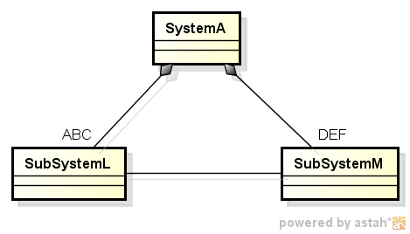

1. 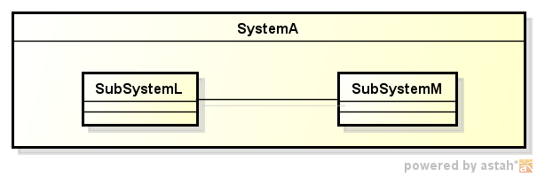
2. 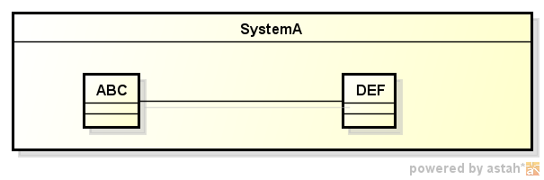
3. 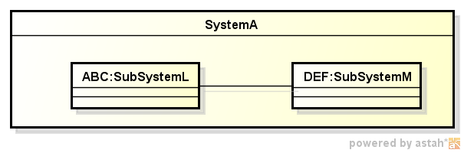
4. None of the Above

5) What constitute the features of the class Light:

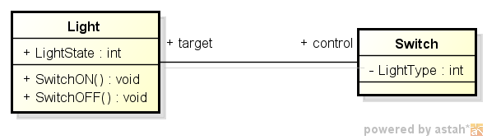

1. SwitchON, SwitchOFF
2. SwitchON, SwitchOFF, control
3. SwitchON, SwitchOFF, LightState
4. SwitchON, SwitchOFF, LightState, Switch (as control)
5. LightState, Switch (as control)

6) Choose the option which shows derived property:

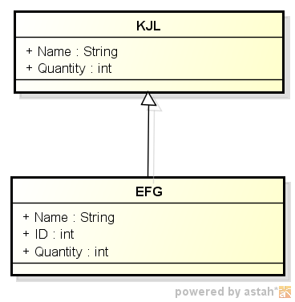 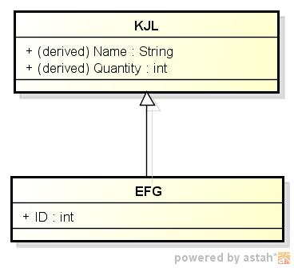 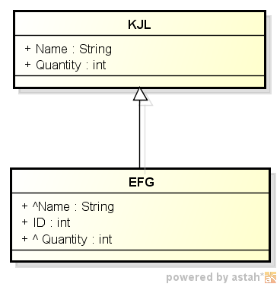 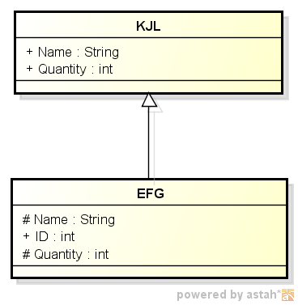

A ) B) c) D)

7) Choose the right statement. A Port is related to:

A) Generalization

B) Parameter

C) Property

D) Realization

8) Choose the items which are included into P2 :

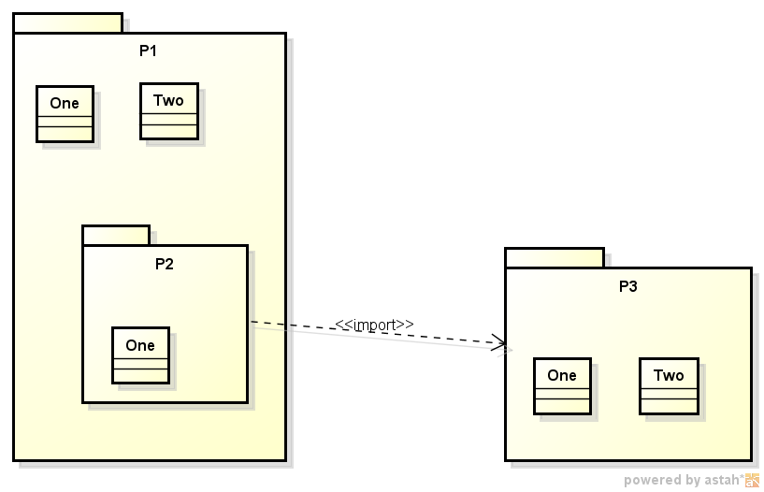

1. One Two
2. Two
3. One
4. Invalid Import

25) What signifies the underlying meaning of an UML Element

A) Abstract Syntax

B) Concrete Syntax

C) Semantics

D) None of the Above

9) Identify the elements not visible outside TRP

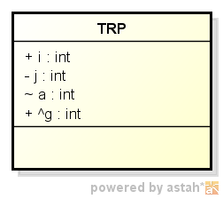

1. i
2. j
3. a
4. g
5. j,a,g

10) Assume that the system is in state A. Event E1 occurs. Identify the sequence

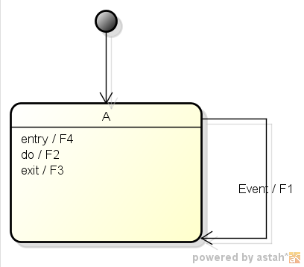

A ) F1

1. F1, F4
2. F3,F1,F4
3. F3,F1,F4,F2

11) Identify the invalid sequence :

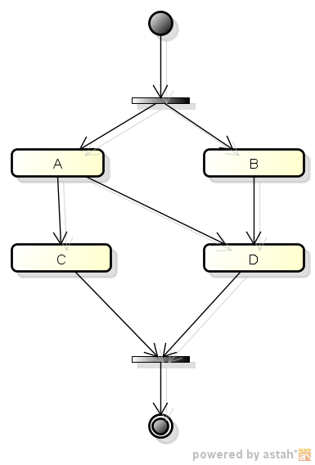

1. A->C->B->D
2. B->D->A->C
3. A->B->D->C
4. B->A->C->D

26) 2 items are required to be displayed. Select the valid use case

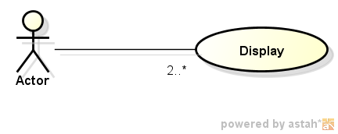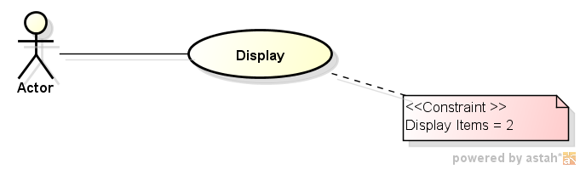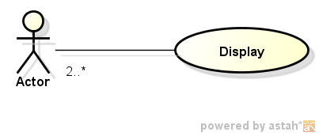

A) B) C)

D) None of the above

12) Choose the right statement :



A )Only (1) is valid

B) Only (2) is valid

C) (1) is Activity (2) is Action

D) (1) is Action (2) is Activity

13) Identify the notation to be used for an Abstract Class

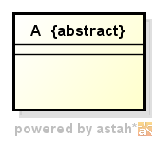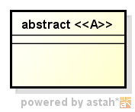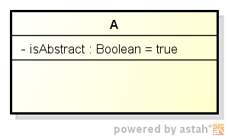

1. B) C) D) None of the above

14) Choose the right option about Enumerations

A) Enumerations are immutable

B) Enumeration Literals are used for comparison

C) Enumerations cannot be Generalized

D) Enumerations cannot be Specialized

15) Consider the class diagram below. Which of the following object diagrams are consistent with the class diagram.

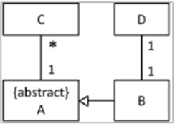

1. 
2. 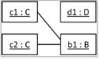
3. 
4. 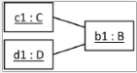
5. 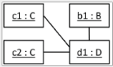

16. Consider the class diagram below. Choose the correct statements.

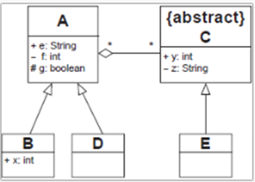

1. An instance of A can see y
2. Objects of B and D can see g
3. Objects of C and B can see f
4. An object of A may or may not contain objects of C

17. Consider the activity diagram. Choose the action sequences, which could possible result during different executions of the activity diagram.

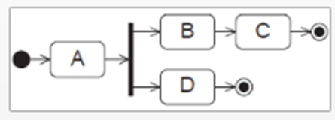

1. A -> B -> D
2. A -> D
3. A -> B ->C
4. A -> B -> C -> D
5. A -> B -> D -> C

18.Choose the activity diagrams which are correct, considering control flow.

1. 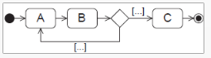

b) 

c) 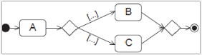

d) 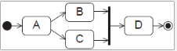

e) 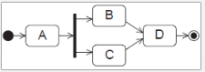

1. 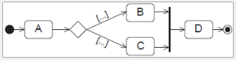
2. )Let us denote sending of p as !p and receiving p as ?p. What is correct about event occurrences of the interaction Q?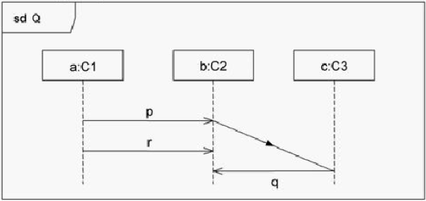

a) !p will precede !q

b) ?p will precede !r

c) ?q may precede ?r

d) !r will precede !q

e) None of the above

20) Choose the correct statements :

1. A Model describes the system from all possible *viewpoints*
2. A Model is complete in the sense that it covers the whole system, although only those aspects relevant to its purpose (i.e., within the given level of abstraction and viewpoint)
3. The semantics of a model describes the underlying meaning of the symbols used in the model
4. None of the above

21) Choose the correct statements :

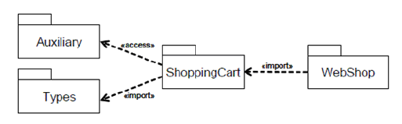

1. The public members of Types are imported into ShoppingCart and but cannot be further imported into WebShop
2. The members of Auxiliary are only privately imported by ShoppingCart and cannot be referenced using unqualified names from WebShop.
3. The members of Auxiliary are only privately imported by ShoppingCart but can be referenced using unqualified names from WebShop.
4. The members of ShoppingCart are privately imported by Auxiliary

22) Consider the below statemachine. Identify the number of pseudostates.

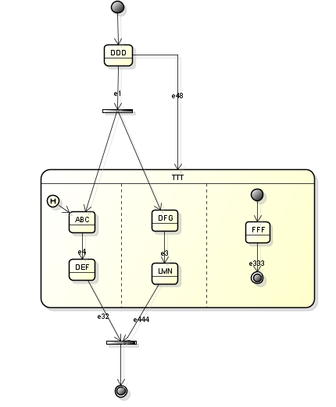

a) 4

b) 6

c) 5

d) 1

e) 2

f) 0

1. Consider the below state machine. In the case of the events occurring as e8,e4, e14,e8, please choose the active state.

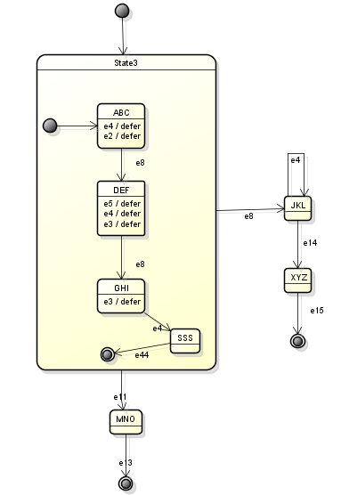

1. State XYZ
2. State SSS
3. State GHI
4. State JKL
5. State DEF
6. Choose the correct statements :
7. A MergeNode is a control node that brings together multiple flows with synchronization
8. MergeNode shall have exactly one outgoing ActivityEdge but may have multiple incoming ActivityEdges.
9. There is no synchronization of flows or joining of tokens for MergeNodes
10. If the outgoing edge of a MergeNode is a ControlFlow, then all incoming edges must be ControlFlows
11. If the outgoing edge is an ObjectFlow, then one of the incoming edges must be ObjectFlows