**About Us**

**LULU SOFTWARE** creates simple and powerful software for your computer. We understand that for some people, technology can be a headache, which is why we designed our software to be smart, reliable and accessible. We’re determined to make your experience with our products as smooth and pleasant as possible. And if you need a little extra help, our Customer Support Team is here to provide it.

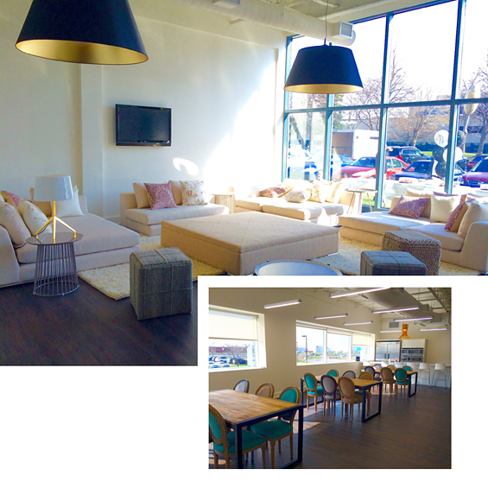

**Our Promise**

To provide simple and efficient software — specifically tailored to your needs.

**We Believe In**

**Being Consumer-Centric**

We exist to satisfy our customers’ needs. Our priority is to make sure the software solutions we offer are parallel to those our customers are seeking. We make it a point to get to know our customers and their needs so we can provide the best possible solutions. Developing and delivering reliable, user-friendly products and offering exceptional customer service are at the core of our belief system.

**Investing in our People**

The livelihood of **LULU SOFTWARE** is intrinsically tied to the personal growth of our employees. That is why we’re committed to the development of their talents, continuously encouraging them to acquire new skills and knowledge. We strongly believe that a successful company draws on the experience of people with various backgrounds and skills, and the diversity of our employees enables us to maintain a fun and productive work environment.

**Having Integrity**

It means doing what’s morally and ethically right without compromise. Our growth and success are dependent on our reputation as individuals and as a corporation. Our integrity enables us to be trusted, which in turn ensures our long-term growth.

**Encouraging Creativity**

**LULU SOFTWARE** is driven by entrepreneurial attitude and vision. Our employees are given the freedom and encouragement to be innovative, and are given the opportunity to improve both on a personal and professional level.