- Create a Jenkins Job to create a calculator. It should give you a dropdown to ask Addition, Subtraction, Multiplication or Division and mail the results.
Hint: Plugin Used (Environment Injector, Extended Email Notification)

SCRIPT:

#!/bin/bash
if [ $operation == 'addition' ]
then
res=`expr $First + $Second`

elif [ $operation == 'subtraction' ]
then
res=`expr $First - $Second`

elif [ $operation == 'multiplication' ]
then
res=`expr $First * $Second`

elif [ $operation == 'divison' ]
then
res=`expr $First / $Second`
else
echo "No matches Found"
fi

echo "${res}"
echo RESULT = $res > prab.properties

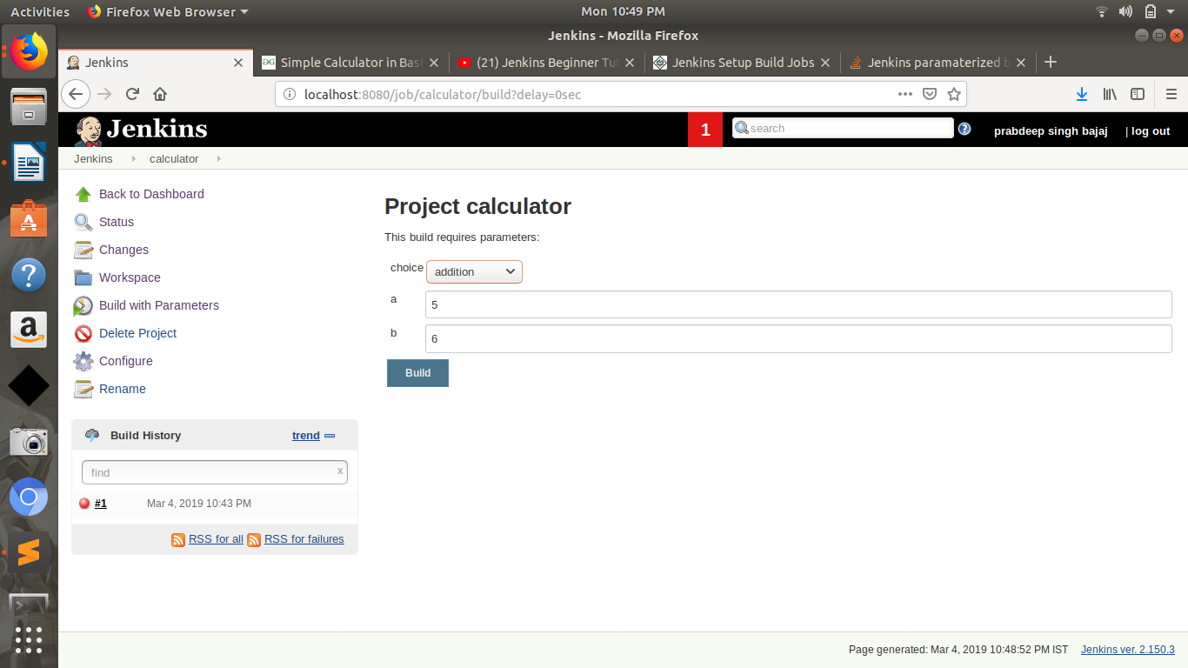

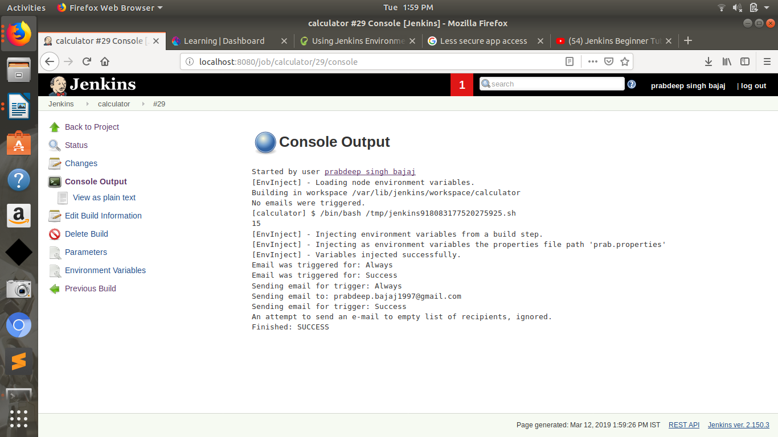
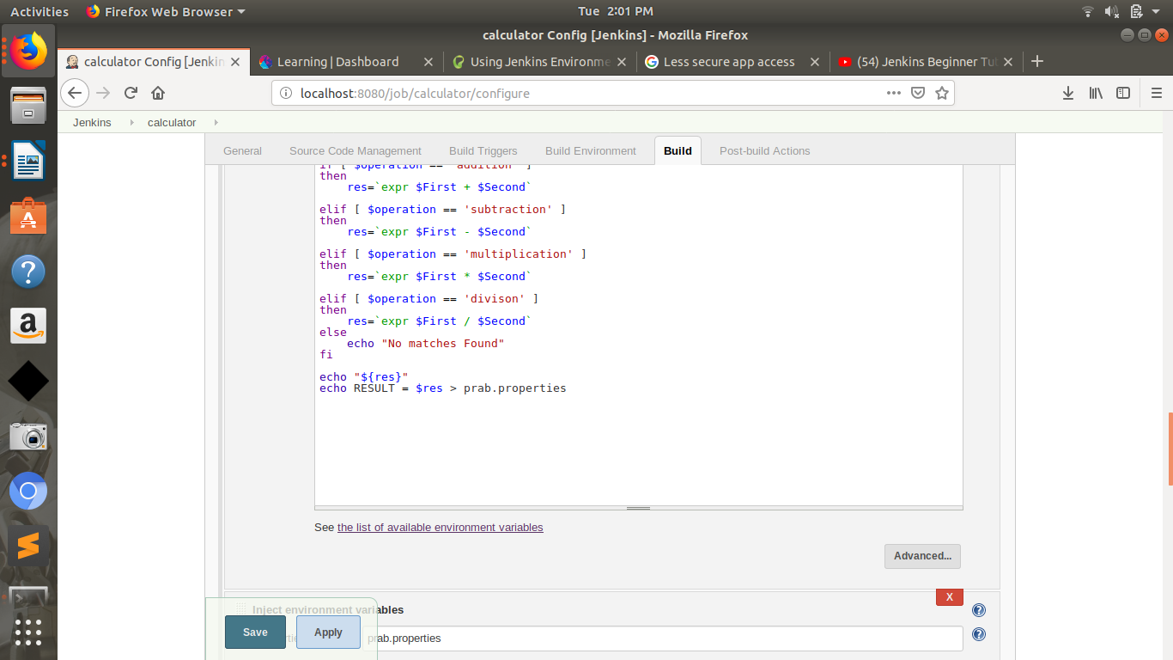

- Create jenkins parameterized job which on selecting different the Env. will display different web pages by nginx.
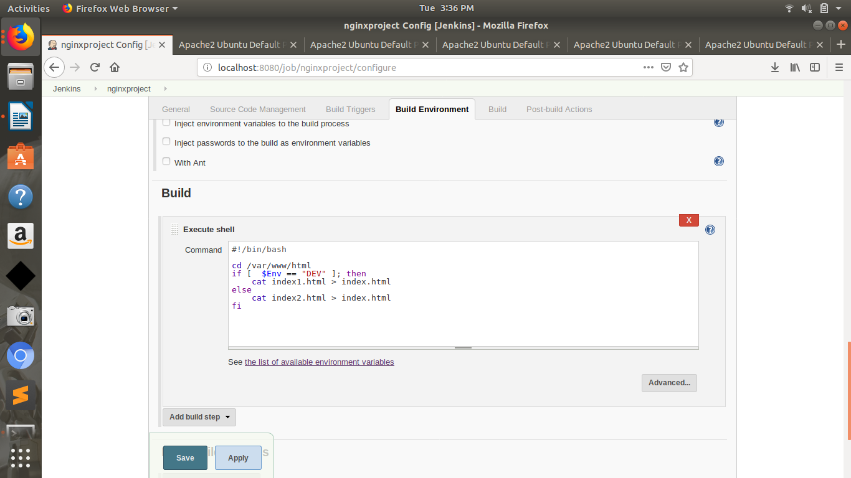
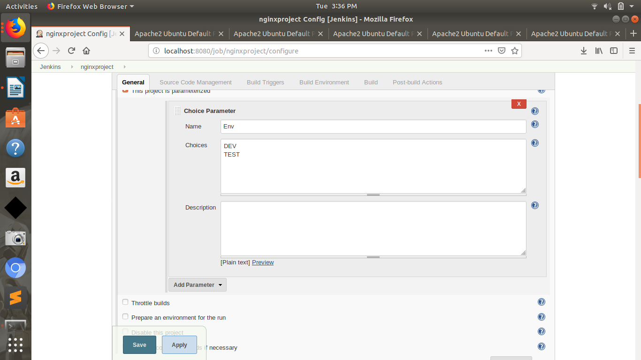

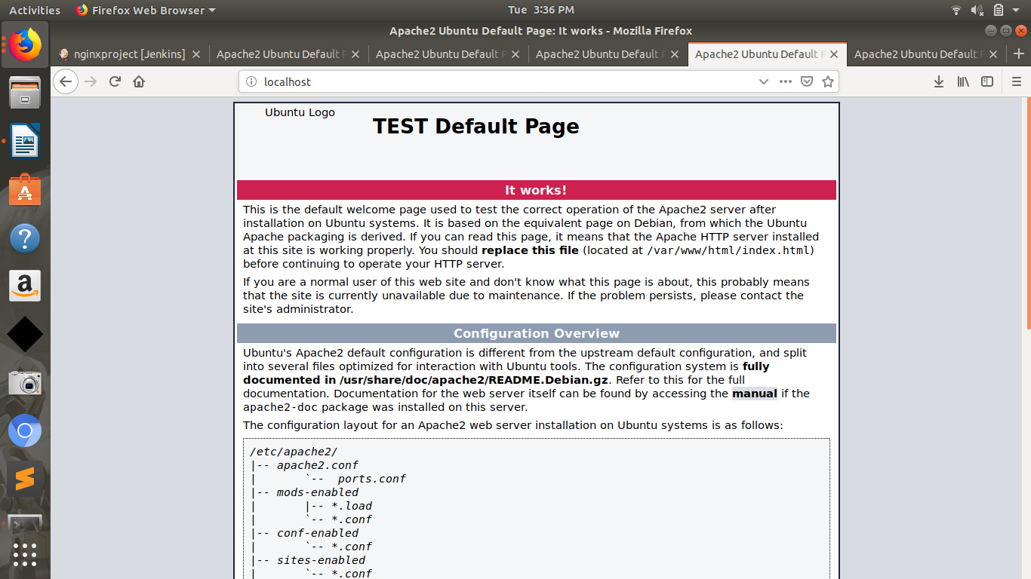

- Java deployment to server by Maven jenkin job.
  - Checkout SCM (https://github.com/bogo-devops/game-of-life.git)
  - Build with Maven plugin
  - SCP war to EC2
  - Deploy by tomcat 8 (any Application Server) and E-mail Notification (only on Jenkins Job status Failure)

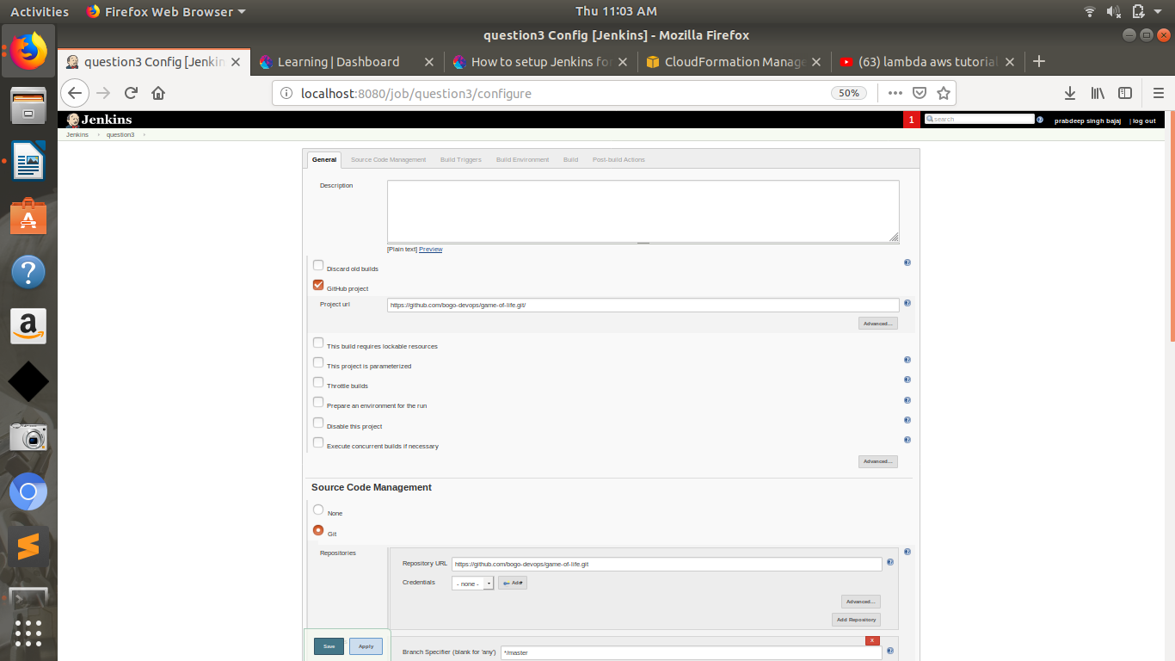

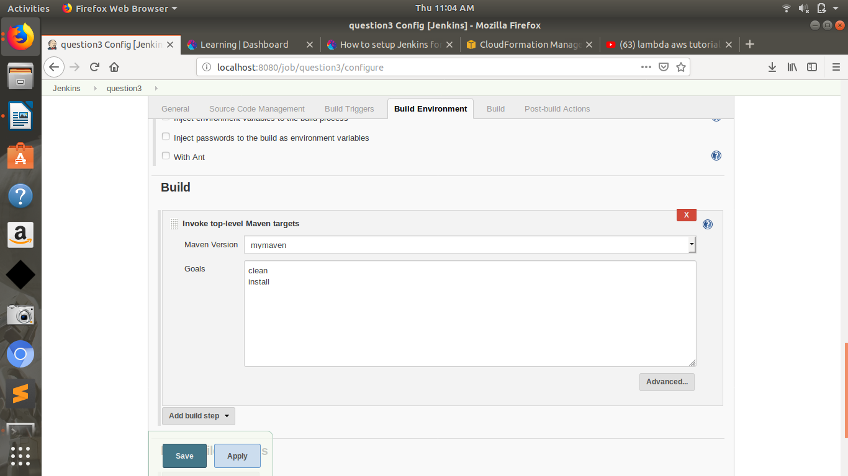
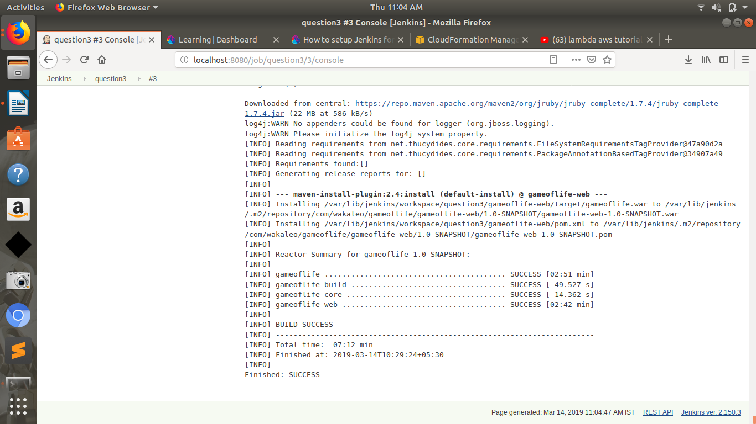

- Jenkins User based access.
Jenkin Job Name: Test, Test123 and Test1234

