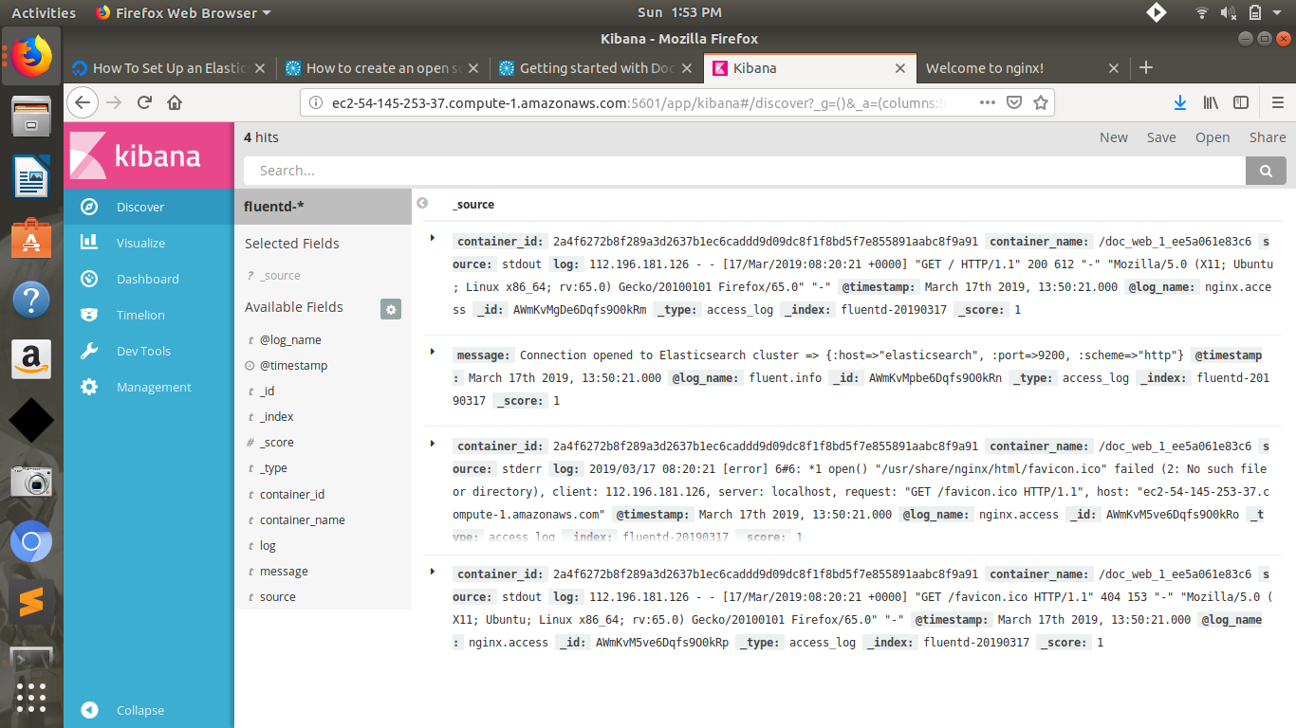
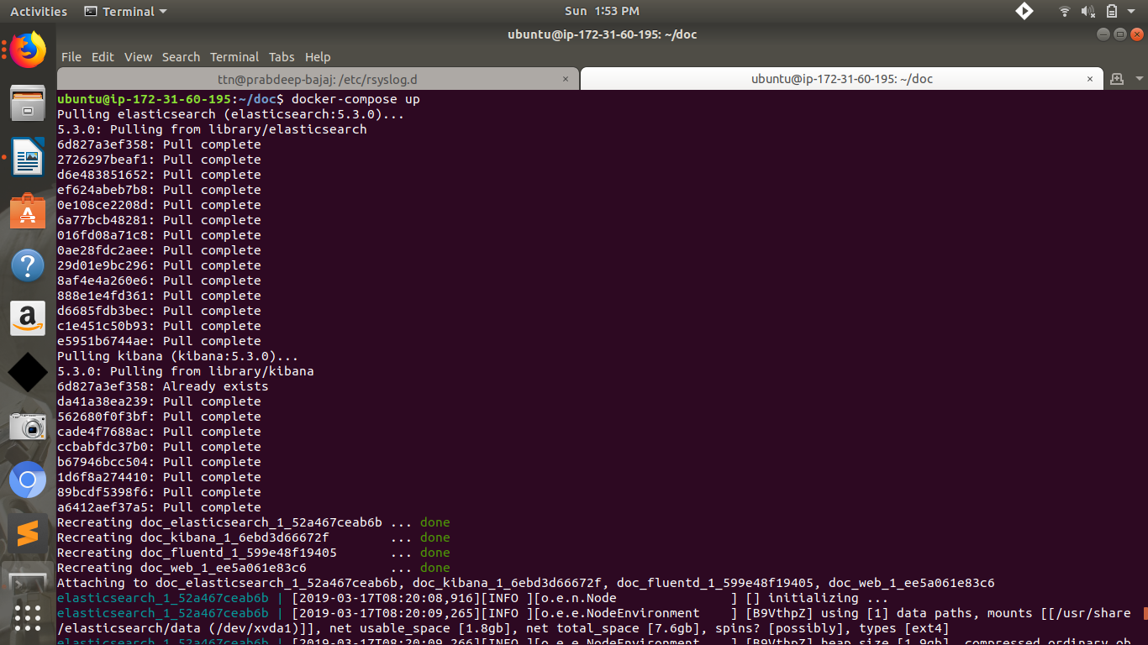
DOCKER_COMPOSE :
version: '2'
services:
web:
image: httpd
ports:
- "80:80"
links:
- fluentd
logging:
driver: "fluentd"
options:
fluentd-address: localhost:24224
tag: httpd.access

fluentd:
build: ./fluentd
volumes:
- ./fluentd/conf:/fluentd/etc
links:
- "elasticsearch"
ports:
- "24224:24224"
- "24224:24224/udp"

elasticsearch:
image: elasticsearch:5.3.0
expose:
- 9200
ports:
- "9200:9200"

kibana:
image: kibana:5.3.0
links:
- "elasticsearch"
ports:
- "5601:5601"

FLUENTD/DOCKERFILE :
FROM fluent/fluentd:v0.12-debian
RUN ["gem", "install", "fluent-plugin-elasticsearch", "--no-rdoc", "--no-ri", "--version", "1.9.7"]
FLUENTD/FLUENTD.conf
<source>
@type forward
port 24224
bind 0.0.0.0
</source>
<match *.**>
@type copy
<store>
@type elasticsearch
host elasticsearch
port 9200
logstash_format true
logstash_prefix fluentd
logstash_dateformat %Y%m%d
include_tag_key true
type_name access_log
tag_key @log_name
flush_interval 1s
</store>
<store>
@type stdout
</store>
</match>

