1. What is MFA
Multi-Factor Authentication (MFA) is a security system that verifies a user’s identity by requiring multiple credentials. Rather than just asking for a username and password, MFA requires other—additional—credentials, such as a code from the user’s smartphone, the answer to a security question, a fingerprint, or facial recognition.
MFA is an effective way to provide enhanced security. Traditional usernames and passwords can be stolen, and they’ve become increasingly more vulnerable to brute force attacks. MFA creates multiple layers of security to help increase the confidence that the user requesting access is actually who they claim to be. With MFA, a cybercriminal may steal one credential but will be thwarted by having to verify identity in a different manner.
Examples of Multi-Factor Authentication include using a combination of these elements to authenticate:
- Codes generated by smartphone apps
- Badges, USB devices, or other physical devices
- Soft tokens, certificates
- Fingerprints
- Codes sent to an email address
- Facial recognition
- Retina or iris scanning
- Behavioral analysis
- Risk score
- Answers to personal security questions

Types of authentication factors
When it comes to MFA, we typically refer to three types of authentication factors:
- Things you know (knowledge), such as a password or PIN
- Things you have (possession), such as a badge or smartphone
- Things you are (inheritance), indicated through biometrics, like fingerprints or voice recognition
The latest MFA solutions incorporate additional factors by considering context and behavior when authenticating. For example:
- Where you are when trying to obtain access, such as a cafe or home
- When you are trying to access, like late at night or during the workday
- What device you’re using, such as a smartphone versus a laptop
- What kind of network are you accessing, like private or public

2. What is ec2 instance profile
An instance profile is a container for an IAM role that you can use to pass role information to an EC2 instance when the instance starts.
If you use the AWS Management Console to create a role for Amazon EC2, the console automatically creates an instance profile and gives it the same name as the role. When you then use the Amazon EC2 console to launch an instance with an IAM role, you can select a role to associate with the instance. In the console, the list that's displayed is actually a list of instance profile names. The console does not create an instance profile for a role that is not associated with Amazon EC2.

If you manage your roles from the AWS CLI or the AWS API, you create roles and instance profiles as separate actions. Because roles and instance profiles can have different names, you must know the names of your instance profiles as well as the names of roles they contain. That way you can choose the correct instance profile when you launch an EC2 instance.

3. Create a role from AWS CLI and which should have s3 full access permission and attach the role to an ec2 instance.
Source : https://docs.aws.amazon.com/AWSEC2/latest/UserGuide/iam-roles-for-amazon-ec2.html
https://docs.aws.amazon.com/IAM/latest/UserGuide/id_roles_create_for-service.html
To create an IAM role and instance profile (AWS CLI)
- Create an IAM role with a policy that allows the role to use an Amazon S3 bucket.
  - Create the following trust policy and save it in a text file named ec2-role-trust-policy.json.
{
"Version": "2012-10-17",
"Statement": [
{
"Effect": "Allow",
"Principal": { "Service": "ec2.amazonaws.com"},
"Action": "sts:AssumeRole"
}
]
}
  - Create the s3access role and specify the trust policy that you created.
aws iam create-role --role-name s3access --assume-role-policy-document file://ec2-role-trust-policy.json
{
"Role": {
"AssumeRolePolicyDocument": {
"Version": "2012-10-17",
"Statement": [
{
"Action": "sts:AssumeRole",
"Effect": "Allow",
"Principal": {
"Service": "ec2.amazonaws.com"
}
}
]
},
"RoleId": "AROAIIZKPBKS2LEXAMPLE",
"CreateDate": "2013-12-12T23:46:37.247Z",
"RoleName": "s3access",
"Path": "/",
"Arn": "arn:aws:iam::123456789012:role/s3access"
}
}
  - Create an access policy and save it in a text file named ec2-role-access-policy.json. For example, this policy grants administrative permissions for Amazon S3 to applications running on the instance.
{
"Version": "2012-10-17",
"Statement": [
{
"Effect": "Allow",
"Action": ["s3:*"],
"Resource": ["*"]
}
]
}
  - Attach the access policy to the role.
aws iam put-role-policy --role-name s3access --policy-name S3-Permissions --policy-document file://ec2-role-access-policy.json
  - Create an instance profile named s3access-profile.
aws iam create-instance-profile --instance-profile-name s3access-profile
{
"InstanceProfile": {
"InstanceProfileId": "AIPAJTLBPJLEGREXAMPLE",
"Roles": [],
"CreateDate": "2013-12-12T23:53:34.093Z",
"InstanceProfileName": "s3access-profile",
"Path": "/",
"Arn": "arn:aws:iam::123456789012:instance-profile/s3access-profile"
}
}
  - Add the s3access role to the s3access-profile instance profile.
aws iam add-role-to-instance-profile --instance-profile-name s3access-profile --role-name s3access
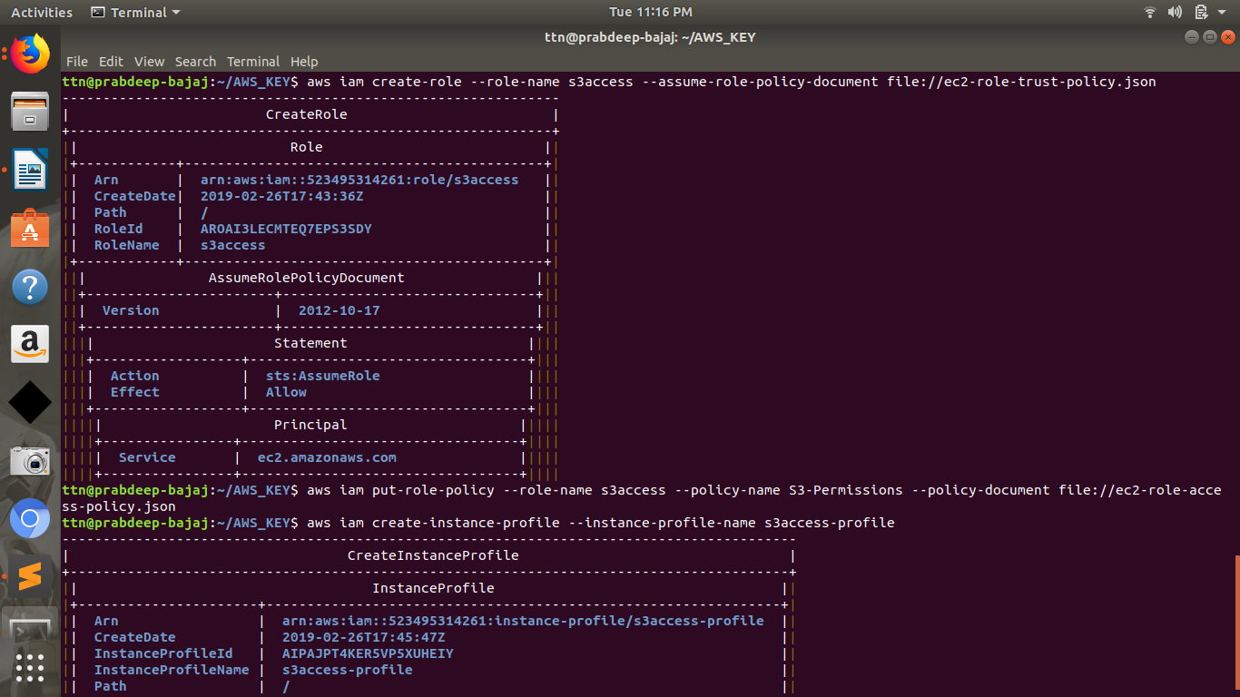
To launch an instance with an IAM role (AWS CLI)
- Use the run-instances command to launch an instance using the instance profile. The following example shows how to launch an instance with the instance profile.
aws ec2 run-instances --image-id ami-11aa22bb --iam-instance-profile Name="s3access-profile" --key-name my-key-pair --security-groups my-security-group --subnet-id subnet-1a2b3c4d

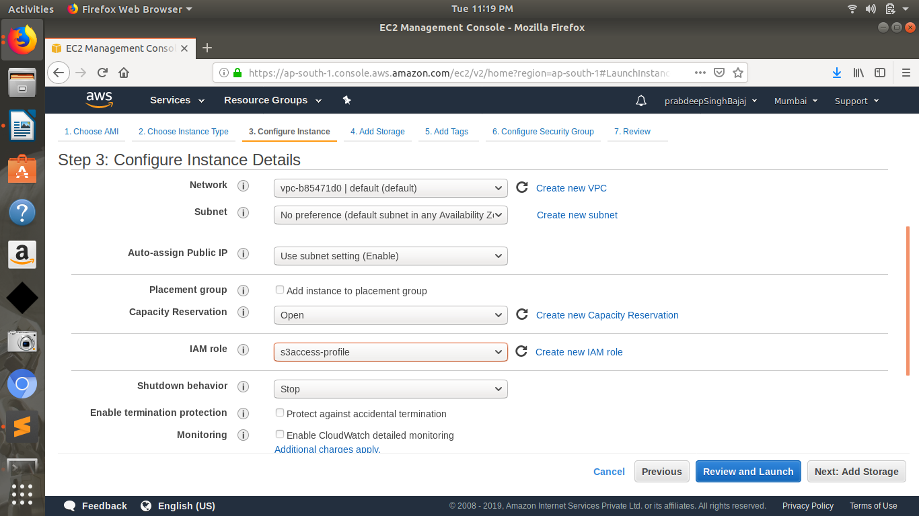

4. Create a policy which should have following things:
- Should have a tag with name 'Owner'
- 'Owner' tag key should have some value.
- The value must be equal to the username of the logged-in user.
{
"Version": "2012-10-17",
"Statement": [
{
"Sid": "Tag",
"Effect": "Deny",
"Action": "ec2:RunInstances",
"Resource": "arn:aws:ec2:*:*:instance/*",
"Condition": {
"ForAllValues:StringNotEquals": {
"aws:TagKeys": "Owner"
},
"StringNotEquals": {
"aws:RequestTag/Owner": "*"
}
}
},
{
"Sid": "Region",
"Effect": "Allow",
"Action": "ec2:*",
"Resource": "arn:aws:ec2:*:*:instance/*",
"Condition": {
"StringEquals": {
"ec2:ResourceTag/Owner": "${aws:username}"
}
}
}
]
}

