- What is the difference between PVM and HVM?

HVM guests are fully virtualized. It means that the VMs running on top of their hypervisors are not aware that they are sharing processing time with other clients on the same hardware. The host should have the capability to emulate underlying hardware for each of its guest machines. This virtualization type provides the ability to run an operating system directly on top of a virtual machine without any modification — as if it were run on the bare-metal hardware. The advantage of this is that HVMs can use hardware extensions which provide very fast access to underlying hardware on the host system.

Paravirtualization, on the other hand, is a lighter form of virtualization. This technique is fast, and provides near native speed in comparison to full virtualization. With Paravirtualization, the guest operating system requires some modification before everything can work. These modifications allow the hypervisor to export a modified version of the underlying hardware to the VMs, allowing them near-native performance. All PV machines running on a hypervisor are basically modified operating systems like Solaris or various Linux distributions.
This is in contrast to HVM, which requires no modifications to the guest OS and the host OS is completely unaware of the virtualization. This may add to the performance penalty because it places an extra burden on the hypervisor.

- Consider a scenario, you have just launched EC2 instances and you are unable to ssh into it, what all things will you check to troubleshoot this.

1.Firstly I will check that whether the Security Group(s) permits access to EC2 instance over SSH from the my IP address. If not then I will choose to edit it from the description tab and then add a rule to it.
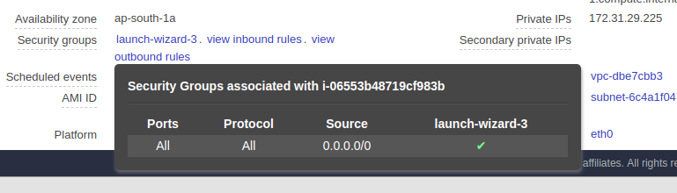
2.The next step will be to make sure that VPC route table is configured to allow trafic to and from the Internet . To do so I will choose Route Tables and then select VPC route table from the list. Else I will choose Internet Gateways and copy the ID of it and edit the route points to 0.0.0.0/0 to the Internet Gateway ID and save the route table
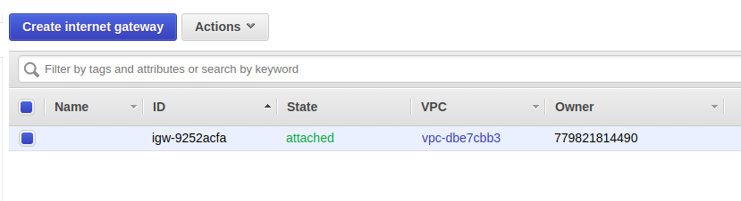
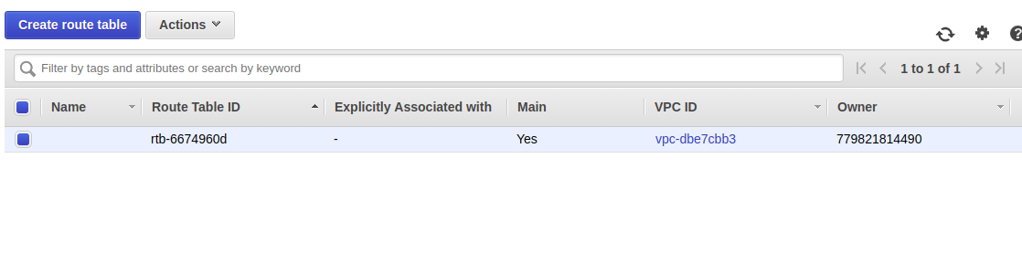
3. I will also check whether the ACL rules allow inbound and outbound IPv4 traffic or not.
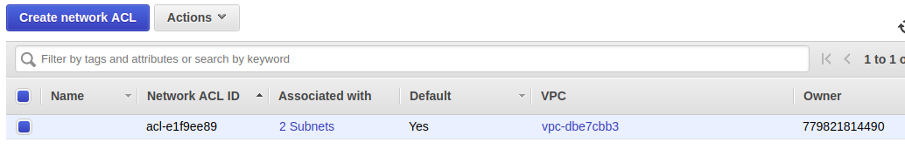

- Launch EC2 instances with user-data (install Nginx and print hello world on the default page), using AWS CLI

COMMAND : aws ec2 run-instances --image-id ami-04ea996e7a3e7ad6b --key-name MyKeyPair --security-groups MyGroup --instance-type t2.micro --user-data file://prab_aws.sh

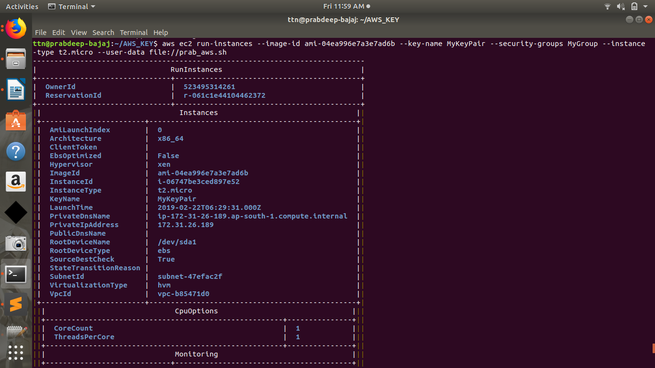
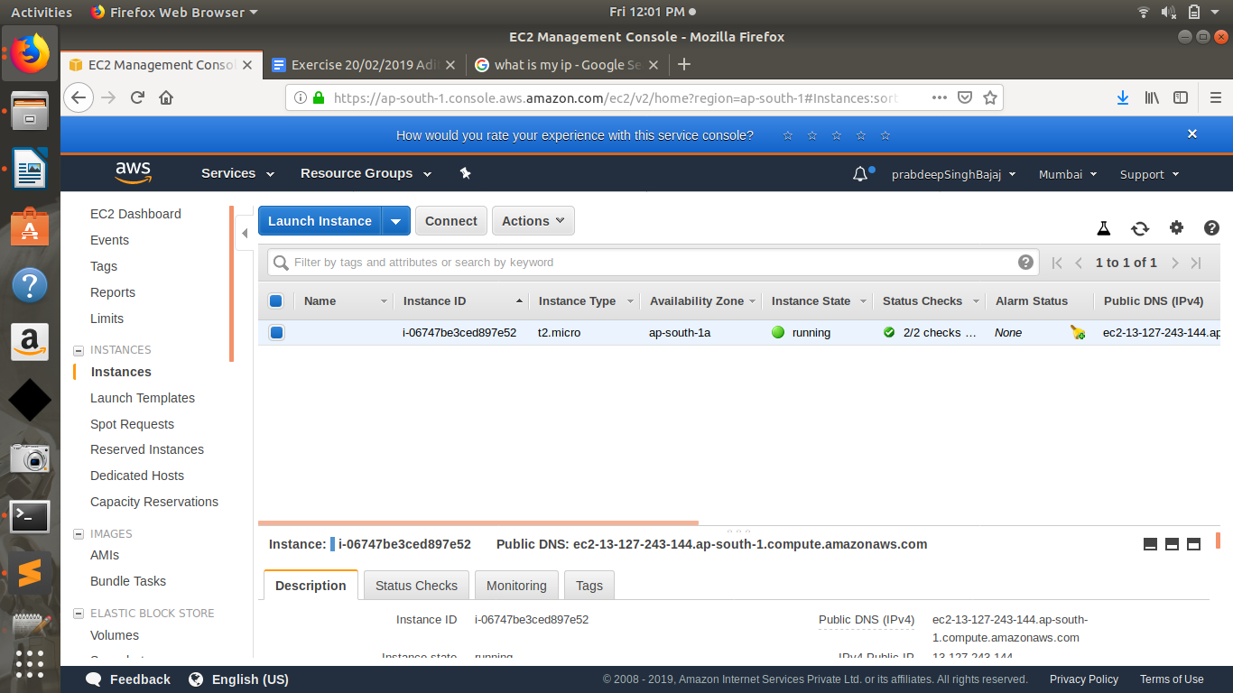

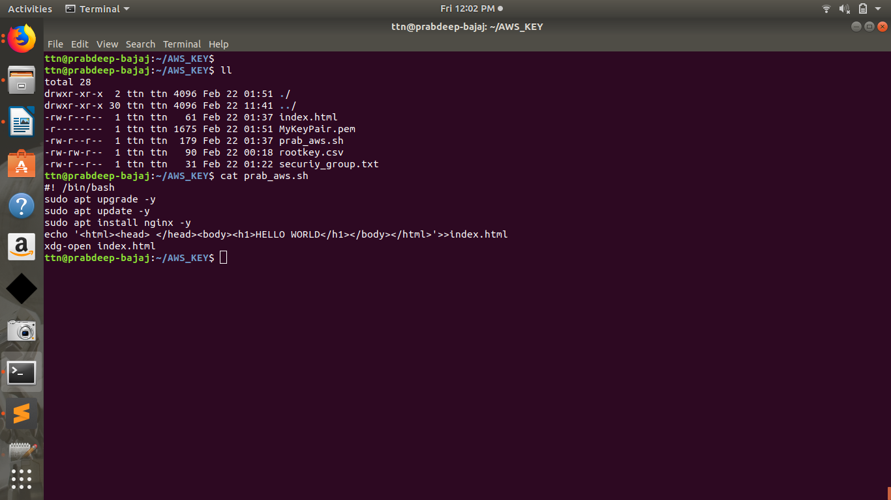

- Add memory metrics for the instance in the cloud watch
https://docs.aws.amazon.com/AWSEC2/latest/UserGuide/mon-scripts.html
https://www.youtube.com/watch?v=aE9ObRt5568&t=306s
{sir, since this service is paid so I am doing this practically but here are the links which describes the respected steps very clearly}

- Increase EBS volume size from 8 GB to 20 GB without rebooting the server on the instance created above

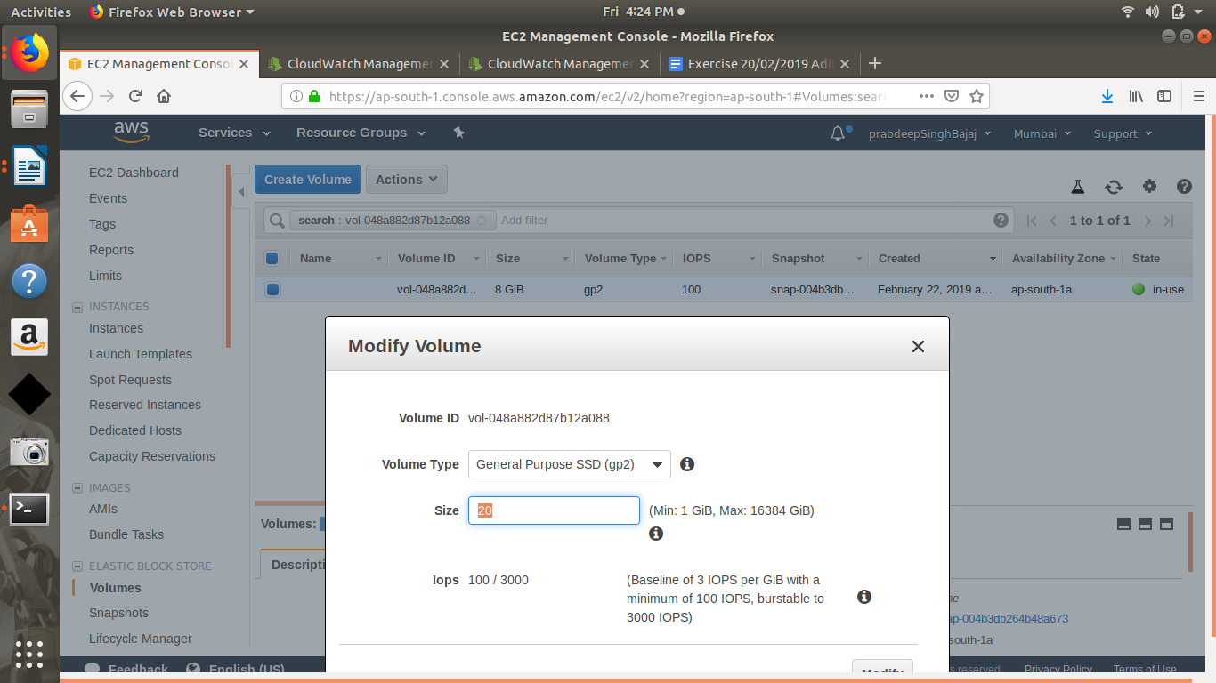

- Convert EBS disk to encrypted EBS disk on the instance created above

Encryption for a new EBS Volume
- From within the AWS Management Console, select EC2
- Under ‘Elastic Block Store’ select ‘Volumes’
- Select ‘Create Volume’
- Enter the required configuration for your Volume
- Select the checkbox for ‘Encrypt this volume’
- Select the KMS Customer Master Key (CMK) to be used under ‘Master Key’
- Select ‘Create Volume’
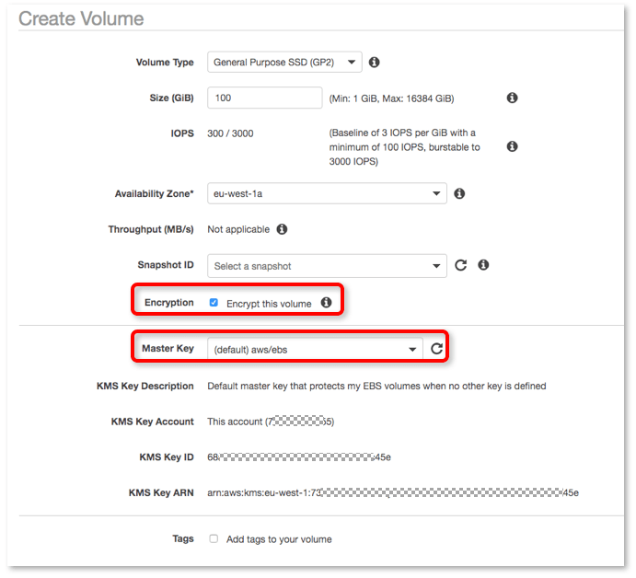
Once your volume has been created, all data saved to this volume will be encrypted when attached to an EC2 instance.

How to Encrypt an Existing EBS Volume
An existing unencrypted volume and the data it contains may not be encrypted. Instead, you’ll need to follow another process, outlined below.
1. Select your unencrypted volume
2. Select ‘Actions’ – ‘Create Snapshot’
3. When the snapshot is complete, select ‘Snapshots’ under ‘Elastic Block Store’ Select your newly created snapshot
4. Select ‘Actions’ – ‘Copy’
5. Check the box for ‘Encryption’
6. Select the CMK for KMS to use as required
7. Click ‘Copy’
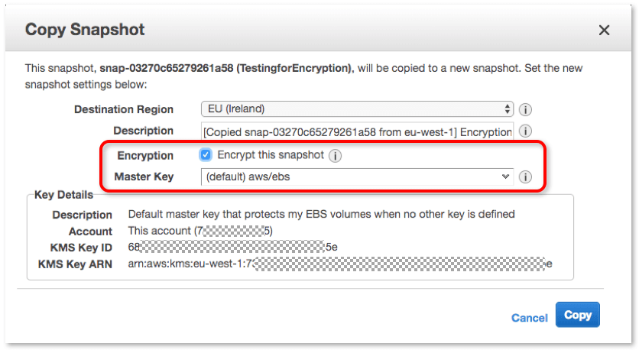
8. Select the newly created snapshot
9. Select ‘Actions’ – ‘Create Volume’
10. You will notice that the normal ‘Encryption’ option is set to ‘True.’ Because the snapshot is itself encrypted, this cannot be modified. The volume now created from this snapshot will be encrypted
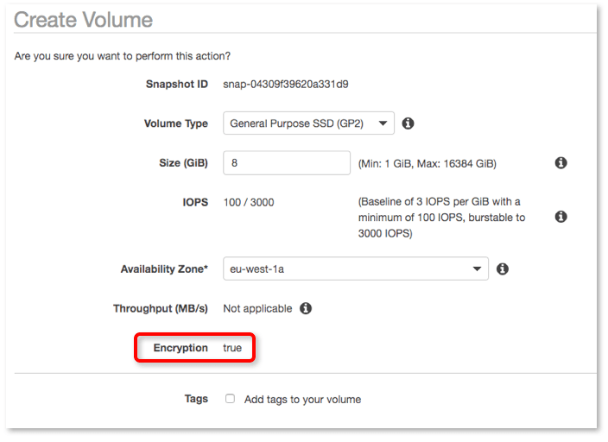

- You have lost the private key for one of the servers, how will you recover ssh access to the server.
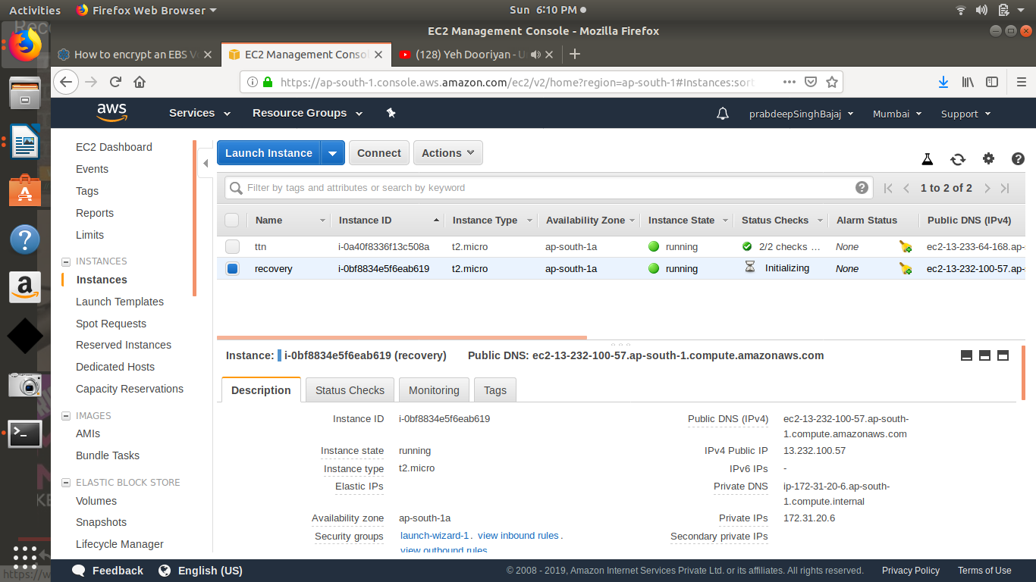
First create a recovery instance :

now detach root volume from first instance and attach as a secondary volume to recovery instance .
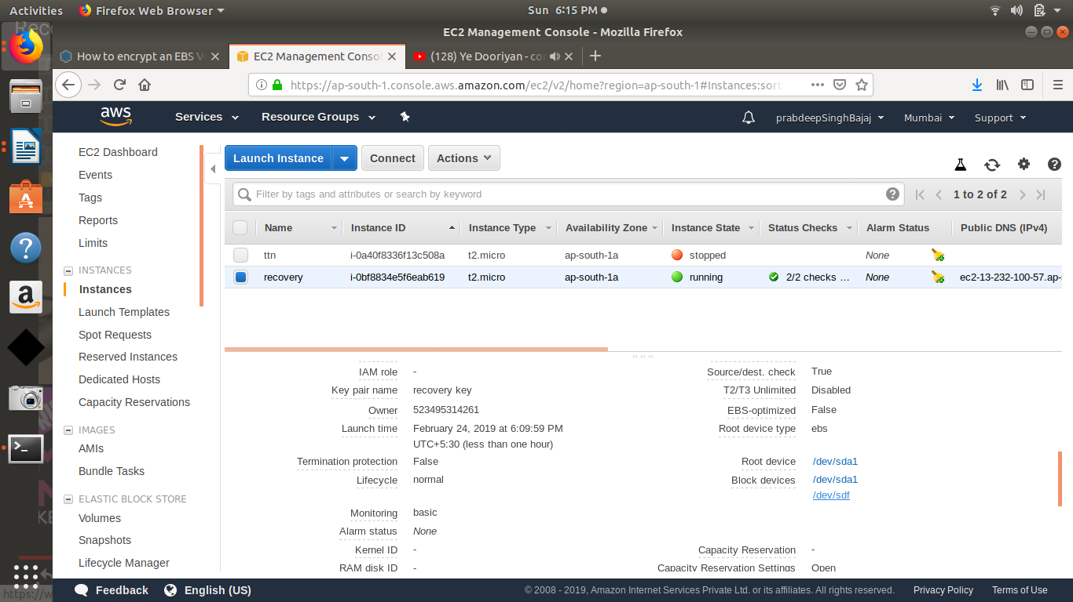
Now mount the block storage and append the recovery key on that root volume
