What is the difference between an Application Server and a Web Server?
A Web server exclusively handles HTTP requests, whereas an
application server serves business logic to application programs through any
number of protocols.
In most cases, the server exposes this business logic through a component
API, such as the EJB (Enterprise JavaBean) component model found on J2EE
(Java 2 Platform, Enterprise Edition) application servers. Moreover, the
application server manages its own resources. Such gate-keeping duties
include security, transaction processing, resource pooling, and messaging

Write down name of Application Servers and Web Servers.
Application: apache tomcat , jetty,Jboss , glassfish etc
Web : apache , nginx etc

What are java servlet?
A servlet is a server-side component written in Java programming language that receives requests from client and sends responses back.
Servlet is the key component that forms a typical Java EE application, beside JSP, EJB, XML and other related technologies. A Java EE application can be packaged in a WAR file (Web ARchive) in order to be deployed on a web server. A web server that can run Java servlet is called a servlet container. The most popular and widely used servlet containers are Apache Tomcat, Glassfish, JBoss, etc.
Technically, a servlet is a normal Java class that extends either:
  - javax.servlet.GenericServlet class for generic client-server protocol, or:
  - javax.servlet.http.HttpServlet class for HTTP protocol.

Describe tomcat directory structure.
/bin : Contains Start/Stop scripts for tomcat for both windows and linux operating system. Also consists of JAR files with classes required to control tomcat server.
/conf : Contains main configuration files (web.xml and server.xml).
/lib : Contains the Tomcat Java Archive (jar) files, shared across all Tomcat components.
/logs : Contains tomcat log files.
/temp: Temporary file storage.
/webapps : Deployment staging directory, where you place your WAR file.
/work : Tomcat`s working directory where Tomcat places all servlets that are generated from JSPs.

How to change default port in tomcat?
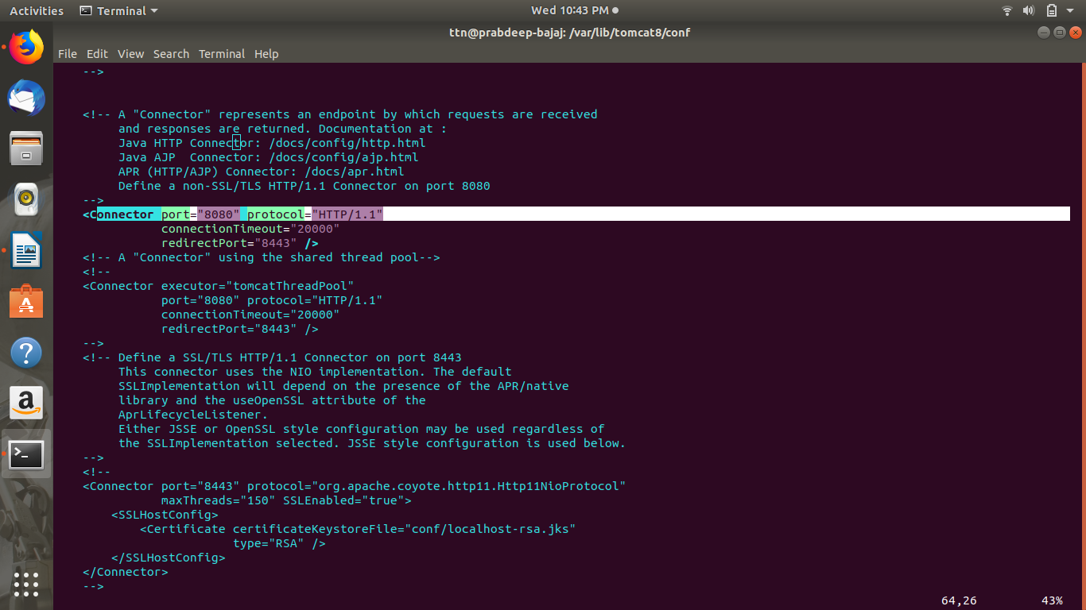
Going to tomcat>conf folder
- Edit server.xml
- Search "Connector port"
- Replace "8080" by your port number
- Restart tomcat server.

Install Tomcat and nginix and set proxy_pass in nginx to display Tomcat.
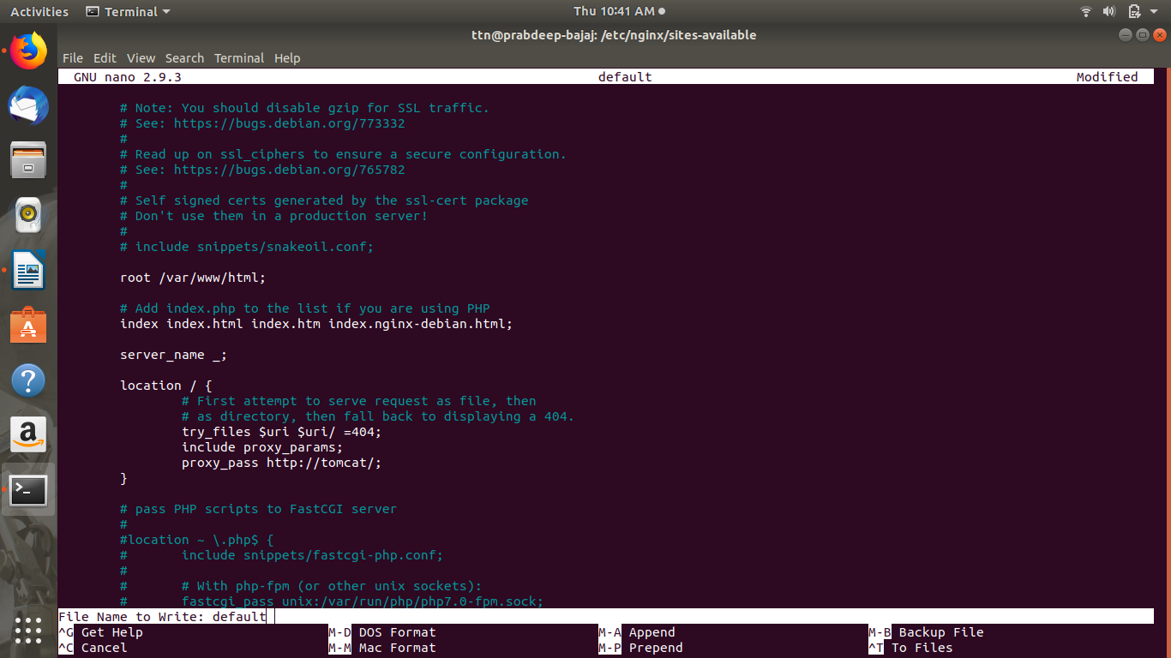

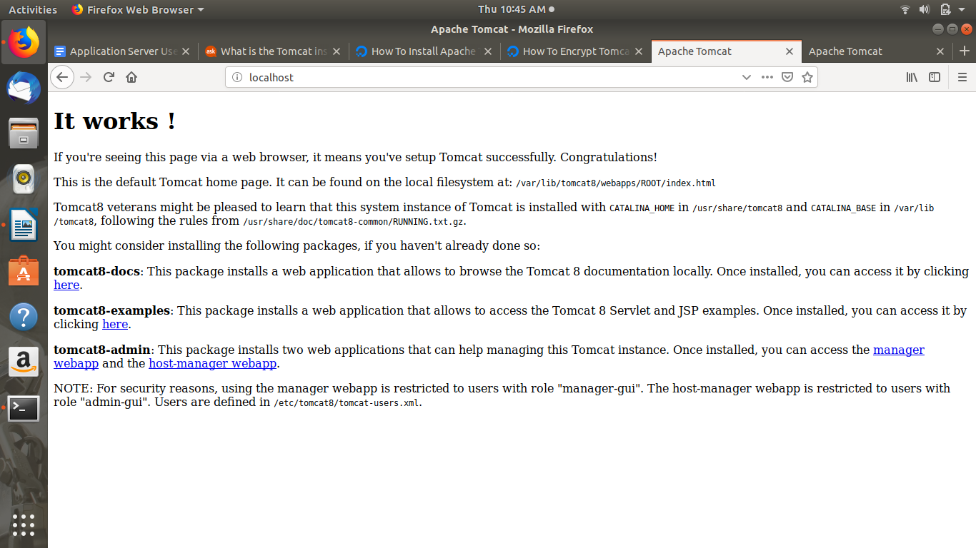

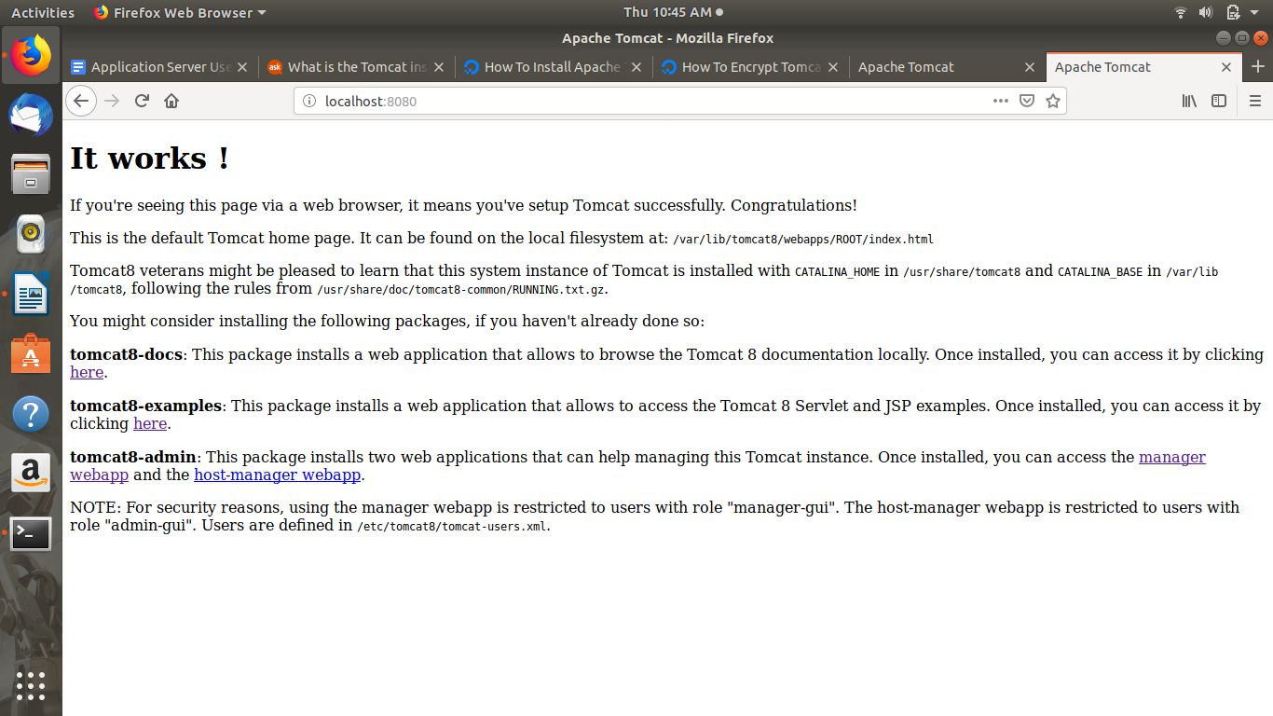

Configure Tomcat as a Service.
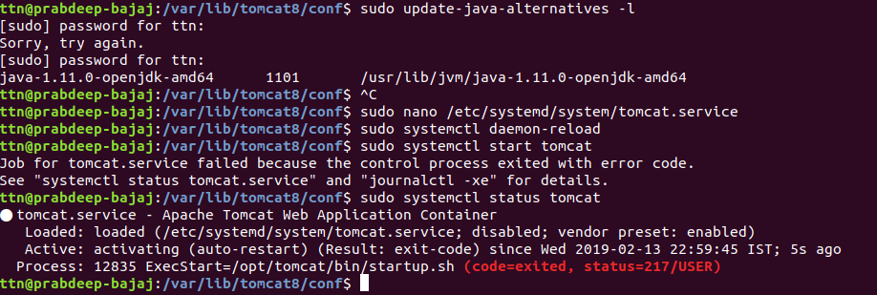

Use any web server in front of tomcat using AJP and HTTP connector.
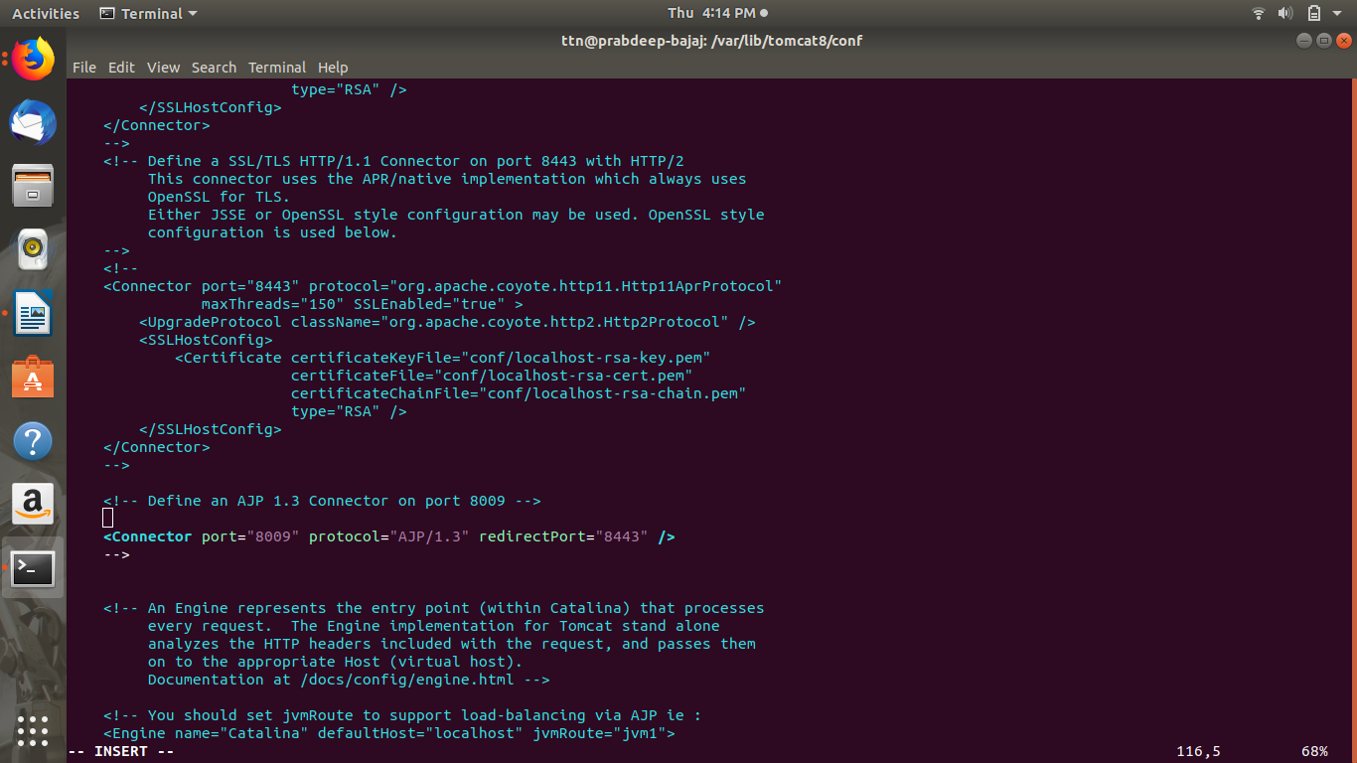
Configure tomcat to use any mysql server.
->ANSWER TO BE DISCUSSS IN THE DOUBT SESSION ON MONDAY

