1) Run Ansible Ad-hoc commands:
To execute command in bash and see the result
sudo ansible myservers -m shell -a '/bin/bash -c "toto=`uname -n` ; touch /var/tmp/\$toto.json;"'
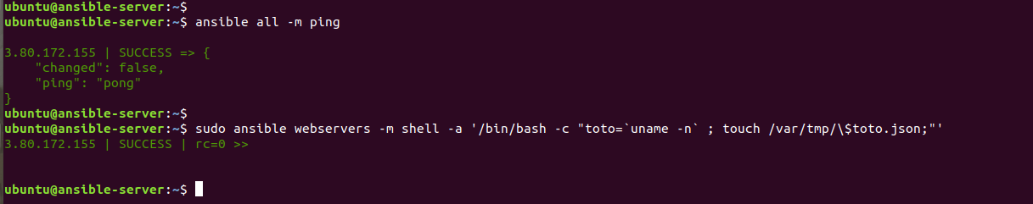
To check all running processes on node.
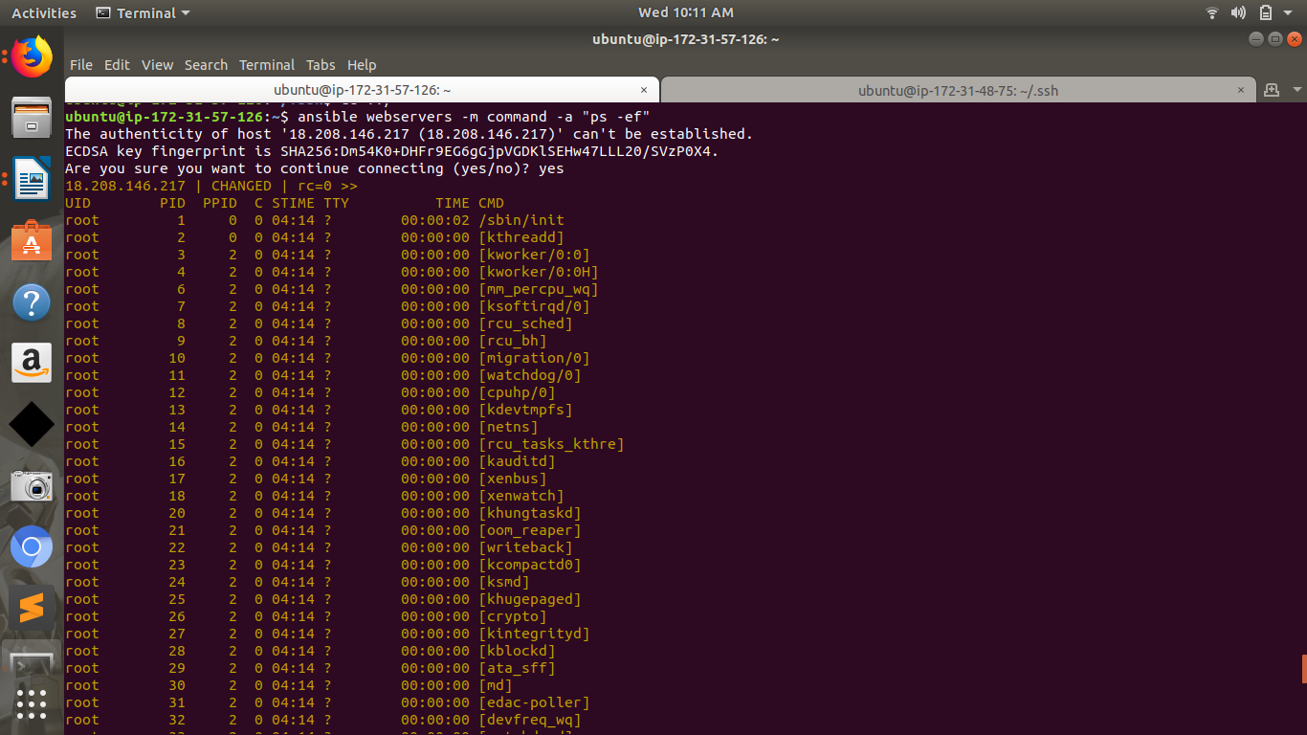

To check disk partitions on node.
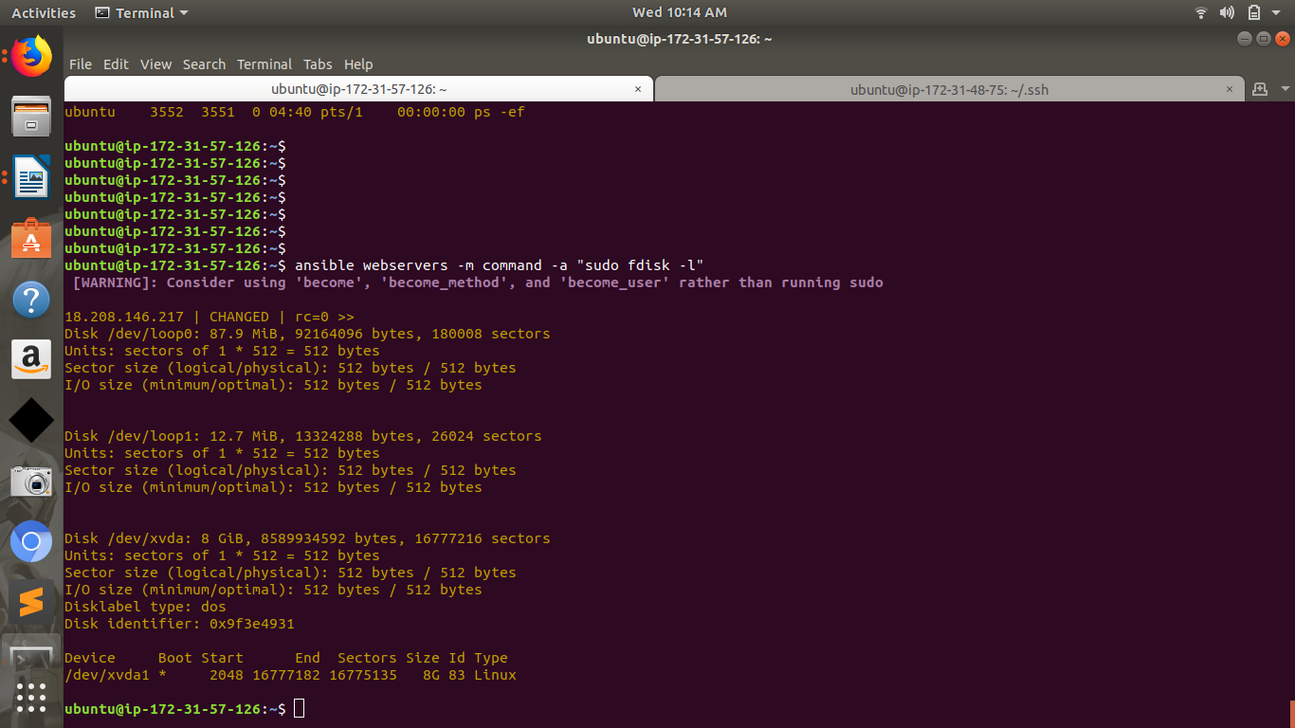
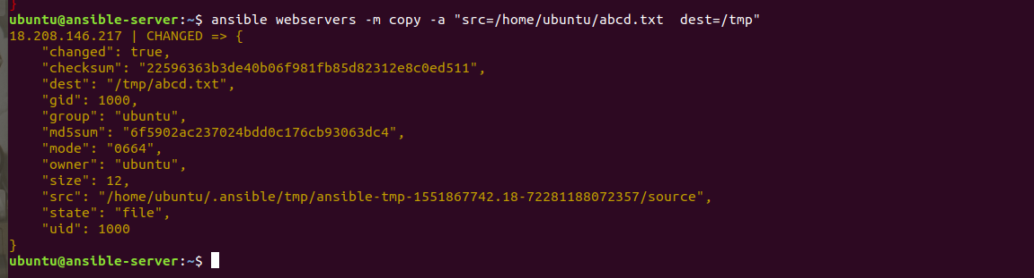
To copying files to multiple nodes concurrently.

To add and delete users.
ansible webservers -m command -a 'sudo useradd prab'
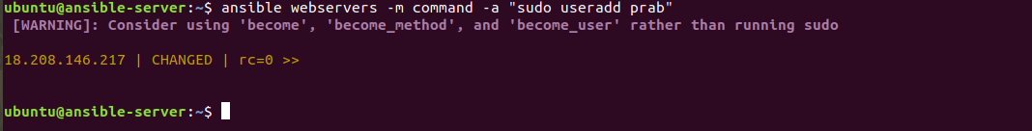
ansible webservers -m command -a “sudo userdel prab”
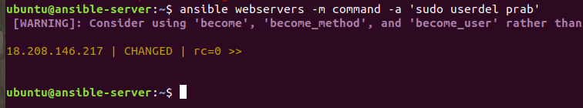
2) Create nginx ansible-playbook and run the node , also check if nginx service and default page is running or not.
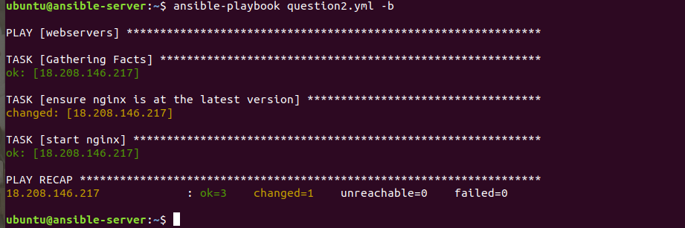
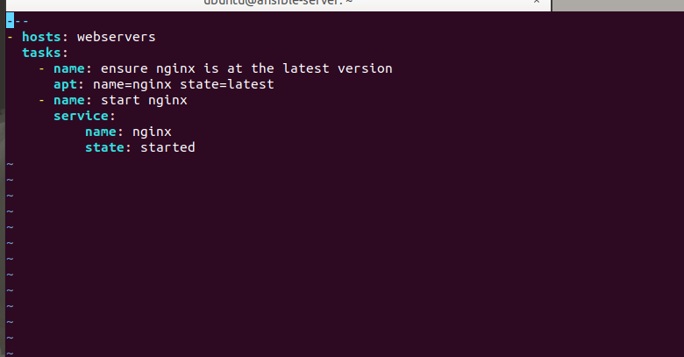
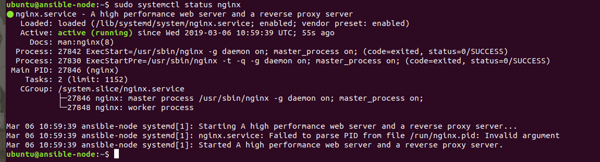
3) Define a host with any name and call two roles – Jenkins Installation along with 8080 and Tomcat Installation along with 8081
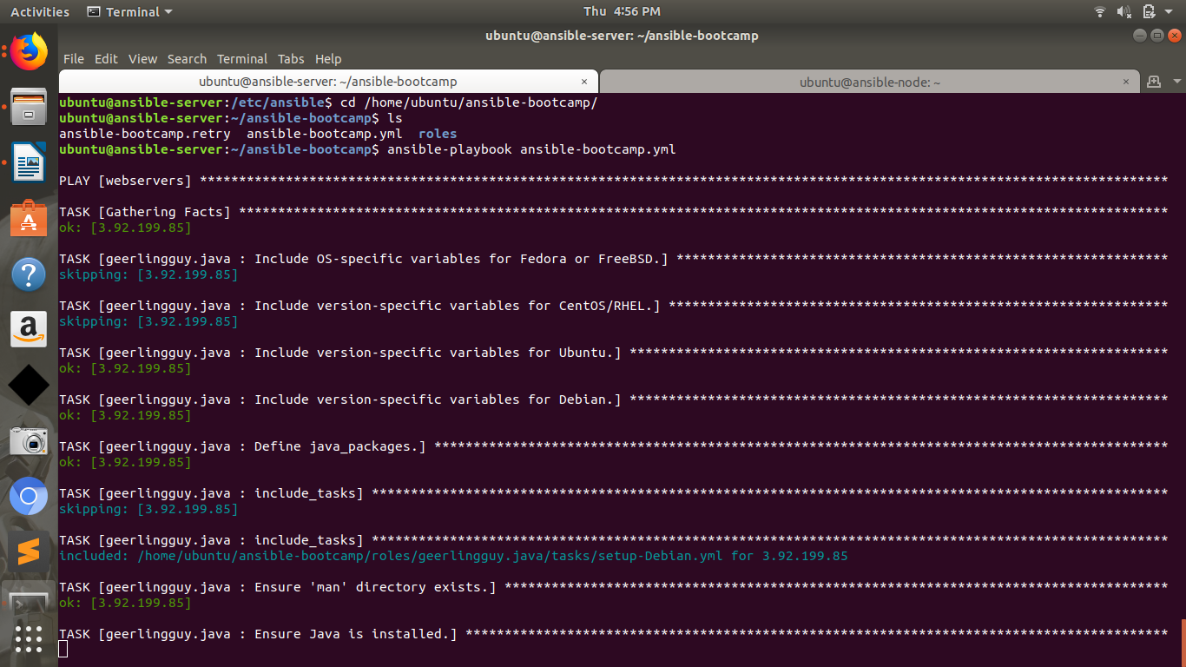
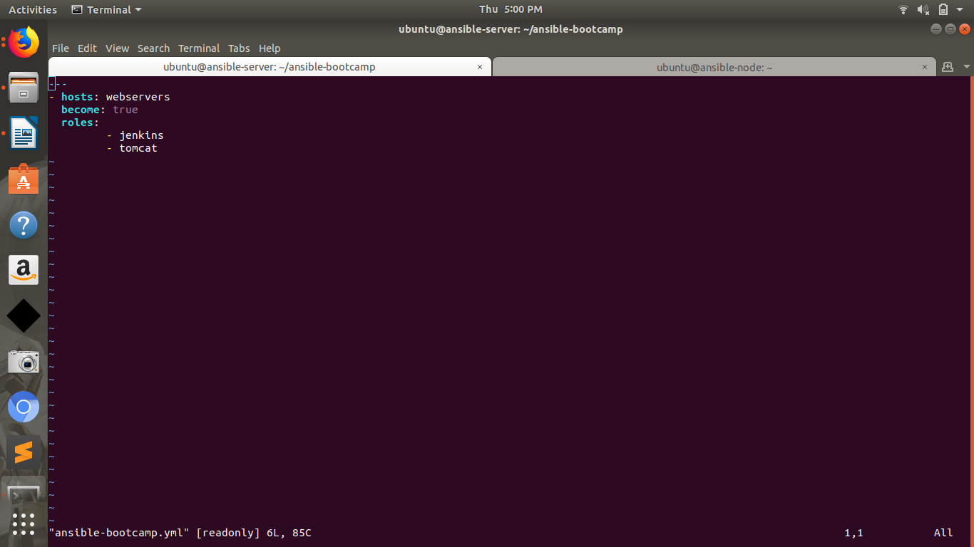
4) Difference between Playbook and Roles
Playbooks are the files where Ansible code is written. Playbooks are written in YAML format. YAML stands for Yet Another Markup Language. Playbooks are one of the core features of Ansible and tell Ansible what to execute. They are like a to-do list for Ansible that contains a list of tasks.
Variables:
Ansible can work with metadata from various sources and manage their context in the form of variables.
Command line parameters
Plays and tasks
Files
Inventory
Discovered facts
Roles

Example:
---
- name: install and start apache
hosts: web
become: yes
vars:
http_port: 80
tasks:
- name: httpd package is present
yum:
name: httpd
state: latest
- name: latest index.html file is present
copy:
src: files/index.html
dest: /var/www/html/

Roles
Roles are a packages of closely related Ansible content that can be shared more
easily than plays alone.

- Improves readability and maintainability of complex plays
- Eases sharing, reuse and standardization of automation processes
- Enables Ansible content to exist independently of playbooks, projects even organizations
- Provides functional conveniences such as file path resolution and default values
- Each role is a directory tree in itself. The role name is the directory name within the /roles directory.

