Create a Lambda function which get triggered from a SNS and lists all the running instances.
FUNCTION :
import json
import boto3
def lambda_handler(event, context):

access_key='xxxxxxxxxx'
secret_key='xxxxxxxxxxxxxxxxxxxxxxx'
ec2 = boto3.resource('ec2')
# create filter for instances in running state
filters = [
{
'Name': 'instance-state-name',
'Values': ['running']
}
]

# filter the instances based on filters() above
instances = ec2.instances.filter(Filters=filters)

# instantiate empty array
RunningInstances = []
for instance in instances:
# for each instance, append to array and print instance id
RunningInstances.append(instance.id)
print (instance.id)
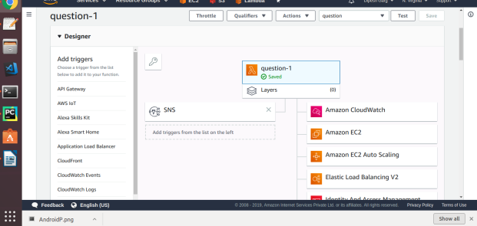

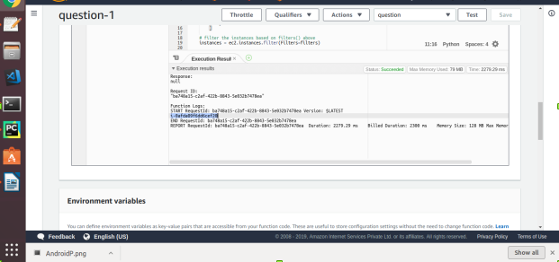

Create a Lambda function which gets invoked whenever a file is added to a s3 bucket and prints the list of all the files present in that bucket.
FUNCTION :

import boto3
def lambda_event(event, context):

from boto3.session import Session

ACCESS_KEY='xxxxxxxxxxxxxxxxxx'
SECRET_KEY='xxxxxxxxxxxxxxxxxxxx'

session = Session(aws_access_key_id=ACCESS_KEY,
aws_secret_access_key=SECRET_KEY)
s3 = session.resource('s3')
your_bucket = s3.Bucket('assignment-s3-03')

for s3_file in your_bucket.objects.all():
print(s3_file.key)

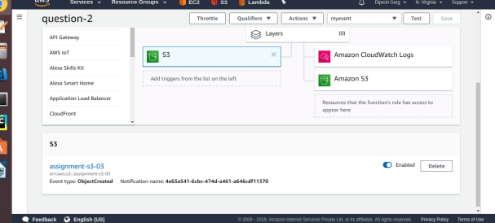

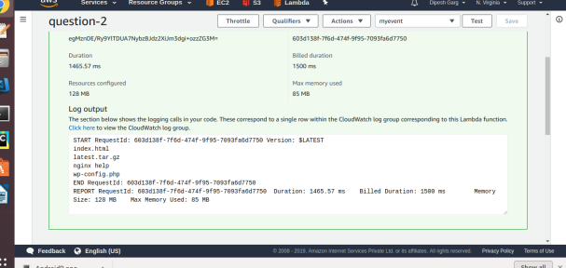

Create a Lambda functions which gets triggered daily and takes the AMI of a particular EC2 instance.
FUNCTION :
import json
import boto3
def lambda_handler(event, context):

access_key='xxxxxxxxxxxxxxxxx'
secret_key='xxxxxxxxxxxxxxx'
ec2 = boto3.client('ec2')
ec2.create_image(InstanceId="i-0afda09f6dd6cef20",Name="ec2")
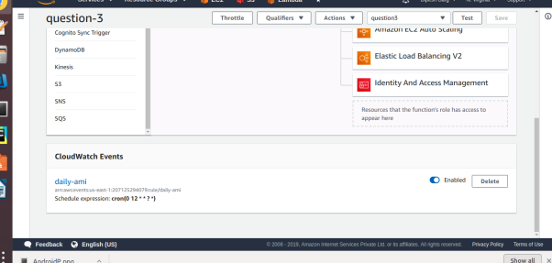
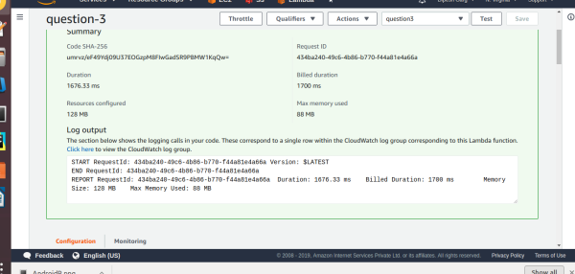

Create a Lambda function which will login to a EC2 instance and prints all the running services. (Use python’s paramiko module to do SSH. Also, launch lambda in a VPC).

Unable to run lambda-no module named paramiko, so made a python function on local
FUNCTION :
import boto3
import paramiko

def functi():
k = paramiko.RSAKey.from_private_key_file("/home/ttn/Downloads/sp.pem")
c = paramiko.SSHClient()
c.set_missing_host_key_policy(paramiko.AutoAddPolicy())
print(k)
host = '3.82.205.106'
print("Connecting to " + host)
c.connect(hostname=host, username="ubuntu", pkey=k)
print("Connected to " + host)

commands = [
"ps"
]
for command in commands:
print ("Executing {}".format(command))
stdin, stdout, stderr = c.exec_command(command)
print(stdout.read())

functi()

