- Monitor Your Estimated Charges Using CloudWatch
Step 1: Enable Billing Alerts
Step 2: Create a Billing Alarm
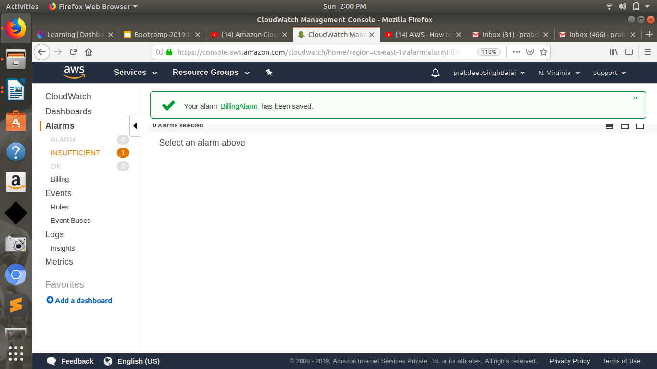
Step 3: Check the Alarm Status
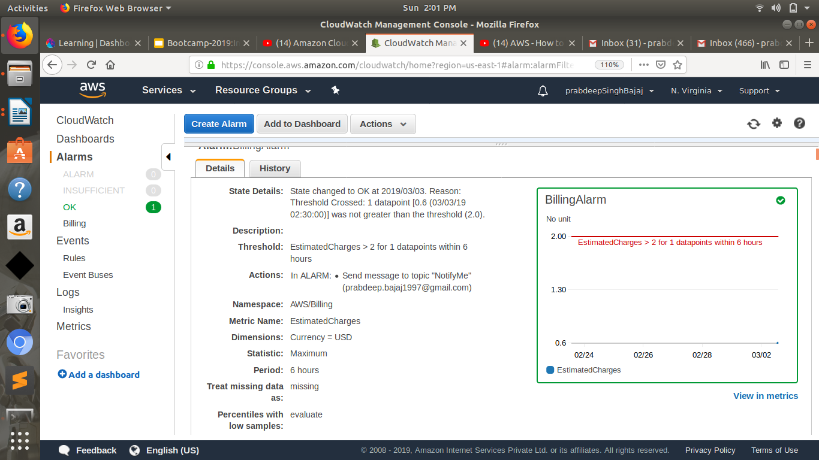

Step 4: Create & Subscribe to SNS Topic
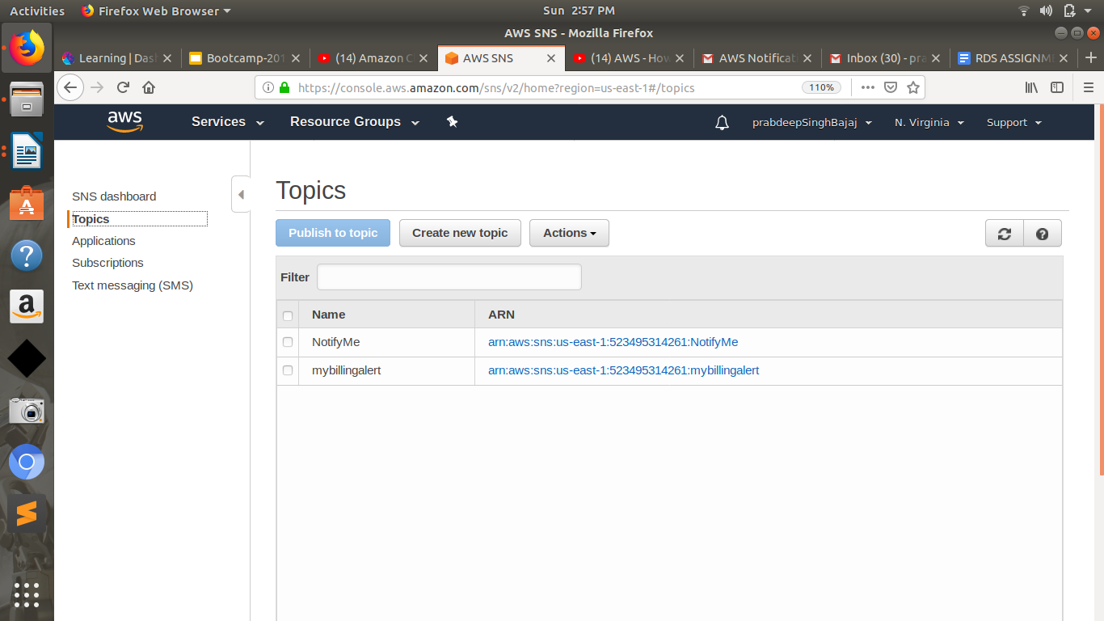

Step 5: Send a notification all the stakeholder, if AWS resource pricing reaches the threshold value.
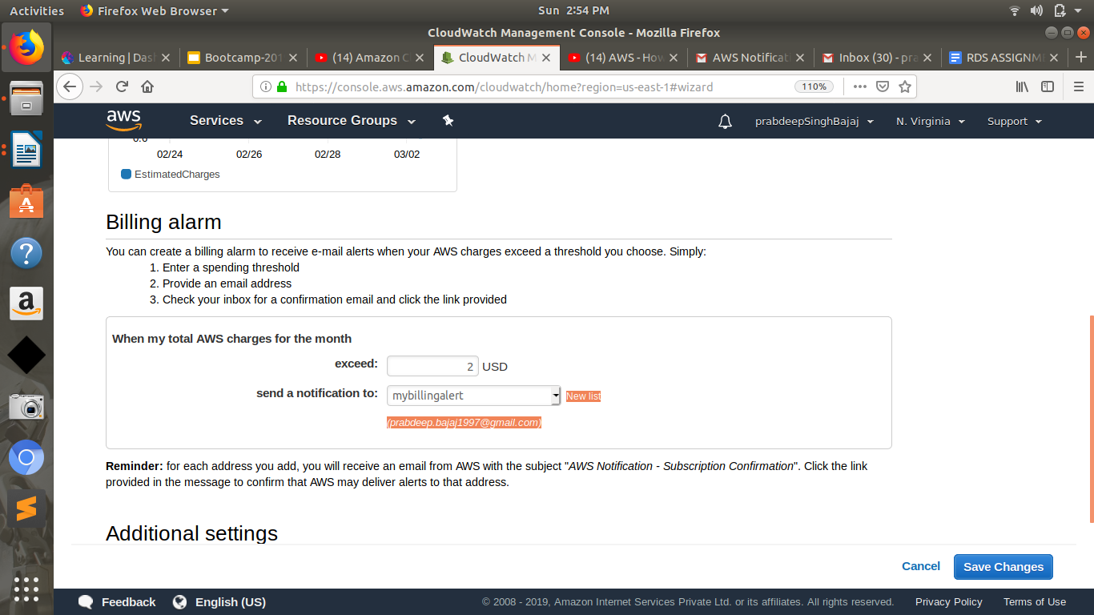

2. Create a custom Memory metric in CloudWatch and set up alarm at 80 % which will autoscale the instance in the autoscaling group.
https://docs.aws.amazon.com/AWSEC2/latest/UserGuide/mon-scripts.html
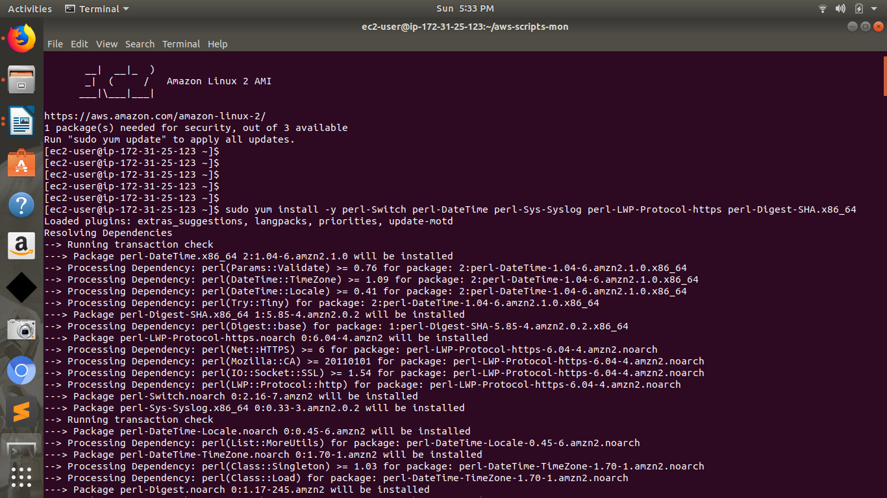
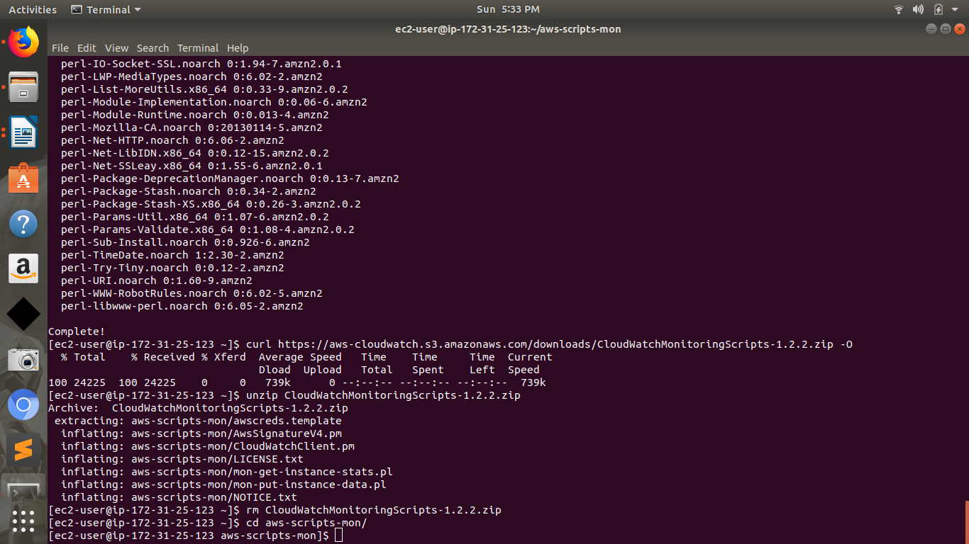
If you associated an IAM role (instance profile) with your instance, verify that it grants permissions to perform the following operations:
- cloudwatch:PutMetricData
- cloudwatch:GetMetricStatistics
- cloudwatch:ListMetrics
- ec2:DescribeTags
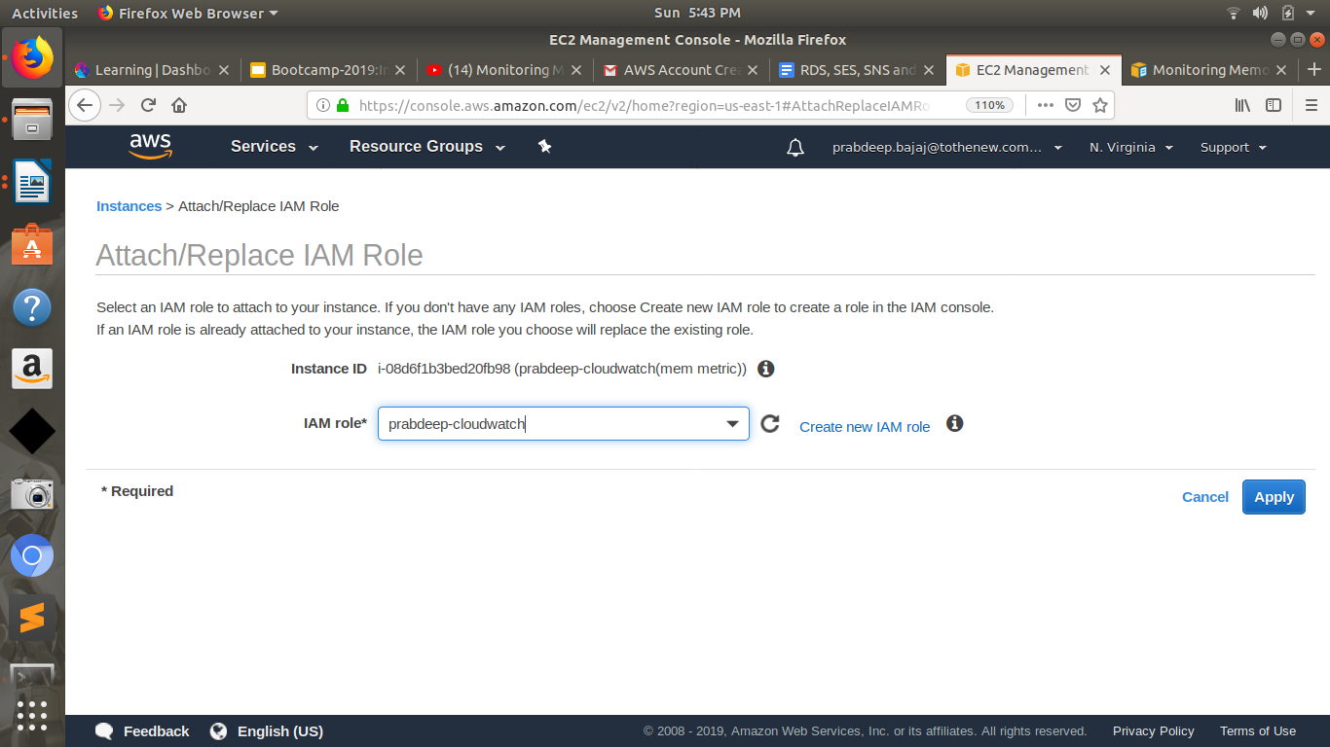
./mon-put-instance-data.pl --mem-used-incl-cache-buff --mem-util --mem-used --mem-avail
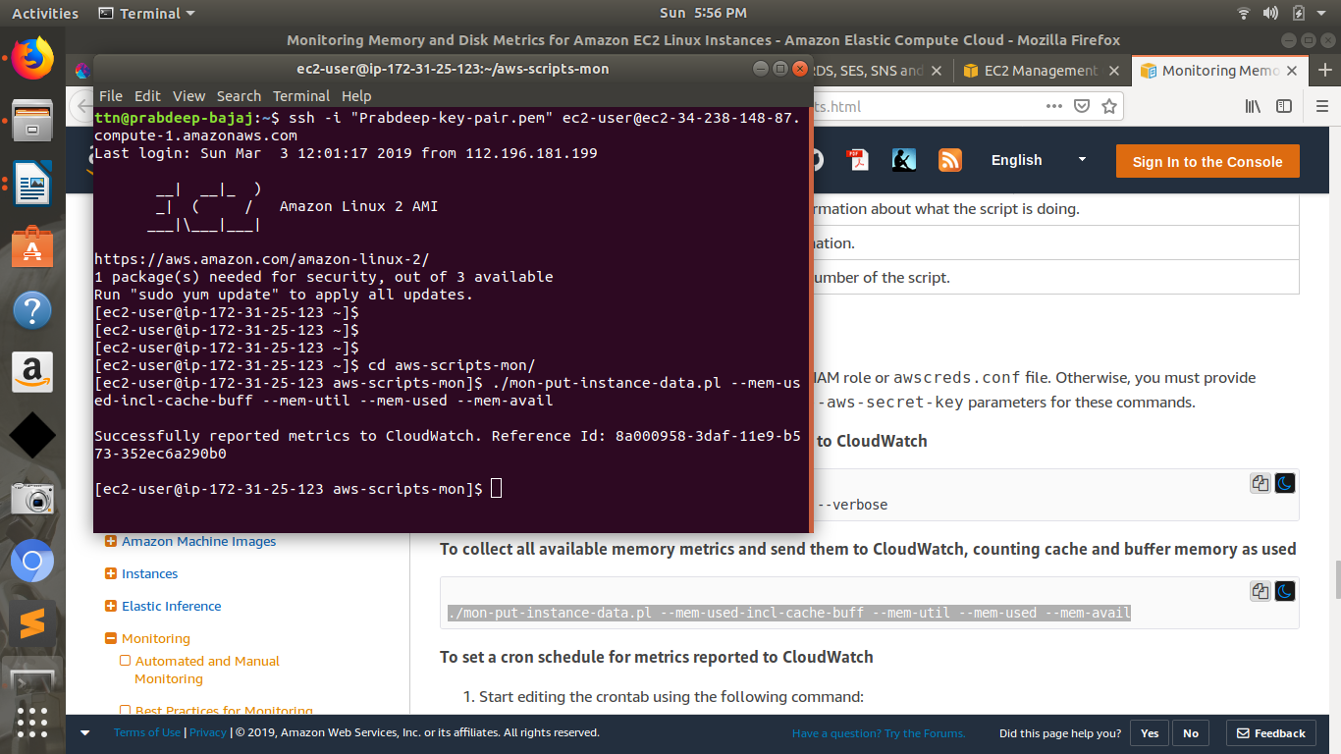
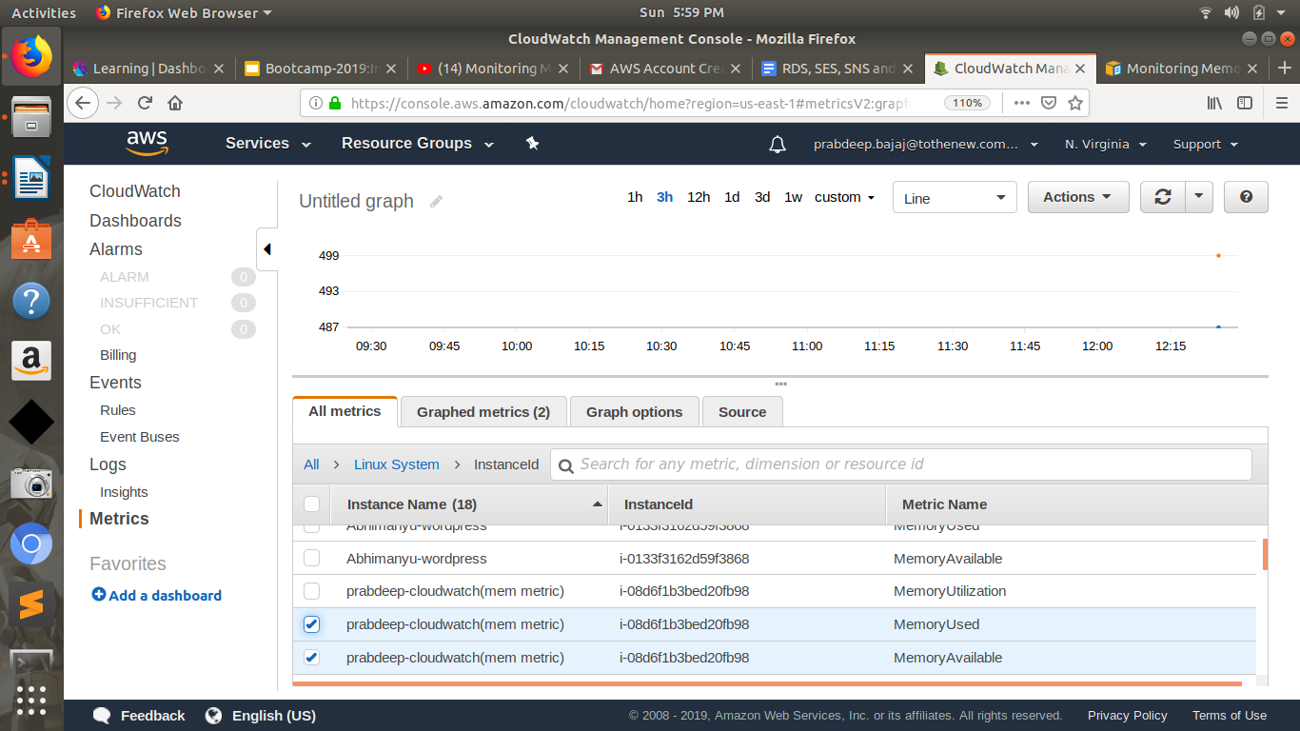
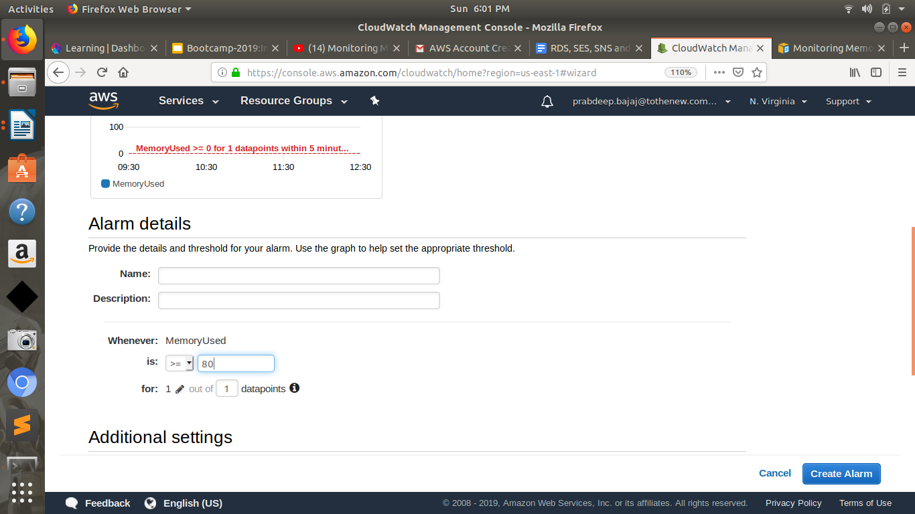
3. Launch RDS aurora with one Read replica and Monitor RDS instance using CloudWatch and set up notification upon CPU utilization is above 80 %.
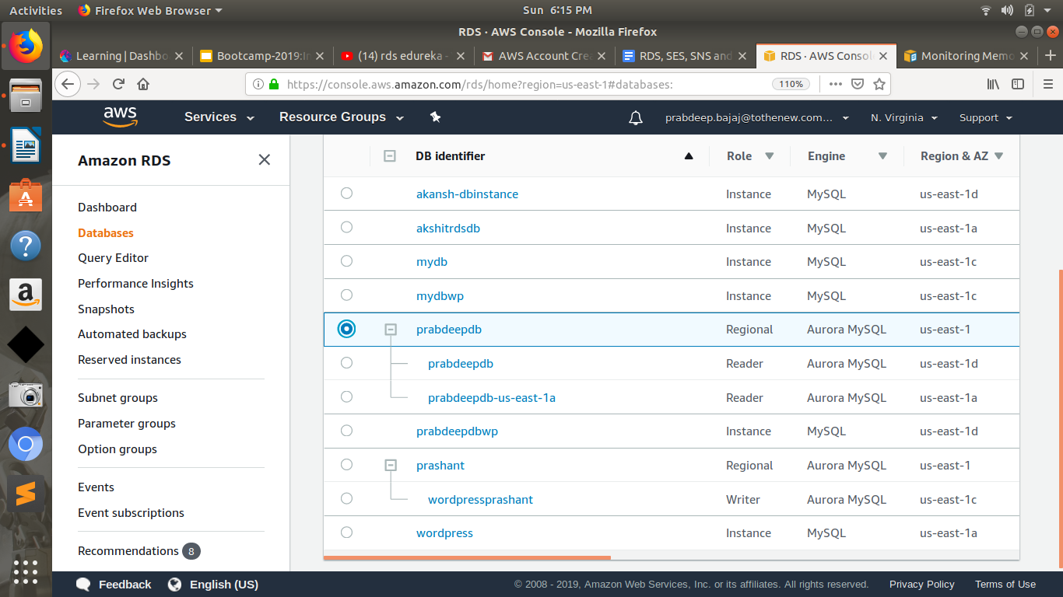
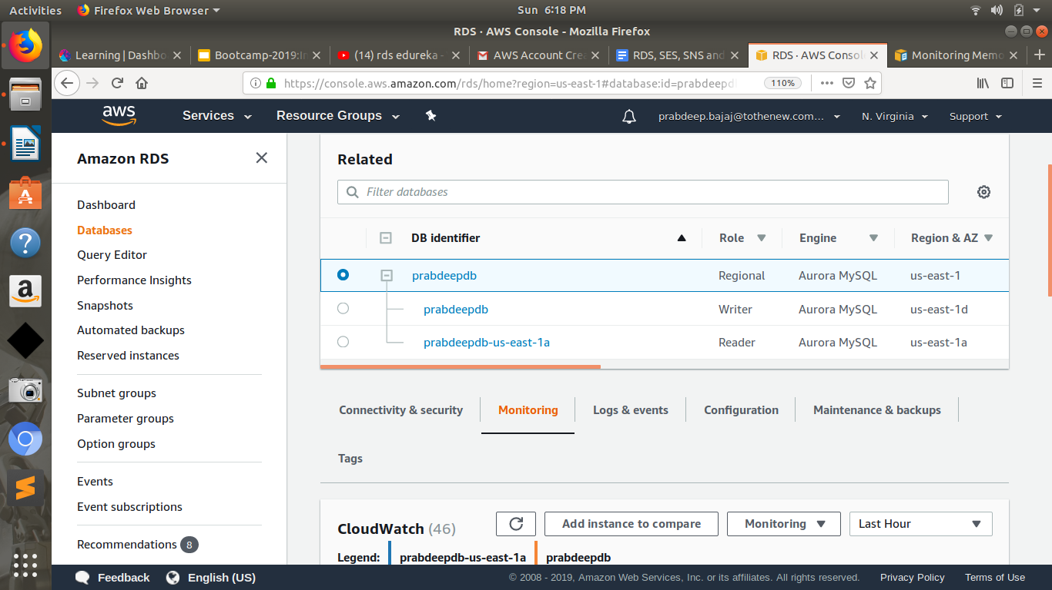

4. Create SNS topic, subscribe to a topic, publish message, unsubscribe the message and delete the topic.
