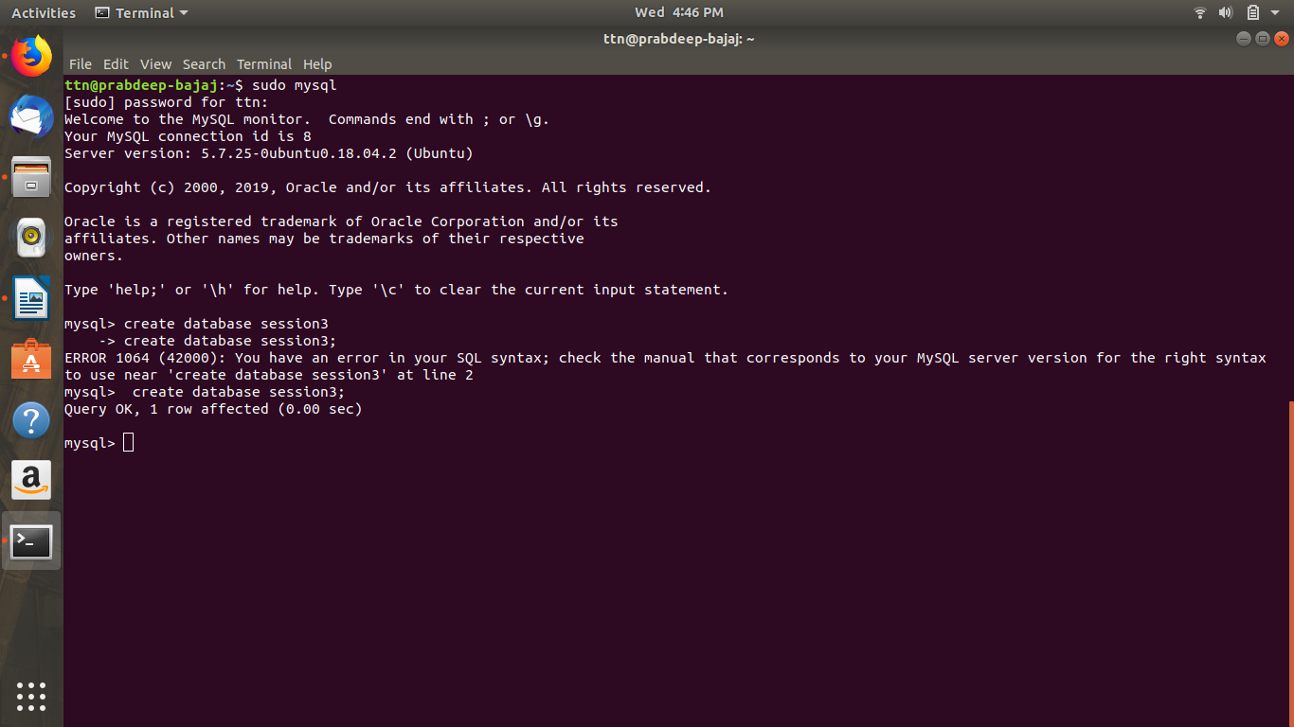
1. Create Database

2.Design Schema
cus_name

order_details
cus_add

cus_id
order_id
CUSTOMER TABLE
ORDER TABLE
SALES TABLE
Sales_id
sales_name
salesperson
customer

3. Create tables
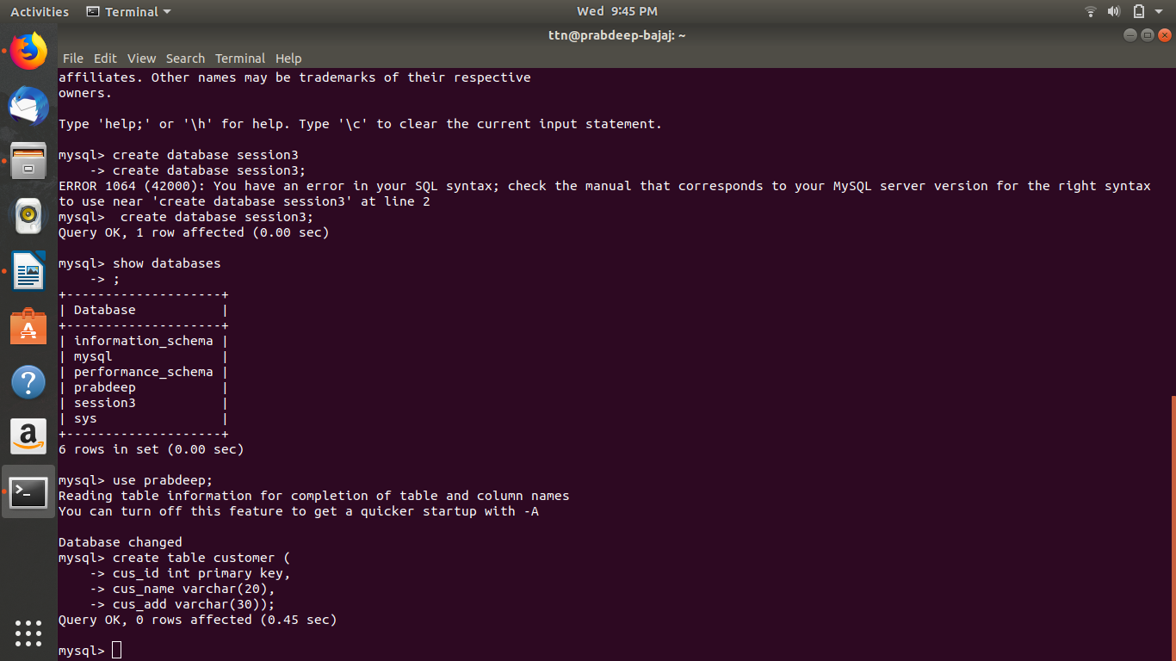
4. Insert sample data
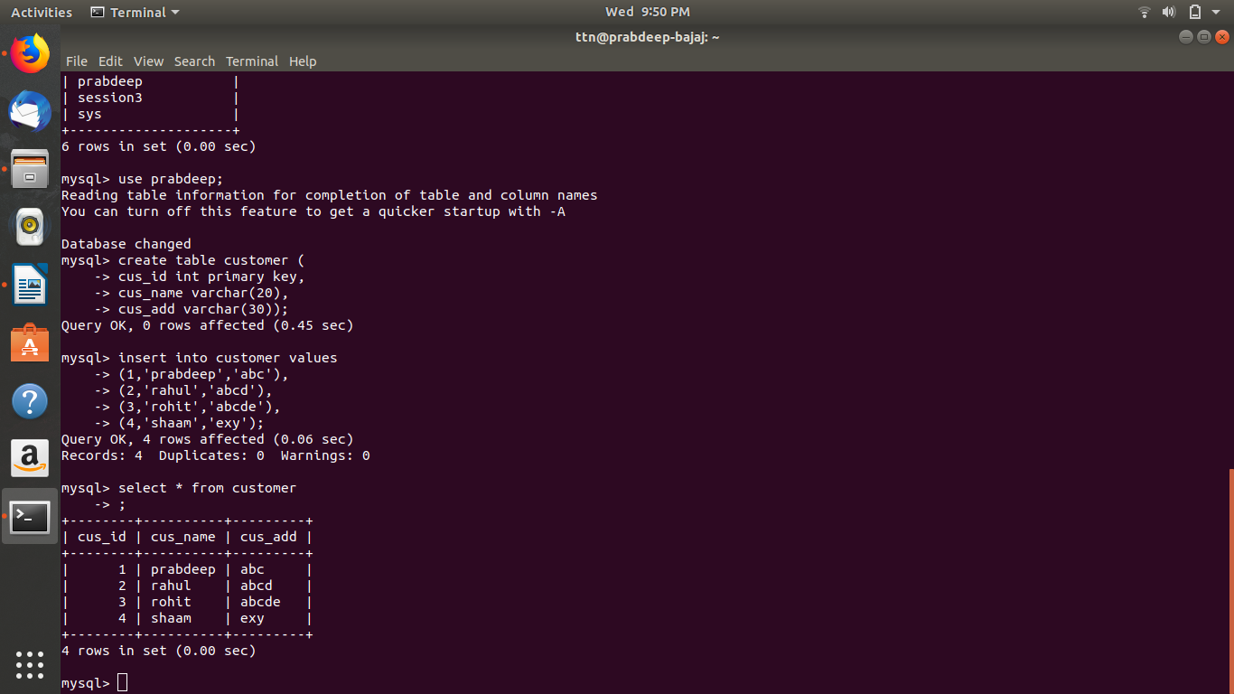

5. Find the sales person have multiple orders.
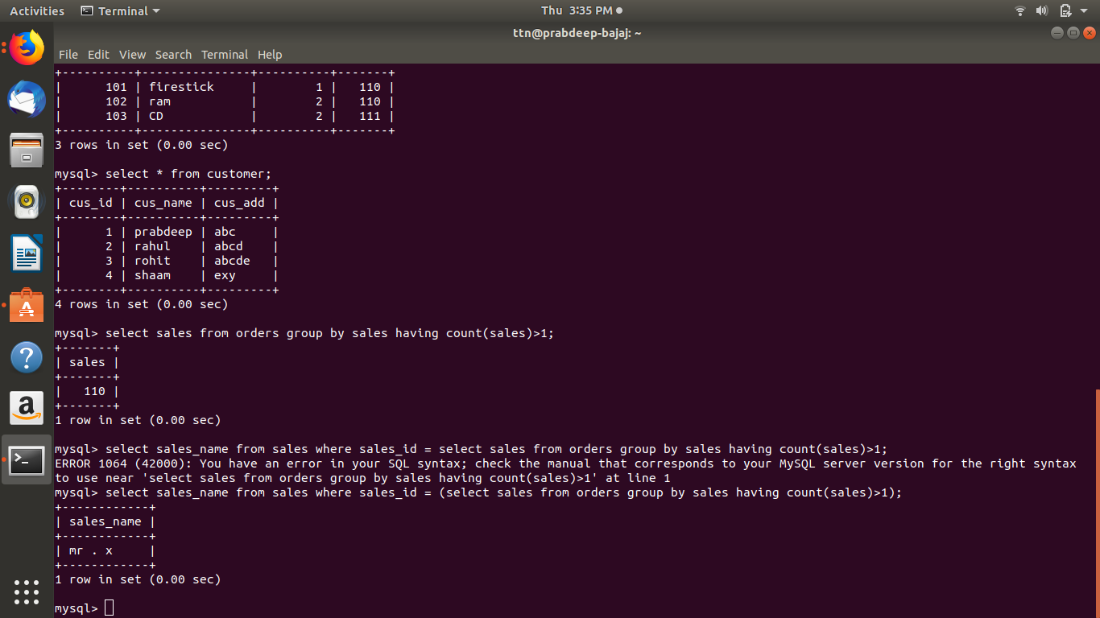
6.Find the all sales person details along with order details

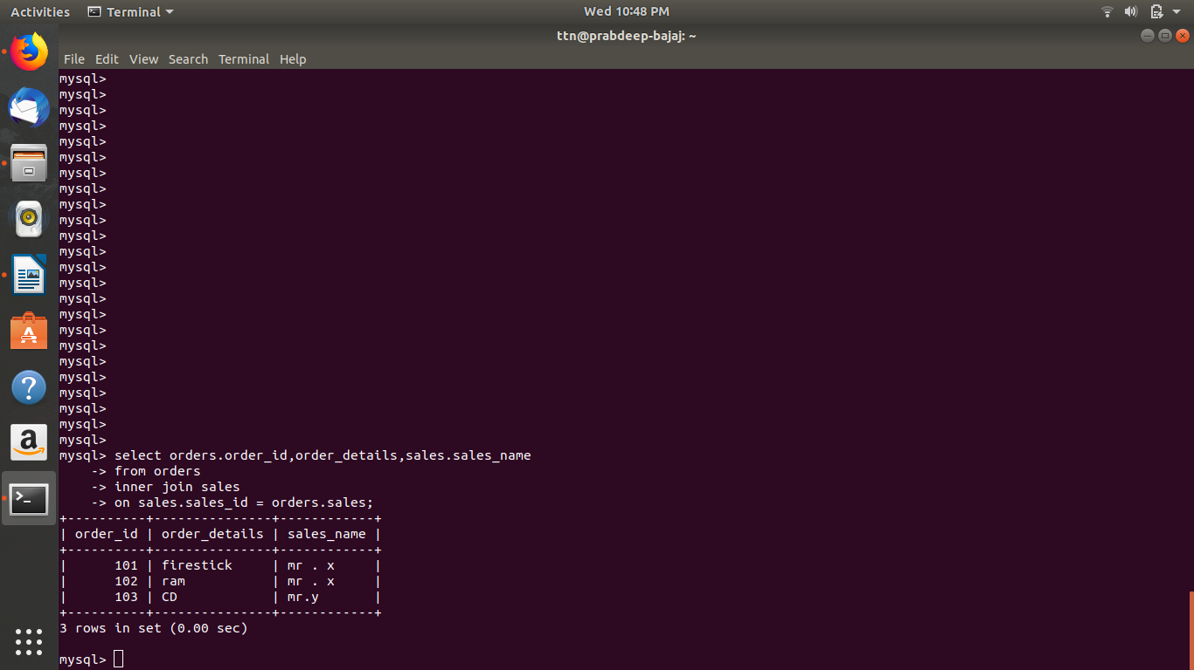

7. Create index
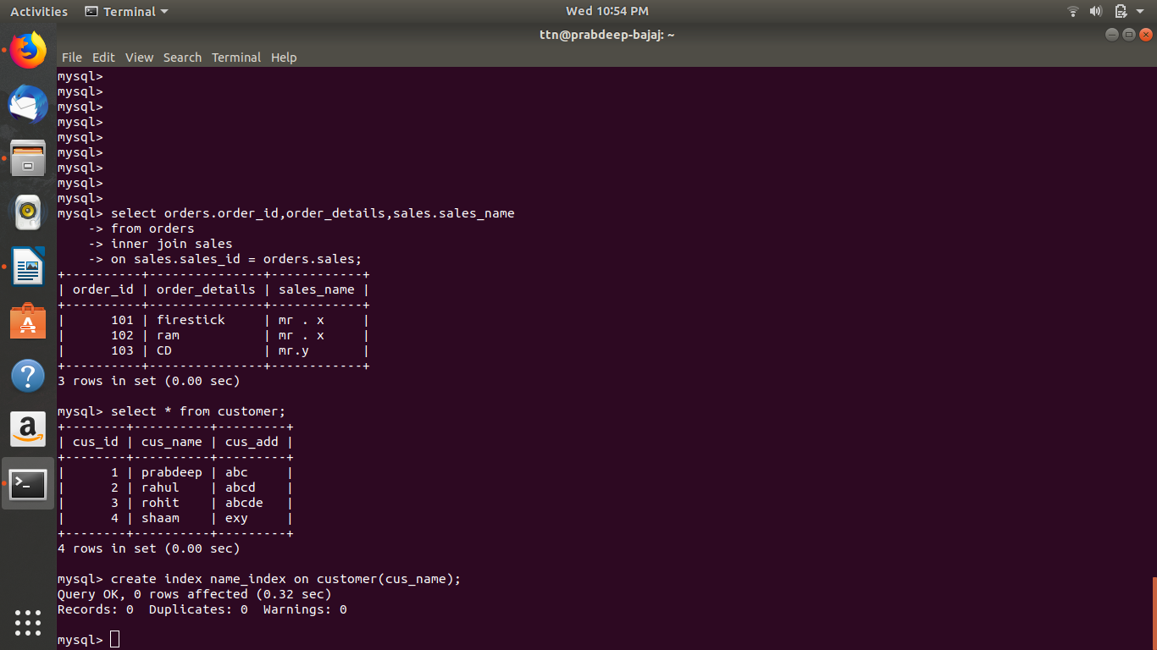

7. How to show index on a table

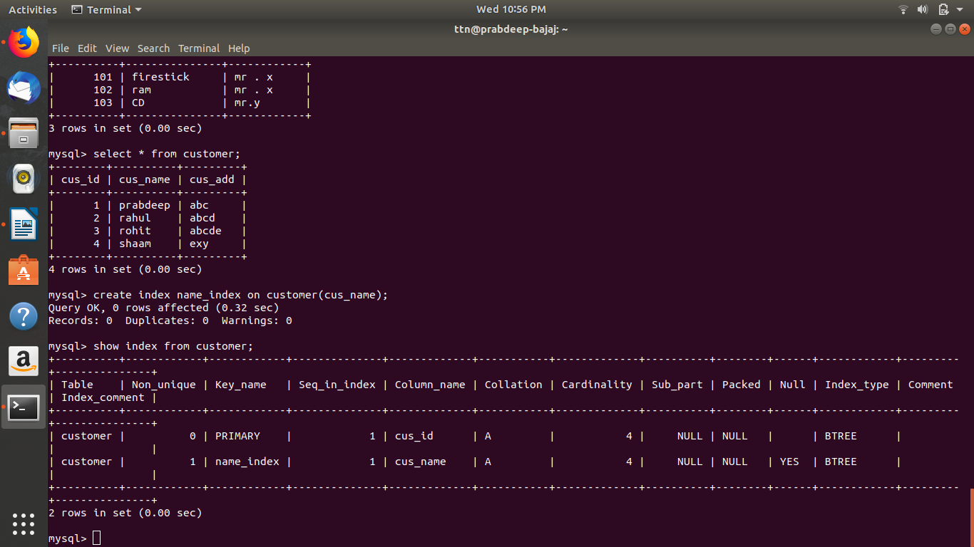

8. Find the order number, sale person name, along with the customer to whom that order belongs to

