- Set the base image to Ubuntu
  - Add File Author / Maintainer
  - Install Nginx
  - Install necessary tools: vim wget curl net-tools
  - Remove the default Nginx configuration file
  - Copy a configuration file from the current directory
  - Expose ports (80)
  - Set the default command to execute when creating a new container

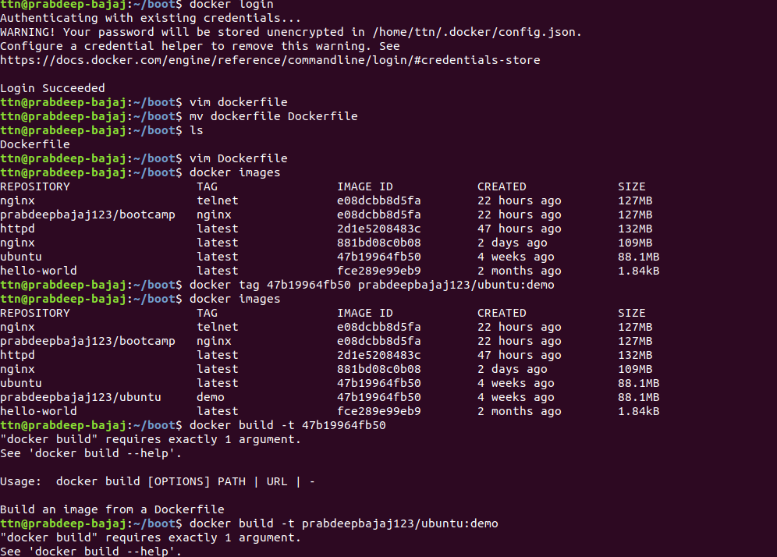
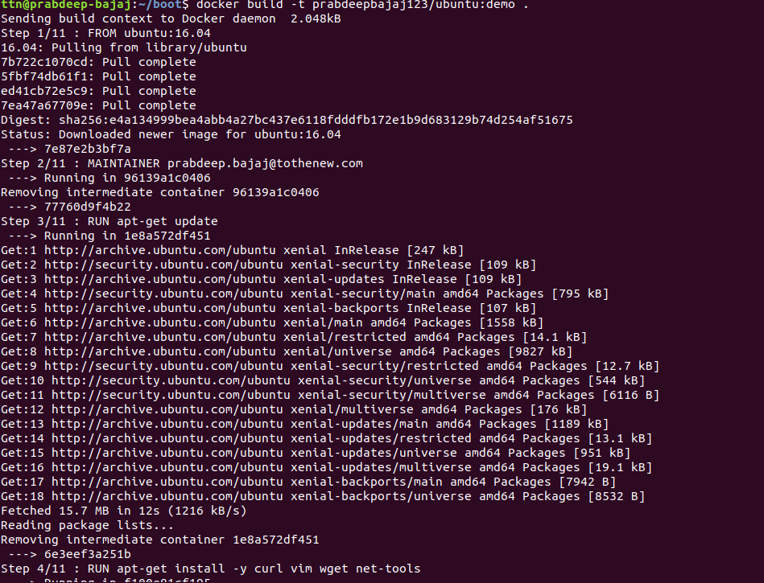
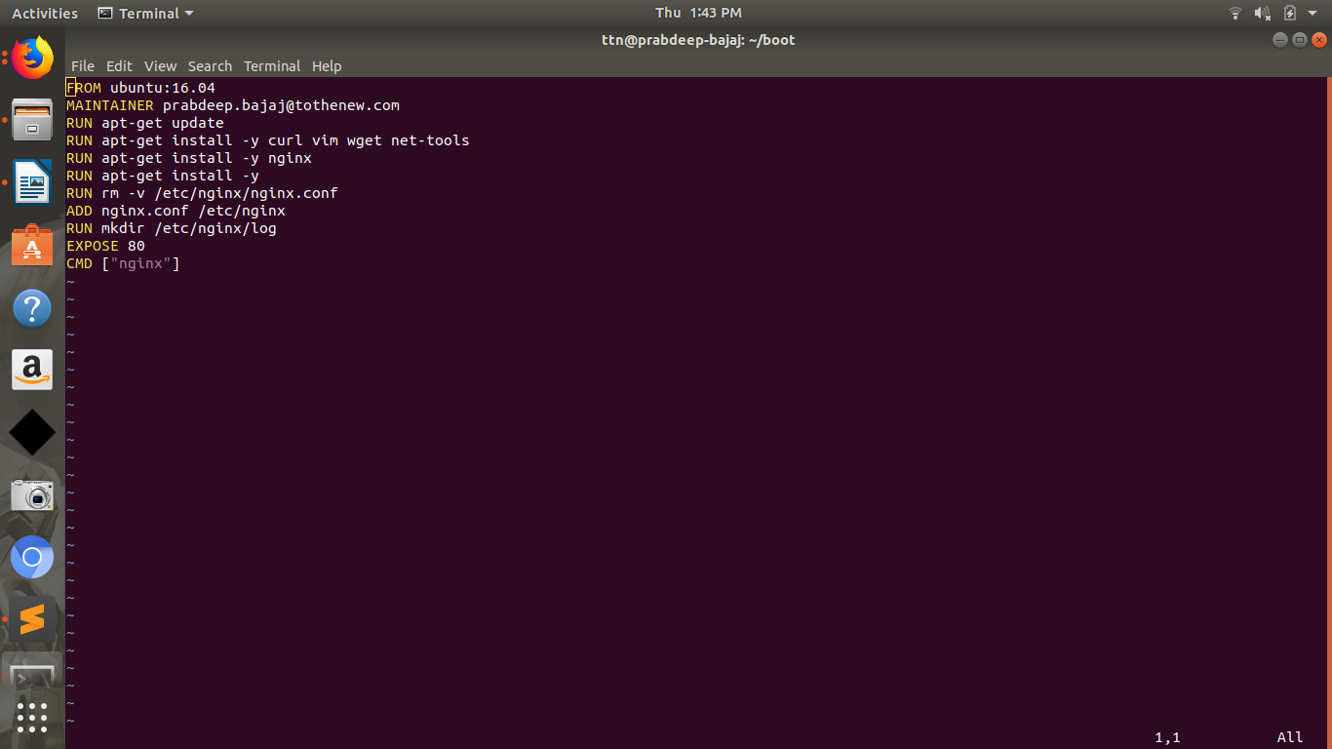
FROM ubuntu:16.04
MAINTAINER prabdeep.bajaj@tothenew.com
RUN apt-get update
RUN apt-get install -y curl vim wget net-tools
RUN apt-get install -y nginx
RUN rm -v /etc/nginx/nginx.conf
ADD nginx.conf /etc/nginx
EXPOSE 80
CMD ["nginx"]

- What is the difference between 'RUN', 'CMD', & 'ENTRYPOINT' in dockerfile?
http://goinbigdata.com/docker-run-vs-cmd-vs-entrypoint/

- How to connect docker client to docker daemon running on other host?
https://www.kevinkuszyk.com/2016/11/28/connect-your-docker-client-to-a-remote-docker-host/

