- Differences between ELB, ALB, and NLB. Where will you use which one?

- Choose a Classic Load Balancer when you have an existing application running in the EC2-Classic network.
- Choose a Network Load Balancer when you need ultra-high performance, the ability to terminate TLS connections at scale, centralize certificate deployment, and static IP addresses for your application. Operating at the connection level, Network Load Balancers are capable of handling millions of requests per second securely while maintaining ultra-low latencies.
- Choose an Application Load Balancer when you need a flexible feature set for your web applications with HTTP and HTTPS traffic. Operating at the request level, Application Load Balancers provide advanced routing and visibility features targeted at application architectures, including microservices and containers.

- Differences between step scaling and target scaling.
Step scaling policies increase or decrease the current capacity of your Auto Scaling group based on a set of scaling adjustments, known as step adjustments. The adjustments vary based on the size of the alarm breach.
After a scaling activity is started, the policy continues to respond to additional alarms, even while a scaling activity or health check replacement is in progress. Therefore, all alarms that are breached are evaluated by Amazon EC2 Auto Scaling as it receives the alarm messages.
If you are creating a policy to scale out, you can specify the estimated warm-up time that it takes for a newly launched instance to be ready to contribute to the aggregated metrics. For more information,
We can also use step scaling for resources beyond Amazon EC2.
With target tracking scaling policies, you select a scaling metric and set a target value. Amazon EC2 Auto Scaling creates and manages the CloudWatch alarms that trigger the scaling policy and calculates the scaling adjustment based on the metric and the target value. The scaling policy adds or removes capacity as required to keep the metric at, or close to, the specified target value. In addition to keeping the metric close to the target value, a target tracking scaling policy also adjusts to the changes in the metric due to a changing load pattern.
For example, you can use target tracking scaling to:
- Configure a target tracking scaling policy to keep the average aggregate CPU utilization of your Auto Scaling group at 50 percent.
- Configure a target tracking scaling policy to keep the request count per target of your Elastic Load Balancing target group at 1000 for your Auto Scaling group.

- Differences between Launch configuration and launch template.

You can create a launch template that contains the configuration information to launch an instance. Launch templates enable you to store launch parameters so that you do not have to specify them every time you launch an instance. For example, a launch template can contain

the AMI ID, instance type, and network settings that you typically use to launch instances. When you launch an instance using the Amazon EC2 console, an AWS SDK, or a command line tool, you can specify the launch template to use.
For each launch template, you can create one or more numbered launch template versions. Each version can have different launch parameters. When you launch an instance from a launch template, you can use any version of the launch template. If you do not specify a version, the default version is used. You can set any version of the launch template as the default version—by default, it's the first version of the launch template.
The following diagram shows a launch template with three versions. The first version specifies the instance type, AMI ID, subnet, and key pair to use to launch the instance. The second version is based on the first version and also specifies a security group for the instance. The third version uses different values for some of the parameters. Version 2 is set as the default version. If you launched an instance from this launch template, the launch parameters from version 2 would be used if no other version were specified.
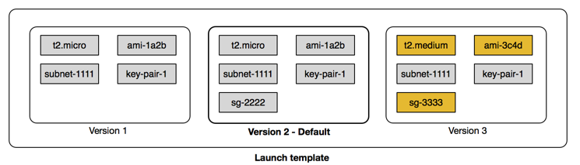

A launch configuration is an instance configuration template that an Auto Scaling group uses to launch EC2 instances. When you create a launch configuration, you specify information for the instances. Include the ID of the Amazon Machine Image (AMI), the instance type, a key pair, one or more security groups, and a block device mapping. If you've launched an EC2 instance before, you specified the same information in order to launch the instance.
You can specify your launch configuration with multiple Auto Scaling groups. However, you can only specify one launch configuration for an Auto Scaling group at a time, and you can't modify a launch configuration after you've created it. To change the launch configuration for an Auto Scaling group, you must create a launch configuration and then update your Auto Scaling group with it.
Keep in mind that whenever you create an Auto Scaling group, you must specify a launch configuration, a launch template, or an EC2 instance. When you create an Auto Scaling group using an EC2 instance, Amazon EC2 Auto Scaling automatically creates a launch configuration for you and associates it with the Auto Scaling group.

- Differences between EC2 healthcheck and load balancer health check

EC2 health check watches for instance availability from hypervisor and networking point of view. For example, in case of a hardware problem, the check will fail. Also, if an instance was misconfigured and doesn't respond to network requests, it will be marked as faulty.
ELB health check verifies that a specified TCP port on an instance is accepting connections OR a specified web page returns 2xx code. Thus ELB health checks are a little bit smarter and verify that actual app works instead of verifying that just an instance works.

- Create 2 auto-scaling groups with
  - launch configuration and
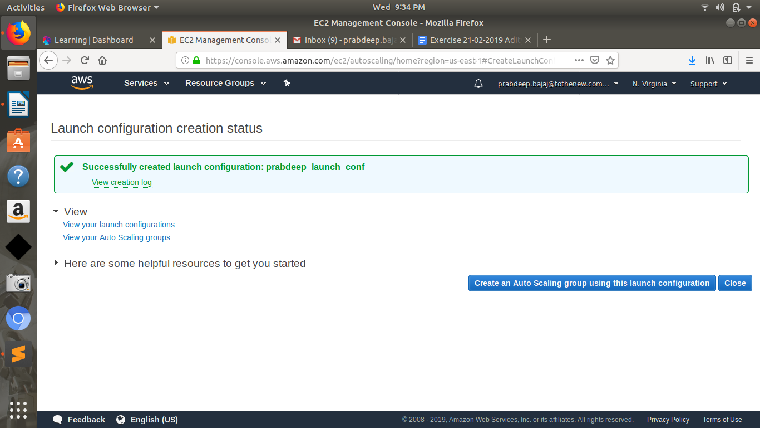
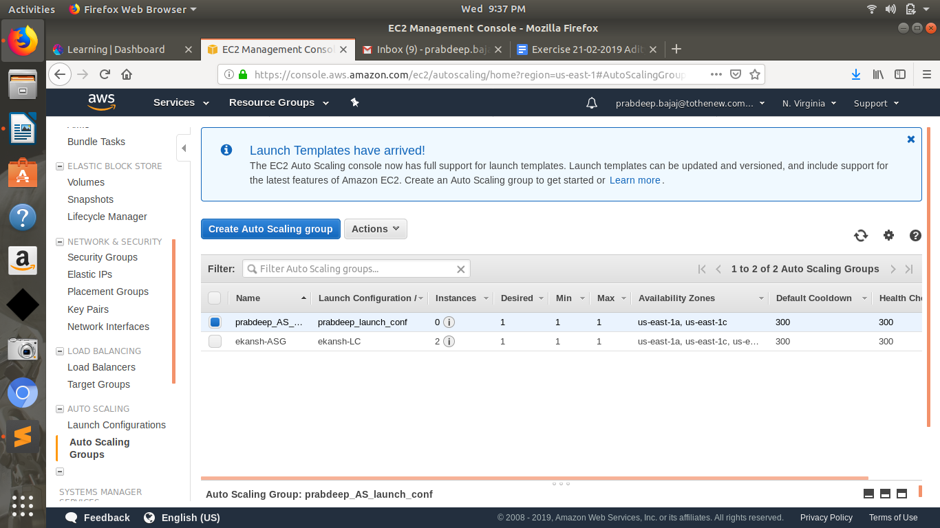
  - launch template
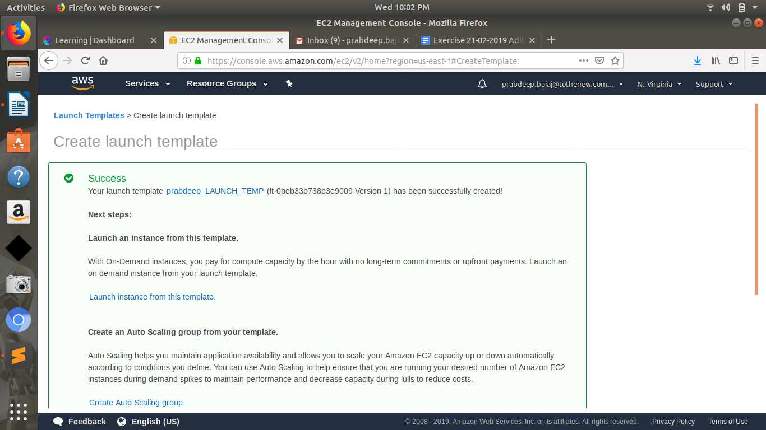
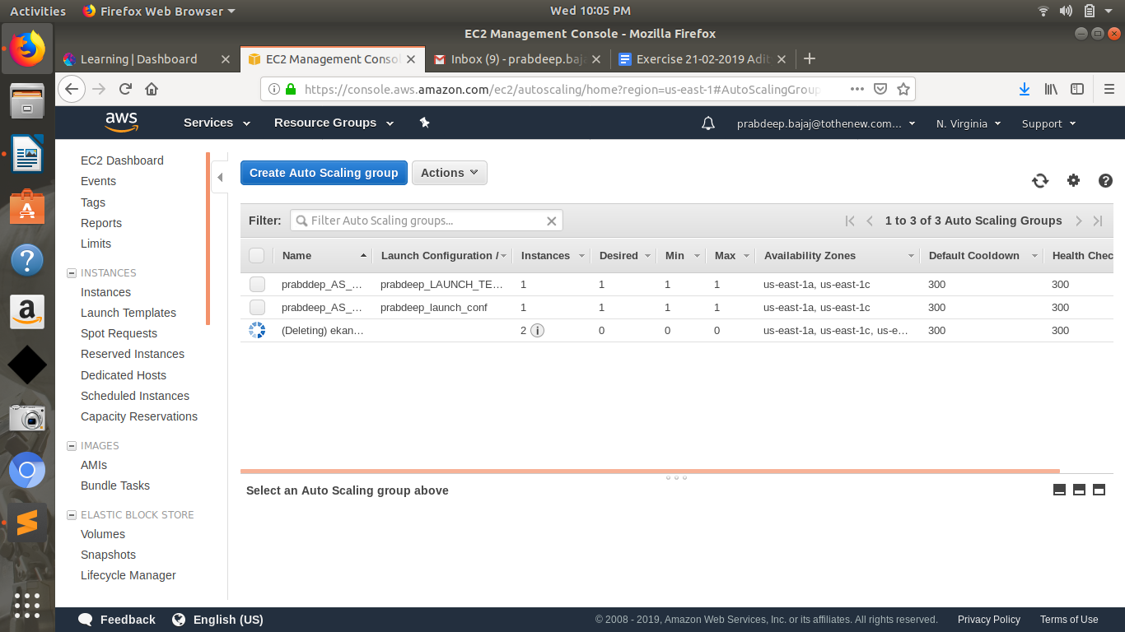

- Setup autoscaling Wordpress application with the Application load balancer. Auto-scaling should be triggered based on CPU usage of EC2 instances.
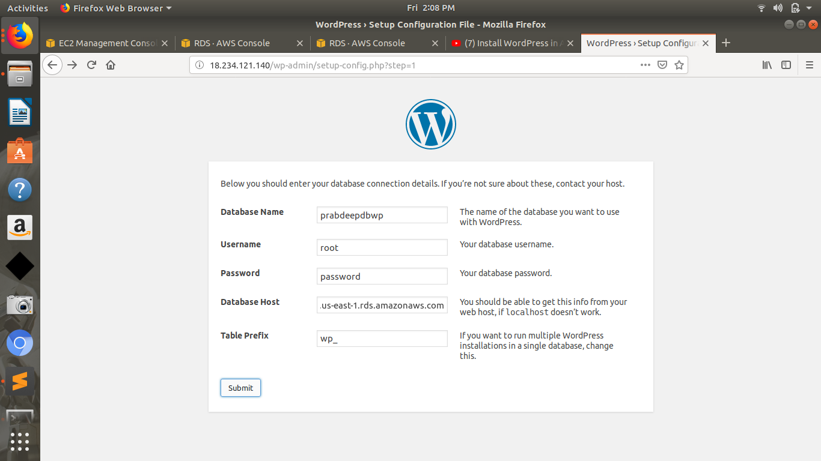
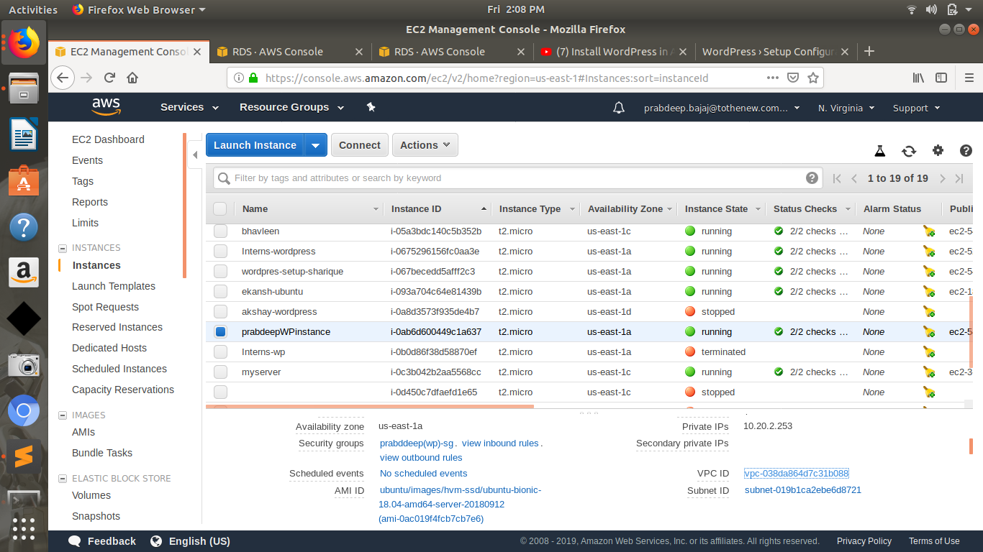
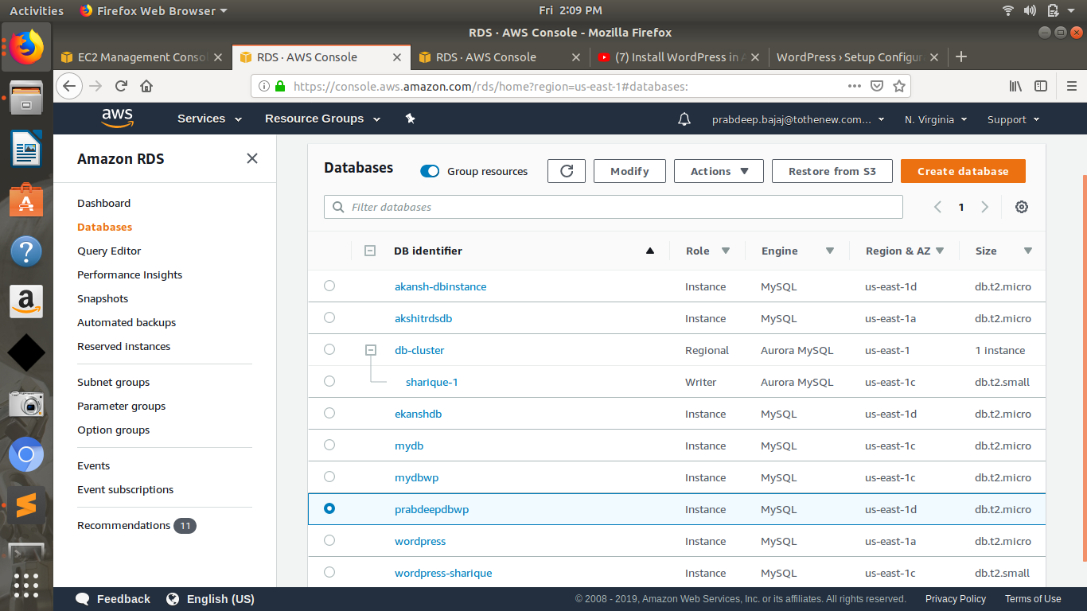

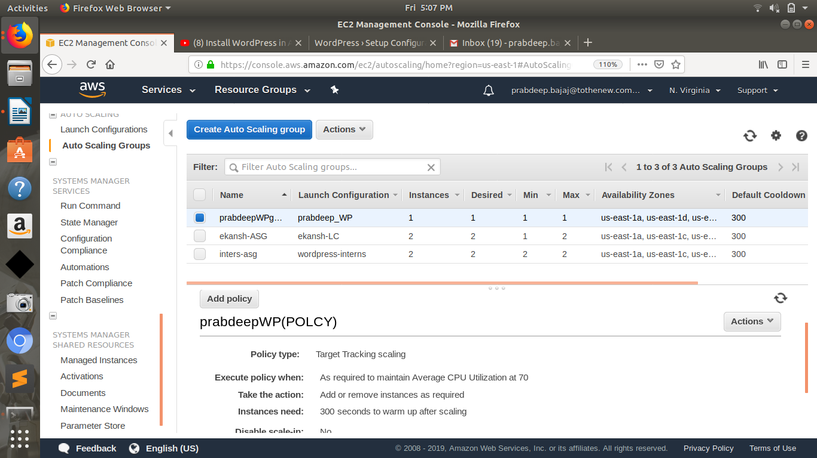
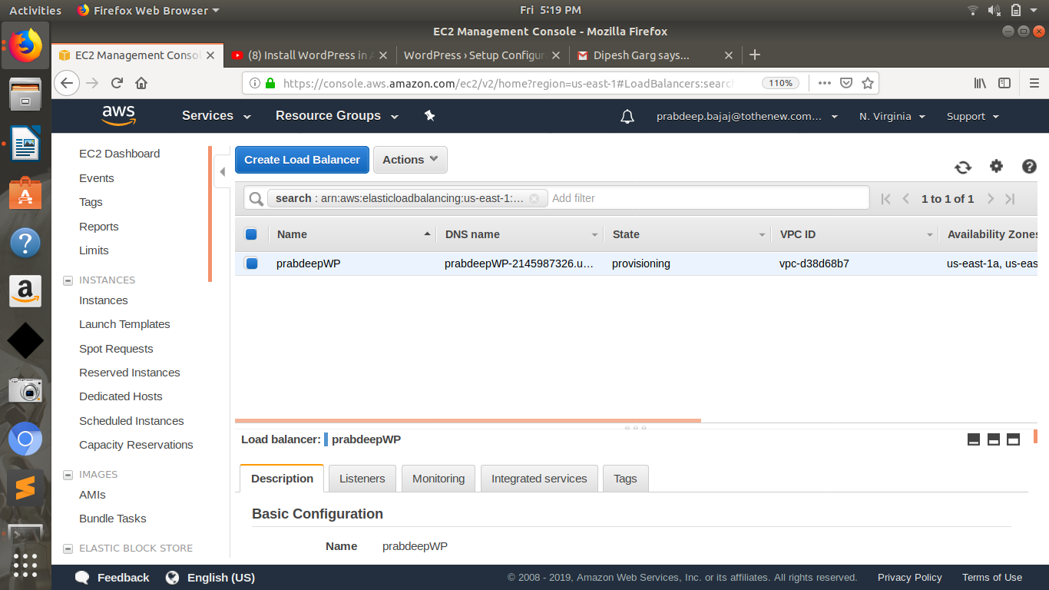

- Create another Wordpress website and use the ALB created above to send traffic to this website based on the hostname

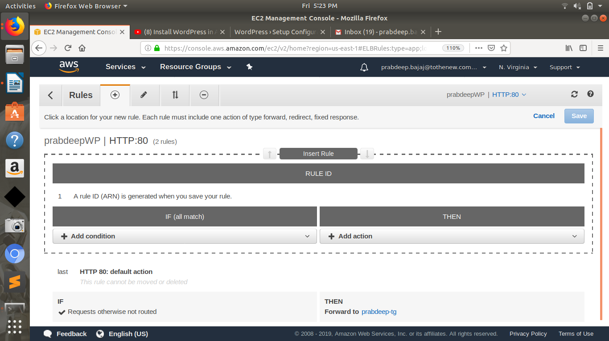
using listeners we can do this task !

- Take an instance out of the ASG.

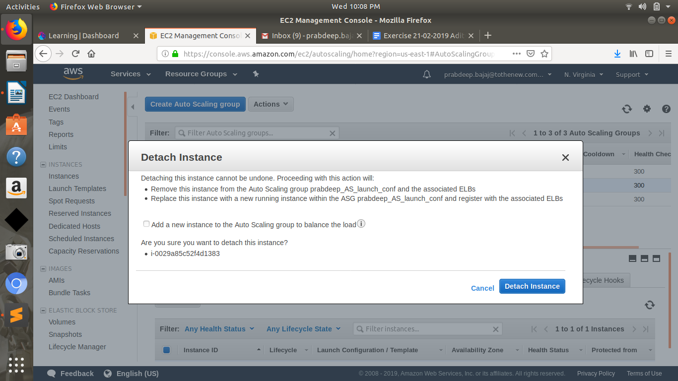
- Put scale-in protection on an instance in the ASG.
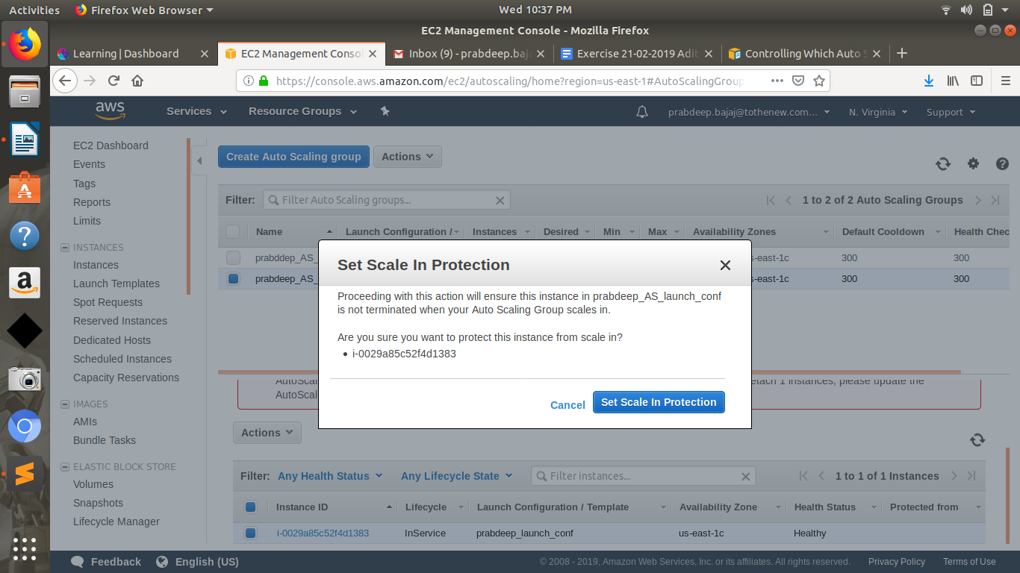
- Put Schedules in ASG to:

  - Remove all instances of the ASG at 8 PM
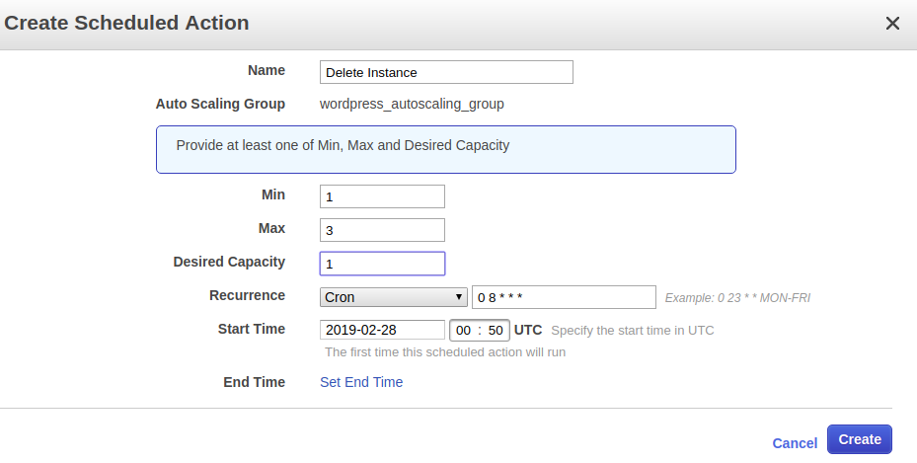

  - Launch a minimum of 2 instances at 10 AM
