CLOUDFORMATION

1. Create a template that
- Creates a VPC, Route tables, 6 Subnets (2 each for public, private and database)
- Launches a bastion server in public subnet with a public ip attached and corresponding security group to allow access to only port 22 from internet.
- Launches an ALB in public subnet, with its own separate security group, listener etc.

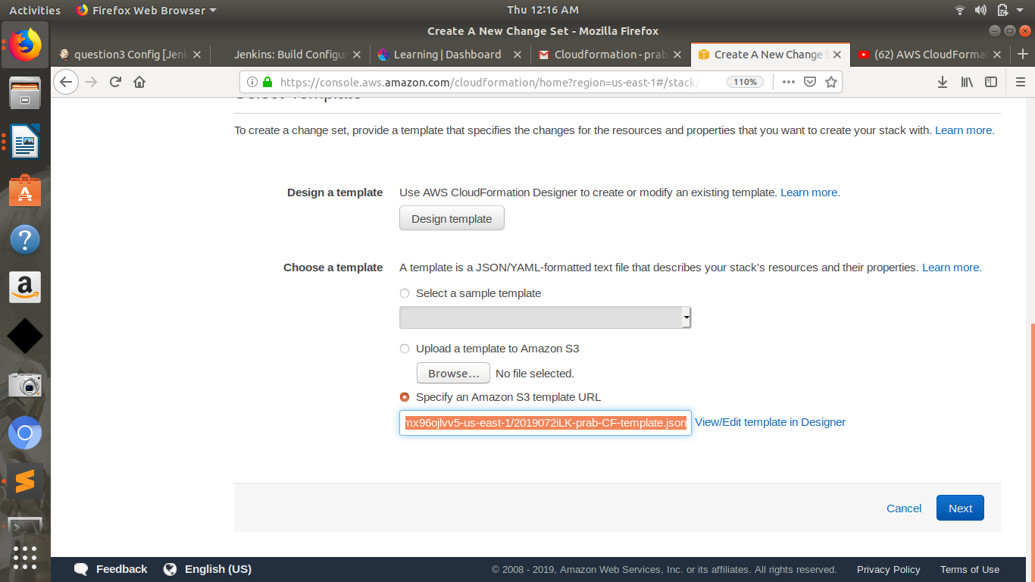
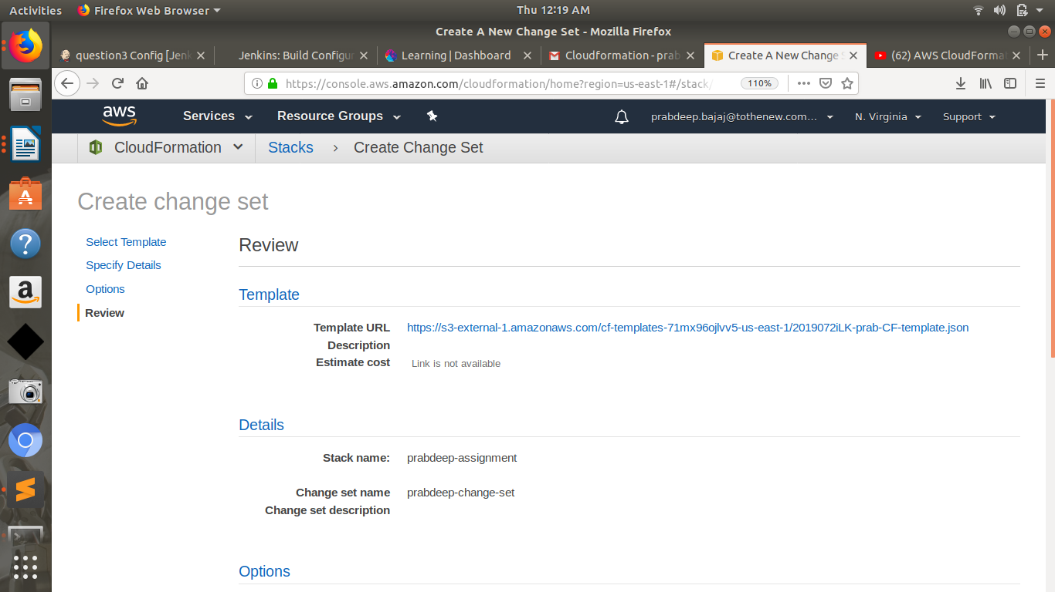

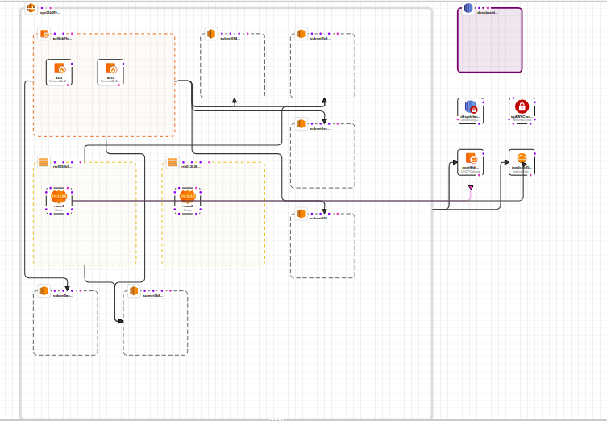

{
"AWSTemplateFormatVersion": "2010-09-09",
"Resources": {
"VPC": {
"Type": "AWS::EC2::VPC",
"Properties": {
"CidrBlock": "172.16.0.0/23",
"InstanceTenancy": "default",
"EnableDnsSupport": "true",
"EnableDnsHostnames": "true",
"Tags": [
{
"Key": "Name",
"Value": "CloudFormation_VPC"
}
]
}
},
"subnet1": {
"Type": "AWS::EC2::Subnet",
"Properties": {
"CidrBlock": "172.16.0.0/24",
"AvailabilityZone": "us-east-1a",
"VpcId": {
"Ref": "VPC"
},
"Tags": [
{
"Key": "Name",
"Value": "Public Subnet1"
}
]
}
},
"subnet2": {
"Type": "AWS::EC2::Subnet",
"Properties": {
"CidrBlock": "172.16.2.0/24",
"AvailabilityZone": "us-east-1b",
"VpcId": {
"Ref": "VPC"
},
"Tags": [
{
"Key": "Name",
"Value": "Public subnet 2"
}
]
}
},
"subnet13": {
"Type": "AWS::EC2::Subnet",
"Properties": {
"CidrBlock": "176.16.1.0/24",
"AvailabilityZone": "us-east-1b",
"VpcId": {
"Ref": "VPC"
},
"Tags": [
{
"Key": "Name",
"Value": "Private subnet1"
}
]
}
},
"subnetd2": {
"Type": "AWS::EC2::Subnet",
"Properties": {
"CidrBlock": "172.16.5.0/24",
"AvailabilityZone": "us-east-1a",
"VpcId": {
"Ref": "VPC"
},
"Tags": [
{
"Key": "Name",
"Value": "database subnet 2"
}
]
}
},
"subnetd1": {
"Type": "AWS::EC2::Subnet",
"Properties": {
"CidrBlock": "172.16.4.0/24",
"AvailabilityZone": "us-east-1b",
"VpcId": {
"Ref": "VPC"
},
"Tags": [
{
"Key": "Name",
"Value": "database subnet 1"
}
]
}
},
"subnet14": {
"Type": "AWS::EC2::Subnet",
"Properties": {
"CidrBlock": "172.16.3.0/24",
"AvailabilityZone": "us-east-1a",
"VpcId": {
"Ref": "VPC"
},
"Tags": [
{
"Key": "Name",
"Value": "Private subnet2"
}
]
}
},
"InternetGateway": {
"Type": "AWS::EC2::InternetGateway",
"Properties": {
"Tags": [
{
"Key": "Application",
"Value": "Internet Gateway Created"
}
]
}
},
"AttachGateway": {
"Type": "AWS::EC2::VPCGatewayAttachment",
"Properties": {
"VpcId": {
"Ref": "VPC"
},
"InternetGatewayId": {
"Ref": "InternetGateway"
}
}
},

"doptfffdf697": {
"Type": "AWS::EC2::DHCPOptions",
"Properties": {
"DomainName": "ap-east-1.compute.internal",
"DomainNameServers": [
"AmazonProvidedDNS"
]
}
},
"NACL": {
"Type": "AWS::EC2::NetworkAcl",
"Properties": {
"VpcId": {
"Ref": "VPC"
}
}
},
"RT": {
"Type": "AWS::EC2::RouteTable",
"Properties": {
"VpcId": {
"Ref": "VPC"
}
}
},
"RT1": {
"Type": "AWS::EC2::RouteTable",
"Properties": {
"VpcId": {
"Ref": "VPC"
}
}
},
"dbsubnetdefault": {
"Type": "AWS::RDS::DBSubnetGroup",
"Properties": {
"DBSubnetGroupDescription": "default",
"SubnetIds": [
"subnet-6c4a1f04",
"subnet-de0db692"
]
}
},
"SG": {
"Type": "AWS::EC2::SecurityGroup",
"Properties": {
"GroupDescription": "Enable HTTPS access via port 443",
"VpcId": "VPC"
}
},
"dbsgdefault": {
"Type": "AWS::RDS::DBSecurityGroup",
"Properties": {
"GroupDescription": "default"
}
},
"acl1": {
"Type": "AWS::EC2::NetworkAclEntry",
"Properties": {
"CidrBlock": "0.0.0.0/0",
"Egress": "true",
"Protocol": "-1",
"RuleAction": "allow",
"RuleNumber": "100",
"NetworkAclId": {
"Ref": "NACL"
}
}
},
"acl2": {
"Type": "AWS::EC2::NetworkAclEntry",
"Properties": {
"CidrBlock": "0.0.0.0/0",
"Protocol": "-1",
"RuleAction": "allow",
"RuleNumber": "100",
"NetworkAclId": {
"Ref": "NACL"
}
}
},
"subnetacl1": {
"Type": "AWS::EC2::SubnetNetworkAclAssociation",
"Properties": {
"NetworkAclId": {
"Ref": "NACL"
},
"SubnetId": {
"Ref": "subnetd1"
}
}
},
"subnetacl2": {
"Type": "AWS::EC2::SubnetNetworkAclAssociation",
"Properties": {
"NetworkAclId": {
"Ref": "NACL"
},
"SubnetId": {
"Ref": "subnet2"
}
}
},
"subnetacl3": {
"Type": "AWS::EC2::SubnetNetworkAclAssociation",
"Properties": {
"NetworkAclId": {
"Ref": "NACL"
},
"SubnetId": {
"Ref": "subnetd2"
}
}
},
"subnetacl4": {
"Type": "AWS::EC2::SubnetNetworkAclAssociation",
"Properties": {
"NetworkAclId": {
"Ref": "NACL"
},
"SubnetId": {
"Ref": "subnet14"
}
}
},
"subnetacl5": {
"Type": "AWS::EC2::SubnetNetworkAclAssociation",
"Properties": {
"NetworkAclId": {
"Ref": "NACL"
},
"SubnetId": {
"Ref": "subnet1"
}
}
},
"subnetacl6": {
"Type": "AWS::EC2::SubnetNetworkAclAssociation",
"Properties": {
"NetworkAclId": {
"Ref": "NACL"
},
"SubnetId": {
"Ref": "subnet13"
}
}
},
"gw1": {
"Type": "AWS::EC2::VPCGatewayAttachment",
"Properties": {
"VpcId": {
"Ref": "VPC"
},
"InternetGatewayId": {
"Ref": "InternetGateway"
}
}
},
"subnetroute1": {
"Type": "AWS::EC2::SubnetRouteTableAssociation",
"Properties": {
"RouteTableId": {
"Ref": "RT"
},
"SubnetId": {
"Ref": "subnet2"
}
}
},
"subnetroute2": {
"Type": "AWS::EC2::SubnetRouteTableAssociation",
"Properties": {
"RouteTableId": {
"Ref": "RT"
},
"SubnetId": {
"Ref": "subnet14"
}
}
},
"route1": {
"Type": "AWS::EC2::Route",
"Properties": {
"DestinationCidrBlock": "0.0.0.0/0",
"RouteTableId": {
"Ref": "RT"
},
"GatewayId": {
"Ref": "InternetGateway"
}
},
"DependsOn": "gw1"
},
"route2": {
"Type": "AWS::EC2::Route",
"Properties": {
"DestinationCidrBlock": "0.0.0.0/0",
"RouteTableId": {
"Ref": "RT1"
},
"InstanceId": "01234aditya"
}
},
"dchpassoc1": {
"Type": "AWS::EC2::VPCDHCPOptionsAssociation",
"Properties": {
"VpcId": {
"Ref": "VPC"
},
"DhcpOptionsId": {
"Ref": "doptfffdf697"
}
}
},
"ingress1": {
"Type": "AWS::EC2::SecurityGroupIngress",
"Properties": {
"GroupId": {
"Ref": "SG"
},
"IpProtocol": "tcp",
"FromPort": "443",
"ToPort": "443",
"CidrIp": "0.0.0.0/0"
}
},
"egress1": {
"Type": "AWS::EC2::SecurityGroupEgress",
"Properties": {
"GroupId": {
"Ref": "SG"
},
"IpProtocol": "-1",
"CidrIp": "0.0.0.0/0"
}
}
},
"Description": ""
}

