1. Explain SQL Mode in MySQL and set NO_ENGINE_SUBSTITUTION SQL NO_ENGINE_SUBSTITUTIONMode for MySQL from MySQL Shell and from the conf file as well.
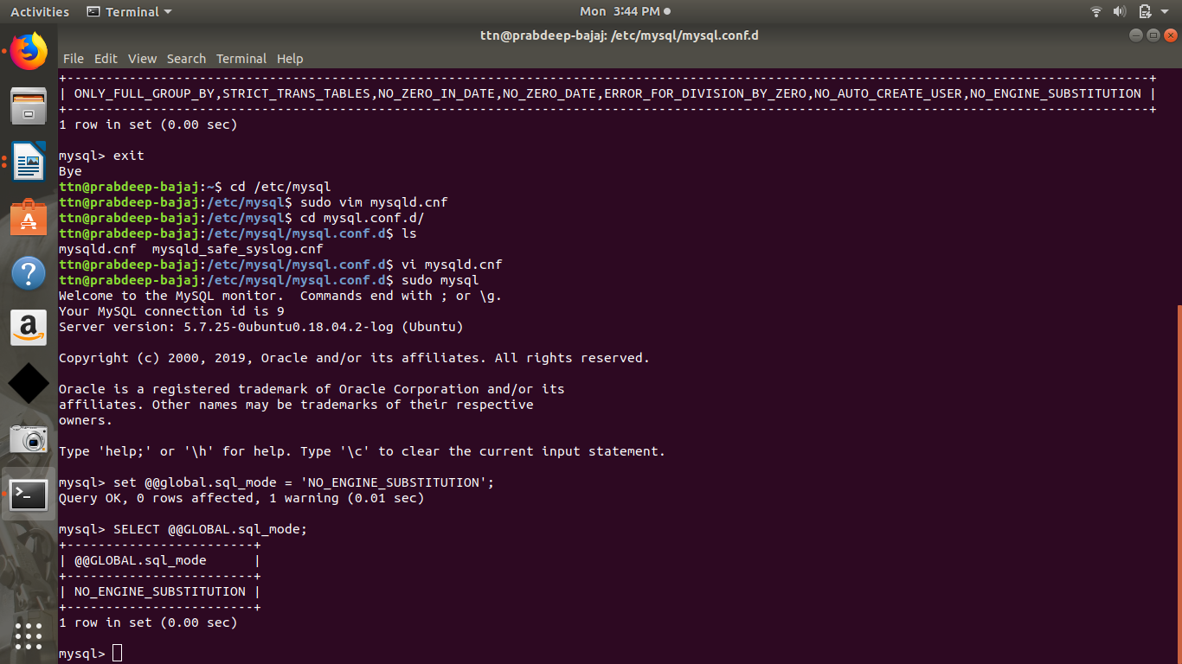
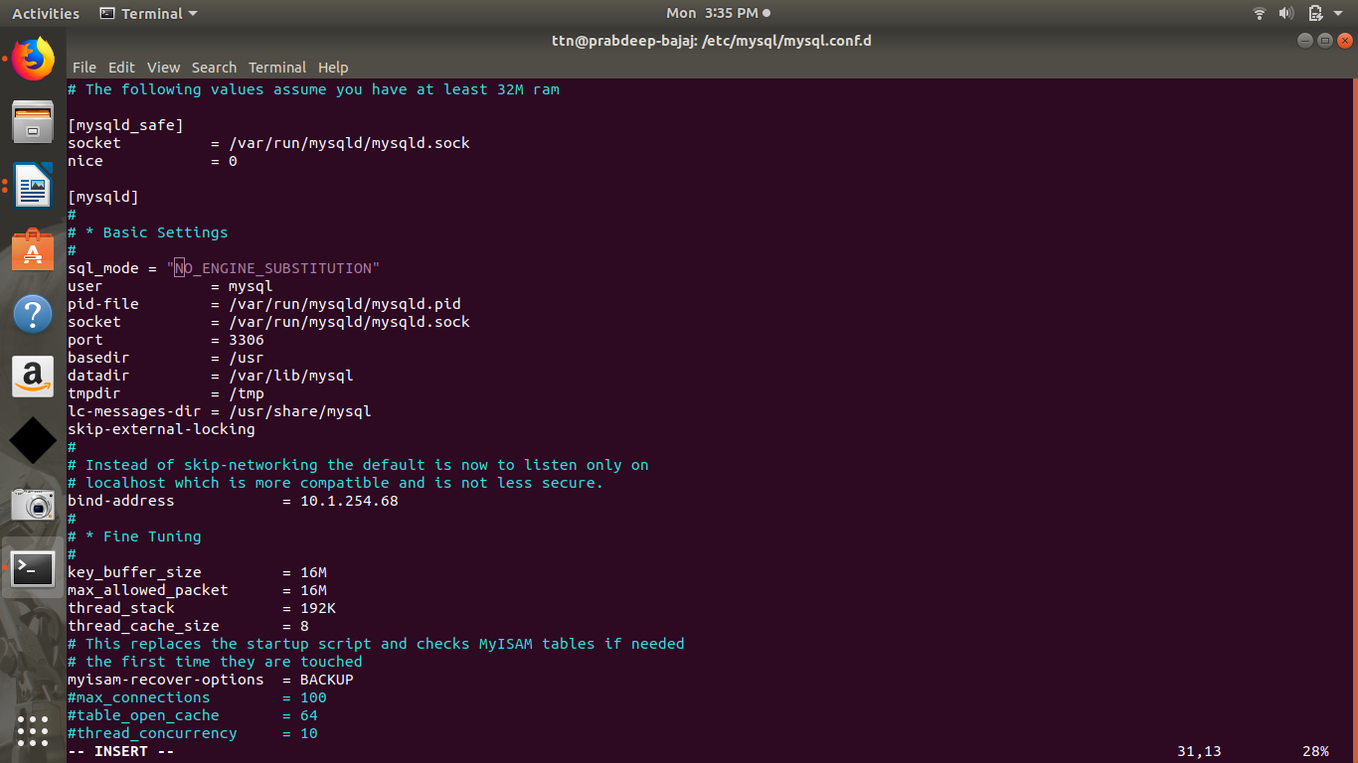

2. Create a bash script to write current CPU and Memory of your laptop to a file and put that script as a system service.

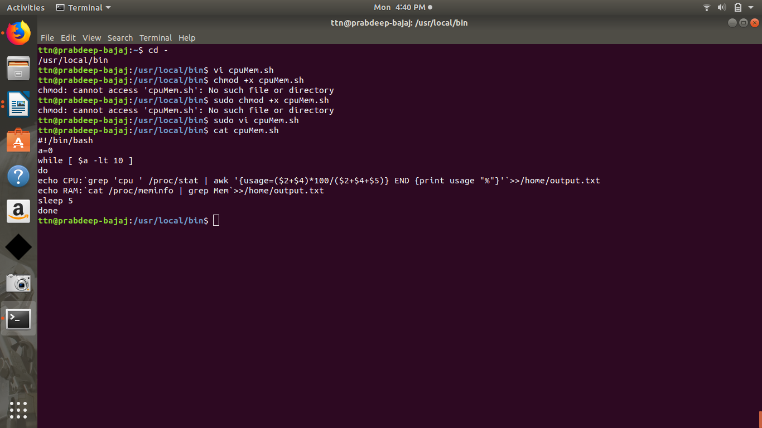
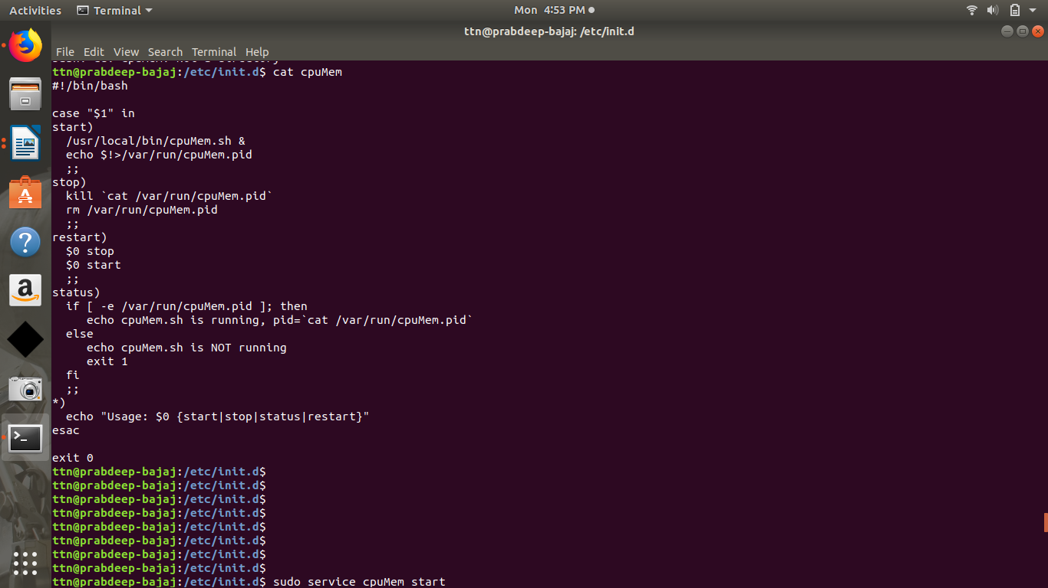

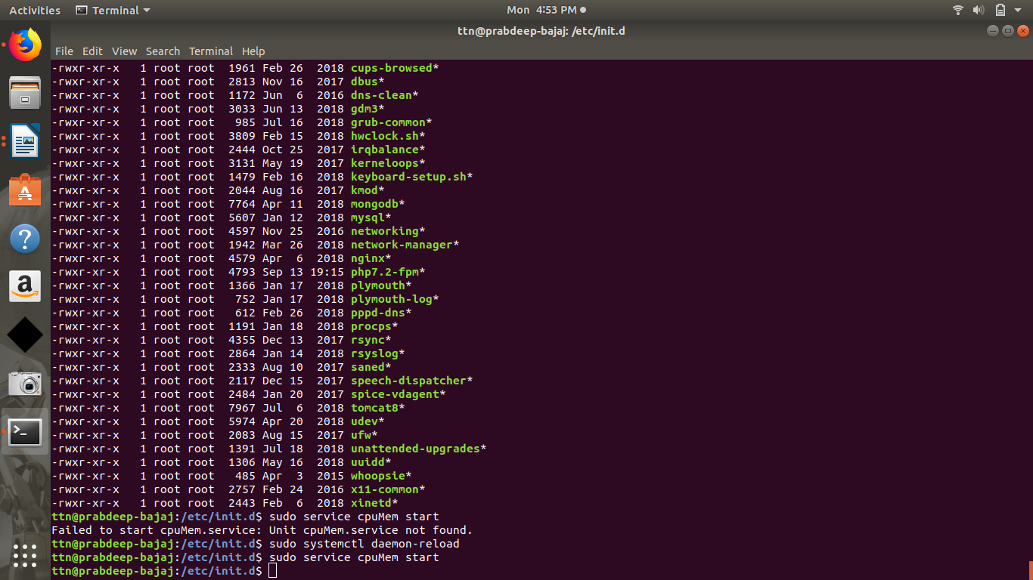

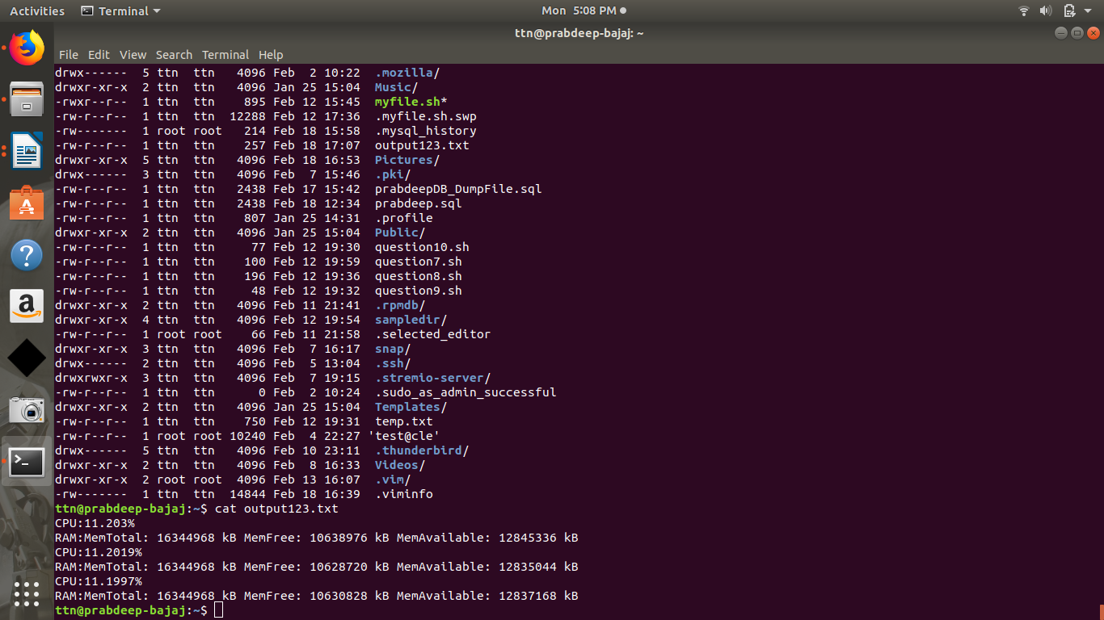

3. Create a sample script which should run on system shutdown.
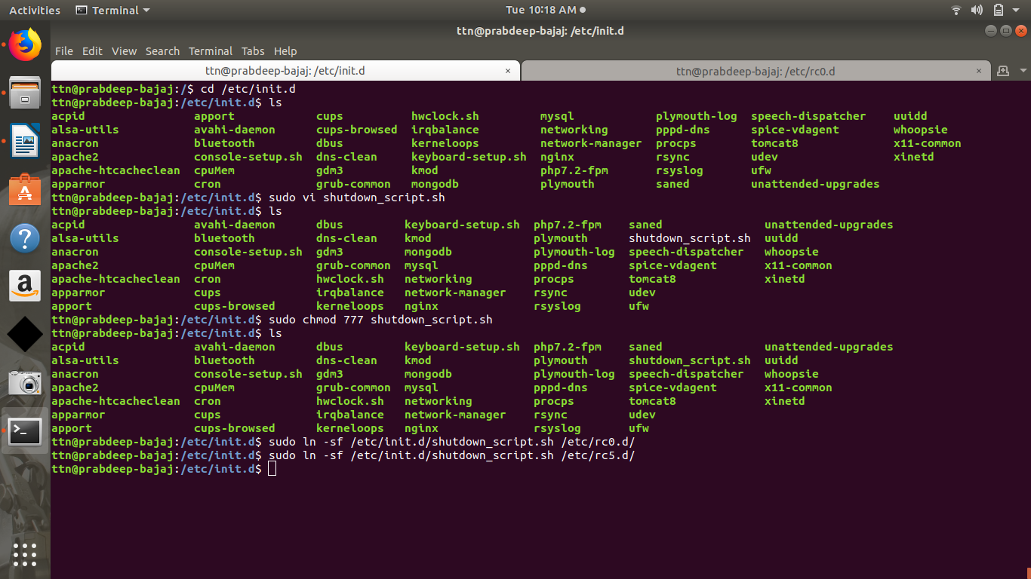
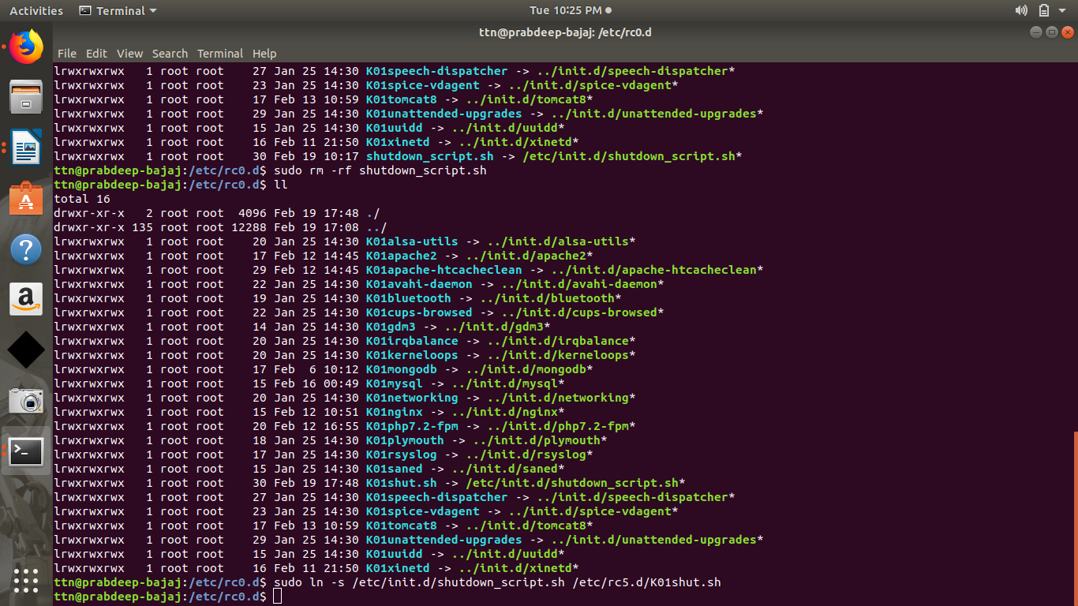
4. Run 2 sample java war file from tomcat and proxy pass the request from nginx to both tomcats in the round robin.
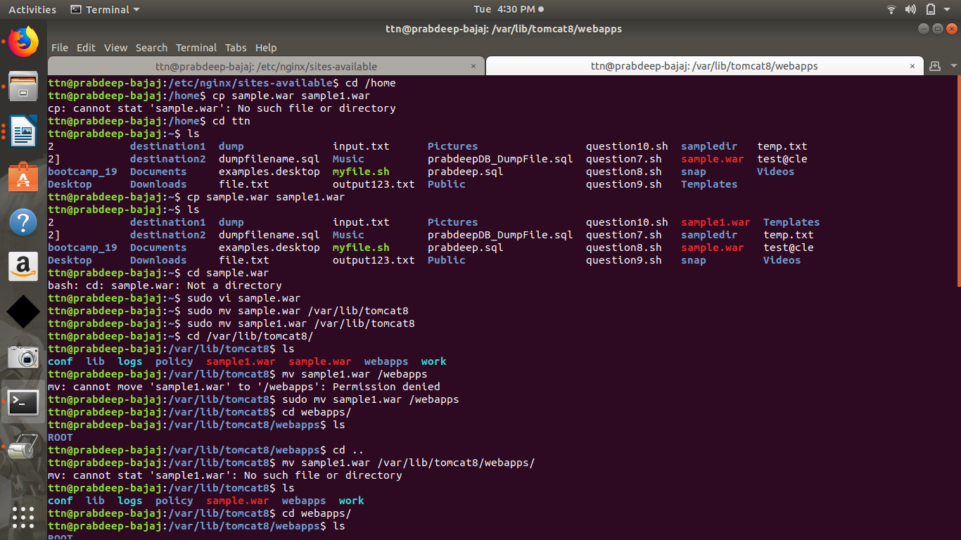

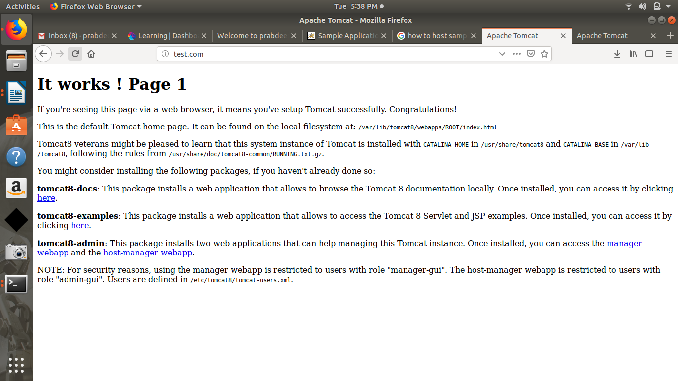

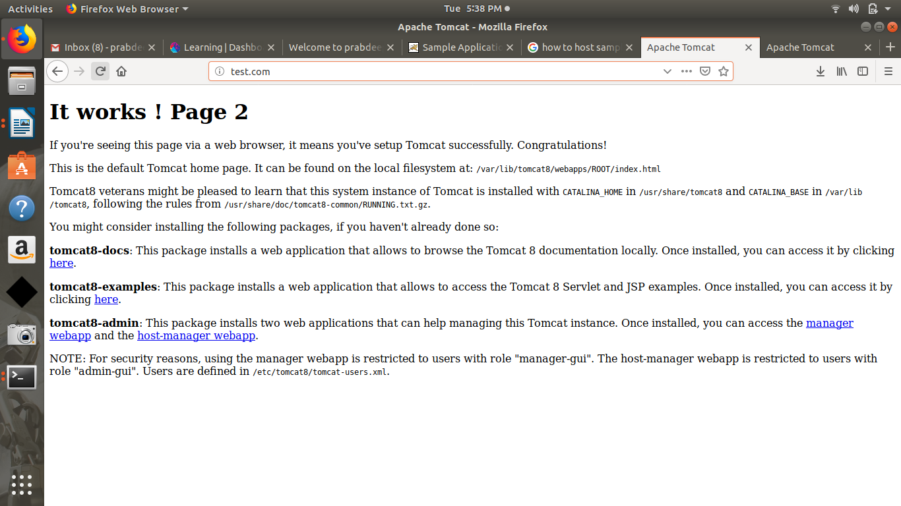
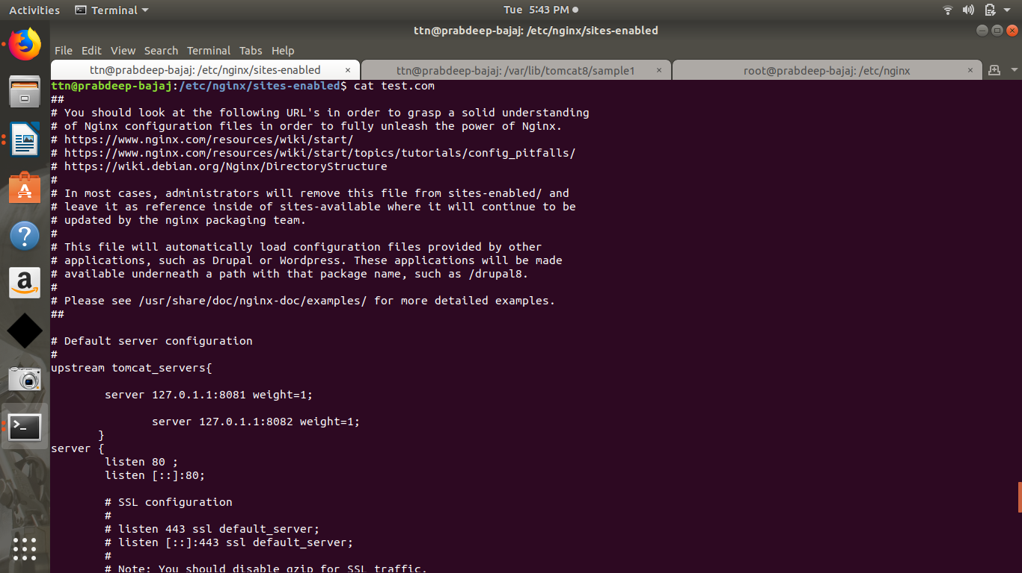
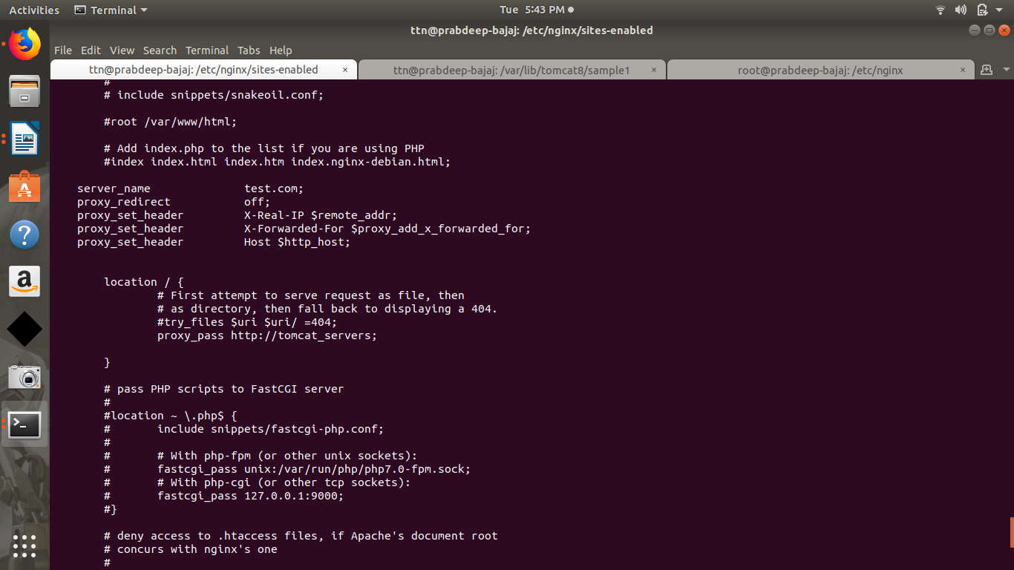
In server.xml :

<Service name="sample">
<Connector port="8081" protocol="org.apache.coyote.http11.Http11NioProtocol"
connectionTimeout="20000"
redirectPort="8443" />
<Engine name="Catalina" defaultHost="localhost">
<Host name="localhost" appBase="sample"
unpackWARs="true" autoDeploy="true">
<!-- SingleSignOn valve, share authentication between web applications
Documentation at: /docs/config/valve.html -->
<!--
<Valve className="org.apache.catalina.authenticator.SingleSignOn" />
-->
<!-- Access log processes all example.
Documentation at: /docs/config/valve.html
Note: The pattern used is equivalent to using pattern="common" -->
<Valve className="org.apache.catalina.valves.AccessLogValve" directory="logs"
prefix="localhost_access_log" suffix=".txt"
pattern="%h %l %u %t &quot;%r&quot; %s %b" />
</Host>
</Engine>
</Service>

5. Print user IP in nginx logs and force your WordPress admin portal to be open from a certain IP only.
