Using Jenkins and AWS cli configured the following task:
Create ECS cluster,
Task definition
Register Task definition in Service
Configure service in target group
Deploy a web application on ECS Optimised image t2.small instance.

USING CLI :

http://www.farshidesigns.com/blog/2015/05/14/setup-a-aws-ecs-container-purely-using-cli/

aws configure
aws ecs create-cluster --cluster-name prabdeepcluster
aws ec2 create-key-pair --key-name prab --query 'KeyMaterial' --output text > prab.pem
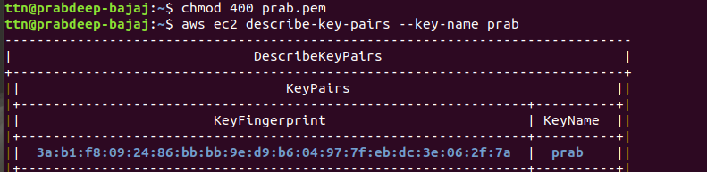
aws ec2 create-security-group --group-name MySecurityGroup --description "my sg for Ecs"
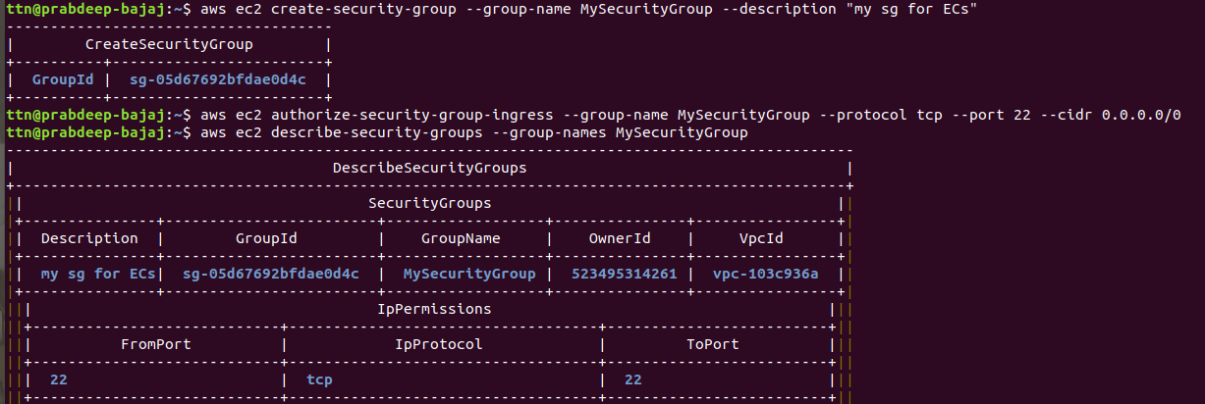
aws ec2 run-instances --image-id ami-07eb698ce660402d2 --count 1 --instance-type t2.micro --key-name prab --iam-instance-profile Arn=arn:aws:iam::523495314261:instance-profile/ecsroles --security-groups MySecurityGroup --user-data file://userdata.txt

aws ecs list-container-instances --cluster MyCluster
TASK DEFINITION JSON :
{
"requiresCompatibilities": [
"EC2"
],
"containerDefinitions": [
{
"name": "nginx",
"image": "nginx:latest",
"memory": 256,
"cpu": 256,
"essential": true,
"portMappings": [
{
"containerPort": 80,
"protocol": "tcp"
}
],
"logConfiguration": {
"logDriver": "awslogs",
"options": {
"awslogs-group": "awslogs-nginx-ecs",
"awslogs-region": "us-east-1",
"awslogs-stream-prefix": "nginx"
}
}
}
],
"volumes": [],
"networkMode": "bridge",
"placementConstraints": [],
"family": "nginx"
}
aws ecs register-task-definition --cli-input-json file://sleep360.json

aws ecs run-task --cluster prabdeepcluster --task-definition nginx:1 --count 1

aws ecs describe-tasks --cluster prabdeepcluster --task arn:aws:ecs:us-east-1:523495314261:task/a3c3f83f-56b4-40c2-b441-860da66d6793

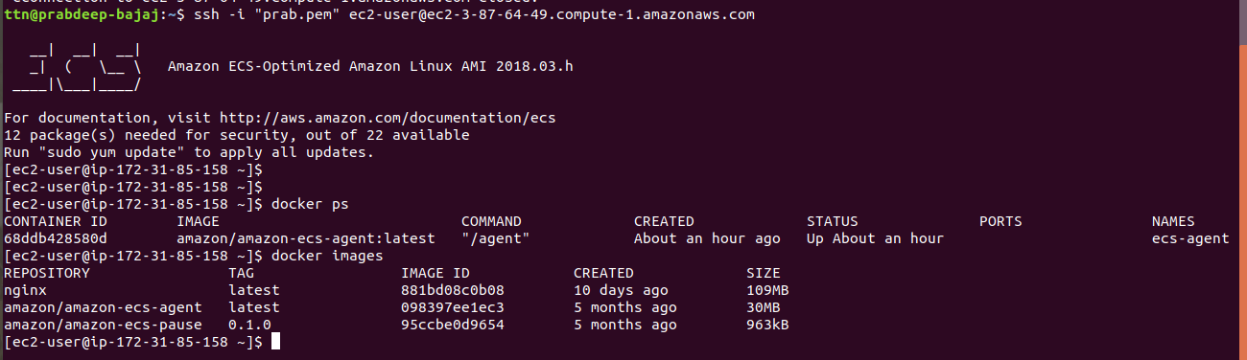

JENKINS BASH SCRIPT :

#!/bin/bash
aws ecs create-cluster --cluster-name prabeepcluster

printf '#!/bin/bash\nECS_CLUSTER=prabdeepcluster" >> /etc/ecs/ecs.config ' > userdata.txt

ec2ID=`aws ec2 run-instances --image-id ami-07eb698ce660402d2 --count 1 --instance-type t2.micro --key-name prab --iam-instance-profile Arn=arn:aws:iam::523495314261:instance-profile/ecsroles --security-group-ids sg-05d67692bfdae0d4c --user-data file://userdata.txt --query 'Instances[].InstanceId' --output text`

sleep 3m

tgarn=`aws elbv2 create-target-group --name prab-tg1 --protocol HTTP --port 8080 --vpc-id vpc-103c936a --query 'TargetGroups[].TargetGroupArn' --output text`

aws elbv2 register-targets --target-group-arn ${tgarn} --targets Id=${ec2ID}

lbarn=`aws elbv2 create-load-balancer --name prab-alb --subnets subnet-098e2837 subnet-1ecc5e79 --security-group-ids sg-05d67692bfdae0d4c --query 'LoadBalancers[].LoadBalancerArn' --output text`aws elbv2 create-listener --load-balancer-arn ${lbarn} --protocol HTTP --port 80 --default-actions Type=forward,TargetGroupArn=${tgarn}

aws ecs register-task-definition --network-mode bridge --family nginx --volumes "[{\"name\": \"test\",\"host\": {\"sourcePath\": \"/var/log\"}}]" --container-definitions "[{\"name\":\"test\",\"image\":\"nginx\",\"cpu\":256,\"memory\":256,\"essential\":true, \"portMappings\":[{\"hostPort\":80,\"containerPort\":80,\"protocol\":\"tcp\"}],\"logConfiguration\":{\"logDriver\":\"awslogs\",\"options\":{\"awslogs-group\":\"awslogs-nginx-ecs\",\"awslogs-region\":\"us-east-1\", \"awslogs-stream-prefix\":\"nginx\"}}, \"mountPoints\": [{\"sourceVolume\":\"test\",\"containerPath\":\"/var/log\",\"readOnly\":false}]}]"

aws ecs create-service --service-name prab-nginx --cluster prabeepcluster --task-definition nginx --desired-count 1 --load-balancers "[{\"targetGroupArn\":\"${tgarn}\",\"containerName\":\"test\", \"containerPort\":80}]" --role ecsroles

