Exercise 1 - Use a deployment to deploy MySQL on minikube cluster #

To complete this exercise you have to deploy MySQL on Kubernetes, using a template file (yaml), with the following characteristics:
- Deploy a MySQL instance on your Kubernetes cluster in a single pod using deployment.
- The MySQL server shall have a database named "sample".
- Your instance shall have a user names *mysql* with *mysql* as the password.
- You shall be able to access your instance from outside of the cluster with MySQL client on your host machine.

**Note**: You are not expected to use persistent volumes nor managing the secrets.

<u>**Assessment**</u>: Connect to MySQL with mysql client utility from host machine and verify that the connection works

source : https://kubernetes.io/docs/tasks/run-application/run-single-instance-stateful-application/

mysql-deployment.yml :

apiVersion: v1
kind: Service
metadata:
name: mysql
spec:
ports:
- port: 3306
selector:
app: mysql
clusterIP: None
---
apiVersion: apps/v1 # for versions before 1.9.0 use apps/v1beta2
kind: Deployment
metadata:
name: mysql
spec:
selector:
matchLabels:
app: mysql
strategy:
type: Recreate
template:
metadata:
labels:
app: mysql
spec:
containers:
- image: mysql:5.6
name: mysql
env:
# Use secret in real usage
- name: MYSQL_ROOT_PASSWORD
value: password
ports:
- containerPort: 3306
name: mysql
volumeMounts:
- name: mysql-persistent-storage
mountPath: /var/lib/mysql
volumes:
- name: mysql-persistent-storage
persistentVolumeClaim:
claimName: mysql-pv-claim

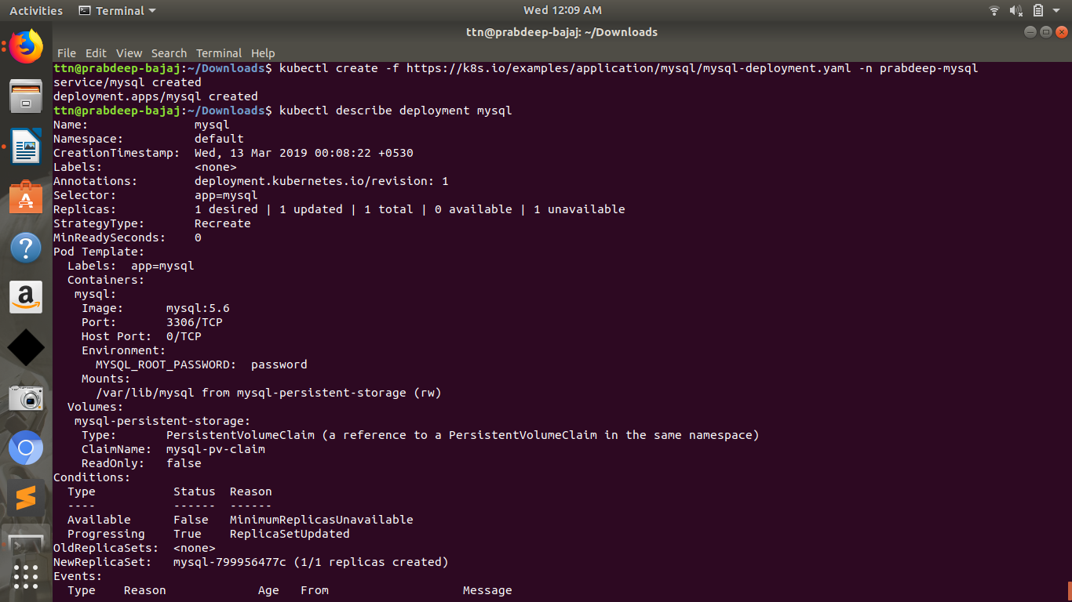
Run a MySQL client to connect to the server:
kubectl run -it --rm --image=mysql:5.6 --restart=Never mysql-client -- mysql -h mysql -ppassword

Exercise 2 - Adding secrets for MySQL in POD #

This exercise is about using a password for the MySQL database that is not exposed in the yaml file describing the application. You will modify the file that you have created during the first exercise and change how the password is passed to the MySQL container:
- You have two options to achieve this lab. Select the one that you prefer. (Create secret using command line or file)
- The password shall not appear in the file describing the application.

**Note**: You are not expected to use persistent volumes.

<u>**Assessment**</u>: Connect to MySQL with the password used in secret.

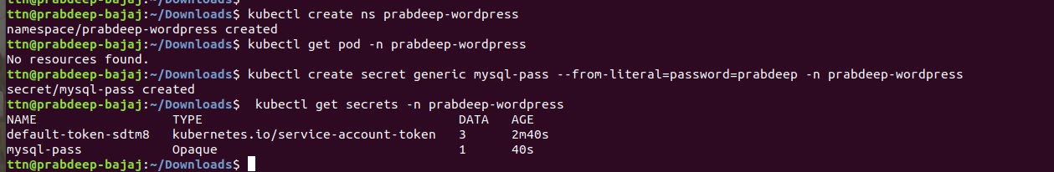

Exercise 3 - Adding wordpress to the deployment #

In this exercise you are asked to deploy Wordpress on your Kubernetes cluster. This deployment of Wordpress shall use the MySQL deployment that you have done in the previous exercises and the website shall be resilient to container outages should they happen.

At the end of this exercise, you must be able to connect to your wordpress website and create your blog. If you delete or restart the wordpress container the website shoud come back up as it was before the operation.

**Note**: You can change the mysql service type created in previous exercises for this exercise.

<u>**Assessment**</u>: Connect to your WordPress deployment and verify that you can create a website.

Source : https://kubernetes.io/docs/tutorials/stateful-application/mysql-wordpress-persistent-volume/

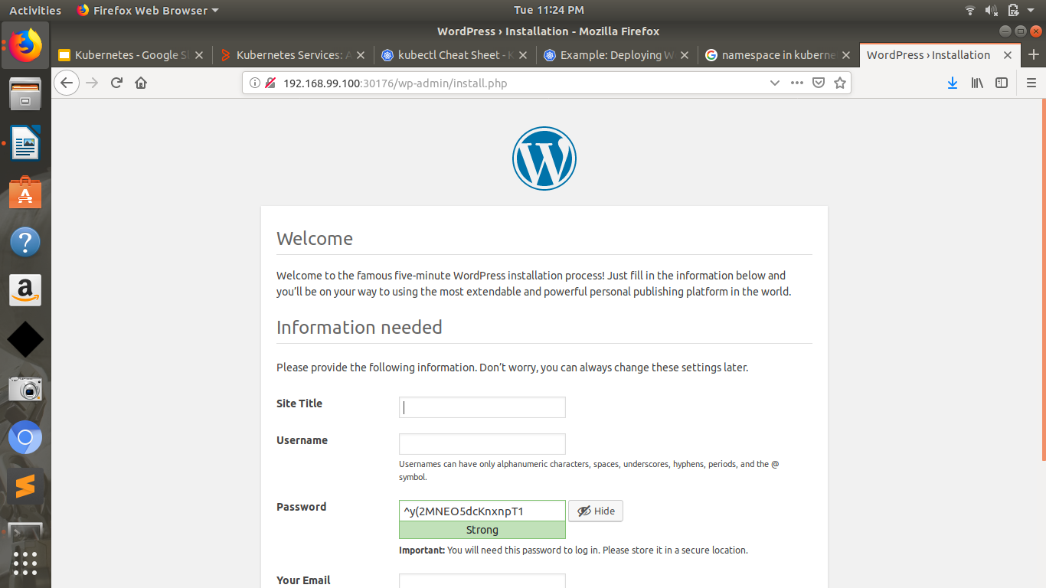

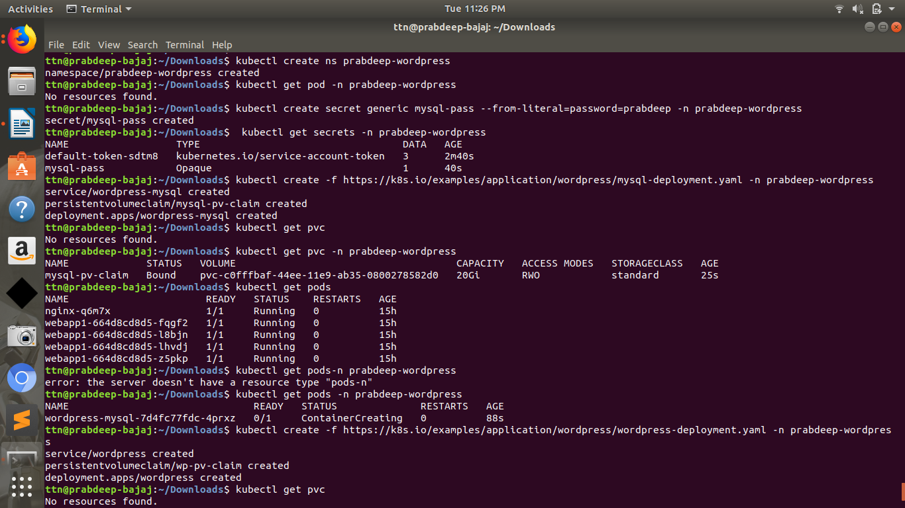

application/wordpress/mysql-deployment.yaml

apiVersion: v1
kind: Service
metadata:
name: wordpress-mysql
labels:
app: wordpress
spec:
ports:
- port: 3306
selector:
app: wordpress
tier: mysql
clusterIP: None
---
apiVersion: v1
kind: PersistentVolumeClaim
metadata:
name: mysql-pv-claim
labels:
app: wordpress
spec:
accessModes:
- ReadWriteOnce
resources:
requests:
storage: 20Gi
---
apiVersion: apps/v1 # for versions before 1.9.0 use apps/v1beta2
kind: Deployment
metadata:
name: wordpress-mysql
labels:
app: wordpress
spec:
selector:
matchLabels:
app: wordpress
tier: mysql
strategy:
type: Recreate
template:
metadata:
labels:
app: wordpress
tier: mysql
spec:
containers:
- image: mysql:5.6
name: mysql
env:
- name: MYSQL_ROOT_PASSWORD
valueFrom:
secretKeyRef:
name: mysql-pass
key: password
ports:
- containerPort: 3306
name: mysql
volumeMounts:
- name: mysql-persistent-storage
mountPath: /var/lib/mysql
volumes:
- name: mysql-persistent-storage
persistentVolumeClaim:
claimName: mysql-pv-claim

application/wordpress/wordpress-deployment.yaml

apiVersion: v1
kind: Service
metadata:
name: wordpress
labels:
app: wordpress
spec:
ports:
- port: 80
selector:
app: wordpress
tier: frontend
type: LoadBalancer
---
apiVersion: v1
kind: PersistentVolumeClaim
metadata:
name: wp-pv-claim
labels:
app: wordpress
spec:
accessModes:
- ReadWriteOnce
resources:
requests:
storage: 20Gi
---
apiVersion: apps/v1 # for versions before 1.9.0 use apps/v1beta2
kind: Deployment
metadata:
name: wordpress
labels:
app: wordpress
spec:
selector:
matchLabels:
app: wordpress
tier: frontend
strategy:
type: Recreate
template:
metadata:
labels:
app: wordpress
tier: frontend
spec:
containers:
- image: wordpress:4.8-apache
name: wordpress
env:
- name: WORDPRESS_DB_HOST
value: wordpress-mysql
- name: WORDPRESS_DB_PASSWORD
valueFrom:
secretKeyRef:
name: mysql-pass
key: password
ports:
- containerPort: 80
name: wordpress
volumeMounts:
- name: wordpress-persistent-storage
mountPath: /var/www/html
volumes:
- name: wordpress-persistent-storage
persistentVolumeClaim:
claimName: wp-pv-claim

