***Amazon Web Services (AWS)***

**Introduction:**

Amazon Web Services (AWS) is a [subsidiary](https://en.wikipedia.org/wiki/Subsidiary) of [Amazon](https://en.wikipedia.org/wiki/Amazon.com) that provides [on-demand](https://en.wikipedia.org/wiki/Software_as_a_service) [cloud computing](https://en.wikipedia.org/wiki/Cloud_computing) [platforms](https://en.wikipedia.org/wiki/Computing_platform) to individuals, companies, and governments, on a metered pay-as-you-go basis.

It enables users to access on demand computing services like database storage, virtual cloud server, etc.

AWS is a comprehensive, easy to use computing platform offered by Amazon. The platform is developed with a combination of infrastructure as a service (IaaS), platform as a service (PaaS) and packaged software as a service (SaaS) offerings.

Amazon Web Services provides services from dozens of data centers spread across [availability zones](https://searchaws.techtarget.com/definition/availability-zones) (AZs) in regions across the world

**Benefits:**

* **Flexible**: AWS enables organizations to use the programming models, operating systems, databases, and architectures with which they are already familiar. In addition, this flexibility helps organizations mix and match architectures in order to serve their diverse business needs.
* **Cost-effective**: With AWS, organizations pay only for what they use, without up-front or long-term commitments. Scalable and elastic. Organizations can quickly add and subtract AWS resources to their applications in order to meet customer demand and manage costs.
* **Secure**: In order to provide end-to-end security and end-to-end privacy, AWS builds services in accordance with security best practices, provides the appropriate security features in those services, and documents how to use those features.
* **Experienced:** When using AWS, organizations can leverage Amazon’s more than fifteen years of experience delivering large-scale, global infrastructure in a reliable, secure fashion.

**Important AWS Services**:

Amazon Web Services offers a wide range of different business purpose global cloud-based products. The products include storage, databases, analytics, networking, mobile, development tools, and enterprise applications, with a pay-as-you-go pricing model.

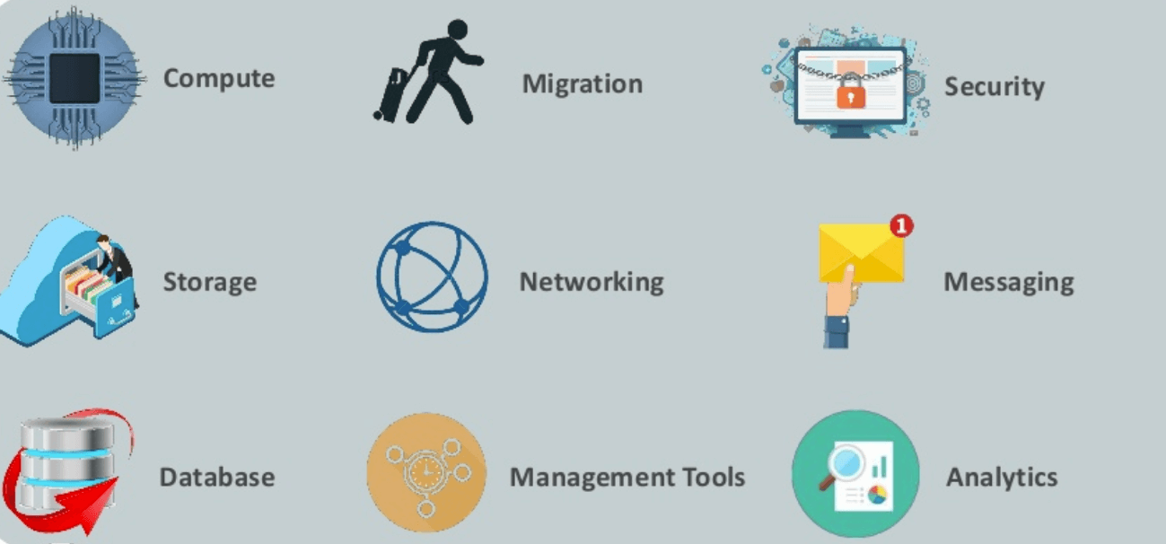

Fig: AWS Services

**1. Compute:** some of the cloud Compute service of AWS are

* Ec2(elastic compute cloud)
* Lightsail
* Elastic Beanstalk
* ELS(elastic container service for kubernets)
* AWS Lambda

**2. Migration:** Migration services used to transfer data physically between your datacenter and AWS.

* **DMS (Database Migration Service)**
* **SMS (Server Migration Service)**
* **AWS Storage Gateway**

**3. Security: AWS takes good care of the end to end security and privacy of the companies by providing some services.**

* **IAM (Identity and Access Management)**
* **Certificate Manager**
* **WAF (Web Application Firewall)**
* **Cloud Directory**
* **KMS (Key Management Service)**

**4. Database: AWS provides some fast, easy to use, scalable, Reliable Database Services to store the data of organization.**

* **Amazon RDS**
* **Amazon DynamoDB**
* **Neptune**

**5. Management: AWS provides some management services which are helpful in monitoring the environment and managing the infrastructure and resources.**

* **CloudWatch**
* **Cloudtrail**
* **CloudFormation**
* **Config**
* **AWS Auto scaling**
* **System Manager**

**6. Application: AWS provides some services to know about the application of the organization and do some tasks.**

* **Step Functions**
* **Simple Notification Services**
* **Simple Queue Services**

**7. Developer Tools: AWS provides some developer tools to handle the codes for the software development Projects.**

* **Codestar**
* **Codecommit**
* **codebuild**
* **Code pipeline**
* **Code9**

**8. Analytics: AWS provides some services to do the analytics task for the organizations.**

* **Athena**
* **ElasticSearch**
* **CloudSearch**
* **Quicksight**
* **Data pipeline**

**9. Storage: AWS**  provides scalable object storage for data backup, archival and analytics helps a n IT professional stores data and files as S3 (simple storage service) objects.

* **Amazon Glacier**
* **Amazon Elastic Block Store (EBS)**
* **AWS Storage Gateway**

### **10. Networking:**

### An Amazon Virtual Private Cloud ([VPC](https://searchaws.techtarget.com/definition/Amazon-Virtual-Private-Cloud-Amazon-VPC)) gives an administrator control over a virtual network to use an isolated section of the AWS cloud.

### Admins can balance network traffic with AWS load balancing tools, including Application Load Balancer and [Network Load Balancer](https://searchaws.techtarget.com/definition/AWS-Network-Load-Balancer-NLB).

### AWS also provides a domain name system called [Amazon Route 53](https://searchaws.techtarget.com/definition/Amazon-Route-53) that routes end users to applications.

### An IT professional can establish a dedicated connection from an on-premises data center to the AWS cloud via [AWS Direct Connect](https://searchaws.techtarget.com/definition/Direct-Connect-AWS-Direct-Connect).

**Companies using AWS:**

* Instagram
* Zoopla
* Smugmug
* Pinterest
* Netflix
* Dropbox
* Etsy
* Talkbox
* Playfish

**Applications of AWS services:**

Amazon Web services are widely used for various computing purposes like:

* Web site hosting
* Application hosting/SaaS hosting
* Media Sharing (Image/ Video)
* Mobile and Social Applications
* Content delivery and Media Distribution
* Storage, backup, and disaster recovery
* Development and test environments
* Academic Computing
* Search Engine
* Social Networking.

**Advantages of AWS:**

* AWS allows organizations to use the already familiar programming models, operating systems, databases, and architectures.
* It is a cost-effective service that allows you to pay only for what you use, without any up-front or long-term commitments.
* You will not require to spend money on running and maintaining data centers.
* Offers fast deployments
* You can easily add or remove capacity.
* You are allowed cloud access quickly with limitless capacity.
* Total Cost of Ownership is very low compared to any private/dedicated servers.
* Offers Centralized Billing and management
* Offers Hybrid Capabilities
* Allows you to deploy your application in multiple regions around the world with just a few clicks.

**Disadvantages of AWS:**

* If you need more immediate or intensive assistance, you'll have to opt for paid support packages.
* Amazon Web Services may have some common cloud computing issues when you move to a cloud. For example, downtime, limited control, and backup protection.
* AWS sets default limits on resources which differ from region to region. These resources consist of images, volumes, and snapshots.
* Hardware-level changes happen to your application which may not offer the best performance and usage of your applications.