A Major Project Final Report on

**ONLINE SERVICE PLATFORM:SAHAJ**

Submitted in partial Fulfillment of the Requirements for

**The Degree of B.E in Information Technology**

Under Pokhara University

Submitted By:

**Prabin Bhattarai, Roll No: 171428**

**Raman Neupane, Roll No: 171430**

**Manish Gaire, Roll No: 171422**

Under the supervision of

**Er.Madan Kadariya**

Date:

03 August 2022



**ACKNOWLEDGEMENT**

This project would not have been possible without the joint efforts of many individuals. It has

been a pleasure for us to acknowledge the assistance and contributions that were very important and supportive throughout the project. We would like to thank them sincerely. We are indebted to our project supervisor Er. Madan Kadariya for his guidance and support throughout the project development period which helped our project to grow and foster to a level we didn’t think of reaching in such a short period of time.

Last, but not the least, we would like to thank our teachers and colleagues who have been knowingly or unknowingly the part of this project with their views during the entire development time.

We would also like to expand our deepest gratitude to all my colleagues who helped us for helping throughout the project.

Team Member

Prabin Bhattarai

Manish Gaire

Raman Neupane

**ABSTRACT**

The purpose of our project is to provide the customers easy way of getting the home services through home i.e. service from a single tap. Today in digital world which makes users easy to get services online on single click. This online platform serves both the service receiver and service provider by establishing effective communication. Our platform providing two way communication between service provider and service receiver can eliminate exhausting efforts of searching the suitable service provider and also ensures the intended job for the service provider. A feedback based rating system can improve the skills of any service provider and service receiver can eventually get better service.

**Keywords: - Home Services, Service Provider, Online platform.**

**LIST OF FIGURES**

Figure 1 Incremental Model 6

Figure 2: Use-Case Diagram for Admin 12

Figure 3: Use-Case Diagram for Service Provider 13

Figure 4: Use-Case Diagram for Customer 14

Figure 5: System Architecture 15

Figure 6: E-R Diagram 16

Figure 7 :Activity Diagram For Login & Registration 17

Figure 8: Activity Diagram for Admin 18

Figure 9: Activity Diagram for Service Provider 19

Figure 10: Activity Diagram for Customer 20

Figure 11: Sequence Diagram for Admin 21

Figure 12: Sequence Diagram for Service Provider 22

Figure 13: Sequence Diagram for Customer 23

Figure 14: DFD Diagram Level 0 24

Figure 15: DFD Diagram Level 1 For Admin 25

Figure 16: DFD Diagram Level 1 For Service Provider 26

Figure 17: DFD Diagram Level 1 For Customer 27

Figure 18: Context Diagram 28

Figure 19: Design Class Diagram 29

Figure 20: Gantt Chart First Iteration 33

Figure 21: Gantt Chart Second Iteration 34

**TABLE OF CONTENT**

Contents

1. INTRODUCTION 1

1.1. PROBLEM STATEMENT 1

1.2. PROJECT OBJECTIVES 2

1. .3 SCOPE AND LIMITATIONS 3

1.3.1. SCOPES 3

1.3.2. LIMITATIONS 3

1.4. SIGNIFICANCE OF THE PROJECT 3

2. LITERATURE REVIEW 4

2.1. Urban Company: 4

2.2. Bookgara: 4

2.3. Just Dial: 4

3. METHODOLOGY 5

3.1. SOFTWARE DEVELOPMENT LIFECYCLE 5

3.1.1. ANALYSIS PHASE 6

3.1.2. DESIGN PHASE 6

3.1.3. CODING PHASE 7

3.1.4. TESTING PHASE 7

3.1.5. MANAGING INCREMENTS 7

3.2. PROS OF INCREMENTAL MODEL 10

3.3. WHY DID WE CHOOSE THE INCREMENTAL MODEL? 10

4. SYSTEM DESIGN AND ARCHITECTURE 11

4.1. USE CASE DIAGRAM 11

4.1.1. ADMIN 12

4.1.2. SERVICE PROVIDER 13

4.1.3. CUSTOMER 14

4.2. SYSTEM ARCHITECTURE 15

4.3. DATA MODELING 16

4.3.1. E-R DIAGRAM 16

4.3.2. ACTIVITY DIAGRAM 17

4.3.3. SEQUENCE DIAGRAM 21

4.4. FUNCTIONAL AND BEHAVORAL MODELING 23

4.4.1. DATAFLOW DIAGRAM 23

4.4.2. CONTEXT DIAGRAM 28

4.4.3. DESIGN CLASS DIAGRAM 28

5. TASK DONE SO FAR 30

6. TESTING Error! Bookmark not defined.

6.1. TEST EVIDENCE **Error! Bookmark not defined.**

6.1.1. TEST 1.1 **Error! Bookmark not defined.**

6.1.2. TEST 1.2 **Error! Bookmark not defined.**

6.1.3. TEST 1.3 **Error! Bookmark not defined.**

6.1.4. Test 1.4 **Error! Bookmark not defined.**

7. RESULT AND DISCUSSION 35

8. PERFORMANCE ANALYSIS AND VALIDATION Error! Bookmark not defined.

9. TASKS REMAINING Error! Bookmark not defined.

10. PROJECT TASK 32

10.1. GANTT CHART 33

11. REFERENCE 36

# INTRODUCTION

When someone need aid with small but major household tasks, the trouble arises when service skilled persons are unavailable or the trusted providers are impossible to find, who delivers consistently flawless service on instance. Our online platform for household services provides the most expedient and annoys free way to get your domestic work done. We aim to help in providing optimal solutions to all your household troubles with more efficiency, ease and majorly, a delicate touch. A single click system describes booking highly skilled in-house professionals and gets your service done on time. Customers’ overall willingness to pay is significantly and positively correlated with the expectation that fee-based services would be better, and with the belief that “pay for what you get” is the right thing to do. Keeping that in sense our platform is basically a marketplace for household services and it is the platform where the rates are standardized and there is no necessitate haggling over prices. Several aspects like plumbing, electrical works and painting services are involved in a system to provide happy and healthy home atmosphere in order to satisfy consumers. The primary objective of the online platform for household services is about delivering the home services at the door step just by one click. This project discusses about main theme of the online home services, numerous services provided and how the ordering and delivery of services takes place. Online system for household services can be used by any authorized user intending to seek for household services through web based system. To provide an authenticated and authorized login module for the users such as service seekers, service providers and the admin, by providing appropriate credentials at the time of registration. To develop a web based online system for opting household services.

## PROBLEM STATEMENT

As we are all busy doing our regular work and we all have no time to search for the relevant worker for our household problem. It's not easy to find the best and relevant skilled and experienced service provider where we are located, that's why we have to be concerned with third- party which is more time consuming and have to afford more charges than normal. There are already many ways and platforms to pay from anywhere for household expenses but there are lack of platform to hire skilled service providers to maintain relevant problems.

## PROJECT OBJECTIVES

This project aims at developing a "Sahaj" is: -

* + - * To help Skilled and experienced as well as freelancer by providing the platform to connect with users looking for specific services.
      * To provide a platform to all users who are looking for skilled and experienced service providers for their relevant work.
      * To provide a platform that connects the user with service providers and facility to appoint & book.

## SCOPE AND LIMITATIONS

### **SCOPES**

The overall scope of the project is as follows: -

* Simple and easy to use and search for relevant services.
* Have a function for appointing & book service providers.
* To provide a safe and user-friendly environment for online service booking.

### **LIMITATIONS**

The overall limitations of the project is as follows: -

* No guaranteed service.
* Not proper security.

## SIGNIFICANCE OF THE PROJECT

The findings of this study will greatly contribute to the benefit of society as the study contribute for creating a digital society by solving problem in digital way. People need a smart way to do thing nowadays. There is high chance of fraud and presence of third party for acquiring the service. So, as to minimize this kind of misunderstanding our project aims to provide platform to perform direct communication between the service receiver and the service provider. As humans are able to analyze the behavior of the person, we came up with review system with sentimental analysis that helps to find out the right person with the right mentality and good behavior.

# LITERATURE REVIEW

We have observed so many problems which occur in our daily routine, for example the problem of electricity, if the electricity goes there are many problems that occur in our work, like we cannot charge the phones, batteries etc. the electric devices which are used in the kitchen cannot work.

**Existing Systems**

## Urban Company:

Urban Company is Asia's Largest online home services platform lunched in 2014, today operates in India, Australia, Singapore, the USA, the UAE and Kingdom of Saudi Arabia. The platform helps customer book reliable & high-quality services- beauty treatments, massages, haircuts, home cleaning, handymen, appliance repair, painting, pest control and more- delivered by trained professionals conveniently at home. Urban Company's vision is to empower millions of professionals worldwide to deliver services at home like never experienced before.

## Bookgara:

BookGara is a community-based platform which connects people to solve any kind of problem, be it complex or simple. BookGara is where regular people like us can find services, products or news/events all in one place. It is an all-in-one portal where you can get information for the ingredients of your favorite cake, purchase the ingredients, get it delivered to you and then baked by a chef of your choosing.

## Just Dial:

Just Dial Limited is India's No. 1 Local Search engine that provides local search related services to users across India through multiple platforms such as website, mobile website, Apps (Android, iOS), over the telephone (voice, pan India number 8888888888) and text (SMS). Justdial has also initiated ‘Search Plus's services for its users. These services aim at making several day-to-day tasks conveniently actionable and accessible to users through one App.

# METHODOLOGY

We have planned to work according to these methodologies of applying knowledge, skills, tools, and techniques for a wide range of activities to meet the needs of our project Semantic Analysis. This section contains detailed information about the software development process, project approach, and the tool we used for our project.

## SOFTWARE DEVELOPMENT LIFECYCLE

The framework that we planned to incorporate for developing this project is the Incremental model. This model combines a linear sequential model with the iterative prototype model. New functionalities will be added as each increment is developed. The phases of the linear sequential model are Analysis, Design, Coding, and Testing. The software repeatedly passes through these phases in iteration and an increment is delivered with progressive changes.

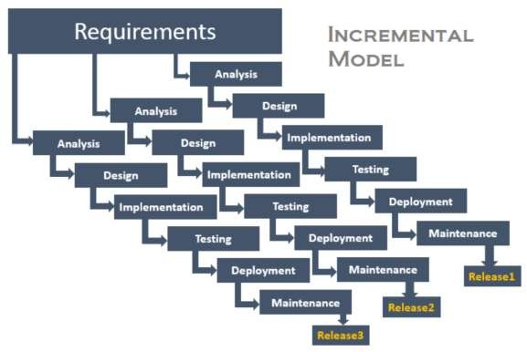

**Figure 1 Incremental Model**

### **ANALYSIS PHASE**

In this phase, analysis was performed in order to find out the requirements of the system. The outcome of this phase would be an SRS which is an acronym for “System Requirement Specifications”.

### **DESIGN PHASE**

In this phase the SRS would be translated into the system’s design. Context Diagram, DFD, ER – Diagram, Use Case Diagram, and Class Diagram will be developed.

### **CODING PHASE**

In this phase, coding would be done according to the design, and a working system is achieved/developed by the end of this process.

### **TESTING PHASE**

In this phase, the system would be tested. With each testing, a list of changes to the system developed is suggested and the changes will be applied to the software and the software would be delivered as a successive increment until a satisfying system is achieved.

### **MANAGING INCREMENTS**

Each stage of the incremental model adds some functionality to the product and passes it on to the next stage. The first increment (generally known as a core product) was used for a detailed evaluation. This process resulted in the creation of a plan for the next increment. The iteration process, which includes the delivery of the increments to the user, continues until the software is completely developed, i.e. iteratively enhances the requirements until the final software is implemented. Our project which implements the Incremental Model comprises three increments which are discussed below:

**INCREMENT I**

Here, we will build a complete skeleton of our project using the flutter framework on which we will add functionality in another iteration. We will have a project discussion with team members and take guidance from the supervisors on whether to keep the design as it is or to Improvise. Then we will make the required changes and move to the next iterations of our project.

**INCREMENT II**: Semantic Analysis Development

In this increment, when the users are asked to access the permission of the messaging app, the users will be provided with a list of different service providers like banks and wallets. And after they grant access the semantic analysis will be performed where the keywords like "debited” and “credited “ are extracted and the relative amount will be stored in the database.

**INCREMENT III**: System Deployment

In this increment, we will get the UI ready along with the user's income and expenses. A report of saving and expenditures will also be generated.

## 3.2 PREDICTION MODEL

## In our project, We have implemented sentimental analysis where we have calculated with the help of natural language processing and machine learning algorithms by automatically identifying the customer’s emotions behind the review feedback. Here, we use rule-based approach where system performs sentiment analysis based on manually crafted rules to identify polarity, subjectivity, or the subject of an opinion.

## Why we choose rule-based approach are as follow:

## These rules contain different natural language processing techniques developed in computational linguistics like stemming tokenization, parsing, lexicons(list of words and expressions), or part of speech tagging.

## 

**Figure 2:Table for user review and its respective analysis**

## 

**Figure 3: 2D Representation**

## 

**Figure 4: Graph Representation**

## 3.3 PROS OF INCREMENTAL MODEL

* More flexible – less costly to change scope and requirements.
* Easier to test and debug during a smaller iteration.
* Easier to manage risk because risky pieces are identified and handled during its iteration.
* Each iteration is an easily managed milestone.
* Handling functionality during iteration process.

## WHY DID WE CHOOSE THE INCREMENTAL MODEL?

* The requirements of the complete system were clearly defined and understood**.**
* Major requirements were defined (however, some details could evolve with time)

# SYSTEM DESIGN AND ARCHITECTURE

An activity diagram visually presents a series of actions or flow of control in a system similar to a flowchart or a data flow diagram. Activity diagrams are often used in business process modeling. They can also describe the steps in a use case diagram. Activities modeled can be sequential and concurrent.

## USE CASE DIAGRAM

It is a diagram that describes the sequence of events of an actor using a system to complete the process. The essence is discovering and recording functional requirements by writing stories of using a system to help fulfill various stakeholder needs. The use case is a narrative description of domain processes. A use case diagram shows a set of use cases and actors and their relationships. The Use case diagrams are especially useful in organizing and modeling the behaviors of a system and describe what a system does from the standpoint of an external observer.

### **ADMIN**

**Figure 5: Use-Case Diagram for Admin**

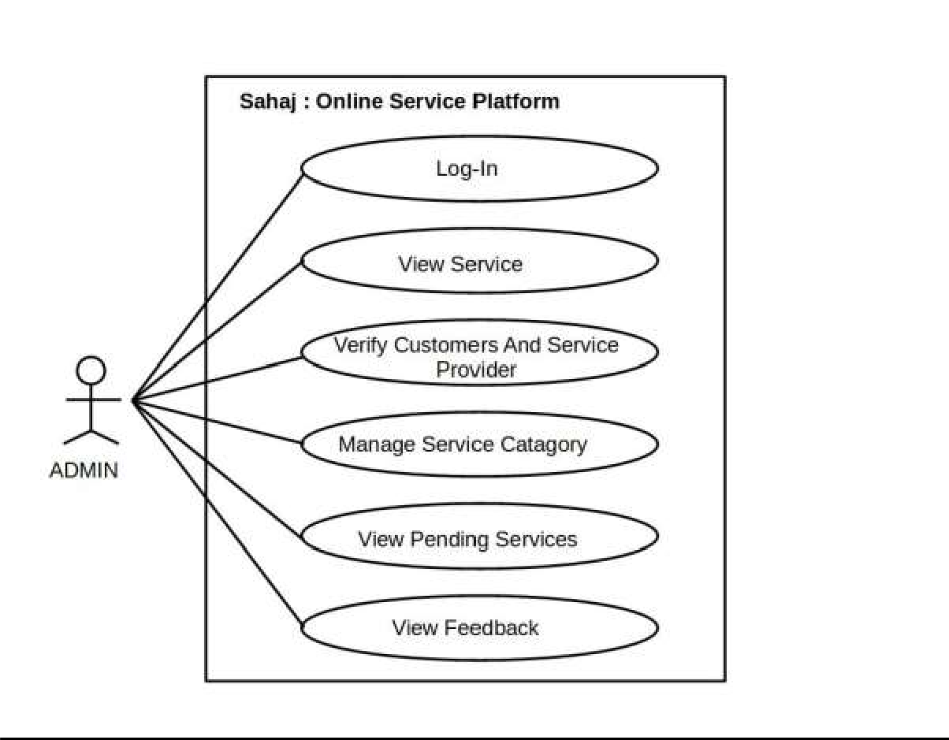

1. Brief Discussion:

This use-case describe how admin login into the system and manage the overall services.

1. Actors:
   1. . Admin
   2. System
2. Preconditions:

There is active connection between system and database and system have login page to access the system.

1. Post Conditions:

Successful login into the system. The admin have update/change/edit the datas and database updated successfully.

### **SERVICE PROVIDER**

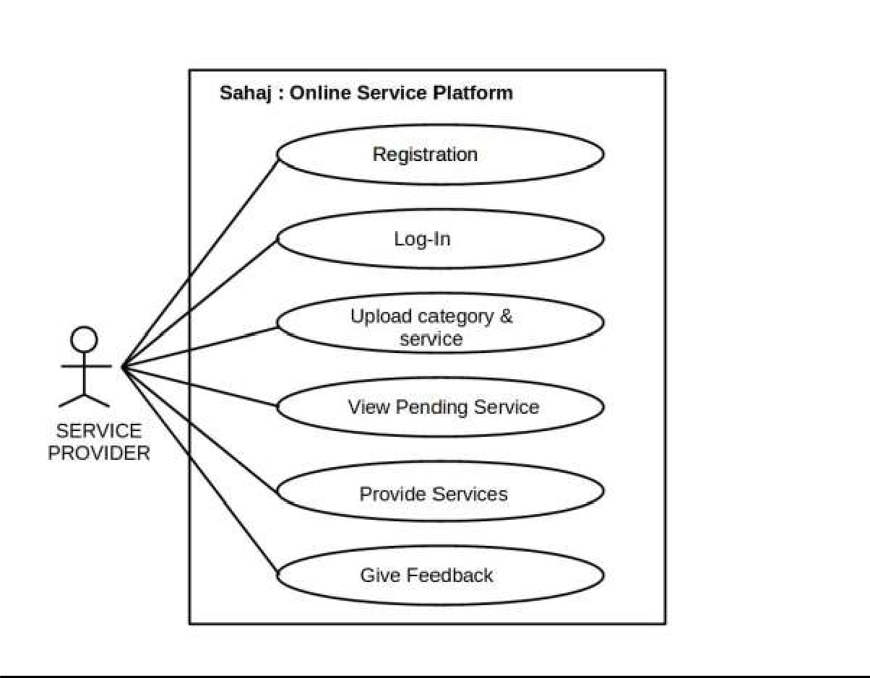

**Figure 6: Use-Case Diagram for Service Provider**

# Brief Discussion:

This use-case describe how service provider login into the system and manage the services.

# Actors:

## . service provider

## System

# Preconditions:

There is active connection between system and database and system have login page to access the system.

# Post Conditions:

Successful login into the system. The vendor have update/change/edit the services and database updated successfully.

### **CUSTOMER**

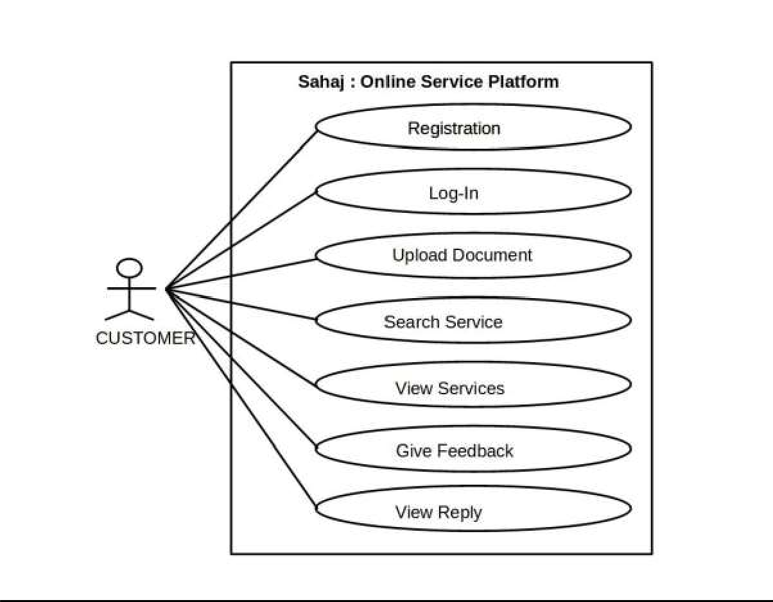

**Figure 7: Use-Case Diagram for Customer**

# Brief Discussion:

This use-case describe how customer access into the system , select the service and book the relevant services accordingly.

# Actors:

## customer

## System

# Preconditions:

There is active connection between system and database and system have customer login page to access the system.

# Post Conditions:

After successful login into the system, the customer book/appoint the relevant services and provide feedback if needed aside database updated syccessfully.

## SYSTEM ARCHITECTURE

Firstly, we validate the user using the login credentials and then we request server for fetch the refined service and service provider overall details using semantic analysis. After that, the final fetched details are provided to the users.

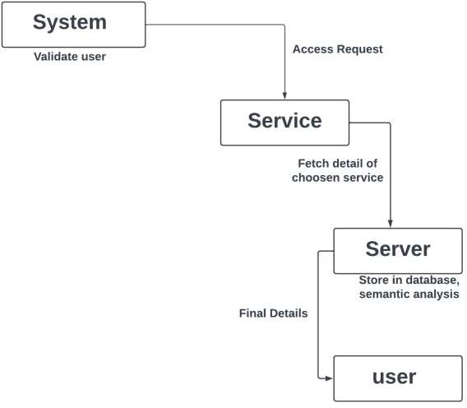

**Figure 8: System Architecture**

## DATA MODELING

### **E-R DIAGRAM**

An entity-relationship diagram (ERD) is a graphical representation of an information system that shows the relationship between people, objects, places, concepts or events within that system. An ERD is a data modeling technique that can help define business processes and can be used as the foundation for a relation database.

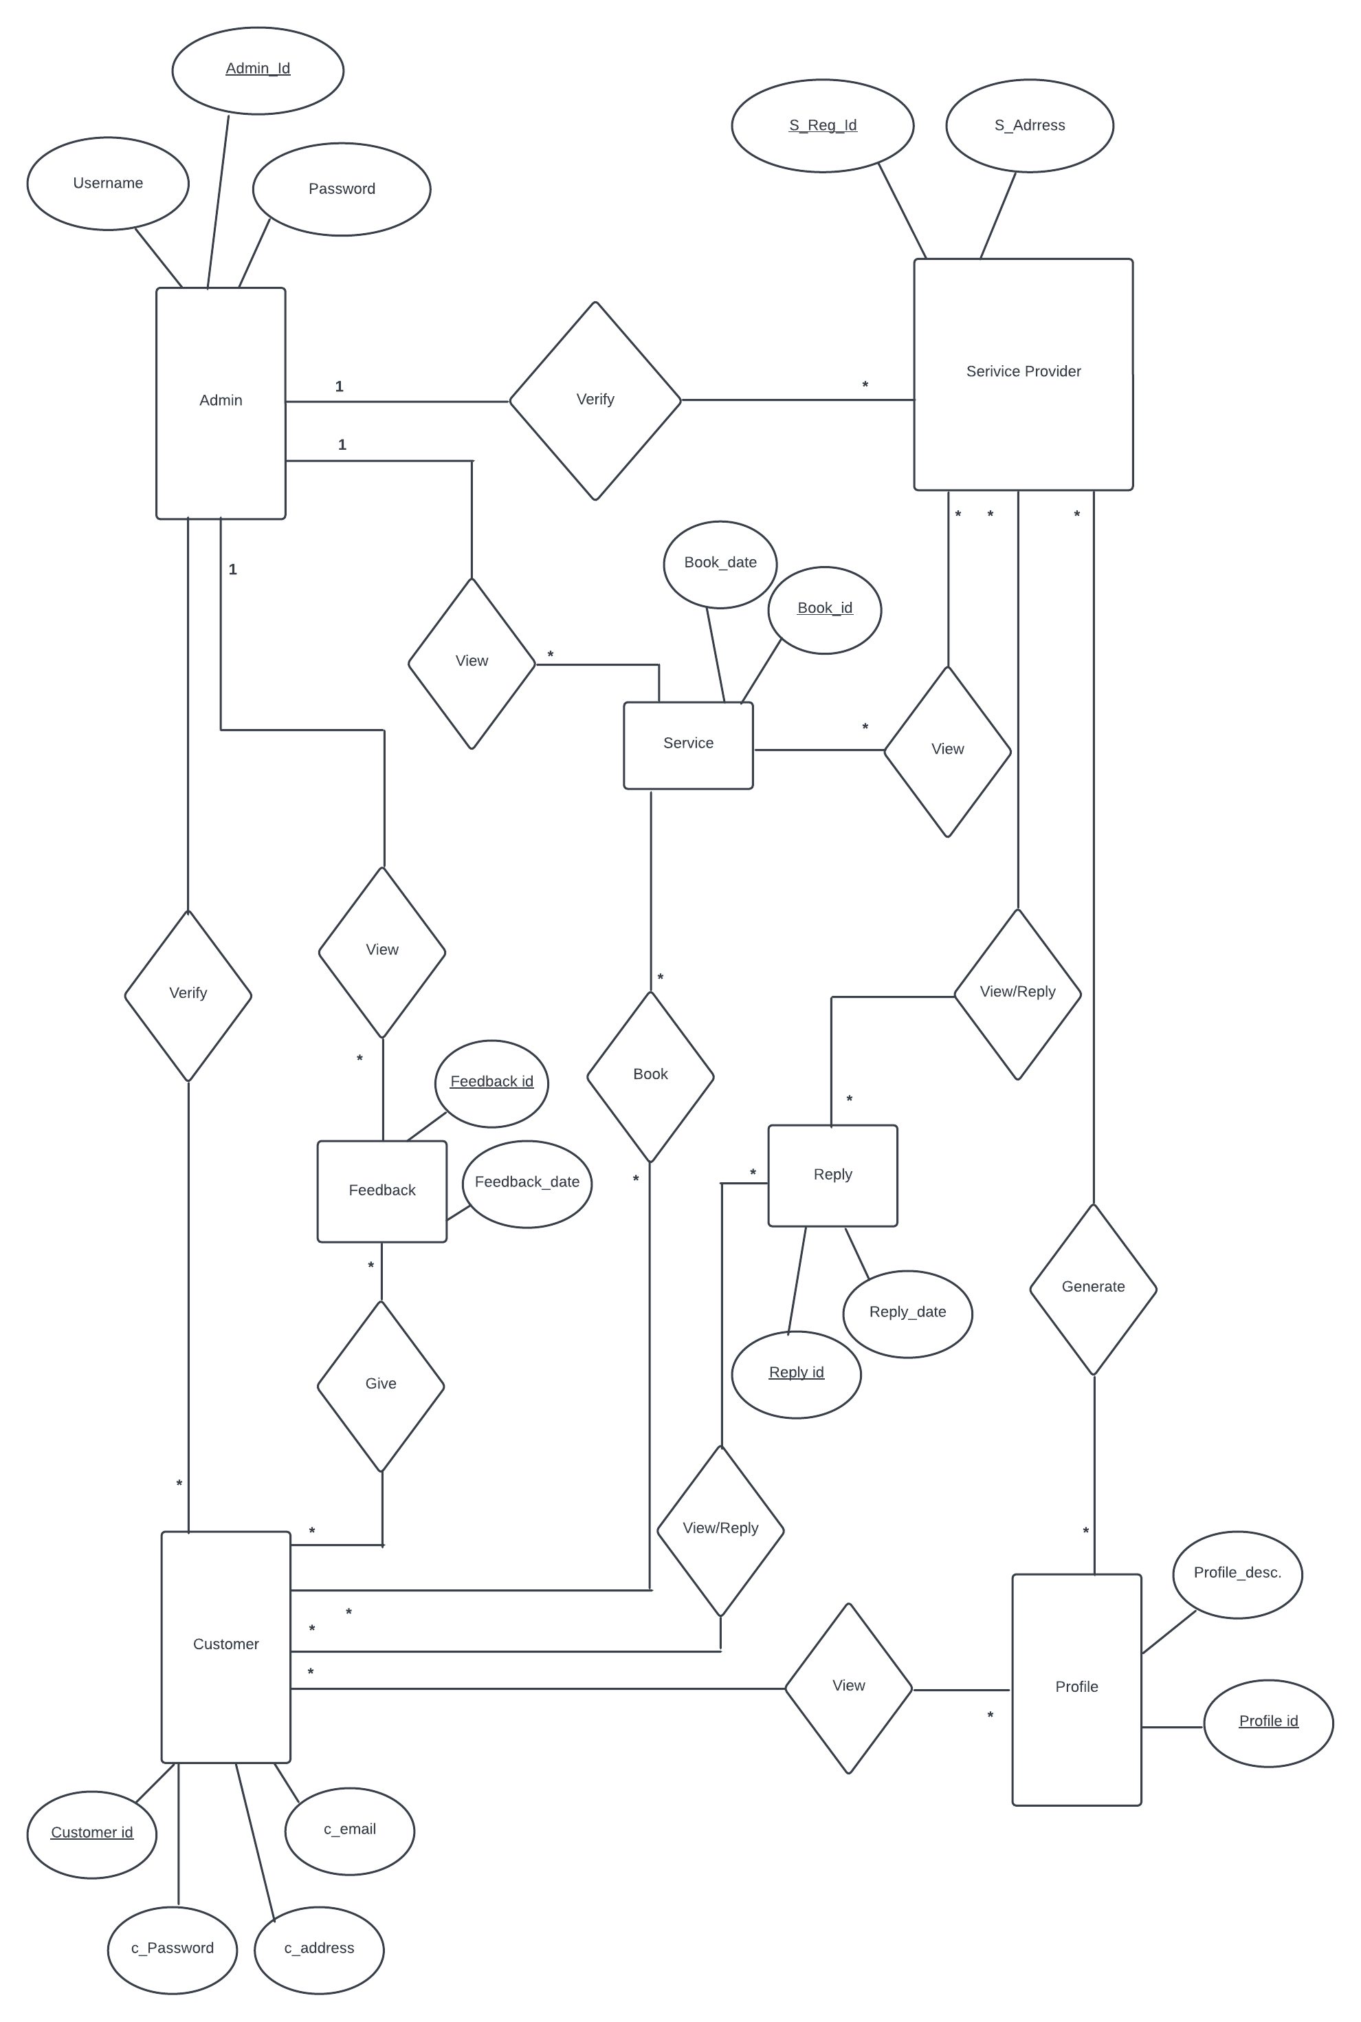 **Fig: E-R Diagram**

### **ACTIVITY DIAGRAM**

Activity diagram describes the flow of control in a system. So it consists of activities and links. The flow can be sequential, concurrent or branched. Activities are nothing but the functions of a system. Numbers of activity diagrams are prepared to capture the entire flow in a system. Activity diagrams are used to visualize the flow of controls in a system. This is prepared to have an idea of how the system will work when executed.

#### **LOGIN & REGISTRATION**

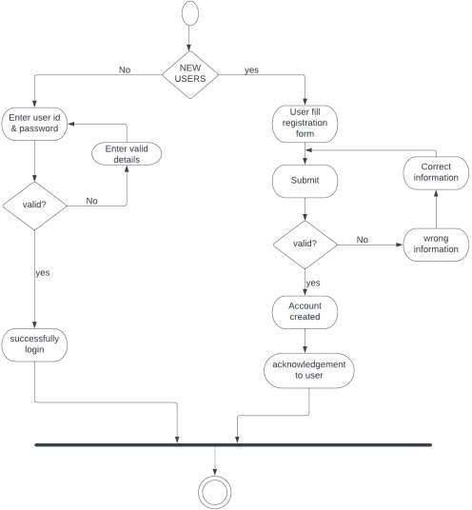Here, the below diagram is activity diagram for login and registration. Here if the user is already registered then user have to enter the user id and password after successful validation then login is success and if the user is new to the system then user should fill the registration form and submit, if valid, account is created and if it is incorrect then correct information should be provided.

**Figure 9:Activity Diagram For Login & Registration**

#### **ADMIN**

In this section, admin logs in and after successfully logged in the admin will be capable of verifying the user, manage category, add and delete service details and also add & delete service provider.

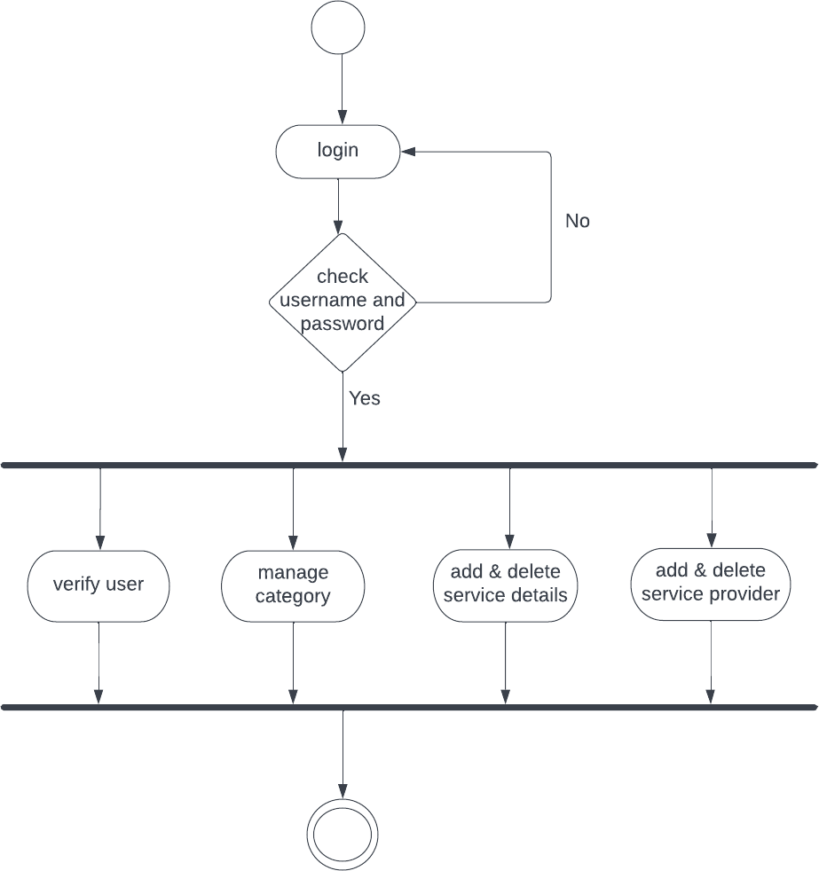

**Figure 10: Activity Diagram for Admin**

#### **SERVICE PROVIDER**

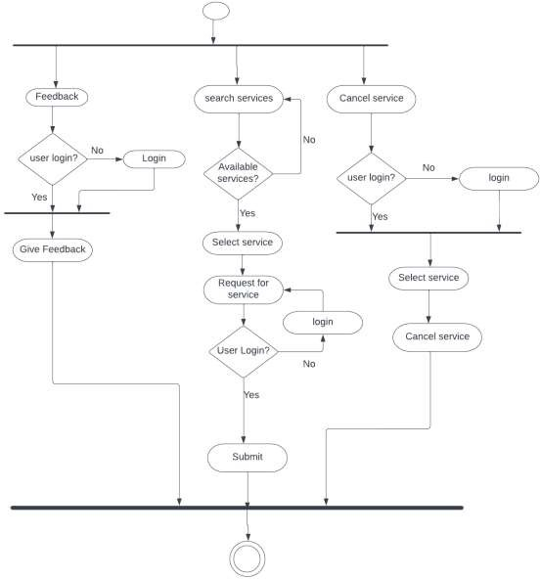

**Figure 11: Activity Diagram for Service Provider**

**j**

#### **CUSTOMER**

Customer can select the available services. And also they are able to provide the feedback to the service providers via review. After this, they can successfully get the desired services.

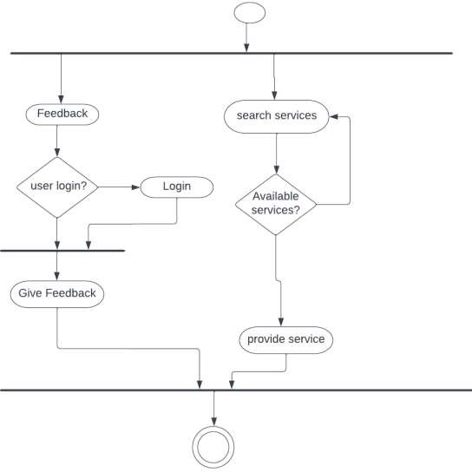

**Figure 12: Activity Diagram for Customer**

### **SEQUENCE DIAGRAM**

A sequence diagram is an interaction diagram that shows how processes operate with one another and in what order. It is a construct of a Message Sequence Chart. A sequence diagram shows object interactions arranged in time sequence. It depicts the objects and classes involved in the scenario and the sequence of message exchanged between the objects needed to carry out the functionality of the scenario. They are typically associated with use case realization in the Logical View of the system under development.

#### **ADMIN:**

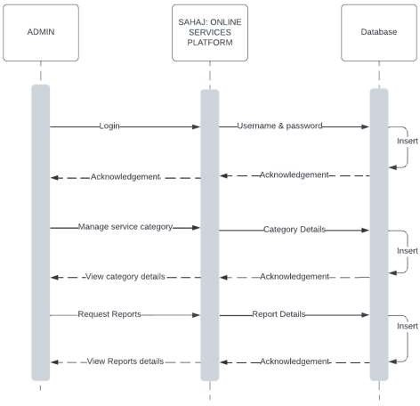Admin logins to the online services platform and after that admin will be able to manage service category, can view category details and also view reports detail. All the above messages are checked in the database and performed serial wise.

**Figure 13: Sequence Diagram for Admin**

#### **SERVICE PROVIDER:**

Service provider fills registration form firstly and the credentials are checked by the database. After successfully login, the service provider can view the ordered service and will be able to provide the service.

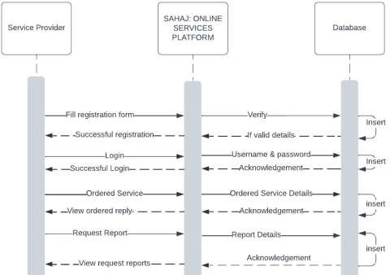

**Figure 14: Sequence Diagram for Service Provider**

#### **CUSTOMER:**

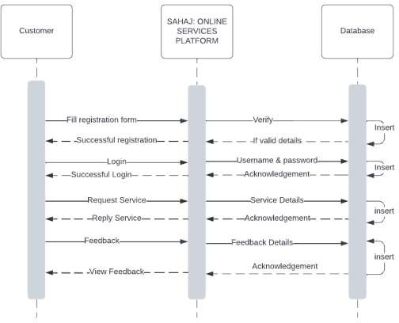

**Figure 15: Sequence Diagram for Customer**

## FUNCTIONAL AND BEHAVORAL MODELING

It gives the basic description of the functions and the behavior of the system.

### **DATAFLOW DIAGRAM**

A data flow diagram is a graphical representation of the “flow” of data through an information system, modeling its process aspects. A DFD shows what kind of information will be input to and output from the system, where the data will come from and go to, and where the data will be stored. It does not show information about the timing of process or information about whether processes will operate in sequence or in parallel.

#### **DFD DIAGRAM LEVEL 0**

It is also known as context diagram. It's designed to ben an abstraction view, showing the system as a single process with its relationship to external entities. It represents the entire system as a single bubble with input and output data indicated by incoming/outgoing arrows.

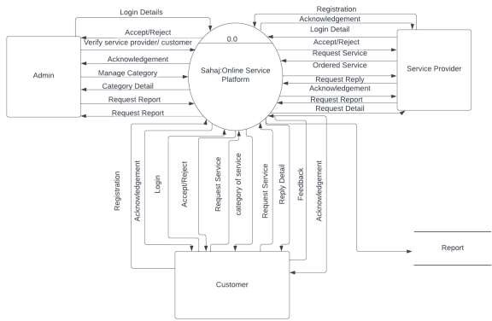

**Figure 16: DFD Diagram Level 0**

**ADMIN:**

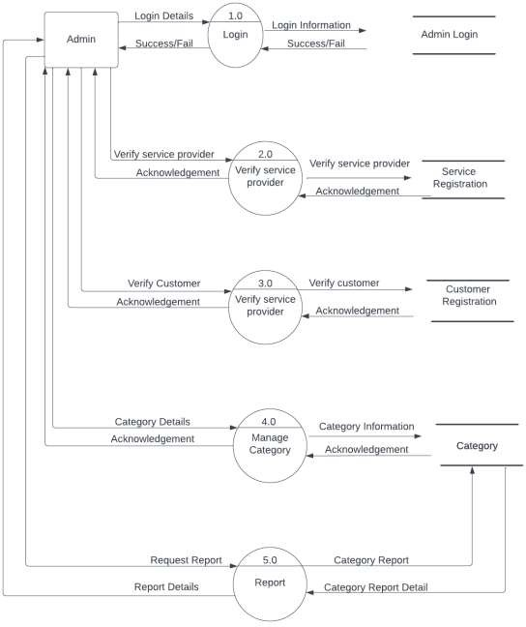

**Figure 17: DFD Diagram Level 1 For Admin**

**SERVICE PROVIDER:**

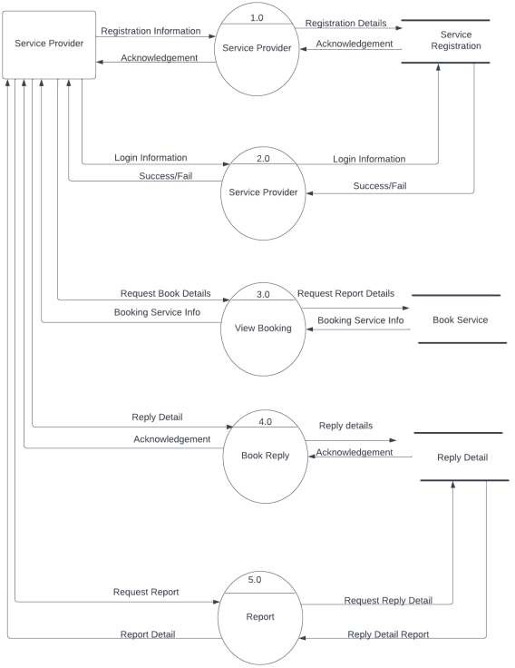

**Figure 18: DFD Diagram Level 1 For Service Provider**

**CUSTOMER:**

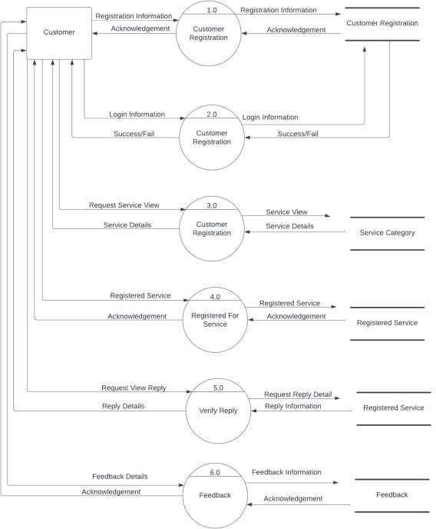

**Figure 19: DFD Diagram Level 1 For Customer**

### **CONTEXT DIAGRAM**

A context diagram gives an overview and it is the highest level in a data flow diagram, containing only one process representing the entire system. It should be split into major processes which give greater detail and each major process may further split to give more detail.

* + - * All external entities are shown on the context diagram as well as major data flow from them.
      * The single process in the context-level diagram, representing the entire system, can be exploded to include the major processes of the system in the next level diagram, which is termed as diagram 0.

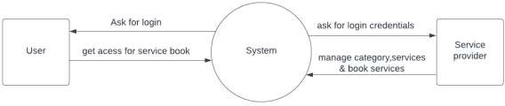

**Figure 20: Context Diagram**

### **DESIGN CLASS DIAGRAM**

In Object Oriented design, Class diagrams are one of the most useful types of diagrams in UML as they clearly map out the structure of a particular system by modelling its classes, attributes, operations, and relationships between objects. UML class diagrams model to describe an object-oriented programming approach. Since classes are the building block of objects, class diagrams are the building blocks of UML. The various components in a class diagram can represent the classes that will actually be programmed, the main objects, or the interactions between classes and objects. The class shape itself consists of a rectangle with three rows. The top row contains the name of the class, the middle row contains the attributes of the class, and the bottom section expresses the methods or operations that the class may use. In general UML Class Diagram, it allows us to:

* Better understand the general overview of the schematics of an application to be developed.
* Illustrate data models for information systems, no matter how simple or complex it is.

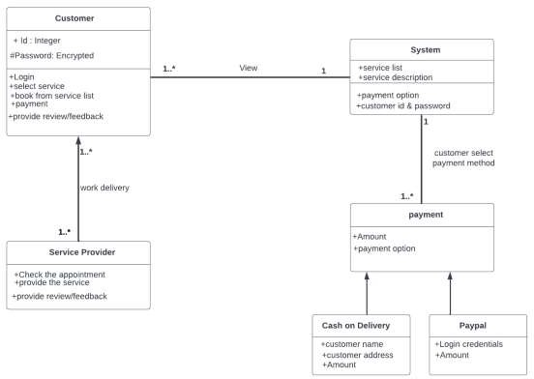

**Figure 21: Design Class Diagram**

# TEAM MEMBER AND DIVIDED ROLES

Table 1:Team member and divided roles

|  |  |  |
| --- | --- | --- |
| **NAME** | **ROLES** | **RESPNSIBILITIES** |
| PRABIN BHATTARAI | BackEnd Developer  Data Analyst  Documentation | * Data analysis and sentimental analysis deployment * Development of BackEnd Functionality * Development of Documentation |
| MANISH GAIRE | FrontEnd /UI Developer  Documentation  Data Analyst | * Development of FrontEnd and UL * Development of Documentation * Data analysis and model deployment |
| RAMAN NEUPANE | Data Analyst  Documentation  BackEnd Developer | * Data analysis and model deployment * Development of BackEnd Functionality * Development of Documentation |

# TOOL AND TECHONOLOGY USED

# While developing the web app we have made use of following tools and technologies for different purpose as mentioned below:

**Table 2: Tool and Technology Used**

|  |  |
| --- | --- |
| **TECHNOLOGY** | **USES** |
| PHP | BackEnd Development |
| Mysql | Database |
| Python, Pandas, numpy, sqlalchemy, TextBlob etc. | Machine learning, Data Analytics |
| HTML, CSS, JavaScript, JQUERY, Bootstrap | Front-end Development |
| Github | Source Code Management |
| Sublime Text, Jupyter Notebook | Text editors |

# PROJECT TASK AND TIME SCHEDULE

The project schedule has been designed as per requirements and constraints involved. This project is scheduled to be completed in about 3 months. Requirement analysis has been given more emphasis. Research and voice collection is to be done first and well documented. Debugging and Testing is to be done prior to the completion of the project.

**Table 3: Project Task and Time Schedule**

|  |  |
| --- | --- |
| **TASK** | **APPROX. DURATION (in**  **days)** |
| **Requirement Analysis and Specification** | **24** |
| **Undertake Analysis of the System** | **29** |
| **Design System** | **46** |
| **Coding** | **53** |
| **Testing and Debugging** | **35** |
| **Documentation** | **57** |

## GANTT CHART

## The Gantt chart below has been constructed on the basis of the above project

## schedule. According to the table the project is completed in 3 months. The

## task is started from preliminary investigations and the other tasks are

## scheduled in accordance.

## 

**Figure 2: Gantt Chart First Iteration**

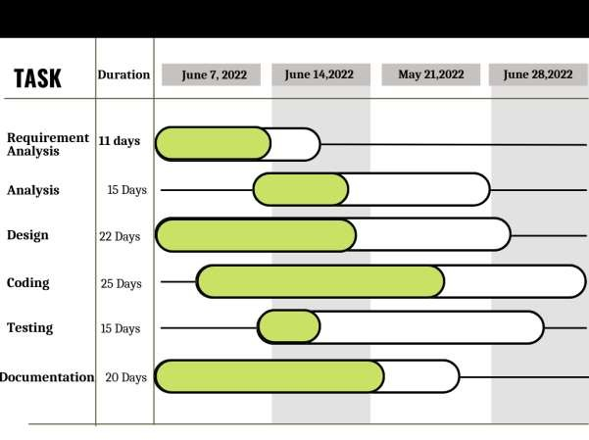

**Figure 3: Gantt Chart Second Iteration**

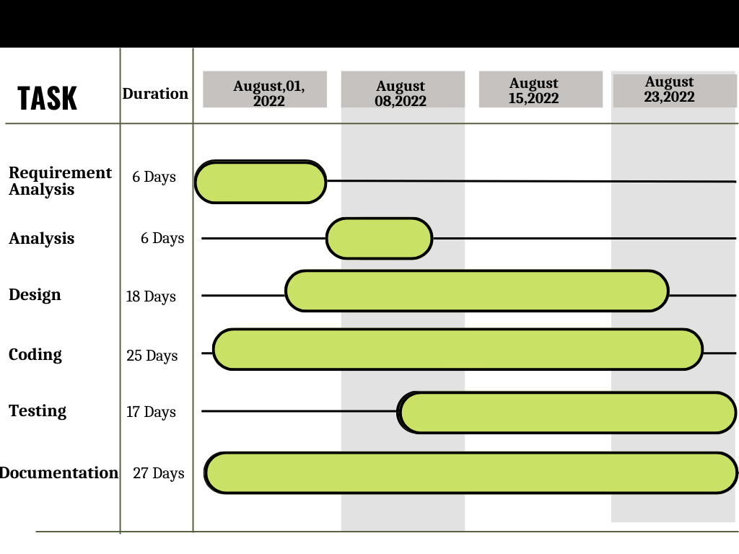

# RESULT AND OUTPUT

On our project we have found the following result and output:

* User can book/appoint service they desire
* User can search and see service accordingly to their need.
* Users are able to give review to the services.
* Admin can add delete/update category .
* Admin can add delete/update category .
* Admin can see the users booking information.

# CONCLUSION AND FUTURE EXTENSIONS

In this project, the results were discussed, as all the basics requirements collections have been completed. Context Diagram, First Level DFD, Use Case Diagram, Class Diagram, Activity Diagram and Sequence Diagram have been designed. All the ideas for the completion of the project have been gathered. The user interface for the system that is the section through which we can interact with the system and the back-end system has been implemented to control the overall system.

Hence, Sahaj is developed to deliver home service to the customers. Sahaj is able to give feedback from the users on the basis of review and using sentimental analysis, we provide the flag tag to the service provider in accordance to positive,negative or neutral.

Online Service Platform is a big website. Due to limitation of time we are not able to provide more features on this website.

* Design can be more enhanced.
* More services and catagories of services can be added.
* Integration with different service provider company for more relevant services.
* We only have developed website, we can go further for mobile applications.

# REFERENCE

* The Multi-service provider Website [ Online] Available : <https://bookgara.com> Accessed on: June 20, 2022
* Report Design and hints website : <https://ukdiss.com/> Accessed on June 23,2022
* The Worldwide Platform for services[Online] Available : https:/[/www.urbancompan](http://www.urbancompany.com/)y[.com/](http://www.urbancompany.com/) Accessed on: May 02,2022
* Introduction to Sentiment Analysis: Concept, Working, and Application

<https://marutitech.com/introduction-to-sentiment-analysis/> Accessed on July 20,2022

* Semantic Analysis, URL: https://monkeylearn.com/blog/semantic-analysis/ Accessed on: August 19, 2022

# APPENDIX

SYSTEM SNAPSHOT

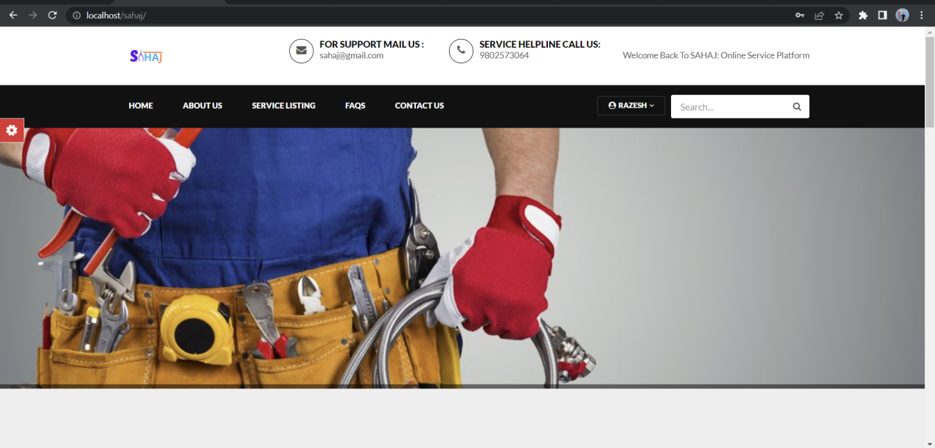

Fig: System Front View

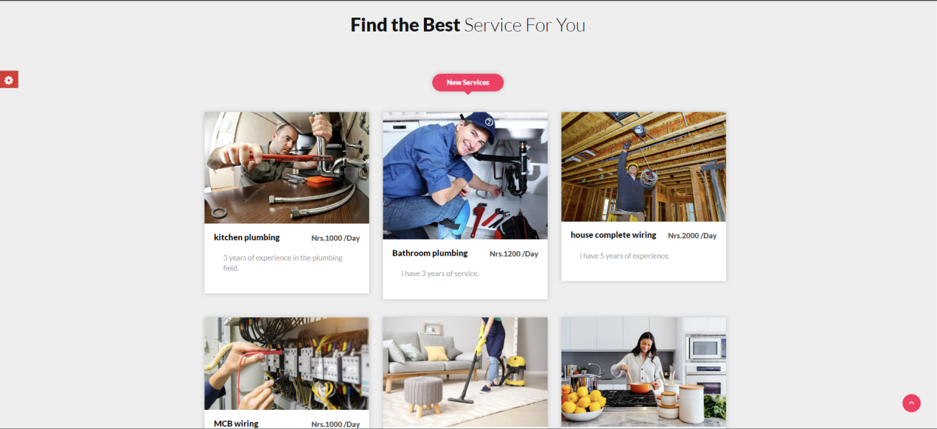

Fig: Service page

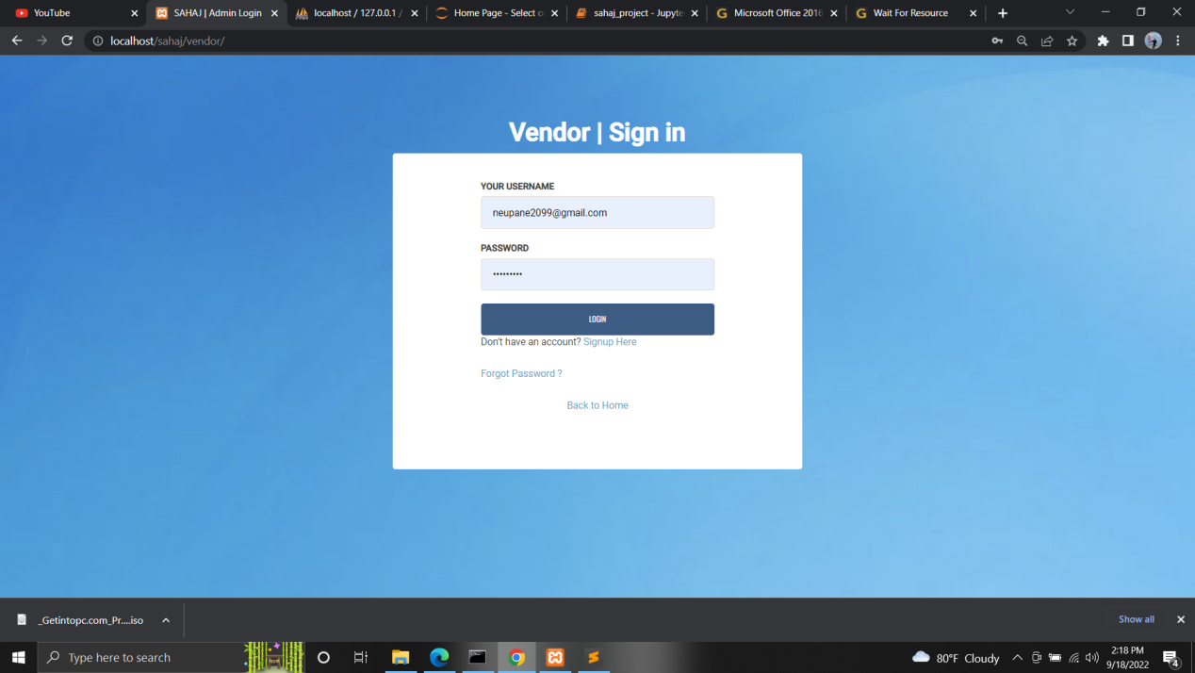

Fig: vendor Login

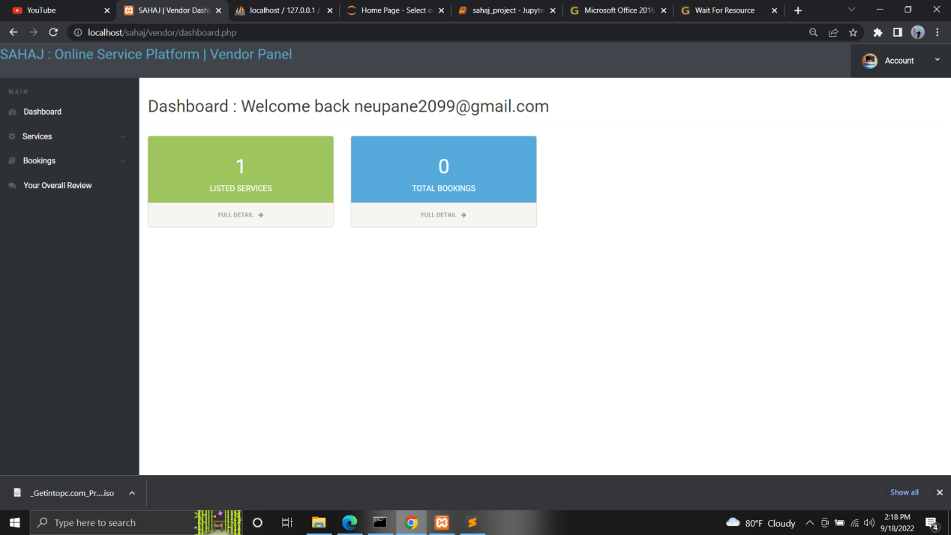

Fig: vendor Dashboard

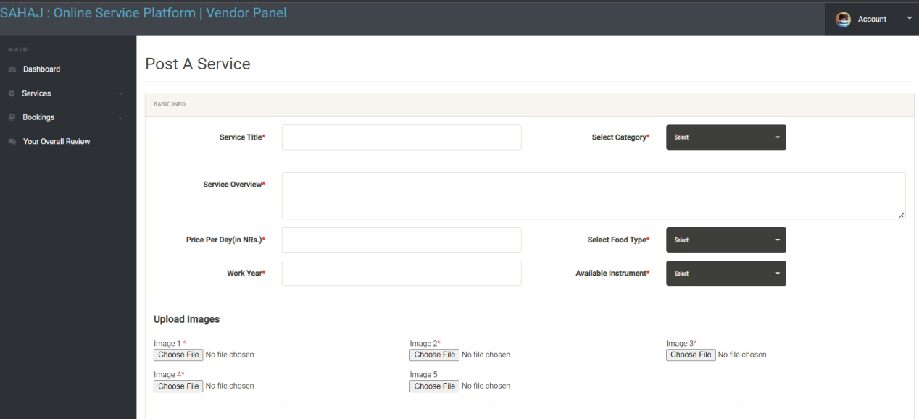

Fig: vendor post a service section

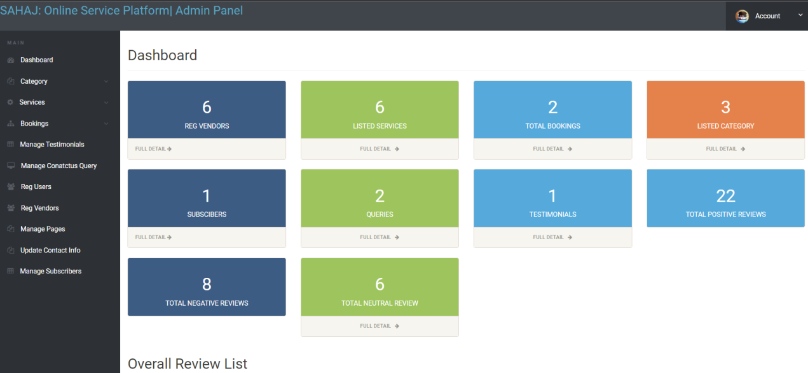

Fig: Admin Dashboard

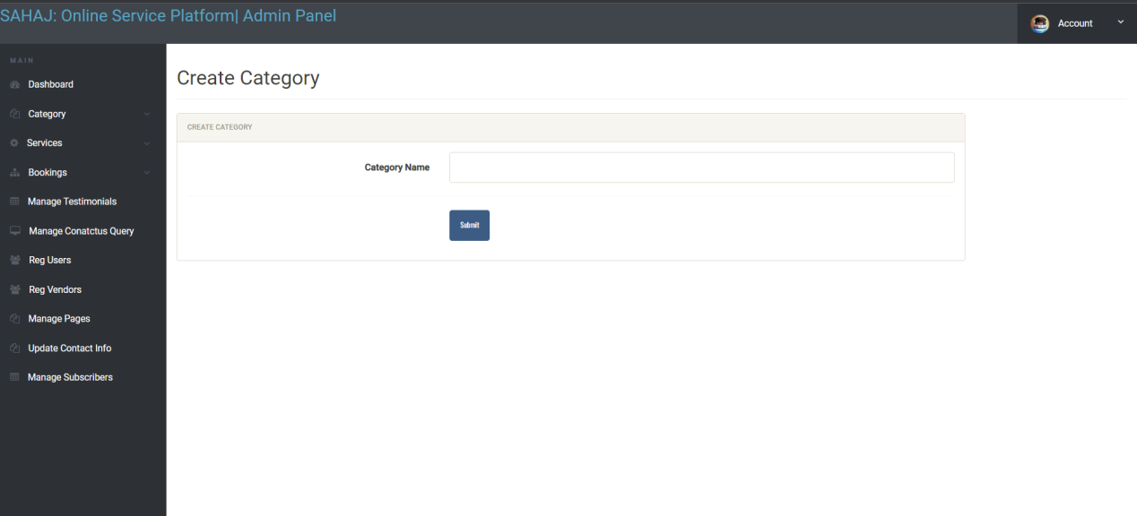

Fig: Admin create category section

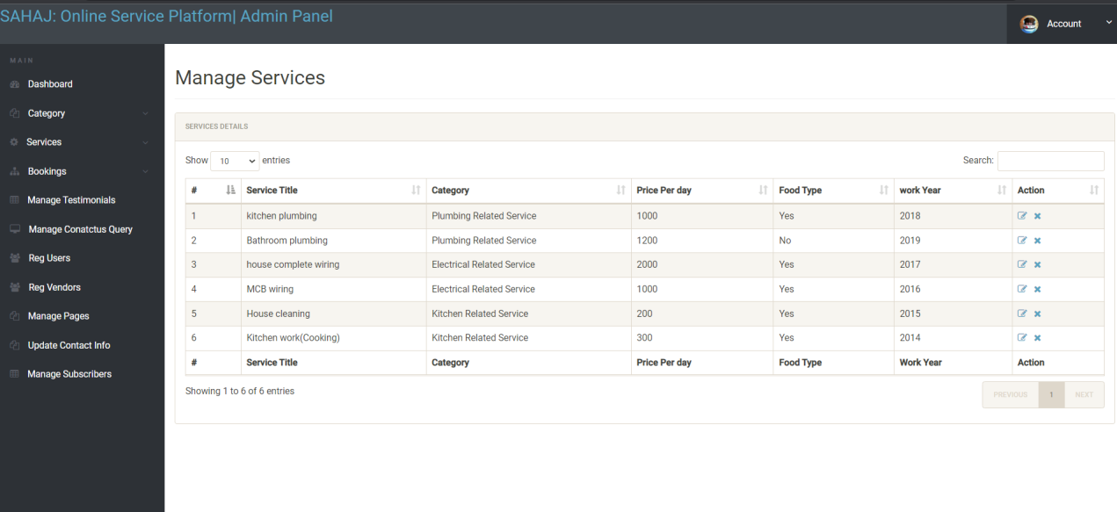

Fig: Admin manage services section

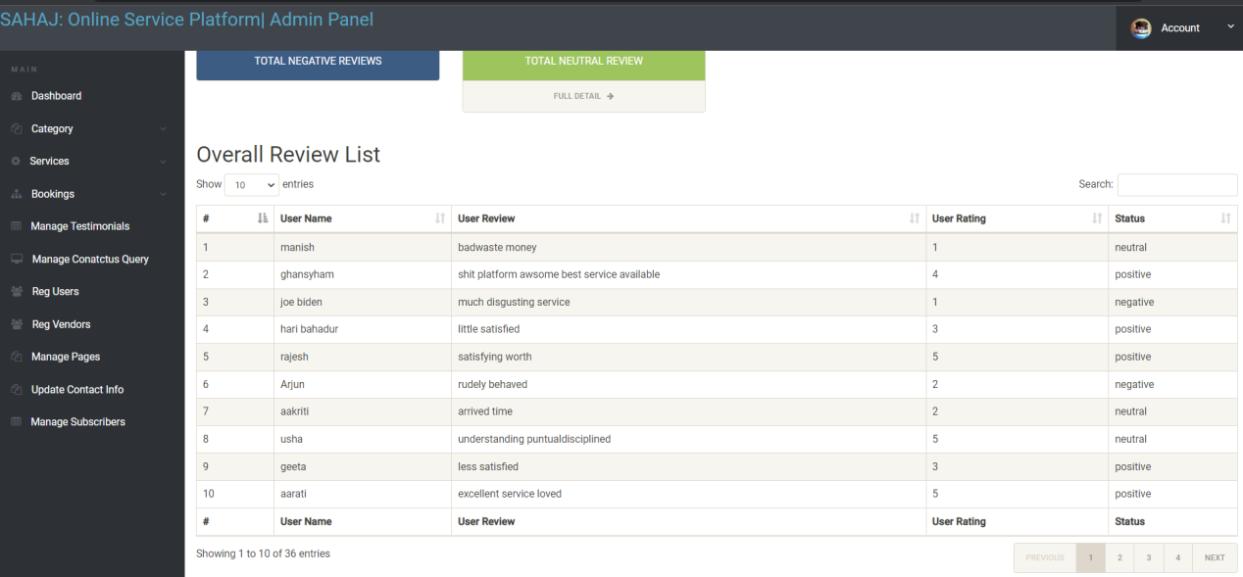

Fig: Admin Overall Review section

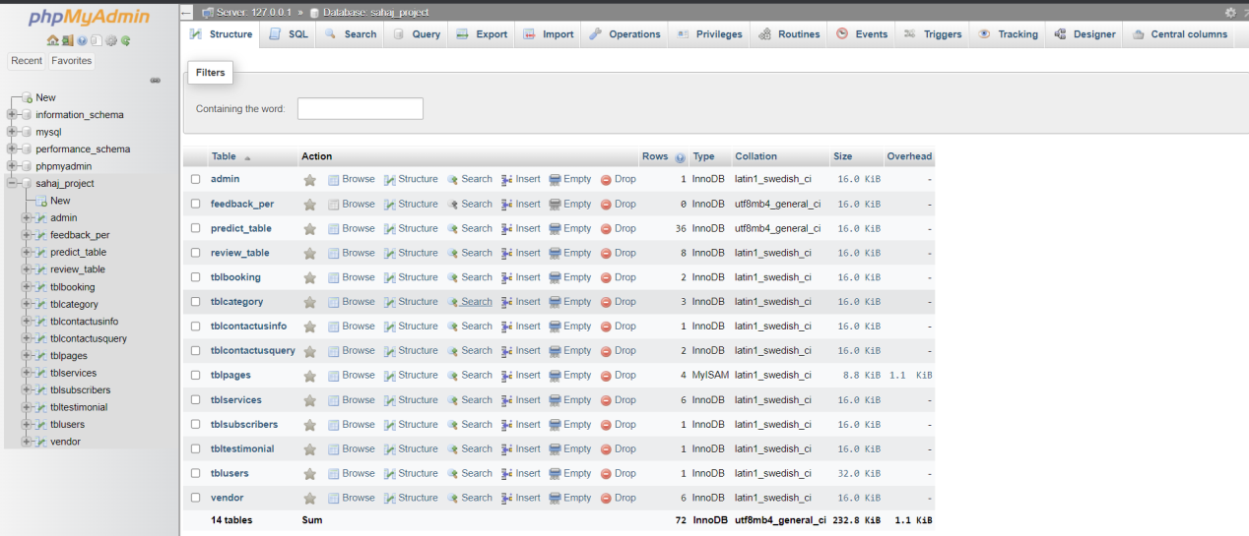

Fig: Database