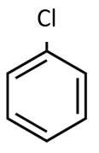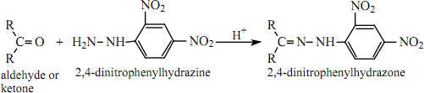

2,4-dinitrophenylhydrazone

H­+

2,4-dinitrophenylhydrazine

propanone

CH3

C=

CH3

CH3

C=O +

CH3

-NO­2

NO­2

N-NH

-NH

NO­2

H­2N-NH

-NH

NO­2

H­2N-NH

-NH

-NO­2

+ NaX

R

X

Ether

+ Na + CH3Cl



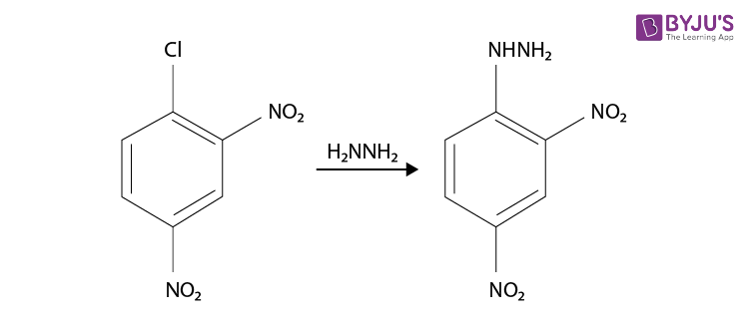

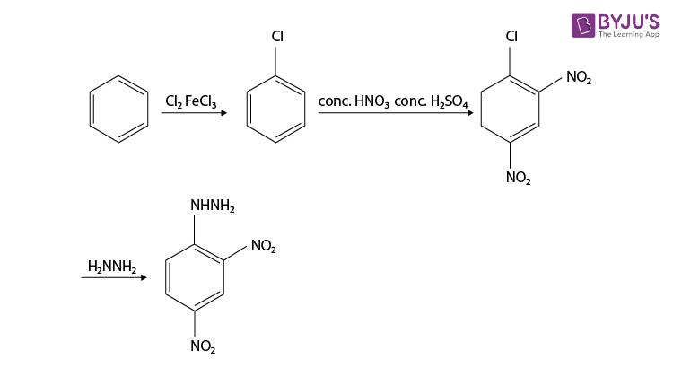

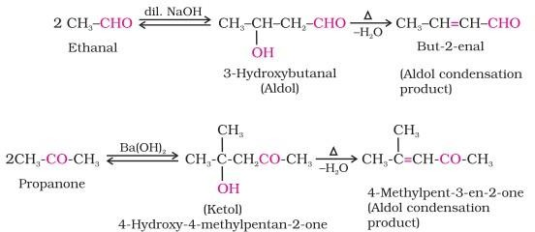

But-2-enal

(Aldol Condensation Product)

Ethanal

3-Hydroxybutanal (ALDOL)

-H2O

OH

dil.NaOH

2CH3-CHO CH3-CH-CH2-CHO CH3-CH=CH-CHO

CH3

CH3

Ba(OH)2

2CH3-CO-CH3 CH3-C-CH2-CO-CH3 CH3-C=CH-CO-CH3

4-methyl-3-ene-2-one

(Aldol Condensation Product)

(Ketol)

4-Hydroxy-4-methylpentan-2-one

propanone

-H2O

OH

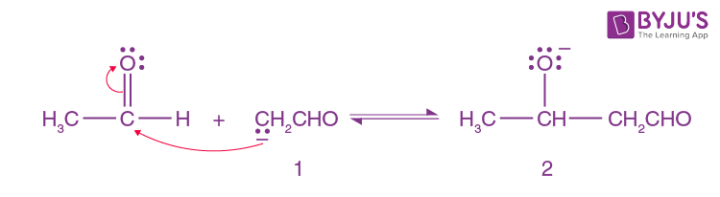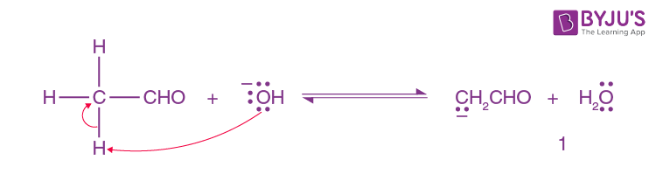 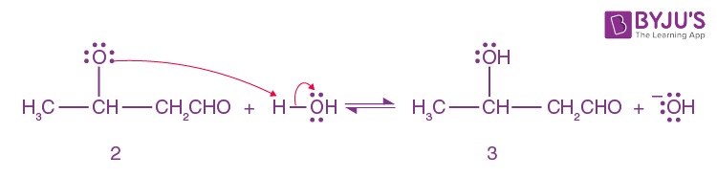 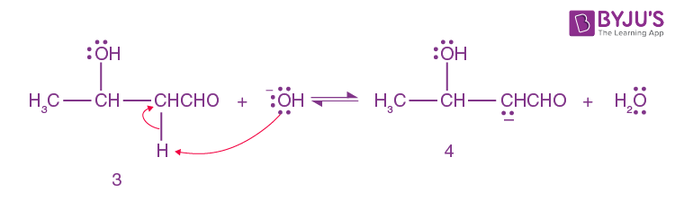 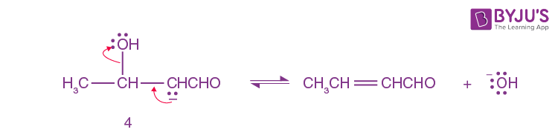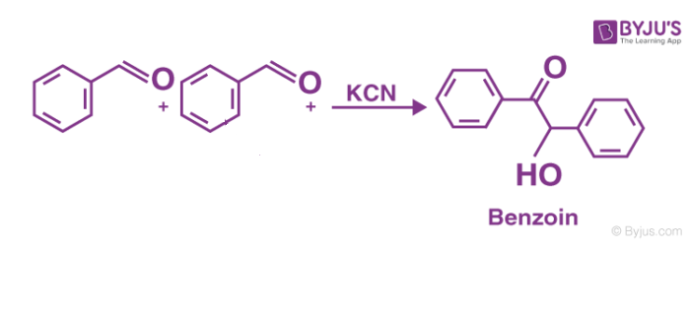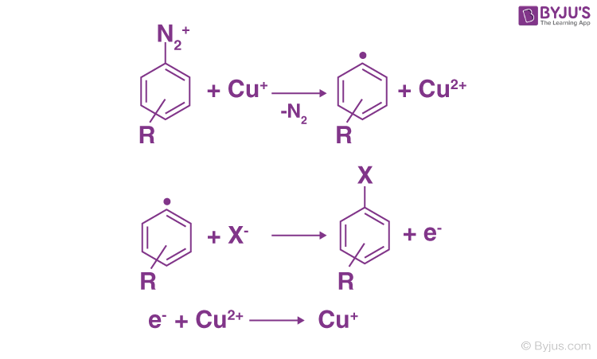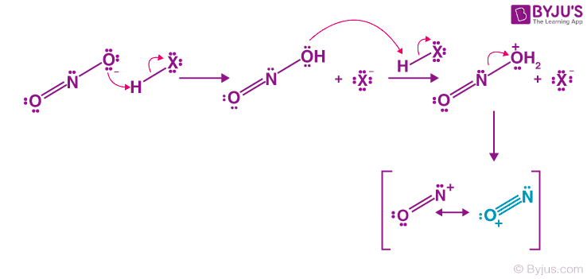

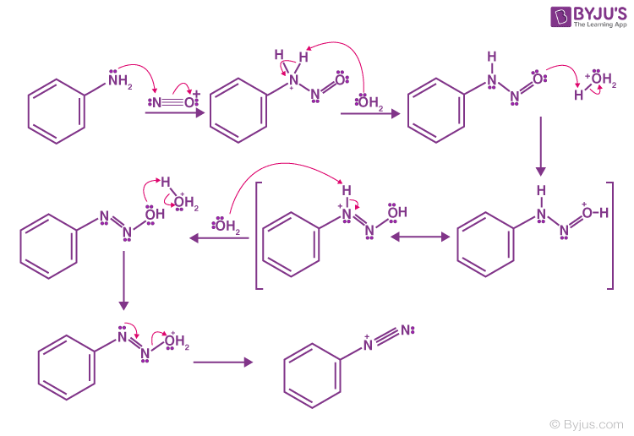



CH3-NH2  + CHCl3 + 3KOH CH3-NC + 3KCl + 3H2O

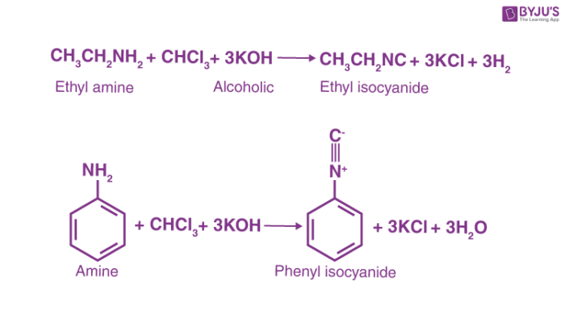

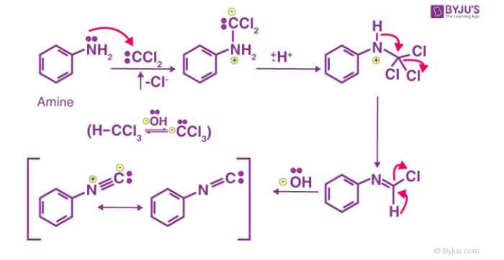

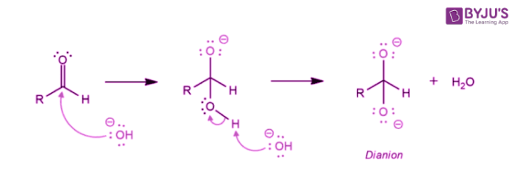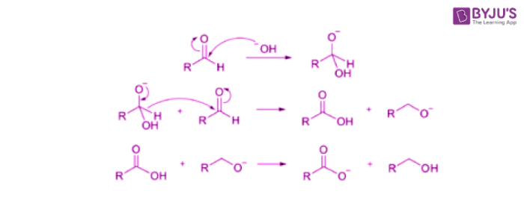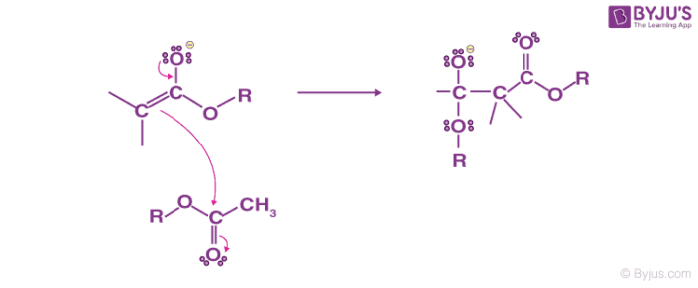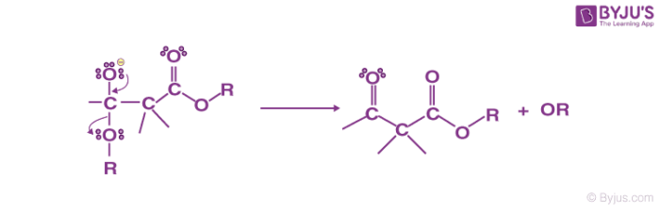

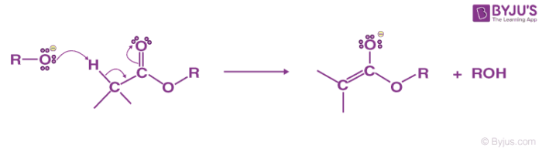

Zn-Hg

C = O CH2 + H2O

HCl

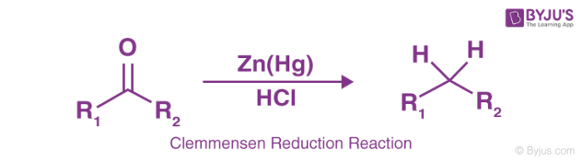

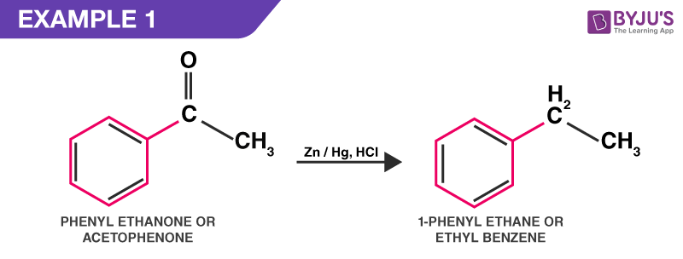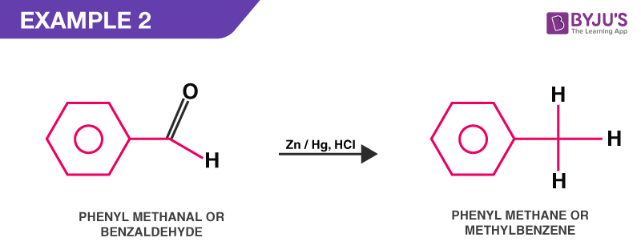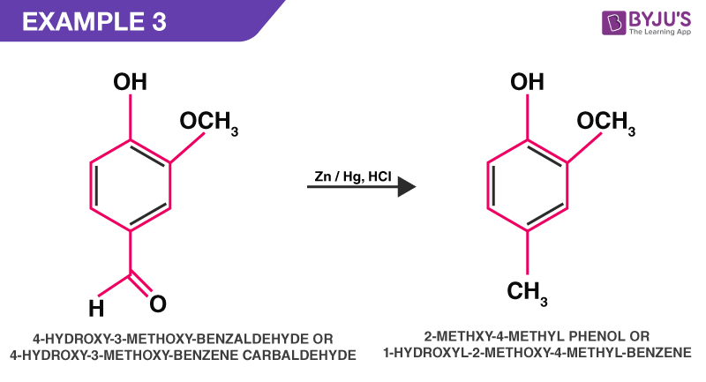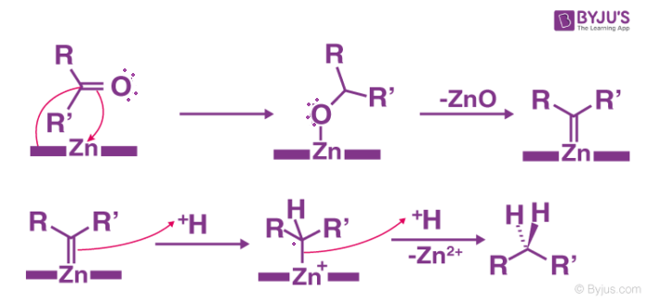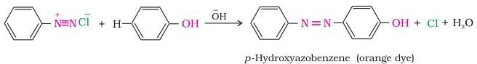





OH

-OH

N=N

OH

N2Cl +

