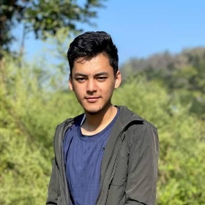

CONTACT

Phone: 9848589357

Email: sitaulaprabesh07@gmail.com

Address: Balaju, Kathmandu

PROJECTS

To view my project, visit my [GITHUB](https://github.com/prabeshsitaula07) profile and navigate to the repository containing the project. From there, you can browse the project's files, view its commit history, and access any associated documentation.

EXPERIENCE

As a high school student with a strong interest in technology, I am eager to explore career opportunities in the field of IT. Although I do not have any direct experience in this field, I have been actively pursuing my education and acquiring knowledge through my academic studies and personal interests. I am currently enrolled in grade 11 and have taken several courses related to computer science and technology, including programming, data structures, algorithms, and database management. I have a solid foundation of knowledge and am eager to continue my education and build my skills in the field of IT. I am highly motivated and committed to professional growth, and I believe that with hard work and dedication, I have the potential to make a valuable contribution to the industry in the future.

ECA

I actively participated in a variety of extracurricular activities, including outdoor sports like football, volleyball, and cricket. I also enjoy indoor games such as carom board and chess, and occasionally engage in e-games. These experiences have improved my teamwork, strategic thinking, and adaptability, contributing to my overall development.

|  |  |
| --- | --- |
| **Tools and Tech** | **Self-Rating** |
| HTML |  |
| CSS |  |
| JavaScript |  |
| Excel data entry |  |
| C Program |  |
| Python  SEO |  |

SKILLS

EDUCATION

Shine Model School: Up to 6th grade

Tarun Ma. Vi: Up to 10th grade

National School Of Sciences: +2

**PRABESH SITAULA**

­­­Web-developer Web-designer Software-developer