EXPERIMENT NUMBER 1
WRITE A PYTHON PROGRAM TO SOLVE 8-PUZZLE PROBLEM
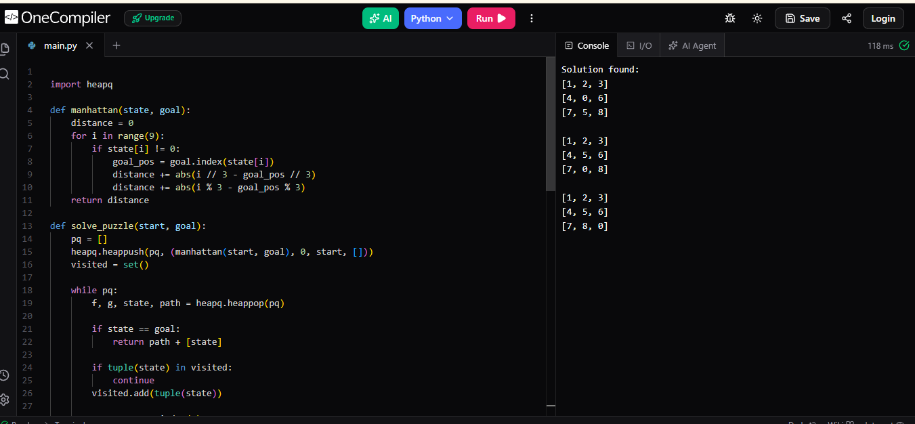
Output Screenshot

