EXPERIMENT NUMBER THREE
CO-2
WRITE A PYTHON PROGRAM FOR WATER JUG PROBLEM
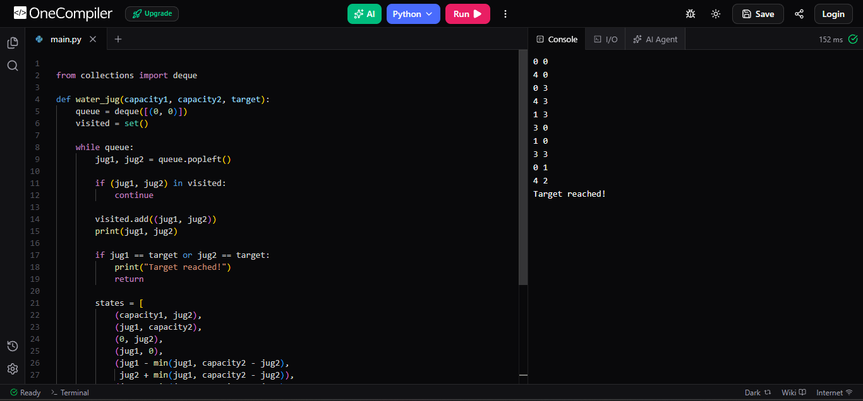
Output Screenshot

