EXPERIMENT NUMBER TWO
CO-1
WRITE A PYTHON PROGRAM TO SOLVE 8-QUEEN PROBLEM
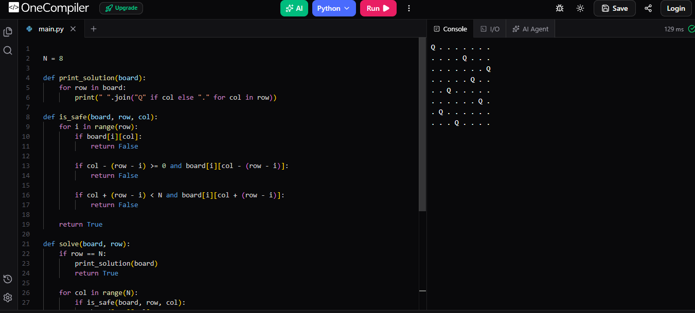
Output Screenshot

